NOAA/CIMSS
Prob Severe Cheat Sheet

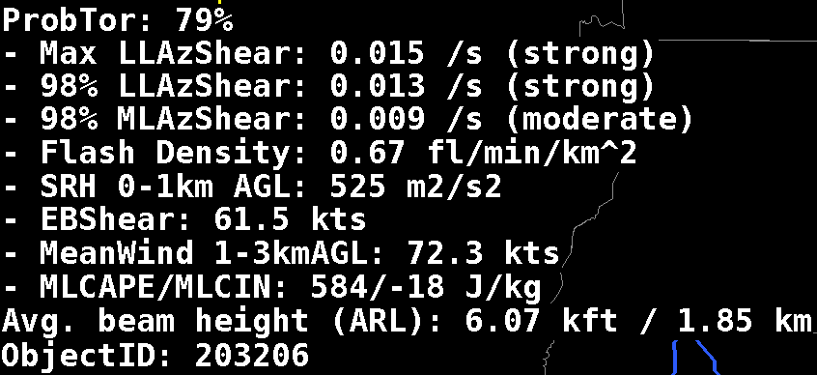

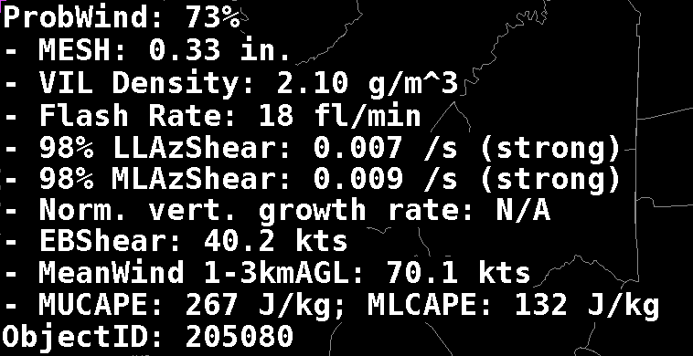
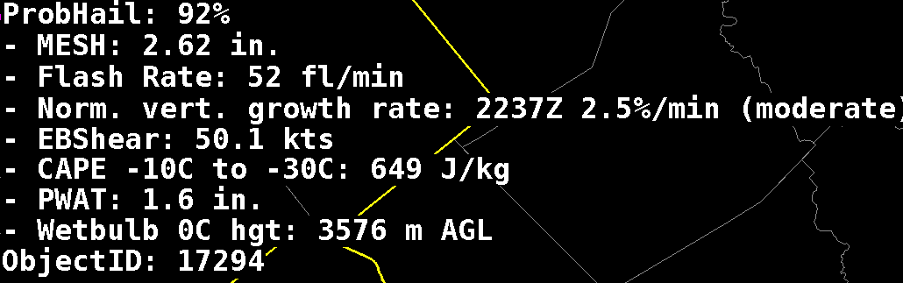

See this link for more information: http://cimss.ssec.wisc.edu/goes/blog/wp-content/uploads/2019/03/NOAACIMSSProbSevereParametersUsed.docx
What is used to compute the probability!

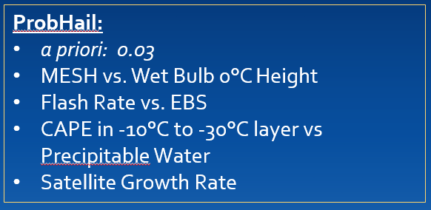
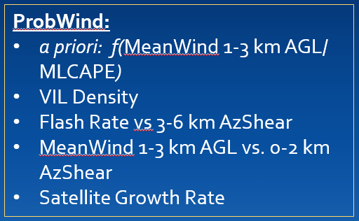
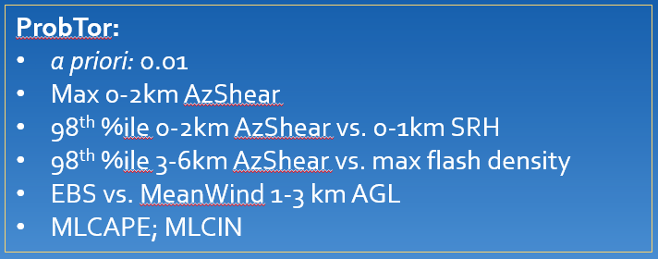

See also this website: https://cimss.ssec.wisc.edu/severe_conv/probsev.html
This is the first ‘hit’ on a web search of ‘NOAA CIMSS Prob Severe’

