GOES-R ABI Cheat Sheet

Band Number | Central Wavelength | Resolution at Nadir | Nickname
1 | 0.47 μm | 1 km | Red
2 | 0.64 μm | 0.5 km | Blue
3 | 0.86 μm | 1 km | Veggie
4 | 1.38 μm | 2 km | Cirrus
5 | 1.61 μm | 1 km | Snow/Ice
6 | 2.24 μm | 2 km | Cloud Particle Size
7 | 3.9 μm | 2 km | Shortwave Infrared
8 | 6.19 μm | 2 km | Upper Level WV
9 | 6.95 μm | 2 km | Mid-Level WV
10 | 7.34 μm | 2 km | Low-Level WV
11 | 8.44 μm | 2 km | Infrared Cloud Top
12 | 9.61 μm | 2 km | Ozone
13 | 10.3 μm | 2 km | Clean IR Window
14 | 11.2 μm | 2 km | Longwave IR Window
15 | 12.3 μm | 2 km | Dirty IR Window
16 | 13.3 μm | 2 km | CO₂

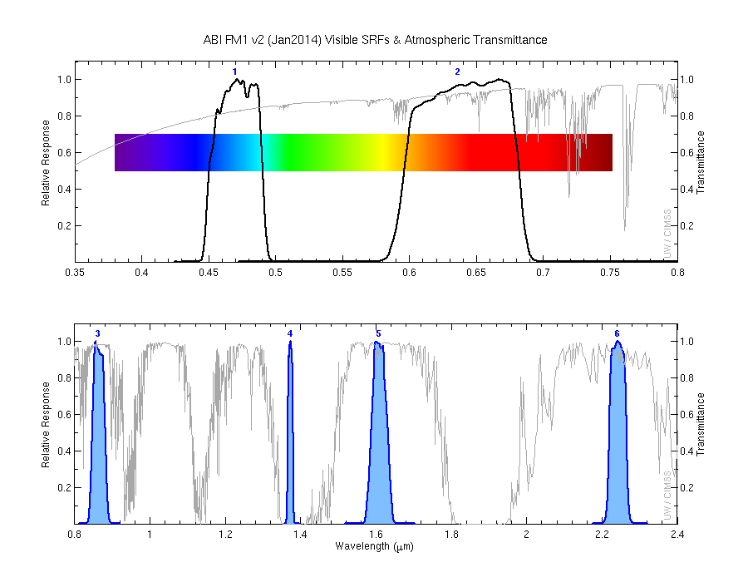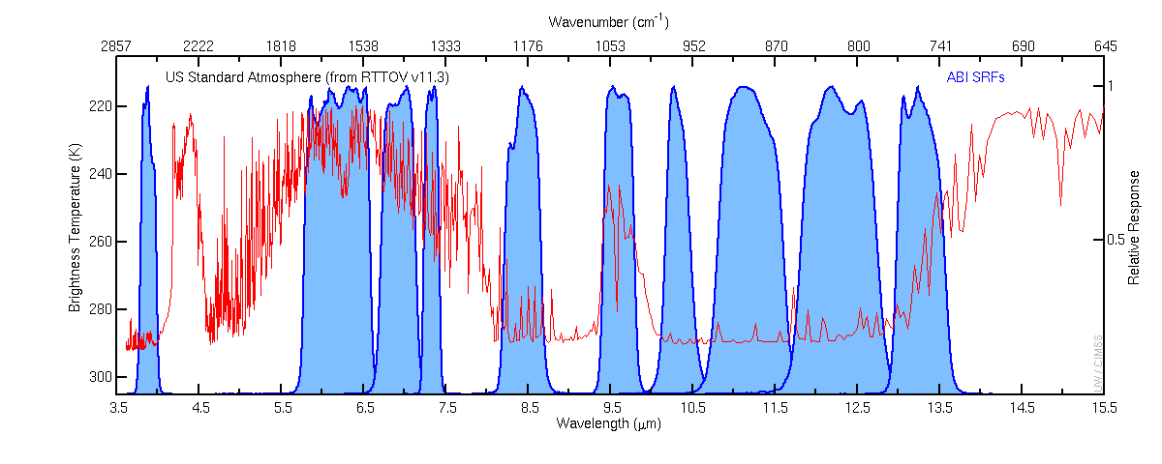
O₃
CO₂
SO₂
H₂O
6
16
15
14
13
12
11
10
9
8
7
5
4
3
1
2

