Bertinoro Quiz 1
27 Aug 2004

Name:_________________________________________

1. The earth-atmosphere spectrum for a given scene is depicted in the figure below:

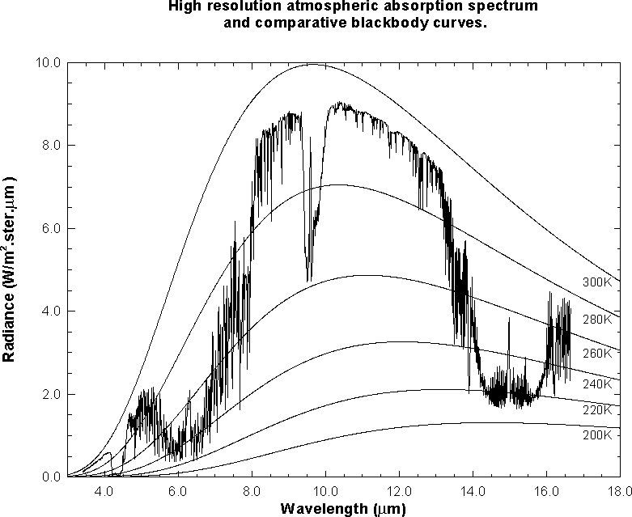

T F The plateau between abscissa values 10.5 and 12 um is a window region of the atmosphere.
T F The tropopause temperature for this scene is roughly 220 K.
T F As atmospheric moisture increases, the brightness temperature difference
[BT(11 um)-BT (12 um)] typically increases.
T F For a clear scene BT(13.3 um) is typically colder than BT(13.9 um).
T F A given percentage increase in temperature produces a larger percentage increase in the
Planck radiance at 4 um than at 11 um.

2. What is the radius of a star (in terms of the sun's radius) that has twice the sun's temperature and three times its flux? Use (1) flux / area equals irradiance and (2) irradiance varies as temperature to the fourth power.

3. In the scatter plot of BT(11um) on the x-axis and [r(1.6um)-r(.6um)] / [r(1.6um)+r(.6um)] on the y-axis, associate A, B, and C with
snow covered land (A, B, C),
non snow covered land (A, B, C), and
cloud (A, B, C)



