Product Description

The objective of this effort is to provide an objective overshooting convective cloud top detection product for evaluation by the Experimental Forecast and Warning Programs (EFP and EWP). Overshooting tops (OTs) are the product of deep convective storm updraft cores of sufficient strength to rise above the storms’ general equilibrium level near the tropopause region and penetrate into the lower stratosphere. Thunderstorms with OTs frequently produce hazardous weather at the Earth’s surface such as heavy rainfall, damaging winds, large hail, and tornadoes. Thunderstorms with an enhanced-V and strong anvil thermal couplet signature in infrared satellite imagery have been shown to be especially severe (Brunner et al. 2009). McCann (1983) shows that the enhanced-V signature can appear 30 minutes before the onset of severe weather on the ground, providing a forecaster with crucial warning lead time. UW-CIMSS has also developed an objective enhanced-V detection product and this may also be included for evaluation within the 2010 SPC Spring Program pending release by the algorithm developers. Turbulence and cloud-to-ground (CG) lightning are found to occur most frequently near the OT region, indicating that OTs represent significant hazards to ground-based and in-flight aviation operations.
Bedka et al. (2010) and Bedka (2010) describe the objective GOES-R ABI OT detection method and showed detection results using MODIS, GOES-12, and MSG SEVIRI imagery. This method uses a combination of 10.7 μm infrared window (IRW) channel brightness temperatures (BTs), a numerical weather prediction (NWP) model tropopause temperature forecast, and OT size and BT criteria defined through analysis of 450 thunderstorm events within 1-km Moderate Resolution Imaging Spectroradiometer (MODIS) and Advanced Very High Resolution Radiometer (AVHRR) imagery. This method is called “IRW-texture” because it utilizes BT spatial gradients (i.e. texture) to identify clusters of pixels that are significantly colder than the surrounding anvil cloud and have a size consistent with commonly observed OTs.
Bedka et al. (2010) show that the IRW-texture outperforms an existing, well-documented OT detection method based on the 6 to 7 µm water vapor (WV) absorption minus the ~11 µm IRW channel BT difference (WV-IRW BTD, a product currently operation at the Aviation Weather Center) with numerous qualitative and quantitative examples. Figure 1 shows an example of OT detection validation using 250 m MODIS visible imagery and a CloudSat radar reflectivity profile. Table 1 shows POD and FAR statistics for synthetic GOES-R ABI and current GOES-12/SEVIRI OT detections relative to CloudSat OT observations. For the 2010 SPC Spring Program, the IRW-texture OT detection product will operate on both operational and rapid-scan imagery over the eastern two-thirds of the continental U.S. Figure 2 provides an example of this domain and GOES-12 OT detection product output.
Bedka et al. (2010) also show the statistical relationship between OTs, aircraft turbulence, and CG lightning. GOES-12 OT detections were compared to objective in-situ Eddy Dissipation Rate (EDR) turbulence observations during the 2005-2008 convective seasons (Apr.-Sept.). Turbulence was found to occur 45% more often (42% vs. 28%) when aircraft fly within 5 km of an OT compared to a non-overshooting cold pixel (See Figure 3 (top)). A non-overshooting cold pixel has an IRW BT ≤ 215 K but little to no horizontal BT gradient between the pixel and surrounding anvil cloud. Moderate or greater turbulence occurs 58% more often at this 5 km radius. Severe turbulence is quite infrequent, ~1.25% of all flights observed within a 0-5 km radius from an OT experienced severe turbulence, but this turbulence was observed 12.5 times more frequently near an OT than a non-overshooting cold pixel. Figure 4 provides an example of a severe turbulence encounter near a detected OT over southern Georgia.
GOES-12 OT detections were also compared with NLDN CG strikes during the 2008 convective season. The nearest CG strike was within 25 km of an OT (non-overshooting cold pixel) for 65% (40%) of all matches (See Figure 3 (bottom)). The frequency of nearby CG strikes increases significantly for OTs with very cold IRW BTs. 71% (31%) of overshooting (non-overshooting cold) pixels with BTs colder than 200 K had a lightning strike occur within a 10 km radius. The results demonstrate that CG lightning is often concentrated near the OT region, especially so for OTs with very cold tops.
Confirmed severe wind, large hail, and tornado events from the European Severe Weather Database (ESWD, Groenemeijer et al. 2004; Dotzek et al. 2009) were compared to a 6-year MSG SEVIRI OT detection database in Bedka (2010) to determine how often OTs are detected near the time and location of confirmed severe weather reports. In a milar study (unpublished at the current time) over the U.S., a 5-year database of OT detections was compared with SPC severe weather reports over the U.S. Figure 5 shows locations and time of day where OTs were most frequently detected within this 5-year U.S. OT database. Due to the common problem of underreporting of severe weather events, this analysis cannot answer the reverse and ultimately more useful question, namely, how often could one expect severe weather to occur near any detected OT?
Table 2 summarizes the results over both the SEVIRI (Europe) and GOES-12 (U.S.) domains. Over Europe, the OT-severe weather relationship was strong for large hail (61%) and severe wind (59%) events but relatively weak for tornadoes (18%). Over the U.S., the relationship was again strong for large hail (48%) and severe wind (54%), but was also strong for tornadoes (54%). Strong atmospheric instability (i.e. CAPE) is necessary to produce the intense updrafts required for OTs, but also large hail formation. Brooks (2009) had shown that large low-level wind shear values are found more often than high CAPE in tornadic thunderstorm environments across Europe. Weaker updrafts in European tornadic storms relative to storms that produce severe hail/winds produce a less prominent or possibly non-existent OT signature in SEVIRI IRW BT imagery. Brooks et al. (2003) shows that the mean CAPE in tornadic storm environments is larger over the U.S. than that over Europe, producing OT signatures that are likely more prominent and better detected via GOES-12 IRW BT imagery. In summary, these results suggest that OT detection output could be used as an additional parameter to increase forecaster confidence that a given storm is producing severe weather.
References

Bedka, K. M., Brunner J, Dworak R, Feltz W, Otkin J, et al., 2010: Objective Satellite-Based Overshooting Top Detection Using Infrared Window Channel Brightness Temperature Gradients. J. of Appl. Meteor. and Climatol.: In Press

Bedka, K. M., 2010: Overshooting cloud top detections using MSG SEVIRI infrared brightness temperatures and their relationship to severe weather over Europe. Submitted to Atmos. Res.

Brooks, H. E., J. W. Lee, and J. P. Craven, 2003: The spatial distribution of severe thunderstorm and tornado environments from global reanalysis data. Atmos. Res., 67-68, 73-94.

Brooks, H. E., 2009: Proximity soundings for severe convection for Europe and the United States from reanalysis data. Atmos. Res., 93, 546-553.

Brunner J. C., S.A. Ackerman, A.S. Bachmeier, and R.M. Rabin, 2007: A quantitative analysis of the enhanced-V feature in relation to severe weather. Wea. Forecasting, 22, 853–872.

Dotzek, N., P. Groenemeijer, B. Feuerstein, and A. M. Holzer, 2009: Overview of ESSL's severe convective storms research using the European Severe Weather Database ESWD. Atmos. Res., 93, 575-586.

Groenemeijer, P., and co-authors, 2004: ESWD – A standardized, flexible data format for severe weather reports. Preprints, 3rd European Conf. on Severe Storms, León, Spain, 9-12 November 2004, 2 pp. [Available at www.essl.org/projects/ESWD/pdf/preprint.pdf]

McCann, D.W., 1983: The enhanced-V: A satellite observable severe storm signature. Mon. Wea. Rev., 111, 887–894.

OT Detection Method | OT Pixel False Alarm Ratio | OT Probability of Detection | Number of OT Detection Pixels Along CloudSat Track | Number of CloudSat OT Events
IRW-Texture  (Proxy ABI from MODIS) | 16.1% | 74.6% | 940 | 114
IRW-Texture (GOES-12 and SEVIRI) | 18.3% | 57.6% | 252 | 59
WV-IRW BTD > 0 K  (Proxy ABI from MODIS) | 81.2% | 99.1% | 15079 | 114

Table 1: Validation statistics for the IRW-texture and WV-IRW BTD OT detection methods. The CloudSat OT events were identified globally, but only 59 of the 114 were observed by GOES-12 and SEVIRI within +/- 5 mins of the CloudSat OT observations.

Severe Weather Type | Match Percentage
SEVIRI European Domain
Tornado | 18%
Severe Wind | 59%
Large Hail | 61%
All Severe Types | 49%
GOES-12 U.S. Domain
Tornado | 54%
Severe Wind | 54%
Large Hail | 48%
All Severe Types | 51%

Table 2: The frequency of tornado, severe wind, and large hail events recorded within the European Severe Weather Database (SEVIRI European Domain) and the Storm Prediction Center database (GOES-12 U.S. Domain) that had a nearby IRW-texture OT detection.
IRW

Figure 1: (top) A CloudSat overpass of a deep convective cloud with an OT over the South Pacific on 9 May 2008 at 2317 UTC. The OT location is identified on the image. (middle) The MODIS IRW BT and WV-IRW BTD at 2315 UTC for pixels along the CloudSat overpass. A positive WV-IRW BTD value would produce a significant number of false OT detections. (bottom-left) The IRW-texture OT detection field (in red) plotted atop 250 meter MODIS visible channel imagery. The location of the Cloudsat-observed OT is labeled on the image. (bottom-middle) 250 meter MODIS visible channel imagery without OT detections, showing the lumpy texture typically associated with OTs in visible channel imagery for all IRW-texture detections. (bottom-right) MODIS 10.7 micron IR window channel imagery. The white diagonal line in the bottom panels shows the location of the CloudSat overpass shown in the top and middle panels.
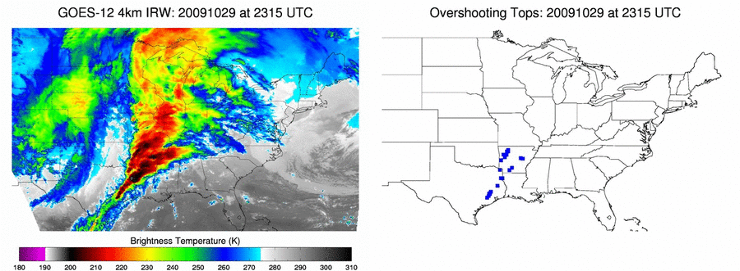
Figure 2: (top) GOES-12 4 km resolution IRW imagery on October 29, 2009 at 2315 UTC. (bottom) The IRW-texture OT detection product at the same date and time. Individual OT detections are identified with blue squares.
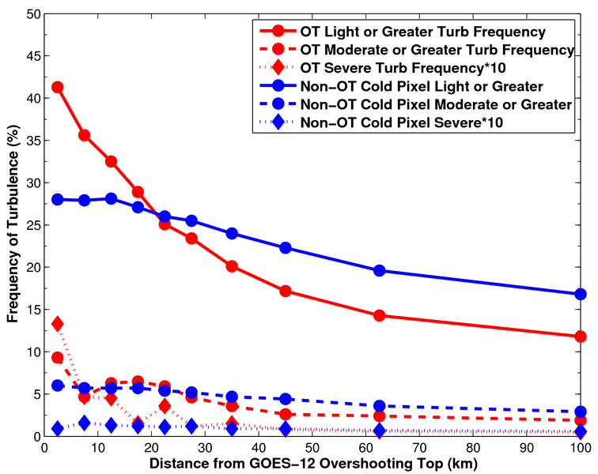
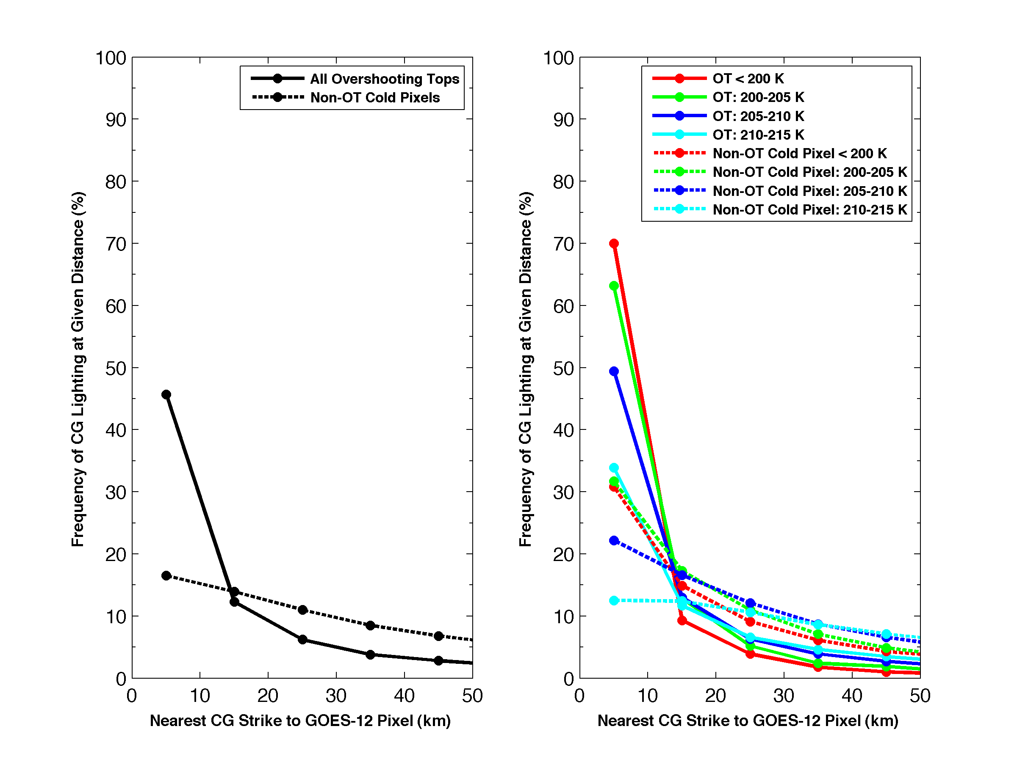
Figure 3: The frequency of objective in-situ aircraft turbulence observations at varying distance from GOES-12 OT and non-overshooting cold pixels (non-OT) from April-September 2005-2008. The frequency of severe turbulence is multiplied by 10 so that variability in the curves can be seen using the y-axis scale appropriate for lesser intensity turbulence. (bottom-left) The distance between both GOES-12 IRW-texture OT detections and non-overshooting cold pixels to the closest NLDN CG lightning strike from May to September 2008. (bottom-right) A similar comparison to the left panel, but overshooting and non-overshooting pixels are grouped into IRW BT bins.

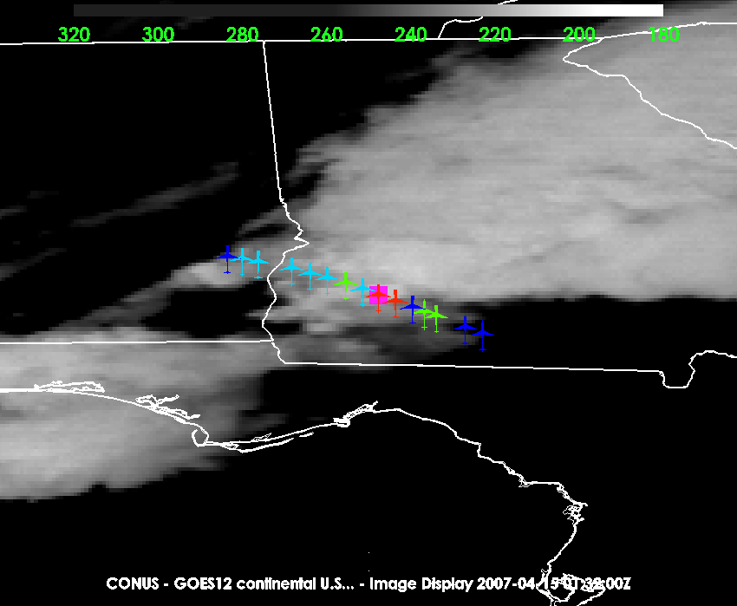

Figure 4: GOES-12 IRW imagery at 0132 UTC on April15, 2007. The IRW BT color scale is provided at the top of the image. The magenta square shows the location of an OT detection. The airplane symbols shows the track of an aircraft within +/- 15 mins of the GOES-12 image which was collecting objective in-situ EDR turbulence observations. Blue indicates smooth flight, cyan indicates light intensity turbulence, green is moderate intensity turbulence, and red is severe turbulence.

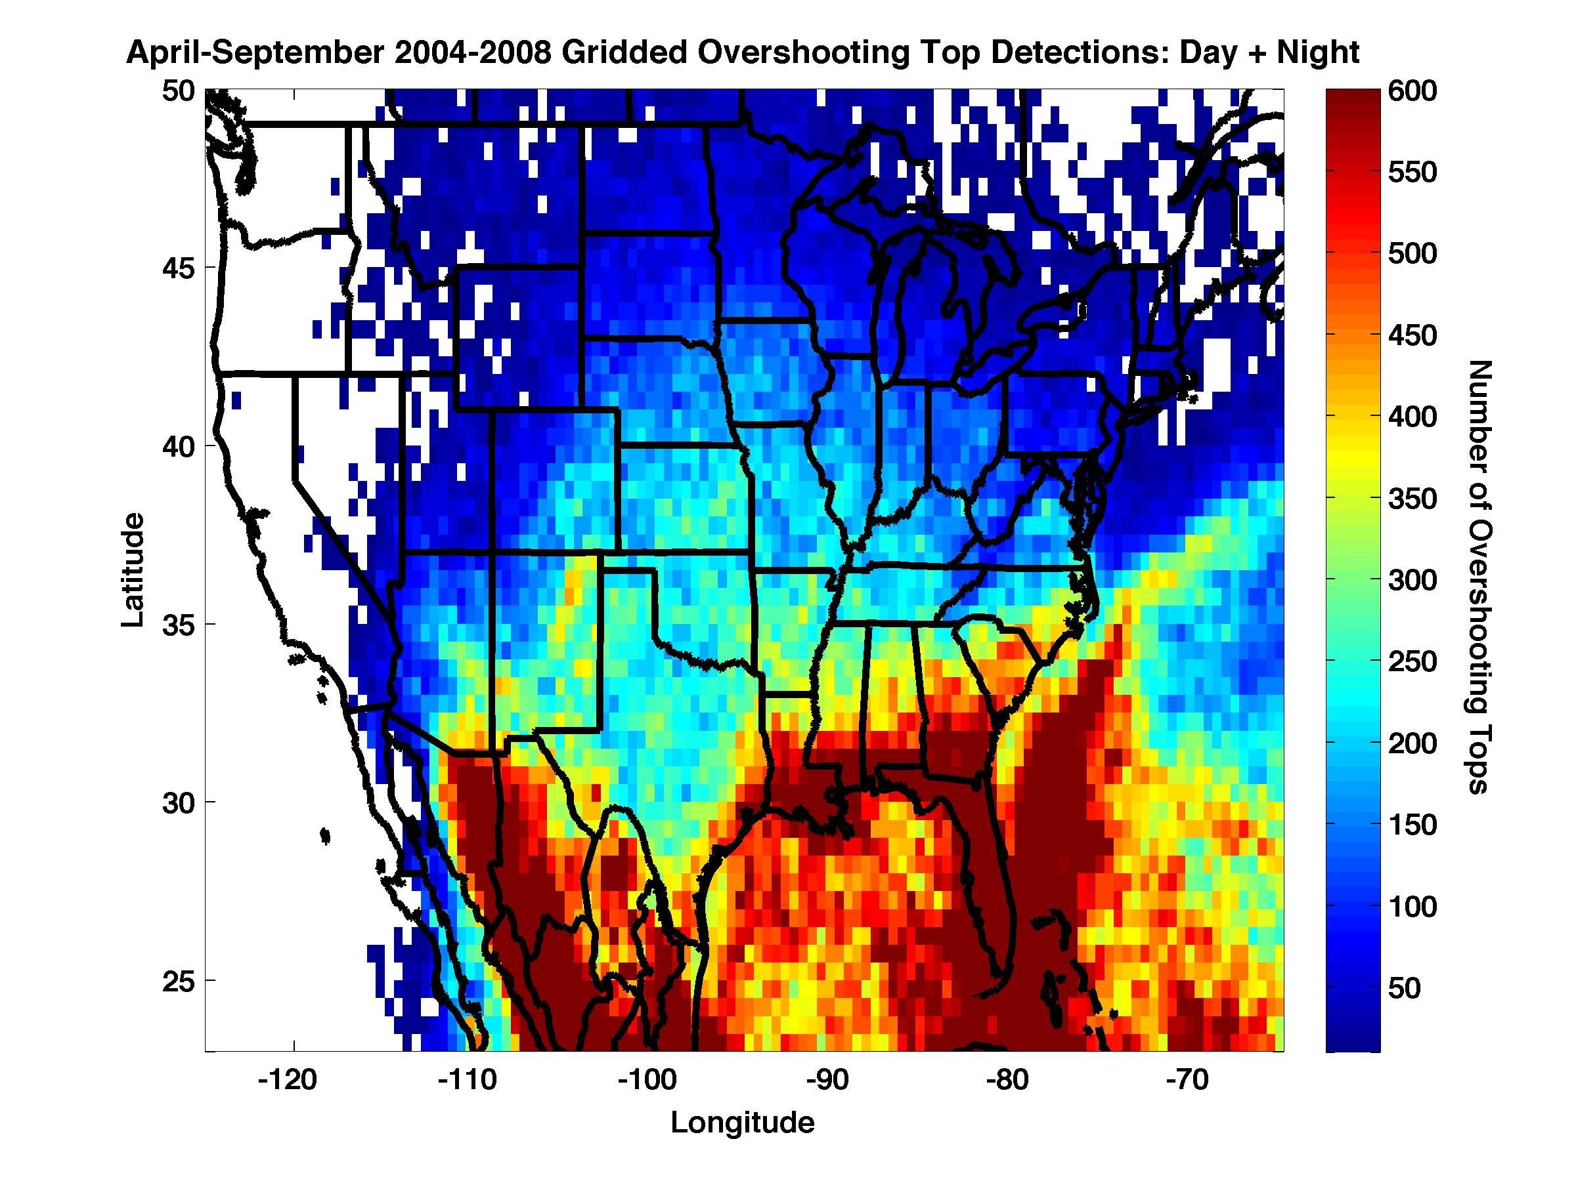
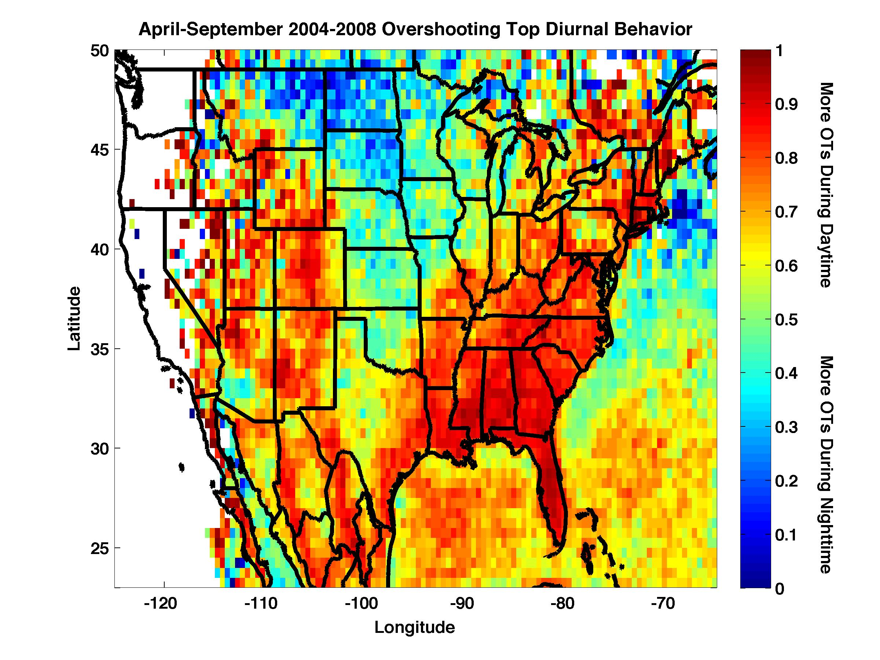
Figure 5: (top) The number of OTs detected by the IRW-texture technique with 0.5 degree grid boxes using GOES-12 imagery from April-September 2004-2008. (bottom) The fraction of overshooting top detections occurring during the daytime hours (9 AM to 9 PM LST). Cool colors indicate that OTs were detected more often during the night (9 PM to 9 AM LST).

