2011 IMAPP Training Workshop: Satellite Direct Broadcast for Real-Time Environmental Applications
Lab 2 - MODIS Products
Kathleen Strabala 2 June 2011 East China Normal University, Shanghai

Table 1: MODIS Channel Number, Wavelength (μm), and Primary Application
Reflective Bands Emissive Bands
1,2 0.645, 0.865 land/cld boundaries 20-23 3.750(2), 3.959, 4.050 sfc/cld temperature
3,4 0.470, 0.555 land/cld properties 24,25 4.465, 4.515 atm temperature
5-7 1.24, 1.64, 2.13 “ 27,28 6.715, 7.325 water vapor
8-10 0.415, 0.443, 0.490 ocean color/chlorophyll 29 8.55 sfc/cld temperature
11-13 0.531, 0.565, 0.653 “ 30 9.73 ozone
14-16 0.681, 0.75, 0.865 “ 31,32 11.03, 12.02 sfc/cld temperature
17-19 0.905, 0.936, 0.940 atm water vapor 33-34 13.335, 13.635, cld top properties
26 1.375 cirrus clouds 35-36 13.935, 14.235 cld top properties

Exercise 1 – Using MODIS to investigate fires.

1a). Load into hydra the local 1km Aqua MODIS file from 11 May 2011, 03:40 UTC, that cover the Eastern part of Russia, a1.11131.0340.1000m.hdf. Start the Multi-Channel Viewer (Start->Multi-Channel Viewer), and then select the small region displayed in Figure 1 (Top right toolbar on Main Hydra window).

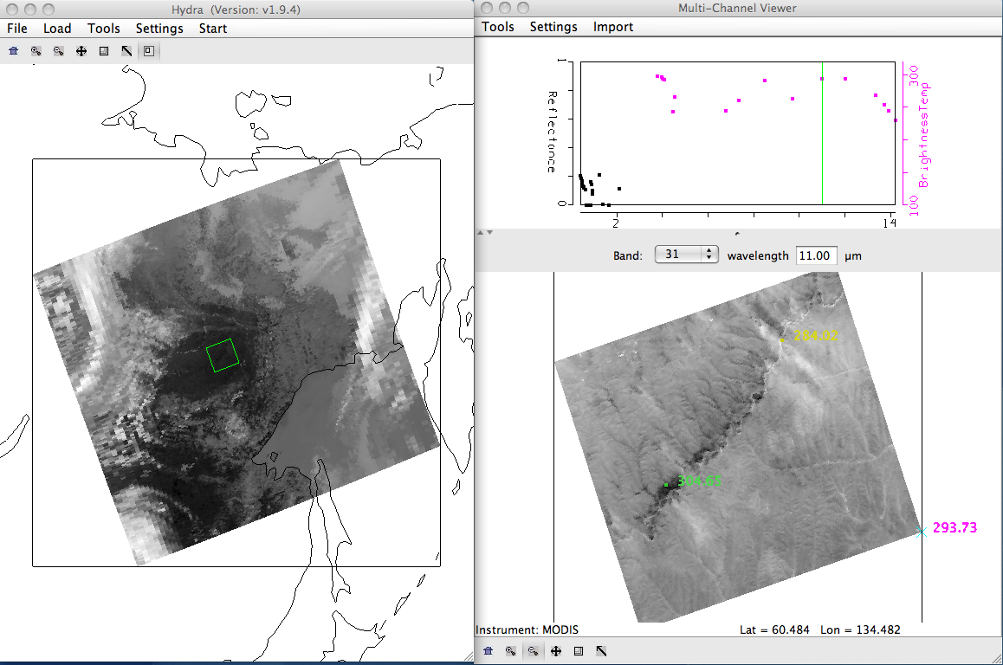
Figure 1. Main hydra window with a selection of a portion of the image from Aqua MODIS on 11 May 2011 at 03:40 UTC (left) and high resolution band 31 (11.00 μm) brightness temperature image in the Multi-Channel Viewer (right).

b). Change the Band to 22 and look at different transects crossing the black spots in the image. To make a transect, select Tools->Transect from the Multi-Channel Viewer top menu. A Transect Window will open. Then use shft+right+drag as you move the cursor to the beginning and ending points you would like your transect to cover. What are the maximum and minimum values of the transect? Do you notice anything that looks strange to you? Grab the transect point locater by right clicking and holding down the mouse button on the green point located at the bottom of the transect window X-axis. Move the position to the location along the transect where there seems to be missing data. Do the same for other missing data points. Where do these point lie in the image? Why do you think the values are missing?

c). Leave the transect window open, and load band 21 (3.99 μm) into the Multi-Channel Viewer. The transect should change to show band 21 values. How do the maxima and minima values compare with band 22? Are there missing values? Now repeat for band 31 (11 μm).

d). What could be some of the causes of the differences that you have found between the three channels? When you are finished, close the transect window.

e). Open the Linear Combinations Window (Tools->Linear Combinations) and make a single image of Band 21 (3.99 μm) by choosing 21 in the red box and then selecting the blank for the mathematical operator, and then click on the Compute button at the top. Then create a combination window of band 21 (3.99 μm) minus band 31 (11 μm) brightness temperature differences (BTDIF4-11) by choosing band 21 in the red box, band 31 in the green box and (-) for the mathematical operator, followed by selecting the Compute button. Create a scatter plot by choosing the band 21 image as the X-axis (XAxis button in the single band image) and the BTDIF4-11 image as the Y-axis (YAxis button in the brightness temperature difference image), and create a scatter diagram by selecting the Scatter button in the Channel Combination Tool window. The MODIS fire algorithm uses a series of tests to determine if a pixel contains a fire. The first step is to identify potential fire pixels. This involves testing a pixel to see if the Band 21 (3.99 μm) brightness temperature (BT4) > 310 K and BTDIF4-11 ((Band 21(3.99 μm) – Band 31(11 μm)) > 10 K. Try out these thresholds by outlining the points which meet this criteria within the scatter diagram by selecting a color at the bottom of the scatter diagram and dragging the box over the region which satisfies both thresholds, starting at the right corner of the scatter diagram and watching the X and Y values in the upper left of the scatter diagram as you drag the box around (Figure 2).

- How do you think this preliminary test performs?
- Do you think it captures all of the fire pixels? Too many?
- What thresholds would you choose for this data set?

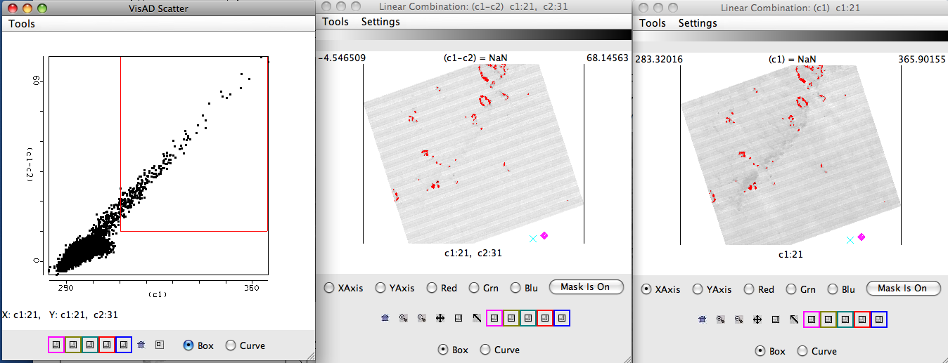
Figure 2. Brightness temperature image of band 21 (3.99 μm) (right panel), band 21 (3.99 μm) – band 31(11 μm)) brightness temperature differences (center panel), and a scatter diagram of the (Band 21(3.99 μm) – Band 31(11 μm)) versus band 21 ((3.99 μm) (left panel) from the Aqua 11 May 2011 MODIS scene.

f). Once the potential fire pixels are identified, other tests are applied to this subset of data points. The first is a simple Band 21 (3.99 μm) brightness temperature threshold test: BT4 (Band 21 3.99 μm) > 360 K. Try out this threshold test in the scene you are looking at. You may wish to set the Set Color Range window to help you with this. How many of the potential fire pixels does this find? If this test is passed, then the pixel is labeled as a fire pixel.

g). Next, the technique attempts to differentiate the fire pixel from the non-fire pixel background region. This involves comparing the potential fire pixel to the surrounding pixels. This contextual approach uses the average brightness temperature of the non-potential fire pixels in Band 21(3.99 μm) that surround the fire pixel along with the Mean Absolute Deviation (the mean of the absolute value of the differences between the average and the deviation from the average: MAD =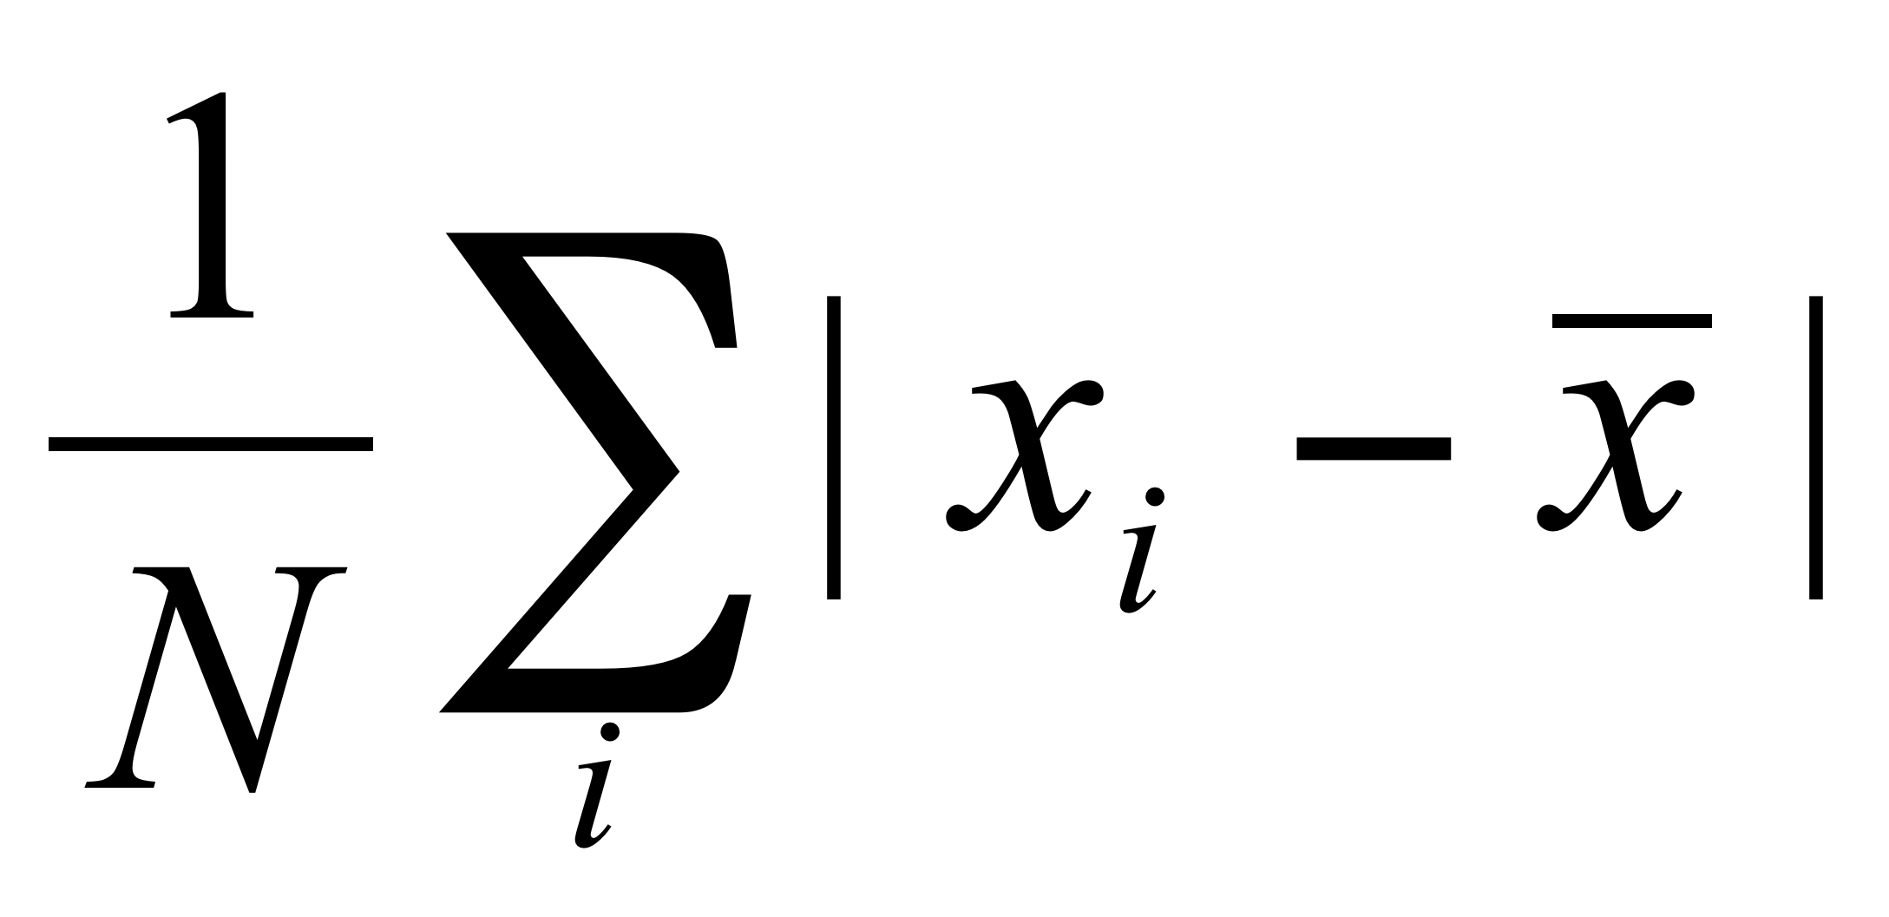 where i is the number of points you are summing). For pixels that did not pass the first BT4 test, they must pass the next 3 dynamic thresholds to be labeled a fire pixel.

Threshold tests | Thresholds for the section of data displayed in Figure 1 from 11 May 2011
- BTDIF4-11 > Average BTDIF4-11 + 3.5 (MAD BTDIF4-11) | - BTDIF4-11 > 3.04 K + 3.5 * (2.1) K  - BTDIF4-11 > 7.35
BTDIF4-11 > Average BTDIF4-11 + 6 K | BTDIF4-11 > 3.04 K+ 6 K  BTDIF4-11 > 9.04 K
BT4 (Band 21 3.99 μm BT) > Average BT4 + 3(MAD BT4) | BT4 > 296.99 K + 3 * 9.54 K  BT4 > 325.61 K

Apply these tests to our scene (you can use the scatter diagram if you would like). How do you think this detection algorithm performs in this region? Are there places that it fails?

h). Load Band 22 (3.99 μm) into the Multi-Channel Viewer. Now overlay the MODIS fire Level 2 product over the image displayed in the Multi-Channel Viewer by loading local image file a1.11131.0340.mod14.hdf. The fire product will be displayed overlaid on the Band 22 image and a new MODIS Fire Mask Product window will be displayed, with a button at the bottom that allows you to toggle the mask off and on (you may have to re-size the window to see it). How do you think the official fire product performs on this scene?

i). Now close the Channel Combination Tool window, and the MODIS fire mask window. Now select a larger region in the main Hydra window, as shown in Figure 3.

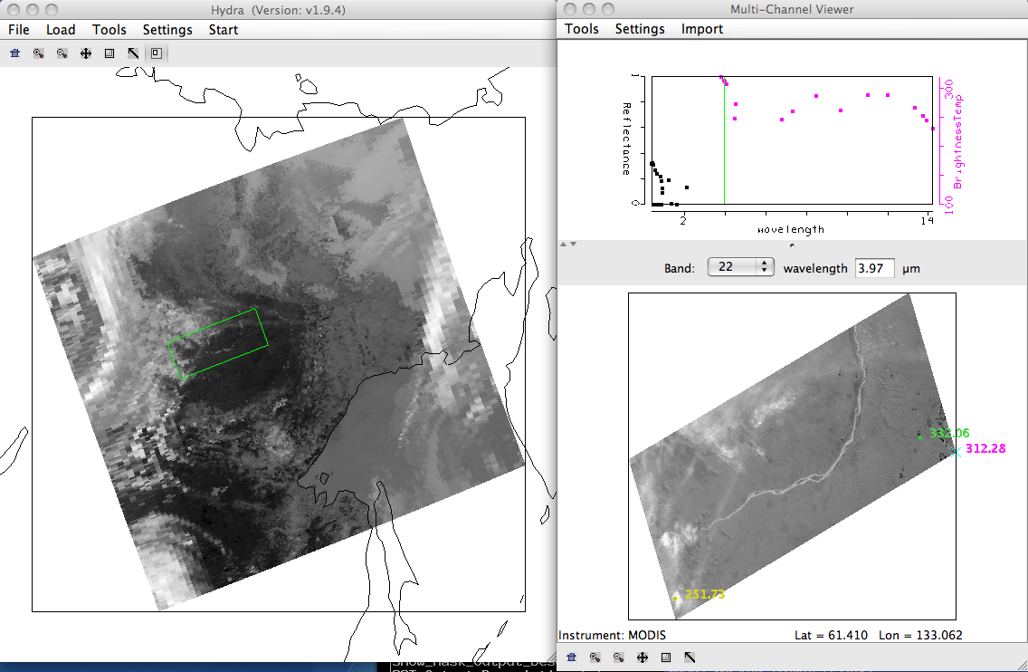

Figure 3. Screen capture of a scene from the Aqua MODIS 11 May 2011 data set from 03:40 UTC.

j). Select Tools->Linear Combinations, and create a scatter diagram of BTDIF 4-11 (Brightness temperature difference 3.99 micron (Band 21) – 11.0 micron (Band 31)) versus BT4 (Brightness temperature at 3.99 microns (Band 21)). Examine the Linear Combinations BTDIF4-11 window. Change the color scale to Color (Settings->color scale->Color). Where are the largest brightness temperature differences located? How can you discriminate cloud from fires? Change the color scale to Gray ((Settings->color scale->Gray).

k). Now select the XAxis button on the Band 21 Linear Combinations window and the YAxis button on the BTDIF4-11 Linear Combinations window and select the Scatter button from the Channel Combination Tool window to create a scatter diagram of BTDIF4-11 versus Band 21 brightness temperatures. Identify the different patterns of the scatter diagram. Where are the clouds? Where are the fires? What are the negative numbers? How would you discriminate between the fires and clouds?

Extra Credit

l). Now create a single band image of Band 31 (11 micron) using the Channel Combination Tool, and then create a BTDIF 4-11 using Band 22 instead of Band 21 (Brightness temperature difference 3.97 micron (Band 22) – 11.0 micron (Band 31)). Then create a scatter diagram of the new BTDIF4 versus BT11. Identify the patterns in this diagram. Would it be easier or harder to develop a technique to find fires using this band combination. Why is it important to have a “fire” channel on MODIS? Why is it so noisy?

m). Describe how these background issues would affect your fire detection:
- Very hot land.
- Multiple fires in a small region.
- Size of the fires.
- Land/Water boundaries.

When you are finished, close all of the windows except the main window and the Multi-Channel Viewer.

Exercise 2 – Using MODIS to investigate smoke aerosols.

2a). We will be using the same 1 km Aqua MODIS data set from Exercise 1. If you have not done it, load in the data set from 11 May 2011, 03:40 UTC (a1.11131.0340.1000m.hdf). Try to select the same region as shown in Figure 1. Now display band 1 (.65 μm). Your display should look like the Hydra windows shown in Figure 4.

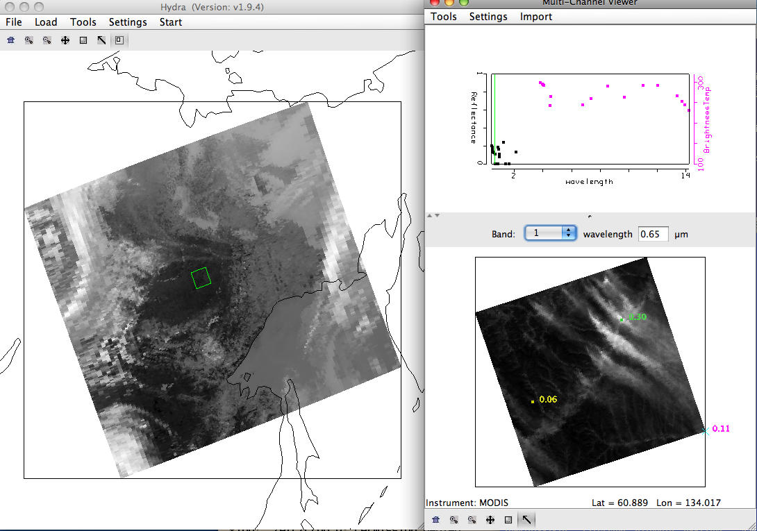
Figure 4. Main Hydra window and Multi-Channel Viewer displaying band 1 (0.65 μm) from the Aqua MODIS scene collected on 11 May 2011, 03:40 UTC.

Examine the scene in visible bands Band 1 (.65 μm), Band 3 (0.47 μm) and Band 7 (2.13 μm). Describe what you see. Are there differences in the values and the locations of the max/min reflectances? What reasons are there for the differences? What are the bright streaks in the image (hint, look at the band 22 (3.97 μm) thermal values for a clue).

b). Open the Linear Combinations window and create single images of Band 1 (.65 μm), Band 3 (0.47 μm) and Band 7 (2.13 μm). Change the color scale to Gray for each band. Now create a scatter diagram of Band 3 (0.47 μm) on the X-axis and Band 7 (2.13 μm) on the Y-axis as shown in Figure 5. Examine the smoke plume by selecting regions of the plume in the image to see where the points lie on the scatter diagram. In which band is the smoke signal stronger?

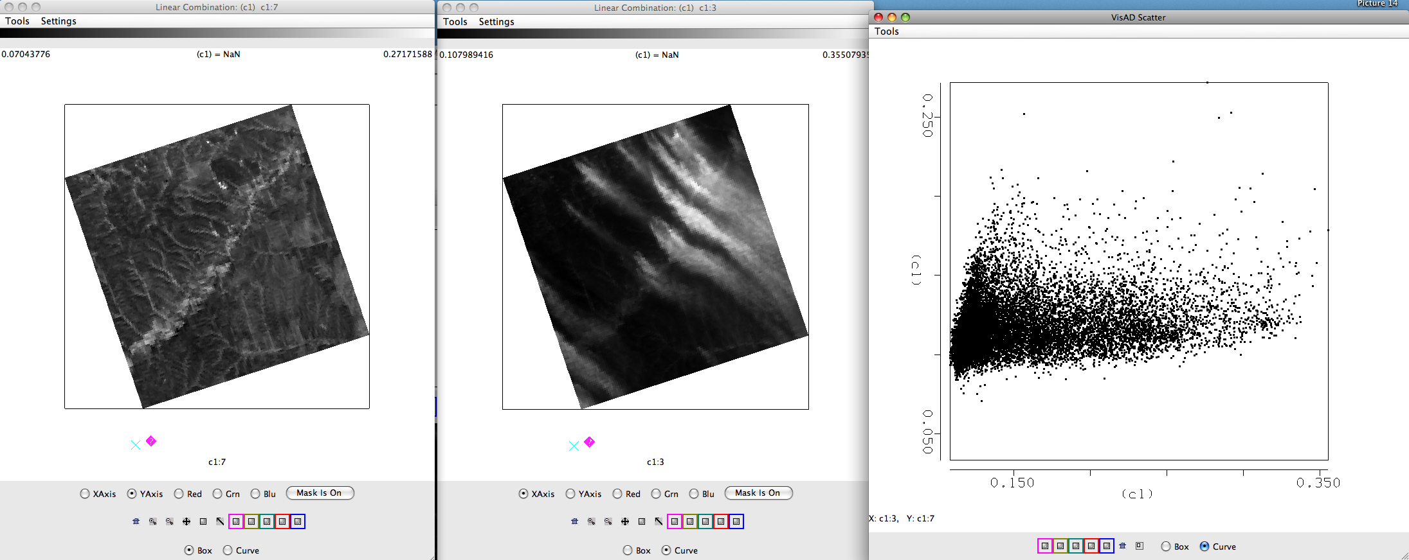
Figure 5. Single band images of Band 7 (2.13 μm) reflectances (left), Band 3 reflectances (center) and a scatter diagram of Band 7 versus Band 3 from the Aqua MODIS scene collected on 11 May 2011, 03:40 UTC.

c). Now do the same for Band 1 (.65 μm) and Band 7 (2.13 μm). How does this compare with the Band 3 (.47 μm) and Band 7 (2.13 μm) results?

d). Can you determine a relationship between the reflectances of the surface background just using the scatter diagram (Hint: what is the slope of the background land pixels).

- e). The MODIS aerosol algorithm utilizes a look up table to get an initial estimate of the aerosol optical thickness τ_{λ} over land, based upon the measured reflectances and the surface reflectance. This relationship can also be approximated by:

τ_{.65} ~ (r_{.65} - .50*r_{2.1})
τ_{.47} ~ (r_{.47} - .25*r_{2.1})

What is the purpose of subtracting out the reflectances in Band 7 (2.13 μm)?

f). Now use the Channel Combinations Tool to create approximate optical thickness images for bands 1 (.65 μm) and band 3 (.47 μm ) (τ_{.65} and τ_{.47)}). Create an image of (Band 1 (.65 μm) - .50 * Band 7 (2.13 μm)). Use the White box in front of the Green band selector to type in the constant. Do the same for (Band 3 (.47 μm) - .25 * Band 7 (2.13 μm)). Change the color scale of both images to gray. Compare the results. Which optical depths are larger? What are the values of the optical depths at the beginning, middle and end of the plumes? Which seems better at detecting optically thin smoke? When you are finished, close the Linear Combinations Window.

g). Now load the cloud mask for our small section of data (file a1.11131.0340.mod35.hdf). This will overlay the Unobstructed_FOV_Quality_Flag into the Multi-Channel Viewer window. Change the MODIS band to Band 3 (.65 μm). How do you think the mask performs over this region? How will it affect the aerosol retrievals? When you are finished, close the Cloud Mask Window and the Multi Channel Viewer.

Exercise 3 – Using MODIS to investigate cloud properties

3a). Load in the local Aqua MODIS file from 28 October 2010 covering Eastern China and the offshore waters (a1.10301.0440.1000m.hdf). Open a Multi-Channel Viewer window as show in Figure 6.

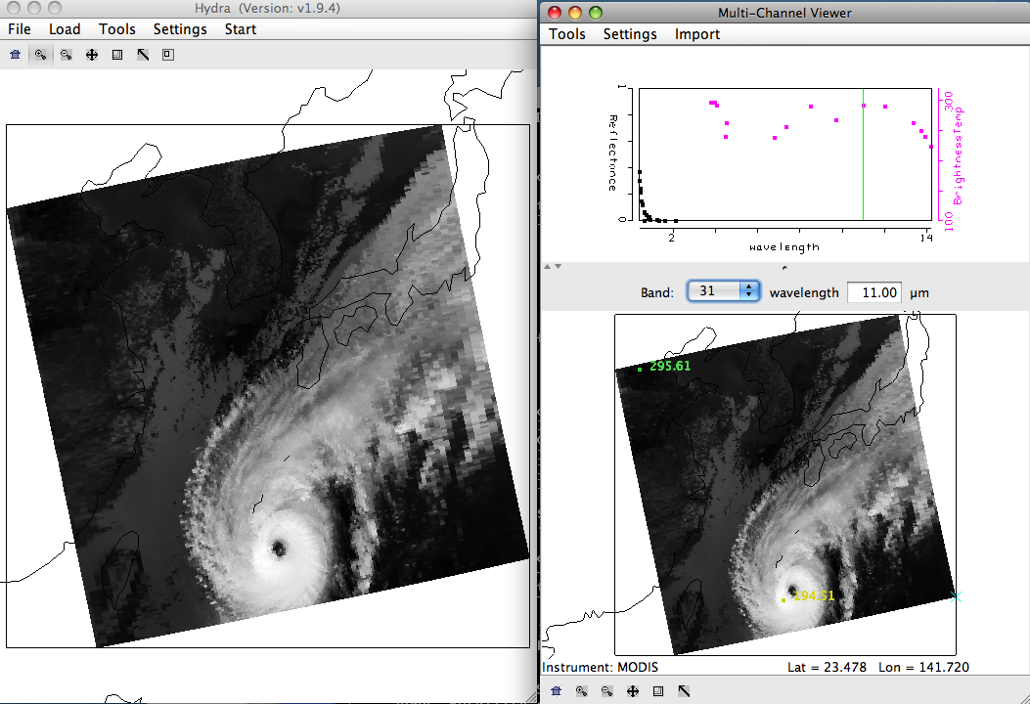
Figure 6. Screen capture of main Hydra window along with the Multi-Channel Viewer as it displays Typhoon Megi captured by the Aqua MODIS instrument on 28 October 2010, 04:40 UTC.

b). Examine the clouds in the visible reflectance bands 1 (.65 μm), 7 (2.13 μm) and 26. How do the reflectances differ over the clouds? Give reasons for the differences. How many cloud layers would you estimate from the bands.

c). Now look at the clouds in thermal infrared bands 20 (3.80 μm) and 31 (11.0 μm). How do the brightness temperatures differ over the clouds? How many cloud layers would you estimate from the bands. What is causing the bands to look so different over the clouds. Identify the ice and water clouds in the scene, and give reasons for your answers.

d). Now select the small region shown in Figure 7 to investigate at full resolution.
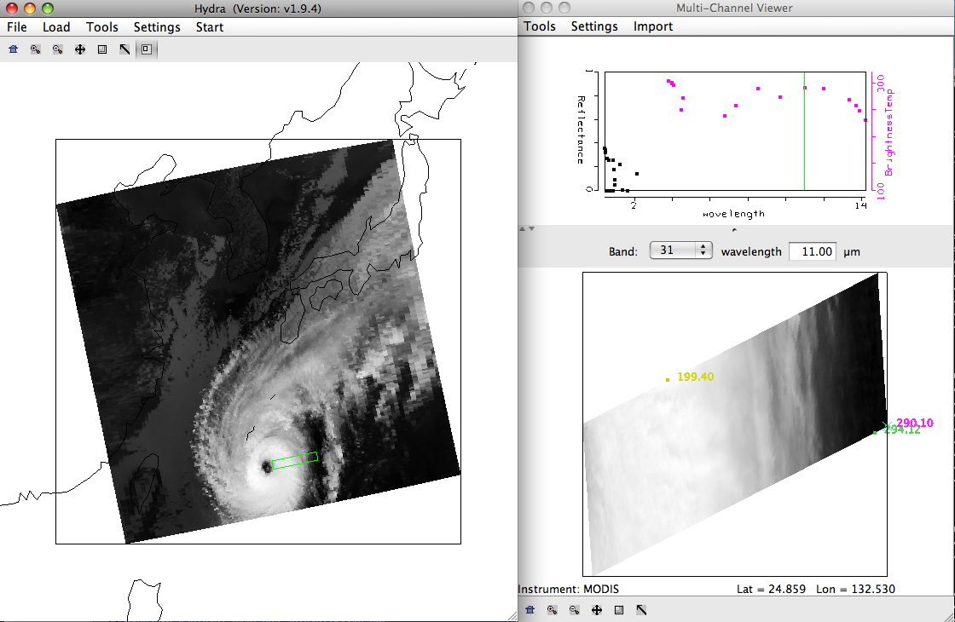
Figure 7. Screen capture of main Hydra window along with the Multi-Channel Viewer as it displays a small slice through Typhoon Megi as observed by the Aqua MODIS instrument from 28 October 2010, 04:40 UTC.

e). Create a scatter diagram of the band 29 (8.50 μm) – band 31 (11.0 μm) brightness temperature differences using the Linear Combinations tool. Create a single band image of band 31 (11.0 μm) brightness temperatures using the Linear Combinations tool. Using these two images, create a scatter diagram of the band 29 – band 31 brightness temperature differences on the Y-Axis and the band 31 brightness temperatures on the X-Axis. Is there a pattern in the data? What is the range of values (max to min difference) in the band 29 (8.50 μm) – band 31 (11.0 μm) brightness temperature differences? Where do the largest differences occur? Why?

f). Create a scatter diagram of the band 31 (11.0 μm) – band 32 (12.01 μm) brightness temperature differences using the Linear Combinations tool. Create a scatter diagram of the band 31 – band 32 brightness temperature differences on the Y-Axis and the band 31 brightness temperatures on the X-Axis. Is there a pattern in this data? What is the range of values (max to min difference) in the band 31 (11.0 μm) – band 32 (12.01 μm) brightness temperature differences? How do they compare with the band 29 (8.50 μm) – band 31 (11.0 μm) brightness temperature differences?

- g). The MODIS cloud phase algorithm uses these thresholds to determine if a cloud is composed of ice:

- Band 31 (11.0 μm) brightness temperature < 238 K or (band 29 (8.50 μm) – band 31) difference > .5 K

- Apply these thresholds to your data in the scatter diagram. If you click in the scatter diagram window using the center mouse button, it will show you the X and Y values so you know where to start to draw your box. See Figure 8.

- 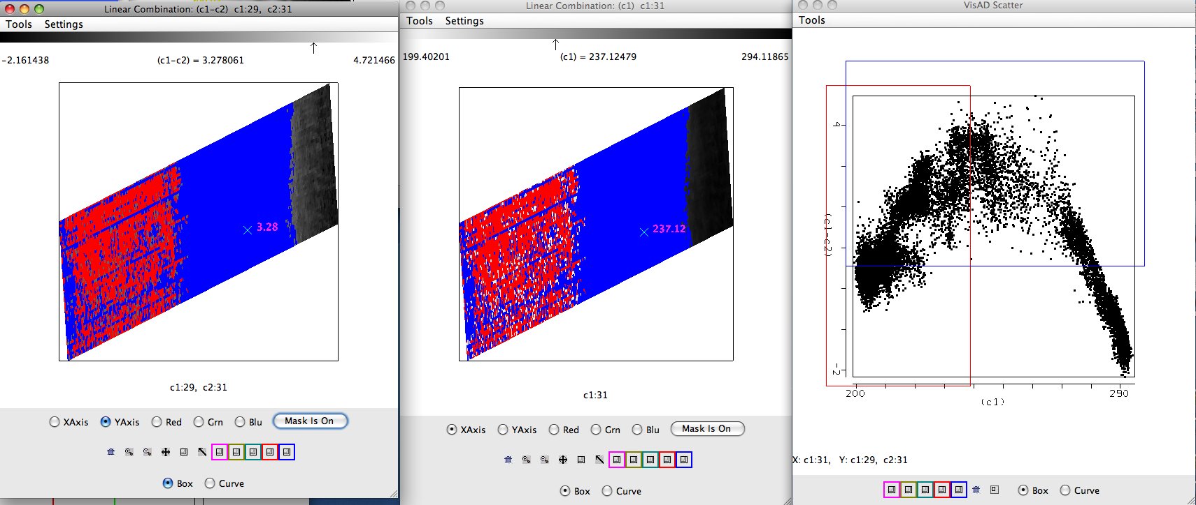
Figure 8. Image of the brightness temperature differences between bands 29 (8.50 μm) and band 31 (11.0 μm), (left panel), an image of the band 31 brightness temperatures (center panel), and the scatter diagram of bands 29 -band 31 brightness temperature differences versus the band 31 brightness temperature differences (right panel) for the same scene as Figure 7. The images have the thresholds described in exercise 3g) applied.

Do the thresholds work well for this ice cloud scene? Does it miss any of the cloud?

h). Close the Linear Combinations window. In the main Hydra window load in the MODIS cloud product file from the same date and time (a1.10301.0440.mod06ct.hdf). This will open a new MOD06 Level 2 Products file window, and overlay the cloud phase product over the image in the Multi-Channel Viewer. How does the result compare with your results from exercise 3g?

i). Now select the small portion of the image shown in Figure 9 in the Hydra main window. Based only on the brightness temperatures in band 31 (11.0 μm), what is the phase of the cloud? Why?

j). Now repeat exercises 3e) and 3f) on this scene. Which brightness temperature difference scatter diagram shows a larger signal for these clouds? How are the patterns similar to the ice cloud scene? What causes the differences?

k). The water cloud algorithm for the MODIS MOD06 cloud phase product uses these thresholds:

- Band 31 (11 mm) Brightness Temperature > 238 K and Band 29 – Band 31 difference < -1.0 K
- Or
- Band 31 (11 mm) Brightness Temperature > 285 K and Band 29 – Band 31 difference < -0.5 K

Apply these thresholds to your scatter diagram. How does it perform? Now load in the cloud mask file from this day and time, filename: a1.10301.0440.mod35.hdf. Is the entire scene cloud covered? So even if the thresholds over the entire scene say that is should be water cloud, only over regions where the cloud mask indentifies clear will the MOD06 algorithm be executed. Close the cloud mask file and load in the Cloud Product (a1.10301.0440.mod06ct.hdf ) file to verify. When you are finished, close the Linear Combinations Tool window and the cloud product file window.

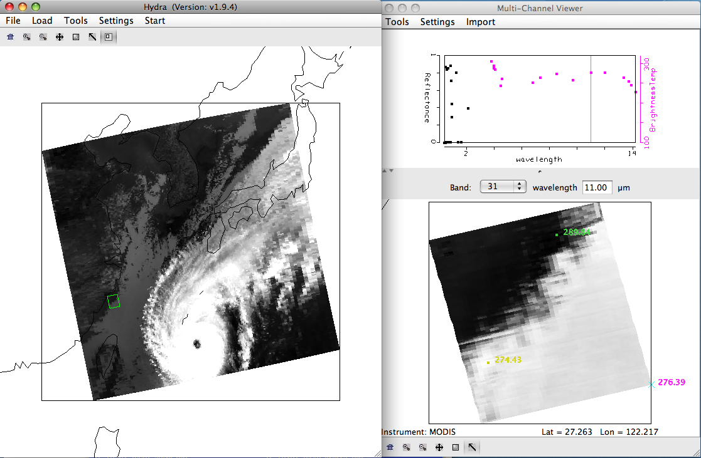
Figure 9. Screen capture of a cloud scene that is part of Typhoon Megi acquired by the Aqua MODIS instrument on 28 October 2010 at 04:40 UTC.

Exercise 4 – Using MODIS to investigate surface reflectances

4a). Exit and restart Hydra, and load in the same Aqua MODIS data segment as exercise 3, from 28 October 2010, 04:40 UTC (a1.10301.0440.1000m.hdf). Open the Multi-Channel Viewer and select the region of data over Korea as shown in Figure 10 in the main Hydra window. You might have to adjust the Color Range to see the outline of the country more clearly (Settings->Set Color Range). Move either the Magenta or Green squares or both, to adjust the 255 brightness levels to correspond to the range of brightness temperature that you want. Display band 1 (.65 μm) in the Multi-Channel View. Now open a new Multi-Channel Viewer from the main Hydra window (Start->Multi-Channel Viewer) and display band 2 (.86 μm) reflectances (See Figure 10). Adjust the color range of the band 1 image so that you can see features in the land (Settings->Set Color Range).

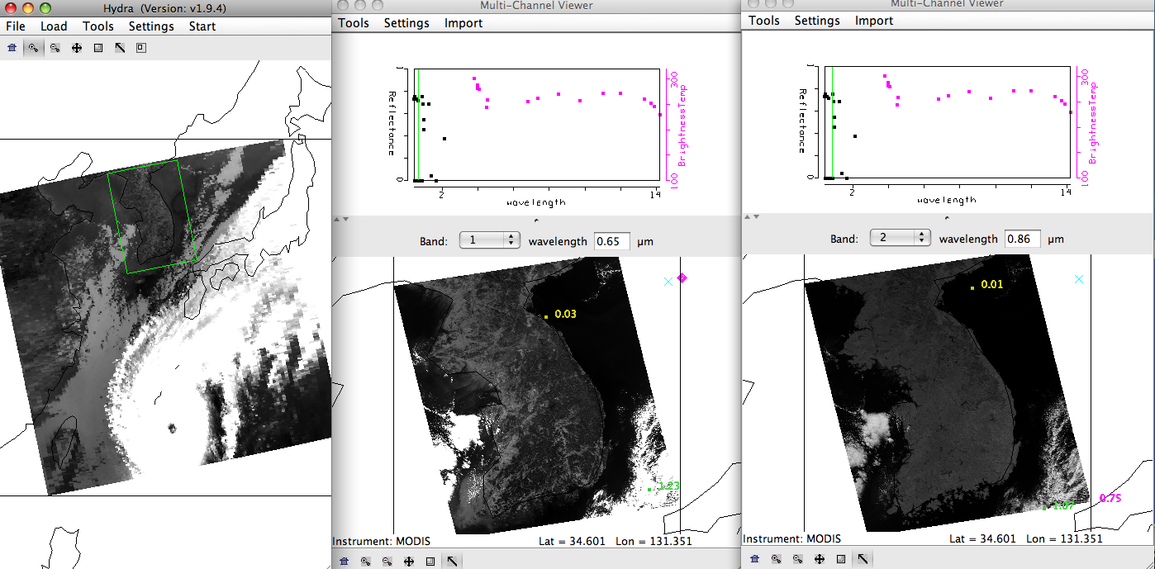
Figure 10. Screen capture of a MODIS Aqua segment of data from 28 October 2010, 04:40 UTC, as displayed in Hydra. They main Hydra window (left panel), band 1 (.65 μm) reflectances (center panel), and band 2 (.86 μm) reflectances (right panel) are shown.

b). Compare the reflectances in these visible bands. How do they compare over land? How do they compare over water? How do they compare over clouds?

c). Create a Transect of the band 2 (.86 μm) reflectances. In the Multi-Channel Viewer window that is displaying the band 2 data, select Tools->Transect. Create a transect that cuts through the Korean Peninsula as shown in Figure 11 by holding down the Shift Key and the right mouse button while you drag the mouse over the image (shft+right+drag). Now overlay the values of band 1 (.65 μm) reflectances over the same transect by selecting Tools->Transect from the Multi-Channel Viewer that is displaying the band 1 data.
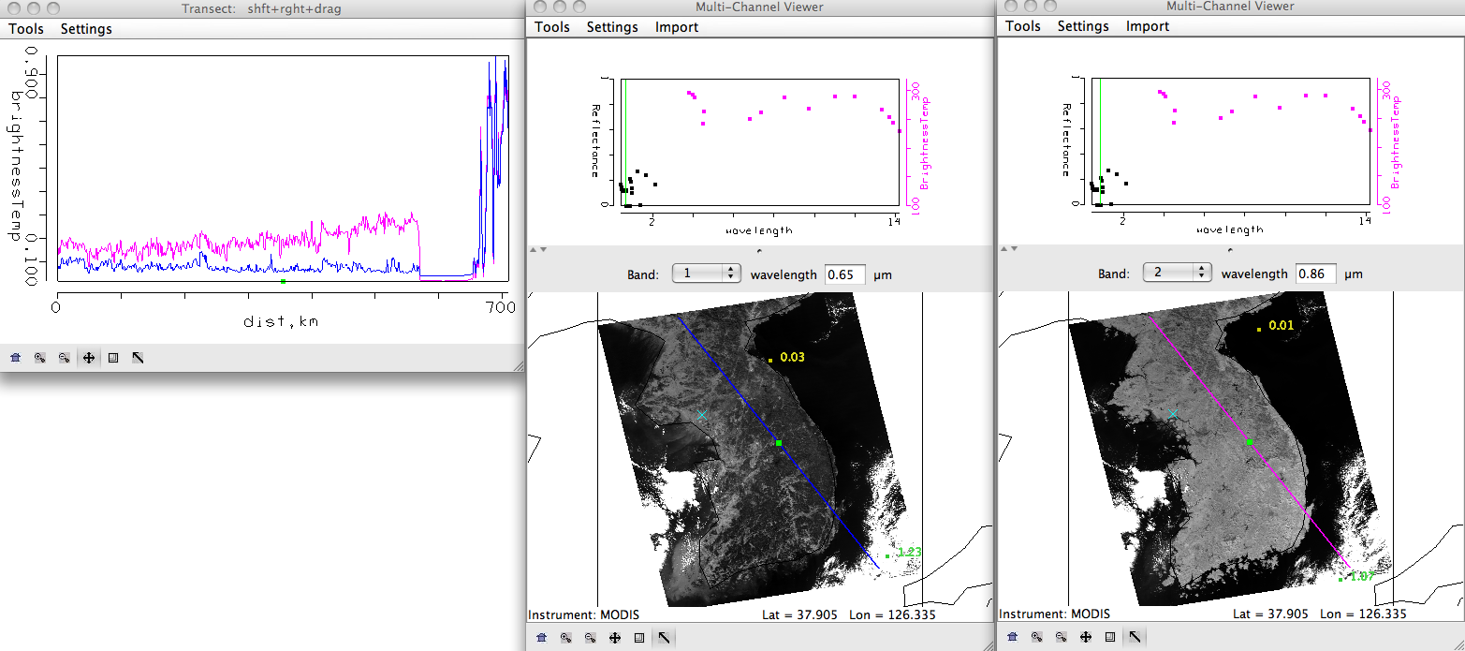
Figure 11. Transect covering a portion of the Aqua MODIS image from 28 October 2010, 04:40 UTC, over the Korean Peninsula for bands 1 (.65 μm) and 2 (.86 μm).

d). Examine the transect. Look closely at the patterns of values along the transect for both bands. Is there a relationship between the two (you can zoom in on a small section of values if you need to)? How do the values compare between these two bands over the water, land and cloud? You can move the transect by right clicking on the green square in either the Transect window so that you can identify where the transect points are in the image. What is the reason for the similarities and differences? Now close the transect window.

e). Create a Red, Green and Blue composite image using the Hydra Tools->rgb option in the Multi-Channel Viewer. The default combination is Band 1 (.65 µm) for red, Band 4 (.56 µm) for green and Band 3 (.47 µm) for blue. Use these defaults to create the image by selecting the Compute button. Note the features in the image. Save the image by selecting Tools->Capture Display.

f). Use the linear combinations tool to create a color image of Normalize Difference Vegetation Index (NDVI) where, NDVI = [Band 2 (0.86µm) – Band 1 (0.65µm)] / [Band 2 (0.86µm) + Band 1 (0.65µm)]. Change the color scale to color (Settings->set color scale->Color). Examine the image. What are the values over the clouds? Why? What are the values over the water? Now limit the range of values displayed to only those above zero (Settings->Set Color Range). Can you discriminate regions with some vegetation from those with little? What are the NDVI values in regions without significant vegetation; what are they in vegetated regions? Now change the color scale back to Gray.

g). Use the Channel Combination Tool to create an image of Band 31 (11.0 µm). Create a scatter diagram of the NDVI that you created in exercise 4f on the Y-axis against Band 31 (11.0 µm) on the X-axis. Select different regions in the scatter plot window (see Figure 12) and look at the corresponding points in the linear combination windows. Is there a relationship between NDVI and band 31 brightness temperatures? Use the RGB image that you created to help you identify different regions. There is also a topographic map that may help you that is located in the data directory with a filename of Korea_Topography.png. How might topography affect the relationship between NDVI and Band 31 (11.0 µm) brightness temperatures?

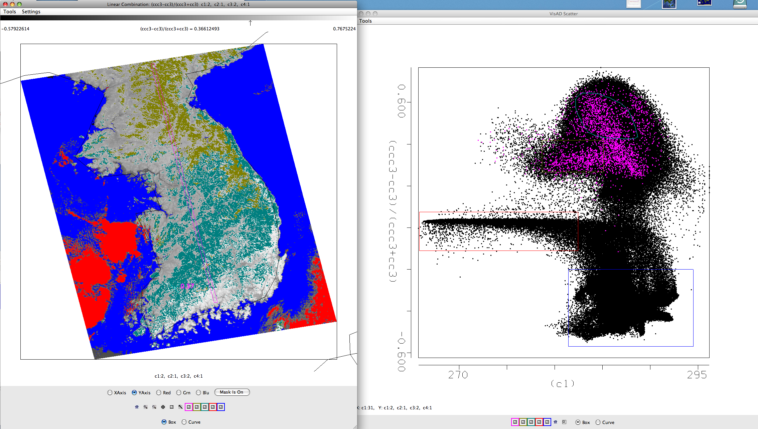
Figure 12: NDVI image (left), and the scatter diagram of NDVI versus band 31 (right) over the Korean Peninsula and surrounding waters.

