Chapter 13 Weather Forecasting
“What will you do after college?” This question inspires excitement, but also dread, in many students. Your future is wonderful to ponder, but difficult to predict. So many different variables can affect your decisions. So many twists and turns may lie ahead!
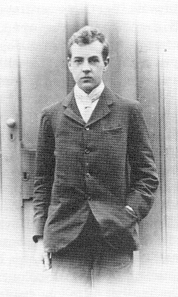
Similarly, the question “What will the weather be tomorrow?” has captivated, but also vexed, meteorologists for decades. Weather forecasting is one of the most fascinating aspects of meteorology. However, an accurate forecast requires a thorough knowledge of all the variables of the atmosphere, and also an understanding of how the atmosphere “twists and turns” and changes through time. This is a very hard task. Until the last century, scientists often assumed that precise weather forecasting was impossible.
It’s not surprising, then, that the founder of modern weather forecasting was also a bit of a “slacker” who could not easily answer the question, “What will you do after college?” Lewis Fry Richardson (right; photo is from p. 17 of O. M. Ashford’s biography of Richardson, “Prophet—or Professor?,” Adam Hilger, 1988) graduated from Cambridge University in England in 1903, but he avoided majoring in any one branch of science. After college, he kept changing jobs and subjects. When he was 26, Richardson’s mother noted that he was having a “rather vacant year with disappointments.” A few years later, Richardson became interested in numerical approaches to weather forecasting. The rest is history: Richardson created, from scratch, the methods of modern weather forecasting that are now used worldwide. His remarkable story will guide us through the intricacies of computer-based forecasting.
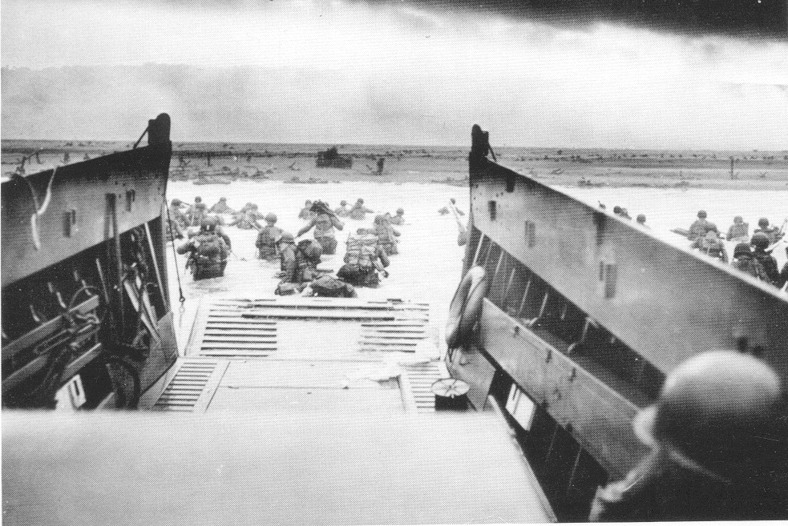
Before we get to Richardson, however, we will survey the various ways that weather forecasting can be done without a computer. From the dawn of civilization until about 1950, humans had to rely on a variety of very imperfect forecasting techniques. This was true during World War II, when a handful of meteorologists had to make the most important forecast in human history: whether or not to launch the “D-Day” invasion of Europe (right; [photo is from the National Archives]). Democracy or dictatorship? For a brief moment in history, the answer depended on an accurate weather forecast. The meteorologists in 1944 used methods that you can use today, and we’ll learn about them here too.

Methods of forecasting by people

Folklore

Long before computers and The Weather Channel, humans needed weather forecasts. Farmers and sailors in particular needed to know if storms were approaching. Over time, various folklore forecasts, often in the form of short rhymes, were devised and passed down through the generations. While memorable, the folklore forecasts are of uneven quality—some good, others laughably bad.
Folklore forecasts are short sayings that try to predict the weather based on sky conditions, special days of the calendar, or the behavior of animals.
Some of the earliest folklore forecasts in Western culture are found in Judeo-Christian religious texts. In the Book of Matthew, Christ is quoted as saying a variant of

“Red sky at night, sailor’s delight
Red sky at morning, sailor take warning.”

This saying is fairly accurate. A clear western sky at sunset allows the sun to shine through the atmosphere, its light reddening due to Rayleigh scattering (Chapter 5) and then reflect off of clouds that are in the eastern sky. Clouds to the east usually move away; as you’ll recall from Chapter 7, storms in the mid-latitudes generally travel to the east under the influence of jet-stream winds. The reverse is true in the morning, when the red sunlight shines on storm clouds approaching from the west. However, this folklore doesn’t work at all in overcast conditions, or at tropical latitudes (see Chapter 8) where weather often moves from east to west.
The Middle Ages Scottish poem “Sir Patrick Spens” contains a famous mariner’s folklore forecast:

“Late late yester’en I saw the new moon
Wi’ the auld moon in her arm,
And I fear, I fear, my dear master,
That we will come to harm.”

The poet’s image of an old moon inside of a new moon refers to an optical effect caused by high clouds: either a halo, corona, or sun dog (Chapter 5). High clouds often occur well in advance of a mid-latitude cyclone’s warm front and are the first sign of approaching bad weather that could sink a boat (Chapters 9 and 10).
This folklore forecast in “Sir Patrick Spens” is pretty accurate. Notice in Chapter 10 that halo-making cirrostratus clouds were reported in the vicinity of the Edmund Fitzgerald wreck site some 36 hours before the shipwreck! However, this forecast requires the moon (or sun) to be up and visible through thin high clouds, conditions that are somewhat hit-or-miss. Also, high clouds can be unrelated to a cyclone’s warm front. Nevertheless, this folklore forecast seems to work: a dedicated amateur meteorologist in Britain in the 1800s observed 150 haloes in six years, and noted that nearly all of the haloes preceded rain within 3 days. (However, it often rains every few days in Britain, so this statistic is less impressive than it initially seems.)
One famous forecast that doesn’t work is Groundhog Day, known as Candlemas Day in medieval Europe:

“If Candlemas Day is bright and clear
There’ll be two winters in that year;
But if Candlemas Day is mild or brings rain,
Winter is gone and will not come again.”

What the weather is at one location in Europe or Pennsylvania on February 2 tells us very little about the weather for the rest of the winter season. The popularity of Groundhog Day in the United States has much more to do with the clever marketing of furry rodents than forecast accuracy.
Even though the Groundhog Day festivities don’t help with weather forecasting, some accurate folklore forecasts do involve animals and plants that are weather-sensitive. One example is the saying

“When spiders’ webs in air do fly
The spell will soon be very dry.”

This forecast seems to be well-founded. Spiders want to catch insects in their webs, and insects will often breed after a rain. However, spiders don’t want to have their webs covered with water; a visible spider web is a lousy trap for insects! So spiders spin webs at the end of a period of rain as the air dries out—for example, after a cold frontal passage in spring. As you know from Chapter 10, high-pressure systems follow cold fronts and often lead to a spell of dry weather. The spider doesn’t know this, but its actions do fit into a predictable pattern of weather changes that humans can anticipate with some success. [Artists: Opportunity for a photo of a beautiful spider web.]
As meteorology developed into a scientific field in the 19th century, folklore forecasts were gradually replaced with rules-of-thumb based on observations of clouds, barometric pressure, and winds. We have already encountered one such example in Chapter 10: Fitzroy’s rhyme about fast pressure rises leading to strong winds behind a low-pressure system. Figure 13.1 shows a modern example, known as a “decision tree.” This combination of rules-of-thumb allows forecasters to make difficult forecasts—will it snow or storm?—based on a series of relatively simple observations. Box 13.1 includes several simpler rules-of-thumb that you can use to make your own weather forecast when you are away from the TV, radio, or computer.

Persistence and Climatology

Other forecasting methods rely on the continuity of weather from one day to the next, or from one year to the next. A persistence forecast is simple: the weather you are having now will be the weather you have later. The accuracy of this forecast is very dependent on where you are, the type of upper-troposphere winds that exist over your location, and how long a forecast you want.
A persistence forecast is, “Tomorrow’s weather will be today’s weather.” A climatology forecast is, “Tomorrow’s weather will be the typical weather for tomorrow.”
For example, a 24-hour persistence forecast works pretty well in places like Hawaii or southern Florida. These locations are rarely under the direct influence of a strong jet stream. However, persistence can be a terrible forecast where the jet stream is strong. In these regions, growing low-pressure systems cause rapidly changing weather. Britain and the Northeast United States are locations where persistence forecasts for more than a few hours in the future are not very good. The reverse is true in situations where the upper-level winds are “stuck” in a “blocking” pattern for several weeks. In these cases—for example, during a drought or the Flood of 1993 in the Midwest U.S.—a persistence forecast may be fairly accurate for days or even weeks at a time.
A climatology forecast relies on the observation that weather at a location doesn’t change much from one year to the next. As a result, a long-term average of weather on a certain day or month should be a good guess as to the weather for that day or month. The most obvious climatology forecast for the Northern Hemisphere mid-latitudes is, “Cold in December, warm in July.” You don’t need to be a meteorologist to make that forecast! Its success derives from the fact that weather, although changeable, is strongly determined by the tilt of the Earth and the global energy budget discussed in Chapter 2.
Climatology forecasts can be quite specific. A favorite is the “White Christmas” forecast, i.e. what is the percent chance that at least one inch of snow will be on the ground at a particular location on December 25 (Figure 13.2)? This forecast depends on the past thirty years of weather observations on Christmas Day across the United States. It would change somewhat if more, fewer, or different years were used in the climatology.
Today’s mathematically based forecast methods still use climatological statistics as a “reality check.” They make sure that the computer models aren’t going off the deep end, climatologically speaking.

Trend and Analog

We know that persistence forecasts are doomed to failure, ultimately, because the weather does change. An approaching cyclone brings precipitation and falling barometric pressure. Thunderstorms sprout ahead of a cold front. A trend forecast acknowledges that weather does change, but that the patterns causing the weather, such as an extratropical cyclone, are themselves unchanging (“steady-state”) in speed, size, intensity, and direction of movement.
A trend forecast is, “Tomorrow’s weather will change due to approaching weather systems that aren’t changing.” A nowcast is a forecast for the next few hours, not tomorrow. An analog forecast is, “Today’s weather is like the weather type on a day many years ago. Tomorrow’s weather will be similar to the weather that followed that long-ago day.”
Benjamin Franklin pioneered the concept of trend forecasting in 1743. Clouds ruined an eclipse for Ben in Philadelphia, but his brother in Boston saw the eclipse clearly. The clouds did not reach Boston until many hours later. Franklin discovered that “nor’easter” cyclones frequently moved up the East Coast, a trend that could be used to forecast the weather (Figure 13.3).
Trend forecasts work quite well for a period of several hours, which is called nowcasting. This is because large-scale weather systems such as cyclones don’t change too much over a short time period. However, in Chapter 10 we learned that cyclones have definite life cycles and can change remarkably in size, speed, and intensity from one day to the next. Therefore, the accuracy of trend forecasts tails off quickly when they are for longer than a few hours ahead.
The analog forecast also acknowledges that weather changes. Unlike the trend method, it also assumes that weather patterns can evolve with time. The key—and flawed—assumption for the analog forecast is that history repeats itself, meteorologically speaking. The analog forecaster’s task is to locate the date in history when the weather is a perfect match, or “analog,” to today’s weather. Then the forecast for tomorrow is simple: whatever happened in the day after the analog. The forecast for the day after tomorrow is whatever happened in the second day after the analog, and so forth.
Analog forecasting therefore requires many years’ worth of weather maps and an efficient way to compare one map to another. One approach, borrowed from personality testing in psychology, is to categorize the weather into a small number of weather types. If today’s weather is a Type B (see Figure 13.4), then you compare it to all other Type B days and create a multi-day forecast based on how the weather evolved in the days after the Type B cases.
But does meteorological history repeat itself? Very rarely, although we saw in Chapter 10 that strong Great Lakes cyclones do recur around November 10th. For how long could the historical analog help you forecast the weather—a day? Maybe. A week? Highly unlikely. A month? Impossible. Even so, meteorologists used analog forecasting by types widely in the United States from 1935-1950. Overblown claims for its long-term accuracy then led to a strong backlash among scientists.
Recently, researchers have returned to weather typing via sophisticated statistical approaches. Today we know that certain weather patterns in widely separated locations—for example, Alaska and the U.S. East Coast—vary vis à vis each other in a predictable way during global phenomena such as El Niño-Southern Oscillation (Chapter 8). These long-distance relationships are called “teleconnections” and are used by forecasters today to make forecasts months into the future. In short-term forecasting, an analog method called “pattern recognition” is still used by weather forecasters to supplement today’s computerized methods. But in the end the complexities of weather, like human personalities, defy simple categorization.

A real-life-or-death forecast: “D-Day,” June 1944
It was the largest military invasion of all time. Nearly three million Allied soldiers and support personnel, 4,000 watercraft and 600 warships assembled along the southern coast of England during World War II in the spring of 1944. Their goal: to cross the narrow, often stormy English Channel into Nazi-occupied France. Hitler’s German army knew the Allies were coming, but didn’t know when. That decision was largely in the hands of meteorologists.
This forecast could not rely on folklore; it was one-of-a-kind. Boats, aircraft, and paratroopers all required special weather conditions. The Allied commanders determined that suitable weather for the invasion required all of the following for the coast of southern England and the Normandy region of France:

- Initial invasion around sunrise
- Initial invasion at low tide
- Nearly clear skies
- At least 3 miles of visibility
- Close to a full moon
- Relatively light winds
- Nonstormy seas
- Good conditions persisting for at least 36 hours, preferably for 4 days
And, to top it off:
- At least 2 days’ advance forecast of these conditions.

To make this forecast, the Allied supreme commander General (later U.S. President) Dwight “Ike” Eisenhower assembled three teams of the world’s best meteorologists:
Cal Tech meteorology professor (and classical pianist) Irving Krick and his protégés formed the American team. Krick strongly advocated analog forecasting.
An “odd couple” led the British Royal Air Force team. Sverre Petterssen of the Bergen School knew all about air masses and cyclone lifecycles. C. K. M. Douglas made his forecasts by looking at weather maps and sensing what would happen next by pattern recognition.
Cambridge engineer Geoffrey Wolfe and Rhodes scholar mathematician George Hogben headed the third team, from the British Royal Navy.
The three forecast teams devised separate forecasts using their diverse methods. Over the phone, they hashed out their differences with their leader, British meteorologist James Stagg. Stagg molded the three forecasts into one consensus forecast and presented it to Ike.
The immense Allied invasion force came together in England in late spring of 1944. Eisenhower gave his meteorologists a crucial initial task. What were the odds, month-by-month, that the weather required for the invasion would actually occur based on past experience? The meteorologists made a fateful climatology forecast. The odds were 24-to-1 in May, 13-to-1 in June, and 33-to-1 in July. The reasons for the long odds: low tide with a full moon is a fairly rare event. Also, persistent calm weather due to “blocking highs” is more common in western Europe in spring than summer.
Based on these odds and the need for more time to assemble the invasion force, Ike settled on early June, probably June 5th, as the “D-Day” of invasion. The only alternative would be two weeks later. After that, the climatological odds for success would drop quickly.
However, just as May turned to June, placid weather turned stormy over Europe. A series of strong mid-latitude cyclones developed and deepened (Figure 13.6a-c), a winter-like pattern not seen in the Atlantic in June in the past forty years! So much for climatology and persistence forecasts.
What was the all-important forecast for June 5th? Krick’s team found historical analogs that called for acceptable weather that day. Petterssen’s theories and Douglas’s intuition said otherwise. The Royal Navy forecasters flip-flopped between fair and foul weather. Stagg and his deputies wrestled consensus out of chaos and presented Eisenhower with a bleak, windy forecast.
Early on June 4th, Eisenhower cancelled the invasion for the next day—even though the weather overhead was clear and calm! But the forecasters were right; the 5th was a windy, wet mess in the Channel, a potential disaster for the invaders. Meanwhile, the largest invasion force in history twiddled its thumbs. Further delays meant lost time and lives.
As if on cue, the weather suddenly changed for the better. Just a few hours after the decision to cancel the June 5th invasion, one of Stagg’s deputies telephoned him. He told Stagg, “A cold front has turned up from somewhere and is already through the Irish west coast” (Fig. 13.6b). Defying the Norwegian model and trend and analog forecasts, several lows had merged into a giant over northern Britain. Their combined winds were pushing cold air and better weather rapidly southeastward toward the English Channel.
It was a whole new ballgame. The teams hastily drew up new forecasts. The analog forecasters said the cold front would rush through the Channel rapidly. But why believe them, when their forecast for June 5th was rubbish? The Royal Air Force forecasters, who had been right about the 5th, were more dubious. Who could be trusted? Another of Stagg’s deputies recalled later, “it was touch and go. It was clear that there was going to be time in between two fronts.” An approaching warm front (Fig. 13.6c) would bring bad weather to the Channel soon. There might be just enough time of marginally acceptable weather for Eisenhower’s force to succeed.
Eisenhower seized the initiative. Before dawn on June 5th, he gave the go-ahead for the Normandy invasion. Ironically, rain and gales now battered his location! Twenty-four hours earlier, he had cancelled the same invasion under clear skies. Such was his faith in his meteorologists’ forecasting ability.
Meanwhile, German meteorologists also noticed the cold front that would give the Allies a chance at invasion on June 6th. But their warnings did not reach the German military leaders. The Nazis had spent a tense May expecting the invasion. Then rainy weather at the beginning of June and the gloomy forecasts signaled a chance for a breather. Surely the Allies would not cross the Channel until later in the month! Field Marshal Rommel left the front to be with his wife on her birthday. Other high-ranking officers went on a hunting party and to a Paris nightclub.
As a result, the Allies completely surprised the German army. June 6th was, as forecast, marginally acceptable invasion weather. Northwest winds behind the cold front that swept through the previous day (Figure 13.6c) churned up rough seas. However, the surprise factor gave the Allies the edge against one of history’s most formidable armies. Partly as a result, World War II in Europe ended earlier and more definitively than it would have otherwise. Sverre Petterssen hailed the forecast for the gutsy Allied invasion of Normandy as “meteorology’s finest hour.”
The forecasters’ celebration was short-lived. The other June window-of-opportunity for D-Day was June 17-20. After the invasion, the Allies made immediate plans to use this period to resupply their troops, now engaged in fierce fighting along the coast of France. What was the forecast? The Allied meteorologists all agreed this time: excellent weather. What really happened: the worst windstorm in the English Channel in forty years. The climatological forecast was for a less than 1% chance of gale-force winds in the Channel in June. Instead, gales blew along the entire length of the Channel for more than three days. This windstorm did more damage to the Allied forces in four days than the Germans had in the two weeks since D-Day!
A weather forecast had helped win World War II. Even so, it was obvious that there had to be a better way to make forecasts. Folklore, climatology, persistence, trends, analogs and intuition were not enough. Even the Norwegian cyclone model couldn’t explain everything.
There was a better way. It had been discovered and tried out over a quarter-century earlier, in wartime, in France. And then forgotten. This method, numerical weather prediction, would revolutionize meteorology and make weather forecasting a true science. Its prophetic discoverer: Lewis Fry Richardson. We now turn to his story to understand how modern weather forecasts are made.

L. F. Richardson and the dawn of numerical weather forecasting
Richardson’s inspiration came from the father of modern meteorology, Vilhelm Bjerknes. In the early 1900s Bjerknes proclaimed “the problem of accurate [forecasting] that was solved for astronomy centuries ago must now be attacked in all earnest for meteorology.” Astronomers can forecast eclipses years in advance. Why can’t we forecast tomorrow’s weather? Bjerknes’ answer: meteorologists don’t yet possess the two basic ingredients for an accurate forecast. They are:
- The conditions of the atmosphere now over a wide area, known as initial conditions; and
Initial conditions are the exact values of atmospheric variables (temperature, dew point, etc.) over a wide area that are used to start a mathematical weather forecast. The primitive equations are the physical laws of the atmosphere that, together with the initial conditions, give a forecast for a later time.
- Mathematical calculation of the atmosphere’s future conditions, using the physical laws that govern the atmosphere’s changes. In their most exact form, they are called the primitive equations because they cannot be solved with algebra and pencil and paper.
Bjerknes admitted that this was a “problem of huge dimensions… the calculations must require a preposterously long time.” He turned his attention to air mass and cyclone studies instead, his grand plan left undone.
Into this void stepped Richardson. During his “slacker” period, Richardson gained on-the-job experience reducing difficult equations to lots and lots of simple arithmetic formulas that could be solved with calculators. The technique of approximating tough real-world problems with numbers is called numerical modeling. The numerical formulas used are called a model, just as a realistic approximation of a train is called a “model railroad.” (See Box 13.2 for a more in-depth explanation of this topic.)
Then in 1911 a vision came to Richardson. In his “fantasy” he saw a vast circular room like a theater. In this room, people at desks representing every part of the globe were solving the primitive equations numerically. It was a kind of meteorological orchestra, with numbers replacing notes. The result of all the effort was a forecast, not a symphony!
Numerical modeling is the translation of tough mathematical problems into simpler arithmetic formulas. These formulas, which are approximately the same as the original problem, are called the model.
This visual metaphor enthralled Richardson. He would approximate the difficult equations of the atmosphere with a numerical model. All Richardson needed was some data to use for initial conditions, the primitive equations, and “a preposterously long time” to run his numerical model and make a forecast. Or, since the forecast would take a very long time to do by hand, he planned to do a “post”-cast of a weather situation that had already happened, as a test case for his approach.
World War I gave Richardson his opportunity. He was a member of the Quaker religion and therefore a pacifist, morally opposed to war. Married and in his mid-thirties, Richardson could have easily dodged the draft in England. Instead, in 1916 he registered as a conscientious objector to the war. For the next two years, he voluntarily drove an ambulance in war-torn France, caring for the wounded while bombs exploded nearby.
During lulls in the fierce fighting, Richardson would fiddle with his equations and his methods of solving them. On a “heap of hay” he attempted the first-ever mathematical weather forecast as Bjerknes had envisioned it. The task was immense for one person to do, so he limited his “forecast” to a prediction of barometric pressure at a point in Germany for the morning of May 20, 1910. Even so, it took him six weeks!
What did Richardson get for all his troubles? A really bad forecast. The pressure at one spot in Germany (Figure 13.6) was supposed to change 145 mb in just six hours. That’s the difference between a major hurricane and an intense high-pressure system! Since his “forecast” was for an actual day many years prior, Richardson could go back and compare his result to reality. May 20, 1910 was tranquil, and the barometric pressure in Germany had changed a couple of millibars at most, not 145. His forecast fantasy had turned into a failure.
Richardson put a good face on his failed test-case forecast and called it “a fairly correct deduction from… somewhat unnatural initial [conditions].” Meteorologists generally applauded his Herculean effort, but no one followed in his footsteps. As we saw earlier, World War II forecasts employed every technique except Richardson’s. By that time, Richardson himself had quit meteorology on moral grounds because the science was being used for military purposes.
But Richardson’s forecast was not a total failure. Richardson, as usual (see Box 13.3), was simply too many decades ahead of his time. The invention of the electronic computer during World War II revived interest in numerical weather forecasting. The modern computer could shave the “preposterously long time” of forecast-making from weeks to hours. In 1950, a simplified computer forecast was made, not in six weeks, but in just 24 hours. The era of real-time, not test-case, forecasting by numerical modeling had begun! By 1966, advances in computers finally allowed meteorologists to use Richardson’s approach on an everyday basis.
Today, weather forecasts worldwide follow a numerical process that Richardson would instantly recognize as his own—with a few key improvements. Below, we compare today’s methods versus Richardson’s in order to understand the process better. Along the way, we discover why Richardson’s forecast failed!

The numerical weather prediction process, then and now

Step One: Weather observations

Richardson made a “forecast” for May 20, 1910 because it was one of the few days in history up to that time when there had been a coordinated set of upper-air observations. Even so, as Figure 13.6 reveals, he wasn’t working with much data—just a few weather balloon reports.
A numerical forecast is only as accurate as the observations that go into the forecast at the beginning of its run, the “initial conditions.” Because weather moves from one place to another rapidly, forecasters must have lots of data worldwide. Today we have global sources of data of many different types, to give the forecast the best possible start. Figure 13.7 shows the types and the spatial distribution of weather data for a typical six-hour period in the modern era of numerical weather prediction. Notice how much more data is available now versus 1910! Surface observations, radiosondes, and satellite measurements supply a majority of the data used for model initial conditions. The newest wide-bodied jet airliners are now providing forecasters with even more upper-tropospheric data along major flight paths (Figure 13.8).
This vast and continuous data-collection process is overseen by the World Meteorological Organization (WMO) and relayed worldwide. In the United States, the National Centers for Environmental Prediction (NCEP) receive the data for use in their forecast models.

Step Two: Data assimilation

In order to do their work, most numerical models look at the atmosphere as a series of boxes. In the middle of each box is a point for which the model actually calculates weather variables and makes forecasts. This three-dimensional boxing-up of the atmosphere is known as the grid; the point in the middle is the gridpoint; and the distance between one point and another is called the grid spacing. Figure 13.9 illustrates this “gridding” of the atmosphere in a model. These models are called, appropriately enough, gridpoint models.
A grid is the dividing-up of the atmosphere into boxes. Gridpoints are at the center of these boxes and are the exact points for which a numerical model makes its forecasts. The distance between one grid point and another is called the grid spacing. Models designed this way are known as gridpoint models.
Gridpoint models of the atmosphere can get fussy when the data in the initial conditions isn’t obtained at exactly the location of the grid points. Notice how irregularly spaced, and sparse, the observations were in Richardson’s test case (Figure 13.6). He needed data at the P’s and M’s on Figure 13.8, but instead his observations were scattered here and there. The process of creating an evenly spaced data set from irregularly spaced observations is called interpolation. It was a key part of Richardson’s forecast, and remains so today for some models.
Richardson then inserted the interpolated data into his numerical model. Observed data is “bumpy.” Surface and upper-air observations are likely to include little gusts and swirls that do not reflect the large-scale weather. So what? Putting this bumpy data into a forecast model is a lot like driving a sport utility vehicle with no shock absorbers over a bumpy road. Things—in this case, the values of the atmospheric variables predicted by the model—bounce around like crazy! The forecast can, like an SUV, crash and become useless.
Worse yet, Richardson unknowingly put a big pothole in his data. Figure 13.10 shows the sea level pressure from Richardson’s original calculations. The little bullseye low pressure center over Germany didn’t exist in reality. Instead, Richardson had made a math error that caused the low to show up, erroneously, in his interpolated data! This big pothole was certain to make a bumpy mess of Richardson’s forecast.
Today, meteorologists know that a crucial step in forecasting is to take the “shocks” out of the data. This process is known as data initialization, and can be thought of as the mathematical equivalent of “shock absorbers.” The goal of data assimilation is essentially to fill in the “potholes” in noisy real-life data before that data enters the model. An example of this filling in, or filtering, is shown in Figure 13.11. This figure is based on the exact same data of Richardson’s in Figure 13.10, except it’s been “smoothed” by data initialization. Notice that the pressure patterns in the two figures are almost identical, except that the pothole low-pressure center is magically erased!
Data assimilation is the job of making observed data “digestible” by the numerical forecast model. Tasks include interpolation of scattered data into a regularly spaced pattern and initialization to remove small-scale “bumps” in the data.
The multiple jobs of interpolating and smoothing the data for use in numerical models are collectively called data assimilation. For those who like food more than cars, this step can be summarized metaphorically in the following way: meteorologists use data assimilation to “cook” the raw data they “feed” into the numerical model so that the forecast doesn’t get “poisoned.”

Step Three: Forecast model integration

Once the data is “cooked,” the model’s formulas “ingest” it and the real forecast begins. Thousands or millions of arithmetic calculations are made in order to get forecasts for atmospheric variables at a later time. Then these forecasts are used as the new initial conditions for a forecast at a still later time. The whole process piggybacks on itself and marches forward in time. Mathematicians call this “integration.” This step puts together the two key ingredients of the forecast: the data and the model’s formulas, which are approximations to the actual “primitive equations” governing the atmosphere.
Richardson solved his formulas by hand and obtained his erroneous result in this step. However, if he had been able to use the smoothed initial conditions in Figure 13.11, his forecast would have been for a pressure change of only 3 mb, not 145 mb! That’s much more realistic. So Richardson wasn’t wrong; his forecast was, as he claimed, poisoned by “unnatural” initial conditions. And he was ahead of his time: mathematical “shock absorbers” weren’t invented in meteorology until about forty years later.
Today, supercomputers have replaced Richardson’s manual calculator. Forecasts that took hours in 1950 now can be performed in seconds on the World Wide Web. However, today’s models are also much more detailed. For example, a 24-hour global forecast for just five weather variables can take over 1 trillion calculations. The end result is that numerical weather forecast models always use the fastest supercomputers in the world, “pushing the envelope” of computing as much as any other science.
In this step, the physical distance between the interpolated data points becomes very important. The smaller the grid spacing, the easier it is for the model to “see,” i.e. resolve, small-scale phenomena. This is called good or “fine” resolution. Wide spacing between gridpoints is called “coarse” resolution. Figure 13.12 shows examples of both coarse and fine resolution; notice that fine resolution simply implies more gridpoints in a given area than coarse resolution.
A model that divides the atmosphere into grids is called a gridpoint model. A narrow grid spacing gives a model good, or “fine,” resolution.
The downside is that fine resolution in a gridpoint model means more points at which the model must make forecasts. So, a forecast model with very fine resolution takes a very long time to compute, even on a supercomputer. Even worse, a coarse-resolution forecast with too wide a grid spacing can “blow up” and crash even if the original data was silky-smooth. (Why? See Box 13.4.) Richardson didn’t know this. His forecast would have gone haywire even if he had owned meteorological “shock absorbers” and he had spent six more weeks to calculate the pressure in Germany for a still later time. Today, this fine-resolution requirement on gridpoint models is a major reason why forecast models still take a long time to run, even on the most powerful supercomputers.

Step Four: Forecast tweaking and broadcasting

Richardson made a “forecast” for one place in Germany. He translated his results into a sea-level pressure prediction. Then he broadcast his result in the form of a book. But the time elapsed from forecast to broadcast was over four years!
Today, forecast centers follow an approach similar to, but much faster than, Richardson’s. Computers create forecasts of variables that forecasters care about: temperature, dew point, winds, and precipitation. Forecasters also look at other more complex variables. Vorticity (see Chapter 10) turns out to be especially useful in forecasting. Some computer forecasts are for as short as six hours into the future, others as much as fifteen days ahead. Then the forecasts are transmitted worldwide in both pictures and words. Using this information, everyone from the NCEP’s colleagues at local National Weather Service offices to your local TV weather personality adds his or her own “spin” to the information, creating a specific forecast tailored to the consumer’s needs. (See Box 13.5 on the special tasks of private-sector weather forecasting.)
In this last step, some of the other forecasting methods—especially climatology and modern-day analog approaches—sneak in the “back door” of the modern forecasting process. They are used to make small improvements on the numerical forecast. But these days, unlike in Richardson’s time or in World War II, forecasters are most likely to be depending on what “the model says.” Bjerknes’ plan and Richardson’s method, once a failure, are now the foundations of modern meteorology.

Modern numerical weather prediction models
The weather forecasts you’ve grown up hearing are based on a small number of numerical models of the atmosphere. These models coordinate the boring-but-essential work of performing all the arithmetic calculations Richardson did by hand. They are complicated computer programs, tens of thousands of lines of computer code long. Hidden in all the details is the stepwise scientific process we examined in the last section, particularly data assimilation and model integration.
Like other complicated pieces of equipment—a car, for example—these computer programs are given names and have their own unique characteristics. Professional forecasters swear they even have identifiable quirks and “personalities”! Now that we’ve talked about the numerical weather prediction process in general, we can look at the individual models that actually help make tomorrow’s forecast.

Short-range forecast models

The first truly modern numerical forecast model was called the “Limited Area Fine Mesh Model,” or “LFM” for short. Meteorologists at NCEP’s forerunner, the National Meteorological Center (NMC), developed it in the mid-1970s. It closely followed Richardson’s methods, but for the United States, not Europe.
The LFM was, as its name advertised, “limited.” It was better than flipping a coin or reading the Farmer’s Almanac. However, it made forecasts only for North America. Its longest forecast was for 48 hours from the present. And its grid spacing was a very coarse 160 km. The LFM, like a nearsighted person, could only “see” larger details and not the finer details of weather, even features several hundred miles across. As a result, it’s not a surprise that the LFM didn’t forecast the 1975 Edmund Fitzgerald cyclone perfectly (see Chapter 10). The LFM is no longer used by NCEP, but it was the forerunner of the later forecast models.
In the mid 1980s the Nested Grid Model (NGM) was implemented at NMC as an improvement to the LFM. Its name refers to the very fine inner or “nested” grid over the United States (Figure 13.12), the region the NMC forecasters cared about most. The NGM also focused more attention on the jet-stream winds; the LFM’s ability to “see” in the vertical was as fuzzy as in the horizontal. More, and smoother, data were incorporated into the model calculations.
In the 1990s, U.S. government scientists began using two new models, the “Eta” and the Rapid Update Cycle (RUC). These models incorporate continued improvements in resolution in all three dimensions. The RUC model is run every three hours and the Eta model is run four times every day. These are vast improvements upon Richardson’s pace of one forecast every six weeks! However, these models are limited to short-term forecasts, a few days at most.
Meanwhile, the British developed the United Kingdom Meteorological Office (UKMO) model, known as “UKMET.” It is similar to the NGM, but is run for somewhat longer forecasts, which are called “medium-range forecasts.”

Medium-range forecast models

For forecasts a week or so into the future, NCEP has relied on a slightly different forecast technique. So far, all of the models we’ve looked at have been gridpoint models that chop the atmosphere into boxes. It’s as if the atmosphere were a football stadium and the gridpoint model “saw” the sellout crowd only in terms of one person per row or aisle. However, as we learned in Chapter 10 the atmosphere, like crowds in football stadiums, can do “The Wave” (Figure 13.13). In fact, the atmosphere can be described completely in terms of different kinds of waves, such as Rossby waves (Chapter 10) and gravity waves (Chapter 12).
Spectral models use this concept as the basis for a very different forecast approach. Instead of calculating variables on points here and there, the spectral approach takes in the whole atmosphere at once and interprets its motions as the wigglings of waves. The primary advantage is that computers can compute waves more efficiently than data at lots of points on a map.
Spectral models are types of forecast models that look at the atmosphere in terms of waves, not gridpoints.
Spectral models, because they can run faster than gridpoint models, have been used to make longer-range and more global forecasts than gridpoint models. The “Aviation” (AVN) or “Spectral” model was developed at NMC in 1981. Its forecasts were especially useful for transcontinental airline flights—hence, the nickname “Aviation.” Today, the AVN makes three-day forecasts for the entire globe. A special version of the AVN, generically called the Medium Range Forecast (MRF), uses more data and makes global forecasts for up to fifteen days in advance!
For decades, United States numerical weather prediction models were the best in the world. Today, the best model is probably the one designed at the European Centre for Medium-Range Weather Forecasts, or “ECMWF.” The ECMWF model is a type of spectral model, but with more waves (i.e., better resolution) than the AVN and special attention to data assimilation. It is used to make forecasts as long as ten days in advance. Instead of creating a different medium-range model for each nation, the European countries have collaborated on one very good model.
LFM, NGM, Eta, RUC, UKMET, AVN, MRF, and ECMWF are the nicknames of modern numerical forecast models. The forecasts made by most of these models are available on the World Wide Web.
However, no one numerical weather prediction model is perfect. Each one is a little different. These small differences can lead to large differences in forecasts. Forecasters today tend to look at what all the models expect for the future. Then, based on their experience with the models, pattern recognition, and even good old-fashioned hunches, the forecasters develop their own forecast.
You can try this yourself. At http://www.stormchaser.niu.edu/machine, forecasts from most of these models can be easily visualized as often as you like and for the weather variables and regions that you care about. Like professional forecasters, you can compare different models’ forecasts to what actually happens and develop your own forecasting savvy! To help you, Table 13.1 summarizes the characteristics of these models, and Figure 13.14 shows an example of visualized model output.
In a nutshell, today’s forecasts are based on science and very complicated computer programs. However, human meteorologists are still a very important part of the forecast process. They use the models’ predictions as “guidance” for the forecast that gets issued to the public. We see this interplay of humans and forecast models in the next section: the successful forecast of the biggest storm of the 20th century in the eastern United States.

A real-life-or-death forecast: The “Storm of the Century,” March 1993

The medium-range forecast

The eastern United States basked in unseasonable warmth in early March of 1993. Cherry trees were on the verge of blossoming in Washington, D.C. Thousands of college students headed south by car or plane toward the Gulf Coast beaches for spring break.
There was just one problem. By late on Monday, March 8th, medium-range forecasts at the National Meteorological Center began calling for an epic winter storm that weekend. Snow, wind, and bitter cold were on the horizon? Unbelievable!
Overseeing the forecast process at NMC in Washington was meteorologist Louis Uccellini. He knew only too well how unreliable the official forecasts could be. In 1979, the worst snowstorm in over fifty years had surprised the nation’s capital. It dropped up to twenty inches of unforecast snow on Washington. The nation’s snowbound leaders, who vote every year on the National Weather Service’s budget, took note.
Uccellini studied that storm and pioneered efforts to understand why the forecast had “busted.” In March of 1993, he was the one in charge of the nation’s forecast, and by his own admission “sweating bullets.” Before the end of the week, President Clinton and two Cabinet secretaries would be getting personal briefings on the forecasts.
But on Monday March 8th, the only sign that the early spring weather would come crashing to a halt was in the output of numerical weather prediction models at NMC and overseas. The MRF forecast five days into the future (Figure 13.15a) called for an extratropical cyclone to develop very far to the south, over the Gulf of Mexico, and then curve up the East Coast and strengthen. The MRF suggested that by the morning of the 14th the storm would be a potent 983 mb low just east of Washington.
However, during the previous month the MRF had made one wrong forecast after another. Strong cyclones popped up on the forecast maps but were no-shows in real life. Could the forecasters trust the MRF now? The NMC meteorologists skeptically accepted the MRF’s guidance. The words “chance of snow” entered the extended forecast for the nation’s capital on Tuesday.
In the days ahead, Uccellini’s group compared the results from the world’s best medium-range forecast models. On Tuesday night (Figure 13.15b), the MRF continued to predict a Gulf low that would intensify and hug the East Coast. However, the ECMWF model painted a much less dire picture. It envisioned a weak 993 mb low far out to sea over the Atlantic. And the UKMET forecast was for a monster 966 mb low over Lake Ontario! Which model was right? The NMC forecasters stuck with the MRF guidance, but played it safe and kept the low at 984 mb, the same as the last forecast.
By Wednesday night the 10th, the forecast picture flip-flopped (Figure 13.15c). Now the European Centre model called for an intense low over Erie, Pennsylvania, not the weak Atlantic low it had predicted only a day earlier. This time it was the British model that called for a weaker low out to sea! The American MRF, in contrast, more or less stayed the course laid out in its earlier model runs. The NMC forecasters trusted the MRF’s more consistent forecast. An intense winter storm would hit the East Coast that weekend—even if the computer models were disagreeing as vehemently as the human forecasters before D-Day!
By the next day, Uccellini’s group at NMC had gained enough confidence to do something unprecedented: warn the nation several days in advance of a killer storm. The vague “Chance of snow” gave way to “a storm of historic proportions [is] forecast over the mid-Atlantic.” This was a big risk, both professionally to the meteorologists and financially to the country. Millions of dollars in lost business would result if the weekend turned out to be nice and sunny!

The short-range forecast for Washington, D.C.

The time for medium-range forecasts had ended. On the 11th, the first short-term storm forecasts from the higher-resolution models came out. Using them, NMC and local NWS meteorologists could make specific snowfall forecasts.
The LFM, NGM, Eta, and AVN models all predicted that a strong low (or lows) would move northeastward out of the Gulf of Mexico into Georgia. Then, as a classic “nor’easter” (Chapter 10) it would deepen as it moved north to Chesapeake Bay.
The NMC meteorologists held their collective breath and predicted a huge 963 mb low—strong as a hurricane—would pass just east of Washington on Saturday night the 13th. As Friday the 12th dawned, they stuck to that forecast. The cyclone would pummel the nation’s capital initially, but the track of the cyclone would be close enough to the city for the low’s warm air to invade the region and change the snow to freezing rain or sleet. This would keep snow accumulations down near the coast (Figure 13.16a). The cyclone would be much stronger than the surprise snowstorm back in 1979. However, due to a slightly different storm path the overall snow totals this time would be about half as much as in 1979, perhaps a foot (Figure 13.16b).
But was all this really going to happen? A local TV weatherman told his viewers, “When those NWS guys start using terms like ‘historic proportions’… you know this one will come through.” Meanwhile, Uccellini, aware of the models’ disagreements and past forecast failures in D.C., sweated a few more bullets. Washington and the entire U.S. East Coast braced for a record storm that would bury the Appalachian Mountains with feet of snow and dump a wintry mix of snow, sleet, and freezing rain on the large coastal cities.

The short-range forecast for Birmingham, Alabama

Tough forecasts weren’t confined to the East Coast that day. An intensifying Gulf low with bitter-cold air also means a chance of snow for the Gulf Coast states—even at spring break. In Birmingham, Alabama, a metro area of one million nestled in the foothills of the Appalachians 250 miles from the Gulf, March snows aren’t unheard of. But when National Weather Service meteorologists in Birmingham on Friday started calling for six inches or more of snow that day and night, eyebrows went up and panicked residents cleaned out supermarket shelves.
Six inches of snow? This was even more than the NMC models suggested (Figure 13.16a). The Birmingham forecasters relied on their local experience and knowledge of the city’s hilly topography, too small-scale for the forecast models to “see.” They had a hunch that, despite the blooming trees and flowers and warmth, the conditions were just right for a climatology-defying snowstorm in Birmingham.
Even so, there was no proof that the storm would come together. Proof would come shortly.

The Storm of the Century appears

On Friday morning the 12th, meteorologists’ eyes turned to the Texas Gulf Coast. There, all the ingredients for cyclone growth discussed in Chapter 10—upper-level divergence, temperature gradients, even warm moist water—came together in a once-in-a-century mix. The storm exploded, Uccellini said later, “like an atom bomb.” The cyclone engulfed the Gulf. By afternoon, oil rigs off the coast of Louisiana were reporting hurricane-force winds! In its first 24 hours of life, the cyclone’s central pressure would drop almost 30 mb. By midnight, the storm had the characteristics of a major cyclone: strong fronts and a massive “comma cloud” (Figure 13.17).
The incredible pressure gradient caused by the dropping pressure led to the first widespread Southern blizzard on record—snow combined with cold and howling winds. The atmosphere became so unstable that thunderstorms developed in the cold air, dumping several inches of snow every hour. In Birmingham, a radio transmitter on top of 1200-foot Red Mountain was struck twelve times by eerie green lightning during “thundersnow.”
Nearly fifty University of Wisconsin students heading for Panama City, FL during spring break were stranded in Birmingham when their bus skidded off a mountainous road. Boasted one, “Don’t they have sand or salt around here? Back home this is nothing.” The thundersnow raged on.

Back at NMC

The numerical models hadn’t foreseen the cyclone’s explosive development over the Gulf (although the aged LFM had been giving hints). NMC forecasters now revised the models’ predicted central pressures downward. The models were often accused of going overboard with their doomsday forecasts. But on the 13th, Nature itself was “over the top”!
What did this mean for the East Coast? The Eta and NGM models now indicated that the cyclone would move inland over Virginia with a central pressure well below 960 mb—simply amazing. Could it be true? The unbelievable was already fact in the South! Importantly, this storm track would turn all snow to rain over the East Coast cities.
The AVN, however, insisted on the same overall scenario that had been based on recent (later than Figure 13.15) guidance from the very similar MRF model: a 960-mb cyclone over Chesapeake Bay. The forecasters knew that the AVN had a reputation for forecasting East Coast cyclone tracks accurately. NMC thus ignored the “Armageddon” predictions of the Eta and NGM and based their forecast on guidance from the AVN. They were right. At 7 pm on the 13th, the cyclone was centered over Chesapeake Bay, its central pressure analyzed at a record-low 960 mb. It was a perfect forecast of a once-in-a-lifetime event.

Nowcasting in D.C.

National Weather Service forecasters in Washington, using the NMC forecasts and their local knowledge, had given 1-2 days’ notice of impending winter storm and blizzard conditions. On the morning and afternoon of the 13th, bands of thunderstorms of snow and sleet rotated around the cyclone into the Washington vicinity. The computer models couldn’t “see” these narrow bands, but Doppler radar (Chapter 5) could. The local forecasters used the radar to make very short-term forecasts of precipitation type, intensity, and winds. Instead of a vague “heavy snow today” forecast, Washington residents received hour-by-hour nowcasts of the tiniest details of a cyclone the size of half a continent.

The aftermath

The “Storm of the Century” buried the eastern United States in enough snow that, if melted, would cover New York State with a foot of water. The amount and extent of the snowfall was unprecedented in American history (Figure 13.18).
In Birmingham, the official total of 13 inches achieved the rare “hat trick” of snowfall records. It was the most snow ever recorded in the city in one day, one month, and even one whole year! In the hills around Birmingham, a retired National Weather Service forecaster carefully measured 18 inches of snow. The forecast had been an underestimate, but it gave residents the warning they needed that a major storm was on the way.
The deep white blanket of snow and an intense anticyclone behind the low caused Birmingham temperatures to drop to 2 degrees above zero Fahrenheit—an all-time March record. Meanwhile, half the state of Alabama was without power and therefore heat in most cases (Figure 13.19). “Prairie Home Companion” storyteller Garrison Keillor, in Birmingham to do his live public-radio variety show, sang: “Oh Susannah, now don’t you cry for me/I’m going to Alabama for a couple of days to ski.”
Washington (Figure 13.20) and other East Coast cities such as New York City fared just as predicted. They generally received about a foot of snow, which turned to ice and slush as the low and its warmer air moved up the coastline.
Some East Coast residents grumbled that this wasn’t the century’s worst storm; they’d seen worse. They didn’t realize that much worse weather had indeed occurred, as forecast, just a few miles inland. Three million people lost electric power nationally! Storm winds gusting up to 144 mph shut down airports across the East. This caused the worst aviation delays in world history. Many spring breaks were spent sleeping on airport carpets.
Other regions were dealt a cruel blow by the unexpected ferocity of the cyclone’s winds and thunderstorms. Forty-seven people died in Florida due to tornadoes and storm surge-like flooding. Cuba suffered $1 billion in coastal flood damages. Severe weather battered Mexico’s Yucatan peninsula. Forty-eight people died at sea in this truly “perfect storm.”
However, the $2 billion in damages and up to 270 deaths attributed to the storm in the U.S. were a fraction of what-might-have-been. What if the year had been 1939 instead of 1993? Folklore, persistence, climatology, trends, and analogs—the methods of forecasters in 1939—could not have forecast such an extreme event as the Storm of the Century. Today’s numerical models of the atmosphere, Richardson’s fantasy come true, could and did—but only when coupled with the wisdom of the meteorologists.
At NMC, Louis Uccellini could stop sweating bullets. Numerical weather prediction had saved the day. Afterward, he observed: “We [meteorologists] attained a level of credibility that we never had before and we haven’t lost since. People took action based on our forecasts and they take action today… that’s the future.”

Why forecasts still go wrong today

Even with forecasting successes like the Storm of the Century, meteorologists are not satisfied. “We always want to push the limits,” Louis Uccellini says. The reason is that numerical weather prediction isn’t perfect. As we saw above, even in the best of forecasts there are times and regions where the models are wrong. Even when tomorrow’s forecast is right, it’s fair to ask: why couldn’t we have known it weeks, not days, in advance?
The limits of prediction today have their roots in Richardson’s original forecast. Richardson’s model, as we’ve seen, had several limitations:
- He didn’t have much data to work with.
- The forecast was for a small area of the globe.
- The forecast was for much less than one day.
- The complicated nature of the equations forced him to make approximations.
- His surface data were “bumpy” and made a mess of the forecast.
- His model’s wide grid spacing would have made a mess of his forecast if “bumpy” data hadn’t done it already.
- The forecast itself inspired little confidence because of its outrageous values.
These limitations directly relate to today’s numerical forecast models. We examine a few of them below.

Imperfect data

The data “diet” of today’s numerical models still includes a large helping of radiosonde observations. However, the number of radiosonde sites in the United States has actually declined over the years. It is easier to ask Congress for money for exciting weather satellites than boring weather balloons. Satellite data are global in coverage, but researchers in data assimilation before satellite data are still trying to figure out how this data can be “digested” properly by the models. Important meteorological features still evade detection, especially over the oceans. The model results are only as good as the data in its initial conditions. This was a reason for Richardson’s forecast failure, and explains some forecast “busts” today, including the surprise January 25, 2000 blizzard that shut down the federal government (once again) in Washington, DC.

Faulty “vision” and “fudges”

Today’s forecasts also involve an inevitable tradeoff (see Box 13.4) between horizontal resolution and the length of the forecast. This is because fine resolution means lots of points at which to make calculations. This requires a lot of computer time. A forecast well into the future also requires lots of computer time because each day the model looks farther into the future requires millions or billions more calculations. If you put fine resolution together with a long-range forecast, the task would choke the fastest supercomputers today. You wouldn’t get your forecast for weeks! Future improvements in computing will help speed things up.
In the meantime, however, the models will still not be able to “see” small-scale phenomena such as those discussed in Chapter 12, not to mention clouds, raindrops, and snowflakes! Good as the models are, it’s a bit shocking to realize that many of the phenomena covered in this textbook are “invisible” to them (Figure 13.21).
To compensate for this fuzzy “vision” of models, the computer code includes crude approximations of what’s not being seen. These are called parameterizations. Even though much science goes into them, these approximations are nowhere close to capturing the complicated reality of the phenomena. This is because the smallest-scale phenomena are often the most daunting to understand (recall from Chapter 12). Therefore, it is not an insult to meteorologists’ abilities to call parameterizations “fudges” of the actual phenomena.
Parameterizations or “fudges” are portions of numerical weather prediction models that are devoted to the approximation of phenomena that the model cannot deal with exactly.
Forecast models have to parameterize or “fudge” all the small-scale phenomena listed above. Worse yet, the atmosphere’s interactions with other spheres, such as the ocean or the land, also have to be approximated—usually very poorly. This seemingly trivial part of modeling turns out to be a critical area for forecast improvement today.
Would Richardson have believed it? Of course. His 1922 forecast book includes entire exhausting sections devoted to the proper handling of the effects of plants, soil moisture, and turbulence on his forecast. Today’s best models devote the most computer time to their parameterizations of tiny phenomena. Their successful approach can be summarized simply: “sweat the small stuff.”

Chaos

Why settle for a 15-day forecast? Let’s say you’re the owner of the best supercomputer in the year 2050. Why not make a forecast for each day out to one month in advance? The reason you wouldn’t is a curious aspect of complex systems like the atmosphere. It is called “sensitive dependence on initial conditions,” and is a hallmark of what’s popularly known as chaos theory. Chaos in the atmosphere does not mean everything is a mess. Instead, it means that the atmosphere—both in real life and in a computer model—may react very differently to initial conditions that are only slightly different.
Since we don’t know the atmospheric conditions perfectly at any time, chaos means that a model’s forecast and reality will look less and less like each other with each passing day. (The same goes for different runs of the same model with slightly different initial conditions.) Meteorologists believe that a two-week forecast is the eternal limit for a forecast done Richardson’s way. No amount of computer improvements, parameterization advances, or complaining will change this limit.
Chaos theory says that small differences at the beginning can lead to large differences later on. Ensemble forecasting uses this fact to assess the amount of confidence that should be placed in a forecast.
Beyond the two-week limit, climatology and statistics must be used to make forecasts. A precise 30-day forecast for a specific location is never going to happen. The final frontier of weather forecasting will be the two-week to two-month forecast. On time scales longer than a month or two, climatic processes such as El Niño can dominate and makes the atmosphere more predictable, while on time scales shorter than two weeks the techniques of this chapter allow us to make better and better forecasts. The news is not all bad, however. Some statistical methods show a lot of promise for long-range forecasting, as we saw in the discussion of hurricane forecasting in Chapter 8.

Forecasts of forecast accuracy: Ensemble forecasting

Is chaos then the eternal roadblock for numerical weather prediction? Not quite. In the past decade, meteorologists have figured out how to use chaos theory to give us something Richardson sorely needed—confidence in the accuracy of a forecast. This method is called ensemble forecasting and it works for both short- and long-range forecasts.
Here’s how ensemble forecasting works. Make a numerical forecast for a certain day. You don’t know for sure that the data for the initial conditions were right. So you make a different forecast using slightly different initial conditions that might be more (or less) accurate. Then make yet another forecast with still different initial conditions. Repeat for many different sets of initial conditions. Then compare all the different forecasts, which are called the “ensemble.” If most or all of the different forecasts agree, then you can have high confidence that their prediction will become reality. If the different forecasts give wildly different results, then you have low confidence in whatever forecast you decide on.
Figures 13.22 and 13.23 show ensemble forecasts for a typical day in July for the Northern Hemisphere. The first figure compares 23 different MRF and AVN model runs for a 24-hour forecast. To simplify the comparison, only a couple of 500-mb contours from each forecast are shown. In general, the different contours overlap each other, except in the tropics. This means that the forecasts generally agree with each other, and chaos is not affecting the short-range forecasts over North America significantly.
In Figure 13.23, the same kind of technique is used, but for 23 different forecasts that extend ten days in advance, not just one day as in Figure 13.22. Notice the difference in the two figures! The contours for the ten-day forecasts are all over the place on the map. This means that confidence in any one of the forecasts is much lower for the ten-day forecast In Figure 13.23 than the one-day forecast in Figure 13.22. This is just what we should expect based on the ideas of chaos theory.
The spaghetti-like tangles in Figure 13.23 are a tangible sign that weather forecasting will never be as precise as the predictions of physics and astronomy for such phenomena as eclipses. Why? Richardson, a co-founder of modern chaos theory, said it first and best: “the [forecasting] scheme is complicated because the atmosphere is complicated.”

The proper perspective

The tangles of “spaghetti” in Figure 13.23 and the long list of reasons why forecasts fail can be depressing. Is the whole enormous numerical weather forecasting approach a waste of time, then? Nothing could be further from the truth.
In just a half-century, numerical weather prediction turned weather forecasting into a true science. Figure 13.24 charts this progress. The best human meteorologists in 1955 were a bit better than a coin flip when it came to predicting the weather patterns at 500 mb 36 hours later. With the introduction of numerical techniques and better and better computers, the errors in forecasts dropped steadily throughout the rest of the century. In the 1990s, NMC/NCEP five-day forecasts became as accurate as the four-day forecasts in the 1980s. Furthermore, their four-day forecasts of the 1980s were as accurate as the three-day forecasts of the 1970s!
Such steady, generally unspectacular improvements are the future of weather forecasting. In your lifetime, you will grow accustomed to, and spoiled by, better and longer-range weather forecasts. As you do, please keep in mind that weather forecasting was a confusion of competing unreliable methods as recently as World War II!

Summary
People can forecast the weather in a wide variety of ways. They can recall folklore rhymes, or watch the skies. They can assume that today’s weather will persist into tomorrow, or that the trend of weather will continue. They can even assume that the weather will be typical from a climatological perspective. These methods are hit-or-miss and inadequate for most modern needs.
Numerical weather prediction is the solving of the equations of the atmosphere—a “model”—on a computer. Lewis F. Richardson created the first numerical forecast model. Even though his “forecast” turned out to be wrong, his approach was sound. Modern forecast models ingest observational data, take out the “potholes” via data assimilation, and then integrate the models forward in time to obtain a forecast. With these models, meteorologists can make precise and accurate weather forecasts for the first time in history. The LFM, NGM, Eta, RUC, UKMET, AVN, MRF, and ECMWF are names of modern numerical forecast models. Forecasts from most of these models are available on the World Wide Web.
Modern weather forecasting today fuses advanced computer modeling with human insight. Together, they save lives and fortunes through increasingly accurate predictions, as in the “Storm of the Century” in March 1993. Limits exist on how good forecasts can become, however. Imperfect data, imperfect knowledge of how the atmosphere works, limits on computing power, and even chaos theory make forecasts go wrong. Even so, modern weather forecasting is one of the great achievements of modern meteorology and all of science.

Terminology
You should understand all of the following terms. Use the glossary and this Chapter to improve your understanding of these terms.

Analog forecast
AVN
Chaos theory
Climatology forecast
Data assimilation
Data initialization
ECMWF
Ensemble forecasting
Eta
Folklore forecasts
Grid
Gridpoint models
Grid spacing
Initial conditions
Interpolation
LFM
Model
MRF
NGM
Nowcast
Numerical modeling
Parameterizations
Persistence forecast
Primitive equations
Resolution
RUC
Spectral models
Trend forecast
UKMET
Weather types

Review Questions

- In Britain it was once said, “If it rains on St. Swithin’s Day (July 15th) it means forty more days of rain.” What kind of forecast is this? Do you trust it? Why or why not?
- What is the difference between a persistence forecast and a trend forecast?
- You travel to a region where the north-south temperature gradient is very strong. Do you think a persistence forecast will be reliable? (Hint: review the concept of the thermal wind in Chapter 7.)
- How might global warming, if real, affect the usefulness of climatology forecasts in the future?
- Some meteorologists say that chaos theory proves that analog forecasts cannot work. Why do they say this? (Hint: think about the small differences between one weather map and another.)
- In Chapter 10, Figure 10.8 shows a small-but-potent extratropical cyclone centered over Wichita, Kansas and headed northeast toward the lower peninsula of Michigan. Would persistence have been a good forecast for the Lake Superior region? What about a climatology forecast? Would a trend forecast have accurately anticipated the storm’s future strength and path? What folklore did the Chippewa Indians have about late-autumn winds on Lake Superior, or “Gitche Gumee”?
- Is a wrong answer always a failure in science? Explain how Richardson’s forecast woes helped lead to today’s much more accurate weather forecasts.
- If the November 1975 “Fitzgerald” cyclone (Chapter 10) happened today, do you think it would be forecast better than it was by the LFM model? Answer with reference to the details in Table 13.1.
- You are an aviation forecaster and you need a good forecast for an airplane flying over Japan in the next six hours. Which American forecast model would you look at, and why?
- NCEP is having a picnic for its forecasters and their families in Washington, D.C. in a week. Which one of their own models would the NCEP forecasters look at to decide whether or not the picnic will be rained out? Which overseas model would they look at first? Why does this overseas model have such a good reputation for accurate forecasts?
- A radiosonde launching site costs roughly $100,000 a year to operate. Why don’t we lobby the government to shut down all the radiosonde sites and spend the money instead on multimillion-dollar supercomputers?
- Which type of data-gathering method is the backbone of modern numerical weather prediction?
- Why is it that different models can give widely varying predictions for the same time and the same region, as shown in Figure 13.15?
- Why can’t today’s numerical models make forecasts for individual thunderstorms five days ahead of time?
- A grandparent says, “Weather forecasts always were terrible, always will be terrible.” After reading this chapter, do you agree? How could you use the examples of D-Day and the Storm of the Century to explain the advances of modern weather forecasting?

Web Activities
Web activities related to subjects in the book are marked with superscript . Activities:

http://members.aol.com/Accustiver/wxworld_folk.html contains the most varied and complete list of weather folklore on the Web. It has some I never heard or read of before! Somehow we should have students visit it. Is it possible to contact the author of it and establish his (cleaned-up) material as a static link on our textbook site? I’m sure students will love to browse all of his folklore (in fact, I first heard about the site from a non-meteorology major).

It’s very hard to know what to do re: Web links for weather forecast models. Many of the official sites are for professional forecasters and would be extremely frustrating for students to use. Upon direct advice from an NCEP scientist, this is why I did not include Web addresses for WMO and NCEP in the text.
My suggestion for a one-stop-shop approach to data and model output is to use http://www.stormchaser.niu.edu/machine, which has been stable for several years and is extremely user-friendly (e.g., good layout, works quickly). A bushel of Web awards have been given to this site. It allows the visualization of all sorts of data as well as most of the models discussed in the text. Unlike many user-friendly sites, though, it doesn’t skimp on the ability to make detailed plots of advanced quantities such as vorticity. Therefore, it’s ideal for a range of students and levels of curiosities. Again, I don’t know the best way to send students there… do we work with the author of it (nice guy, I have connections to him) and establish a for-sure static link on our text page?

http://ProfHorn.meteor.wisc.edu/wxwise/kinematics/barotropic.html is Steve Ackerman and Tom Whittaker’s “toy” barotropic model. I assume it will reside on the text Web site. It’s an excellent idea. So far it’s linked to the text here only through the box on model resolution, but there might be other possibilities (see below). For the time being, I have the following suggested improvements to this Web site:

- The user choices (the drag-down menus) need labeling. Every time I visit, I have to relearn which one is amplitude, which one is grid spacing, etc.
- Students would appreciate the output more if there were a background map behind it, representing the U.S., for example. It would give a sense of scale.
- Along with #2, the amplitude choices would hit home better if they were “weak troughs” instead of “low”, and “strong troughs” instead of “high.” Something along those lines.
- Along with #3, if labels such as H’s and L’s could be put in the troughs and ridges, that would improve student comprehension.
- Along with #2, it would be great if the grid spacing were in tangible units such as kilometers.
- For my purposes in Box 13.4, it would help if somewhere on screen was displayed the value of the Courant number cdt/dx for the current run. I’d have to think what you’d want to use for ‘c,’ but I think we could fake it. It would pound into students the idea that the model blows up when that magic number is over a certain threshold.
- Can there be an option for varying the initial conditions of the model? That would be a way to link to the chaos discussion.
- Would it be feasible or sensible to be able to create an ensemble forecast option by varying the initial conditions?
- Least sensible of all: any way to use this model to re-run the D-Day forecast? See pp. 39-81 of Some Meteorological Aspects of the D-Day Invasion of Europe 6 June 1944, American Meteorological Society, 1984.

ALSO: http://www.geography.ohio-state.edu/classdocs/120/hennon/storm_case/ex4.html has an animation of the Storm of the Century that includes winds and precipitation forecasts from the Eta model. This could be useful. This storm is of course extensively studied, and if so desired we could end up with all manner of Web-based products for it. But this one site is a good example of what we could consider.
Box 13.1 Personal Weather Forecasting

Would you like to be a weather forecaster? Below is a table that can help you forecast the weather based only on what you can see; no weather instruments necessary! Both “typical” and “possible” forecasts are included. Many of them are actually forecasts based on the Norwegian cyclone model in Chapter 10. For more precise forecasts for specific regions, you need the guidance of numerical models of the atmosphere, which are discussed later in this chapter.

Clouds/  Precipitation | Clouds heading  toward  which direction | Surface winds  from  which direction | Typical  Forecast | Possible  Forecast
Cirrus shield covering the sky | E or NE | NE | Cloudy with chance  of precipitation within two days | Continued fair weather; or, major storm coming
Wispy cirrus | SE | NW | Fair weather and unseasonably cool | Bitter cold at night in winter if clouds go away
Cirrocumulus  in bands | E or NE | E or NE | Changing weather soon | Major intensifying storm coming
Nimbostratus  and stratus,  rain and fog | NE | E or SE | Turning partly cloudy and warmer, rain ending | May warm up even at night
Same as above | NE | NE | Windy with cold rain | Rain turning to snow if surface air cold and dry enough
Towering cumulus to the west | E or NE | S or SW | Thunderstorms soon; then clearing and turning colder | Severe weather possible soon
A few puffy  cumulus | Stationary | Light and variable | Partly cloudy; cold in winter, hot in summer | Scattered thunderstorms if very clear (cold, dry) above clouds
Stratocumulus  with flat bases | SE | NW and gusty | Winds dying down at sundown and cool | Increasing high clouds by morning if next storm approaches
Hazy and humid | Stationary | Calm | Hot; unseasonably warm at night | More of the same for a week or longer
Clear with new snow on the ground | --- | Light and northerly | Rapidly dropping temperatures after sunset | Record low temperatures by morning
Cumulonimbus  with continuous  lightning | Anvil top pointed  just to your right | Toward the cloud and gusty | Thunderstorm with heavy rain soon | Severe weather imminent with hail and/or a tornado
Saucer-shaped lenticular cloud over mountains | Stationary | Across the mountains | Partly cloudy; high winds downslope of the mountains | UFO reports!

Box 13.2 Modeling the Equations of the Air

The “primitive equations” of the atmosphere are actually very easy to say in words. They are the conservation principles of momentum, mass, energy, and moisture, combined with the Ideal Gas Law from chemistry. What is hard about these equations is solving them for the variables meteorologists care about—the wind or the temperature.
For example, the equation governing the change in the west-to-east wind u can be written in word form as:

CHANGE OF u AT A POINT OVER TIME =
ADVECTION OF u BY THE WIND AT THAT POINT
+ WEST-EAST PRESSURE GRADIENT FORCE AT THAT POINT
+ CORIOLIS FORCE TURNING THE N-S WIND AT THAT POINT
+ FRICTION AT THAT POINT

This equation is all tangled up. Here’s why: what we want to solve for, the west-east wind u, isn’t all by itself in one term like in a simple high-school algebra problem. The west-east wind is on the left-hand side. It’s also hiding in the advection term. It affects the north-south wind in the Coriolis force term. And it’s embedded in the poorly understood effects of turbulent friction. This messy situation is called “nonlinearity.” There’s no simple solution to this equation. This is one of many reasons why computers, not pencil and paper, are used to make forecasts.
But computers don’t do algebra easily. Everything is 0’s and 1’s to them—numbers. A way must be found to translate that word equation into pure numbers. One method for doing so is called “finite-difference approximations.” It is the technique that L. F. Richardson used in his first-ever numerical weather forecast.
A finite-difference approximation works a lot like a strobe light at a dance hall or disco. A strobe light flashes on and off rapidly; a dancer sees snapshots of your surroundings in the intermittent light. Similarly, a finite-difference approximation “sees” what’s going on for an instant… and then sees nothing… and then sees things for another instant… and then nothing… and so on, as the model marches forward in time.
For example, here’s how to “finite-difference” the left-hand side of our word equation above:

CHANGE OF u AT A POINT OVER TIME is approximately equal to
(u @ RIGHT NOW – u @ EARLIER)/
TIME ELAPSED BETWEEN RIGHT NOW AND EARLIER

Computers can subtract and divide lightning-quick, so this kind of approximation suits them perfectly. The approximation lies in the fact that a “finite” or measurable amount of time may have elapsed between RIGHT NOW and EARLIER. This isn’t the same as the instantaneous change in u at a point, which is what the original primitive equations require.
Similarly, the advection term involves changes in wind over distance, and the finite-difference approach replaces the change with

(u @ HERE – u @ THERE)/
DISTANCE FROM HERE TO THERE

In this case, the “strobe effect” is in space, not time; the model “sees” and calculates weather variables at some places, but not others.
The great advantage of finite-differencing is that nasty math is reduced to lots and lots of arithmetic calculations. Computers can do these effortlessly, even though the drudgery would drive a person insane.
The big drawback is that a forecast based on the finite-difference approximation is not the same thing, exactly, as the original problem. It is a model of the real thing, just as a robot can be a model of a human being. Robots can short-circuit or blow up; humans can’t. In other words, models can have special problems that the real-world situation doesn’t.
In the case of modeling the atmosphere, the big difference between the model and reality is that the atmosphere is a fluid that is always everywhere in time and space. In the model, the finite-difference calculations are only done HERE and THERE and RIGHT NOW and EARLIER. This strobe effect is the “Achilles’ heel” of modeling; we explore it further in Box 13.4.

Box 13.3 L. F. Richardson, Pioneer and Prophet

The hero of this chapter, L. F. Richardson, left an eternal mark on science by doggedly pursuing simple questions with difficult solutions.
Early in his career, Richardson learned numerical solution methods by studying “unsexy” problems. A prime example: the flow of heat through peat bogs, i.e. swamps. A Cambridge University friend was shocked: “Dried peat?” Richardson replied, “Just peat.” Silly as it sounded, it was the ideal training ground for Richardson’s pathbreaking work on numerical weather prediction a few years later.
Around the time of his now-famous forecast, Richardson also became interested in turbulence (Chapter 12)—another phenomenon that is easy to see but difficult to explain. Today, the onset of atmospheric turbulence is predicted using a special parameter known as the “Richardson number,” in honor of his pioneering efforts on this subject.
Richardson’s work on turbulence garnered interest among those wanting to study the movement of poison gas in the atmosphere. His pacifist beliefs offended, Richardson promptly quit meteorology. He went back to school and, at the age of 48, earned a second bachelor’s degree in, of all things, psychology. He studied human perception, gradually becoming interested in the psychology of war.
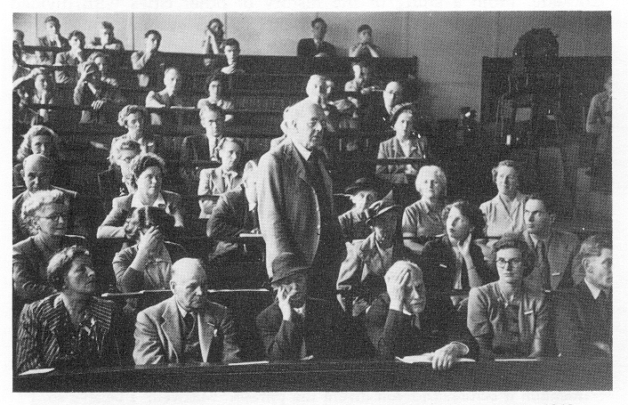
In the years during and after World War II, Richardson uniquely combined his mathematical prowess, his understanding of complex phenomena from meteorology, and his Quaker pacifism. He tried to quantify and predict (and thus avoid) war in much the same way that he had forecast the weather, with data and equations. The political scientists of his era were completely befuddled at this elderly meteorologist with his equations of war (right, photo from a scientific meeting in 1949;[taken from page 217 of Ashford’s biography of LFR..] Note the woman asleep and the exasperated man in the row in front of Richardson!). Richardson encountered great difficulty getting any attention, or even a publisher, for his laborious calculations.
Yet Richardson was, as usual, on the right track. Decades after his death in 1953, scholars realized the worth of his approach. One short paper of his was rediscovered, entitled “Could an arms-race end without fighting?” In the nuclear Cold War days of 1951, Richardson’s equations said, “yes, without a shot being fired,” if one side outspent the other on armaments and the weaker nation bankrupted itself. Almost forty years later, the Berlin Wall came down as an outspent Soviet Union relinquished power quietly in the face of American military buildups. Coincidence—or prophecy?
In the 1960s a mathematician named Benoit Mandelbrot stumbled across an obscure paper of Richardson’s. Its simple subject: how long is a coastline? What a stupid question! That is, until you realize that the shorter a ruler you use, the longer a coastline is. Mandelbrot extended Richardson’s work and discovered that the length of the coastline is intimately related to “fractal geometry,” an aspect of chaos theory.
Meanwhile, in Boston MIT meteorologist Ed Lorenz, using a numerical model based on Richardson’s ideas, discovered “sensitive dependence on initial conditions.” This, too, is a hallmark of chaos, and is discussed at the end of this chapter. Together, these two intellectual heirs of Richardson brought chaos theory to the forefront of 20th century science (not to mention “Jurassic Park”).
L. F. Richardson was so far ahead of his time that he won no major scientific awards or prizes while he was alive. He was the antithesis of a scientific prodigy, doing his best work after the age of thirty. For much of his life he taught in obscure universities. He was not an inspiring lecturer (see photo). He did his research “on the side.” He was a loner and a dreamer. Today, however, Richardson’s name adorns meteorological prizes, peace-studies foundations, and fundamentals of math and meteorology. The pioneer of modern meteorology was also one of the most creative and visionary scientists of the entire 20th century.
Box 13.4 “Blowing Up” a Forecast Model

In Box 13.2, we identified the “Achilles’ heel” of gridpoint models of the atmosphere. It is related to the distance between adjacent gridpoints, known as the “grid spacing,” and the time elapsed between one forecast calculation and the next, known as the “time step.”
The problem itself is the “strobe effect.” If a strobe light at a dance flashes too slowly, dancers can’t see where everyone is in-between flashes. Dancers are moving too fast for the strobe, and they’ll bump into each other and cause a big mess.
Similarly, if weather simulated in a forecast model moves too fast for the time step of the model, then the forecast will be a big mess. When this happens, meteorologists say the model “blew up” because the mess consists of larger and larger, totally unrealistic numbers for the weather variables the model is calculating.
Richardson didn’t know this, because the field of numerical modeling was in its infancy in the early 1920s. This problem hadn’t been discovered yet! In 1928, three mathematicians named Courant, Friedrichs, and Lewy created a criterion that, if violated, would lead to the “blowing up” of a finite-difference model. This “CFL” criterion is:

SPEED OF FASTEST WINDS IN MODEL ≤ GRID SPACING/TIME STEP

The upshot of the CFL criterion is that a modeler can’t arbitrarily choose a horizontal grid spacing without also taking into account the time step of the model. If you want fine horizontal resolution to see small-scale weather, you must have fine time resolution too. Otherwise, the model “blows up” and the forecast crashes. For a horizontal resolution of 50 km, a model typically needs a time step on the order of just 10 minutes.
What does it look like when a model “blows up”? Try it yourself! A simplified “barotropic” model is located on our Web site. Nice troughs and ridges turn into total messes when the horizontal grid spacing and time step don’t satisfy the CFL criterion. The forecast is ruined. The model is useless.
In short, this criterion is the “there’s no such thing as a free lunch” rule translated into numerical weather forecasting. We want fine resolution in both time and space, just like we want a free lunch. But both inevitably come at a price. For meteorologists, the price is high: their best models are required make forecasts every few minutes. These minute-by-minute forecasts are not released to the public; imagine the information overload! They are used by the model itself, and only by the model, to satisfy the dratted CFL criterion. This wastes valuable computer time and vastly increases the computational requirements of numerical weather prediction. But it is a necessary chore. Without it, numerical weather forecasts would “blow up” in meteorologists’ faces.
Box 13.5 A Day in the Life of Private-Sector Meteorology

Historically, government-sector meteorology has been the best-known branch of (and employer in) meteorology. As a consequence of Federal government downsizing during the 1980s and 1990s, this is no longer the case.
Today, private-sector meteorology satisfies the demand for customized meteorological information that is beyond the ability and mission of the National Weather Service to provide. This information can be too small-scale, or too specialized, or too risky for the government to deal with. For these reasons, private-sector meteorology is rapidly growing.
The most visible branch of private-sector meteorology is TV weather, from local stations to The Weather Channel. These on-air personalities often have meteorology degrees but usually rely on the National Weather Service for most of their forecasts. However, their specialized skills in graphics and in communications exceed what the government can provide.
Private-sector meteorology is much more than TV weather, however. One of the largest private-sector meteorology firms is WeatherData, Inc., in Wichita, Kansas. Let’s see what they do on a fairly typical day.
A typical workday for WeatherData meteorologists begins with looking at and even creating their own weather maps, often for an hour or more. They consult satellite and radar loops to get a 3D view of the weather. This way, the forecasters dig deep into what’s actually happening, a necessary prerequisite to making forecasts that push the envelope of current techniques.
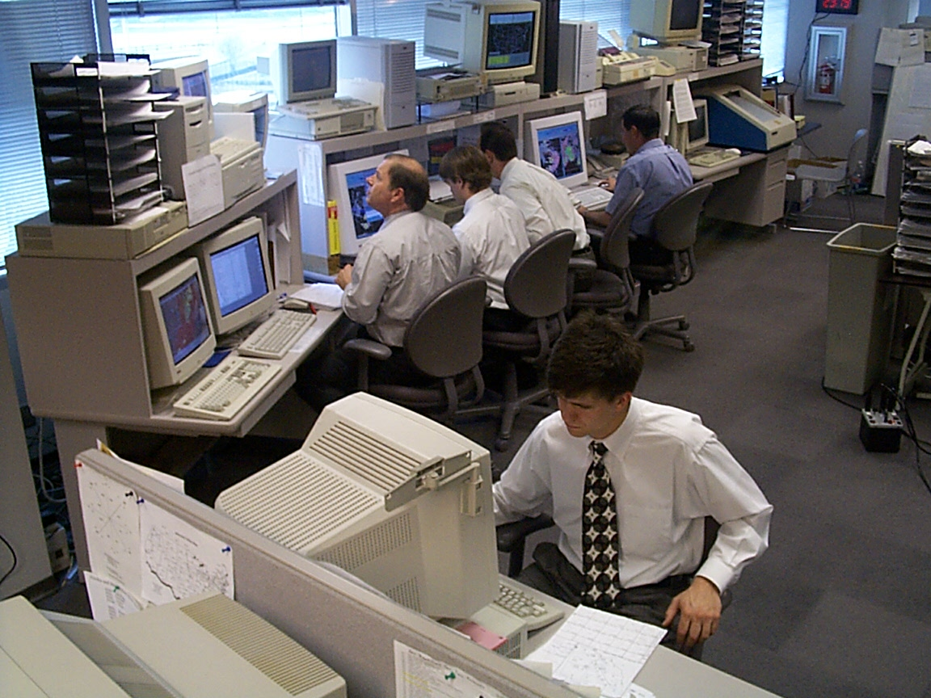
Figure 13B5.1 WeatherData meteorologists develop and send out forecasts during a busy severe weather day. CEO Mike Smith, in the center looking up, works alongside his employees.

Two or three hours into the work shift, it’s time for weather discussion among the various WeatherData meteorologists. What are the key aspects of the weather to focus on today? Where are the trouble spots that matter to WeatherData’s clients? These questions dominate the discussion. Then forecasts for specific clients are fine-tuned based on the consensus of the weather discussion.
Who are WeatherData’s clients? They range from major airlines to railroads to newspapers. New WeatherData forecasters often hone their forecasting skills by making and then sending out forecasts to prominent newspapers such as the Los Angeles Times and the Dallas Morning News. The hours of studying the maps and forecast models is condensed into numbers for individual cities’ high and low temperatures and a graphic symbol for the kind of weather expected that day. According to WeatherData vice president of customer operations Todd Buckley, newspapers get more detail, graphics, and accountability from WeatherData than from official government sources. The newspapers pay for this service.
During this particular shift, fog and low visibilities are keeping planes over the U.S. from landing at large airports. It’s not severe weather, but nevertheless the costs are large: as much as $10,000 per hour per aircraft flying in a holding pattern. Airlines incur costs of tens of millions of dollars per year due to these delays. To stave off these costs, Southwest Airlines, among others, pays WeatherData to provide up-to-the-minute and site-specific forecasts of visibility and other aviation-related weather variables. When planes crash, it’s often WeatherData CEO Mike Smith who is called on to provide expert meteorological testimony in court cases.
Another consumer of WeatherData information is the railroad industry. Trains carrying freight in high-profile double-stack cars often go through mountain passes where winds can on occasion be very strong. If the winds are above a certain speed, the double-stack of freight can blow off, leading to a derailment. A railroad can spend $1-$5 million just to clean up the mess from this kind of derailment! Burlington Northern Santa Fe (BNSF) Railway contracts with WeatherData to provide wind forecasts at specific mountain passes in the Western United States—a level of forecast detail unattainable from the National Weather Service.
Trains can also be blown over by tornadoes. However, it’s a hit-or-miss proposition whether or not a tornado will actually collide with a train. If the two collide, the cost is in the millions. If not, the cost of stopping a train for a tornado that doesn’t occur, or doesn’t threaten that section of track, is about $200 per train per minute of waiting—not chicken feed. So, railroads and other users need to have pinpoint-precise tornado warnings instead of the county-by-county warning system provided by the National Weather Service.
To meet this need, WeatherData has developed its own software that combines government Doppler radar (Chapter 5) graphs with very specific maps showing major transportation arteries such as roads and railway lines. This was critical during the May 3, 1999 tornado that ravaged Oklahoma City (see figure below). This tornado crossed the BNSF tracks, destroying communications lines alongside the tracks and blowing debris onto the tracks. Thanks to WeatherData’s warnings, however, no trains were hit, saving millions of dollars as well as lives.
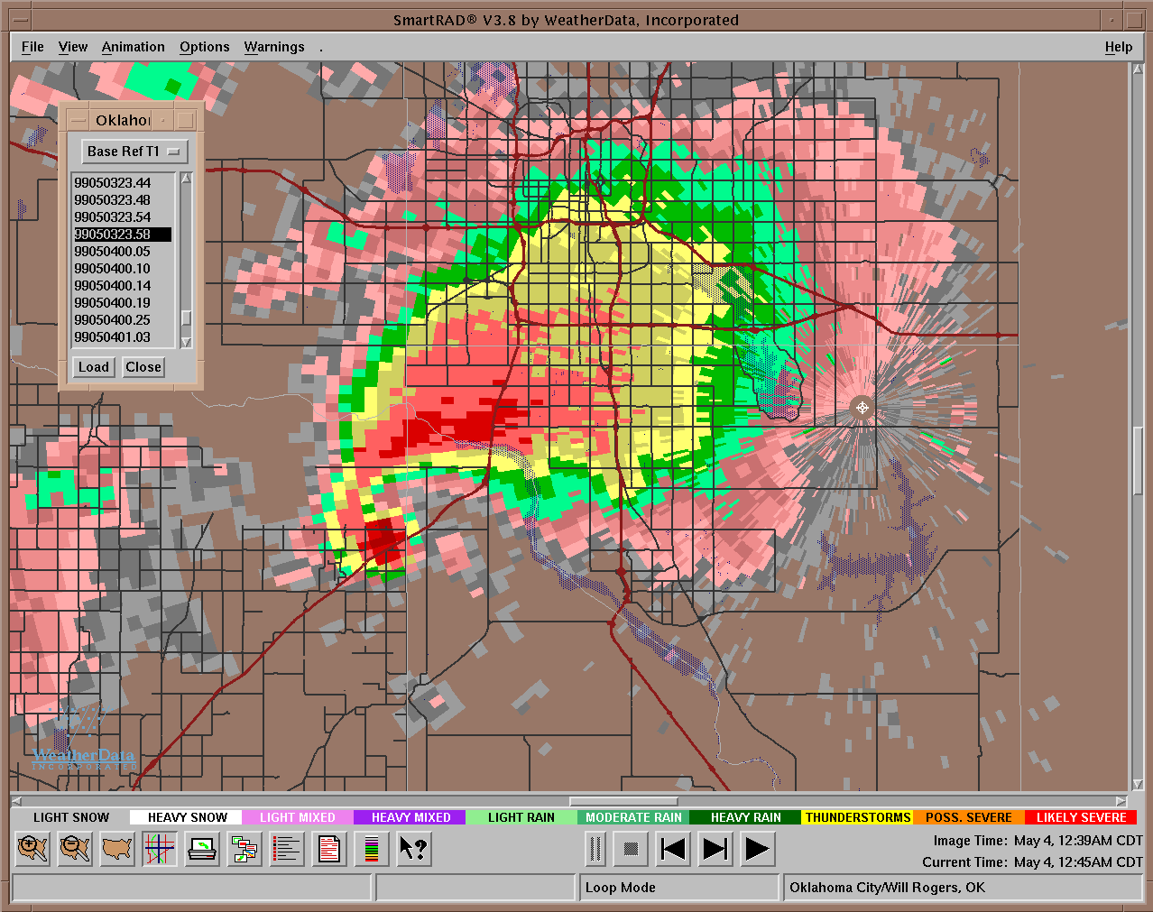
Figure 13B5.2 The “hook echo” (curled red area) of the May 3, 1999 Oklahoma City tornado, as diagnosed by National Weather Service Doppler radar and overlaid on top of a roadmap (black and red lines) of Moore, Oklahoma using software designed at WeatherData, Inc.

Heat waves aren’t as exciting as tornadoes, but they can be just as devastating to energy companies. An electric utility must pay top dollar to obtain energy immediately to supply the spike in demand caused by air conditioners running full blast; otherwise, a power blackout could occur. Sometimes the unexpected costs can run into the tens of millions. And so utilities such as Southern California Edison hire WeatherData to give them precise, agonized-over temperature forecasts.
Once the forecasts are sent to the clients, the work shift is over (unless severe weather threatens, when everyone pitches in). On the way out the glass doors of WeatherData, there is a sense of job satisfaction. Jeff House, lead meteorologist at WeatherData, explains, “The work is rewarding, as one sees how many lives are saved or how much money is saved by clients.”

Table 13.1. Summary of numerical weather prediction models discussed in the text, modified from a table by Prof. John Nielsen-Gammon, Texas A&M University.

Model | First  Used | Horizontal  resolution (km) | Number of vertical grid points | Makes forecast for | Forecast issued at (A.D. or EST) | Longest forecast | Best used for
Richardson | 1916-1918 | 200 | 5 | One spot in Germany | 1922 for a day in 1910 | 3 hours | History lessons!
LFM | 1975 | 160 | 7 | North America | Twice a day | 48 hours | Not currently used
NGM | 1985 | 80 to 160 | 18 | Hemisphere, best for North America | 6 PM, 6 AM | 48 hours | Large-scale weather in U.S.
Eta | 1993 | 22 | 50 | North America | 6 PM, 9 PM, 6 AM, noon | 60 hours | Wide variety of U.S. forecasts
RUC | 1996 | 40 | 40 | Lower 48 states | Every 3 hours | 12 hours | Short-term forecasts over central U.S.
UKMET | 1972 | 60 | 30 | Globe | Twice a day | 6 days | Longer-range forecasts
AVN | 1981 | About 80 | 42 | Globe | Every 6 hours | 3 days | Overseas and U.S. forecasts
MRF | 1985 | About 80 | 42 | Globe | 6 PM | 15 days | Longer-range forecasts
ECMWF | 1979 | About 55 | 31 | Globe | 6 AM | 10 days | Wide variety of forecasts

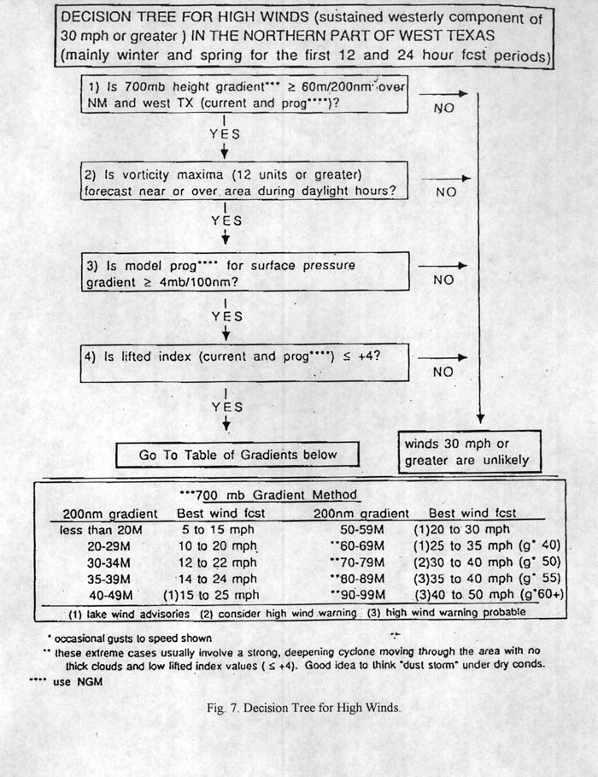

Figure 13.1. A modern rule-of-thumb “decision tree” for forecasting the occurrence of high winds in west Texas, created by National Weather Service meteorologists Greg Murdoch and Jim Deberry. [Found at: http://www.srh.noaa.gov/maf/html/wind.htm Artists: will want to make look like a “concept map.” Simplify wording as follows:
TITLE: “Decision Tree for High Winds in West Texas (northern part)
  - Is the lower-tropospheric pressure gradient strong or very strong?
  - Is there a positive vorticity maximum forecast overhead during the day?
  - Does the forecast model predict a strong surface pressure gradient?
  - Does the lifted index suggest unstable or moderately stable conditions?
Below the Y under 4), you’ll want to have a branching-off of two arrows, like this:
Is the pressure gradient in #1 Is the pressure gradient in #1
strong? very strong?
HIGH WINDS POSSIBLE HIGH WINDS PROBABLE.
Completely omit the table with all the numbers.]

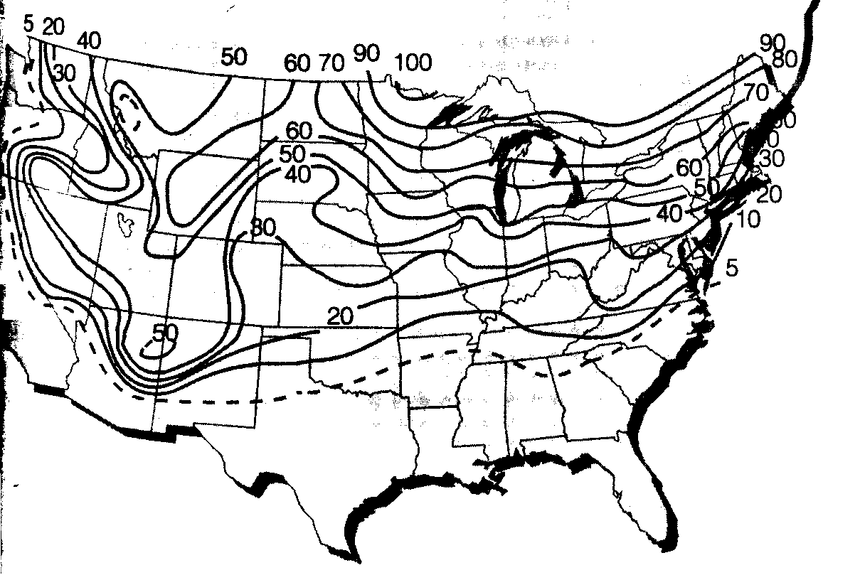
Figure 13.2. Climatological forecast probability of a “White Christmas” across the United States. [Artists: Modify the figure above, taken from Ahrens, 6th edition, p. 361. Add labels in the appropriate locations saying, “Snow a good bet for Minnesota” and “No snow for Florida.”]

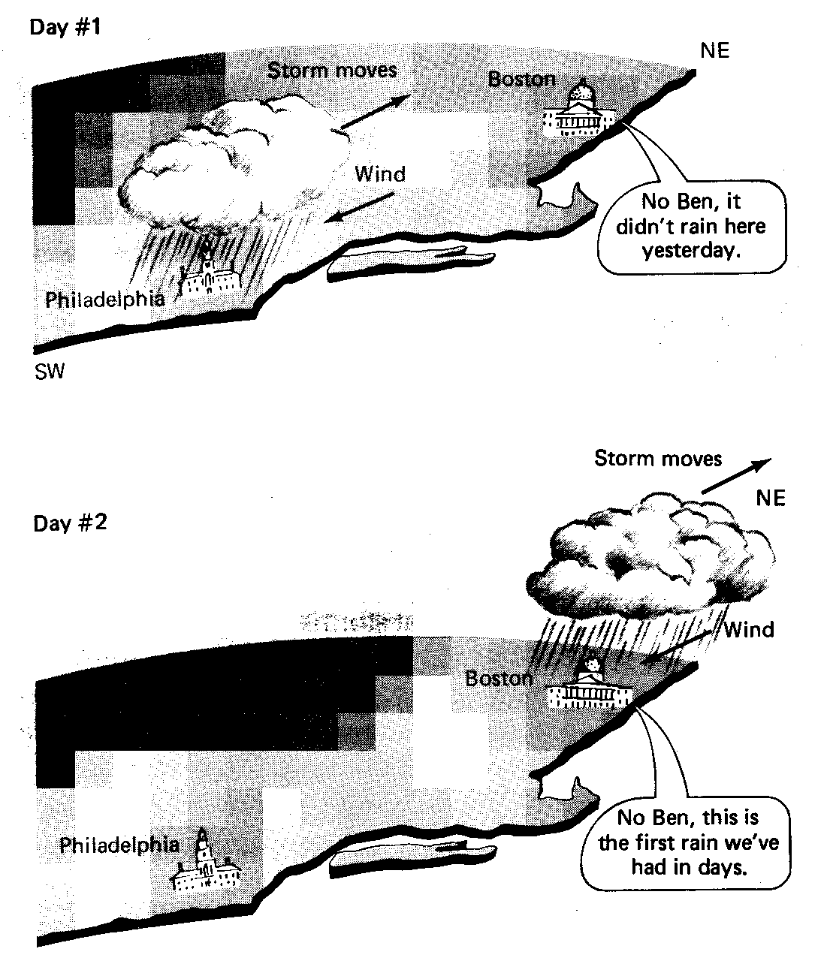

Figure 13.3. A trend forecast based on the assumption that a mid-latitude cyclone moves, unchanging, up the East Coast. [Artists: Modify this figure, from p. 14 of Gedzelman’s out-of-print text The Science and Wonders of the Atmosphere, 1980, John Wiley and Sons. Change the puffy cloud to a low-pressure system with a cold front and a warm front attached to it, like this: L
Only draw it rotated so that the low seems to be lying flat along the ground. In addition, draw in a little Ben Franklin on Philadelphia in the top frame saying, “Expect rain tomorrow.” Change what the guy in Boston in the top frame says to, “Ben, it’s not raining here now.” Then change what the guy in Boston says in the bottom frame to, “Ben, it’s raining here now.”
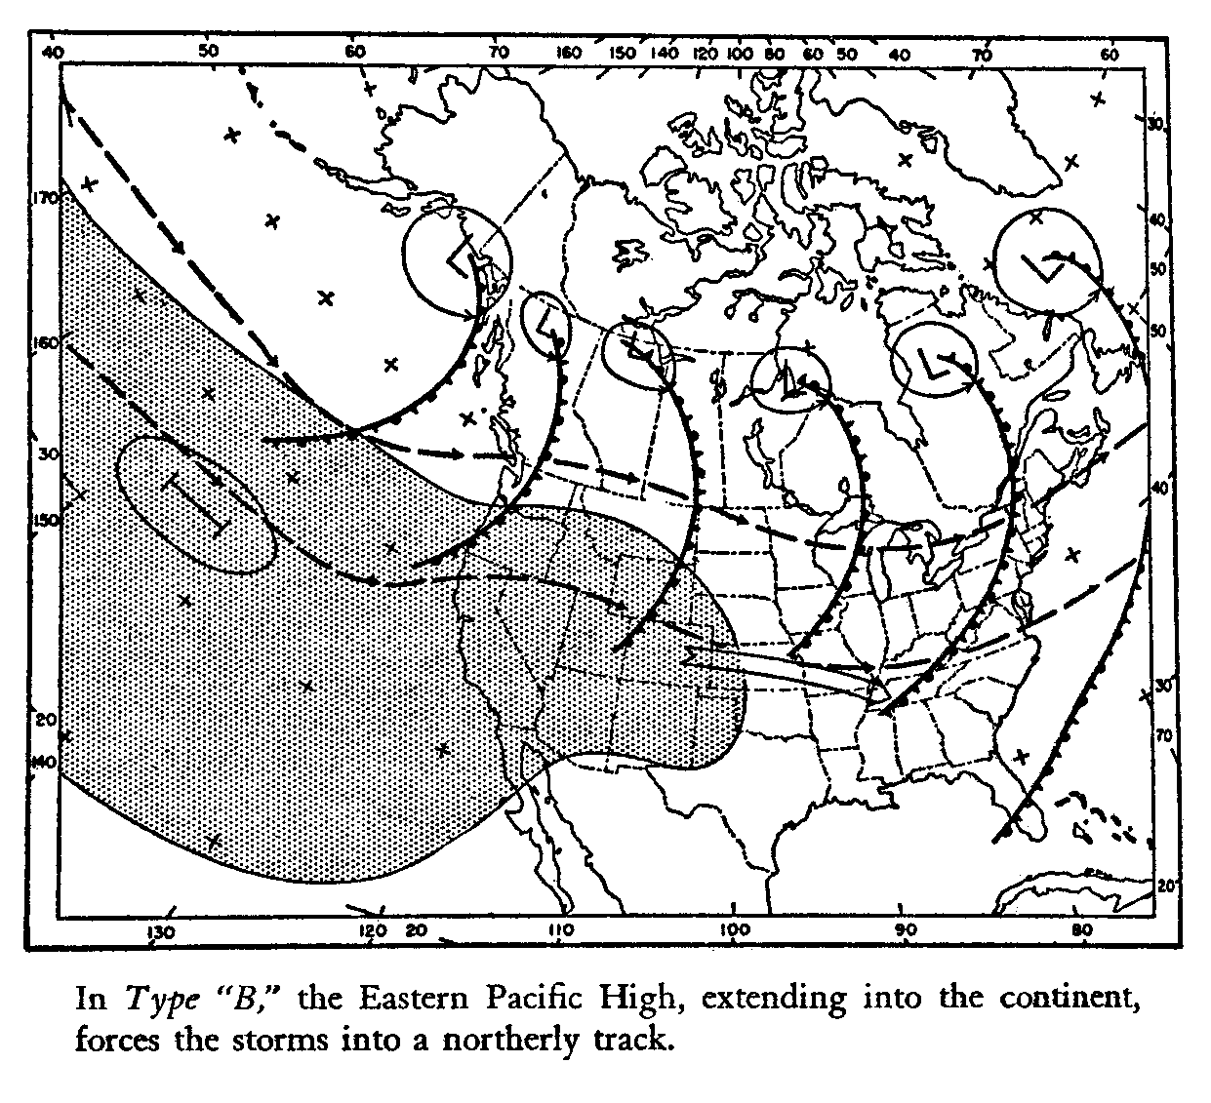
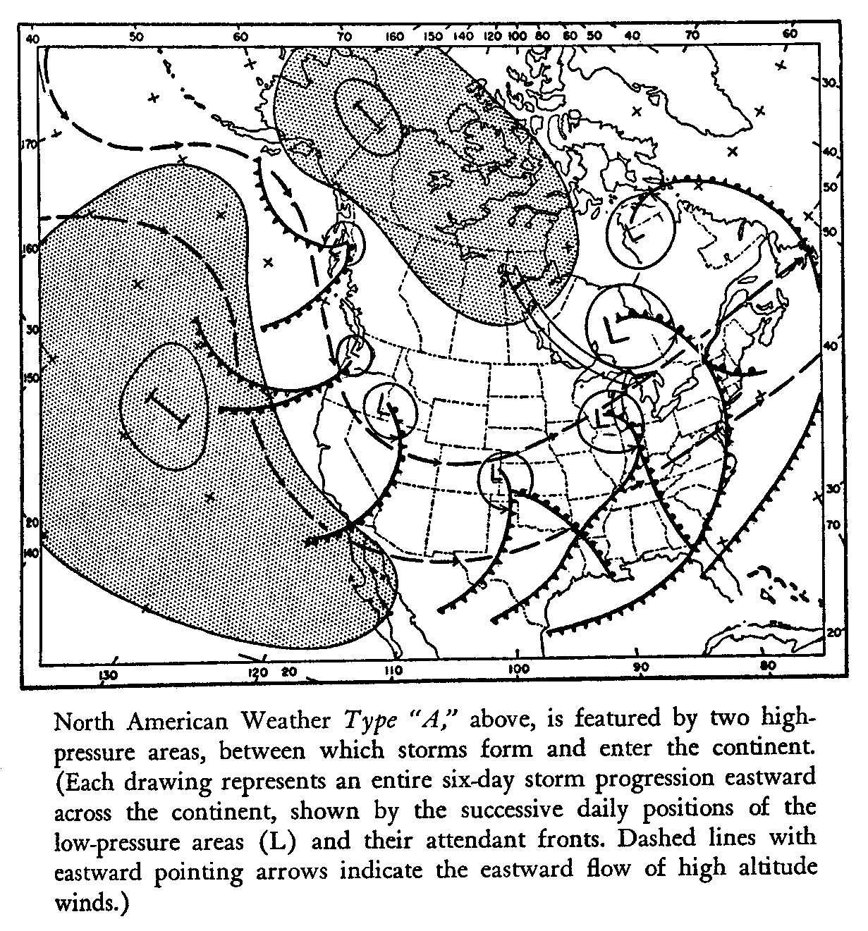
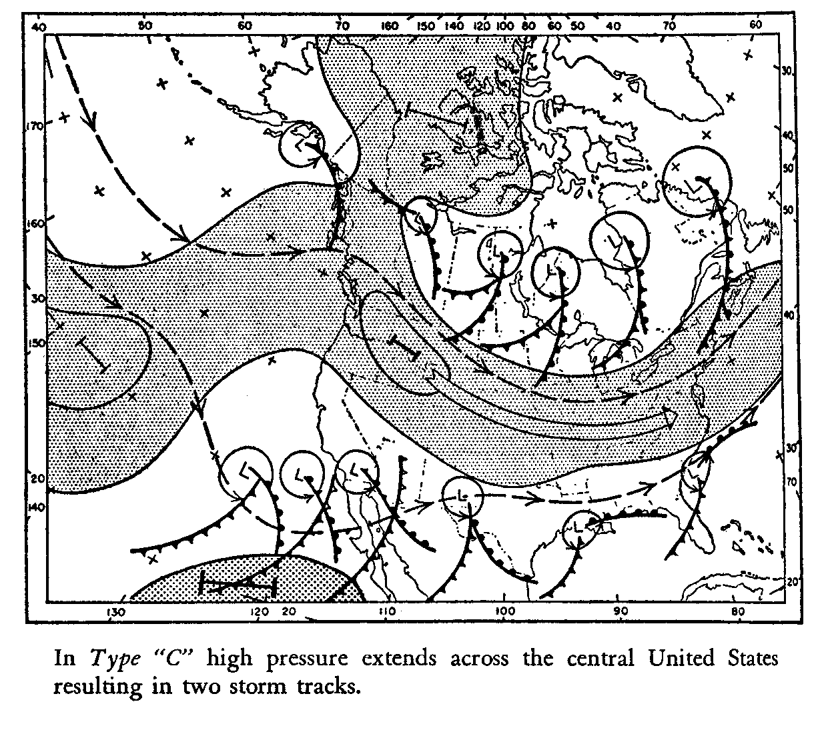
Figure 13.4. Three different “weather types” used in the heyday of analog forecasting . The goal of analog forecasting is to identify which of these types best matches today’s weather and to use the left-to-right sequence of weather in that type as a forecast for the weather tomorrow and day after, etc. [From Krick and Fleming’s Sun, Sea, and Sky, Lippincott, 1954, pp. 97, 98, 100. Artists: will want to modify and simplify so that the three figures are combined into one with letters denoting A, B, or C in one corner. Omit the rest of the captions. Also, the shading of the high-pressure systems is odd; omit it. The goal will be to simplify the figures so that they “work” while being shrunk down as much as possible; don’t want to use too much space on this largely discredited approach.]

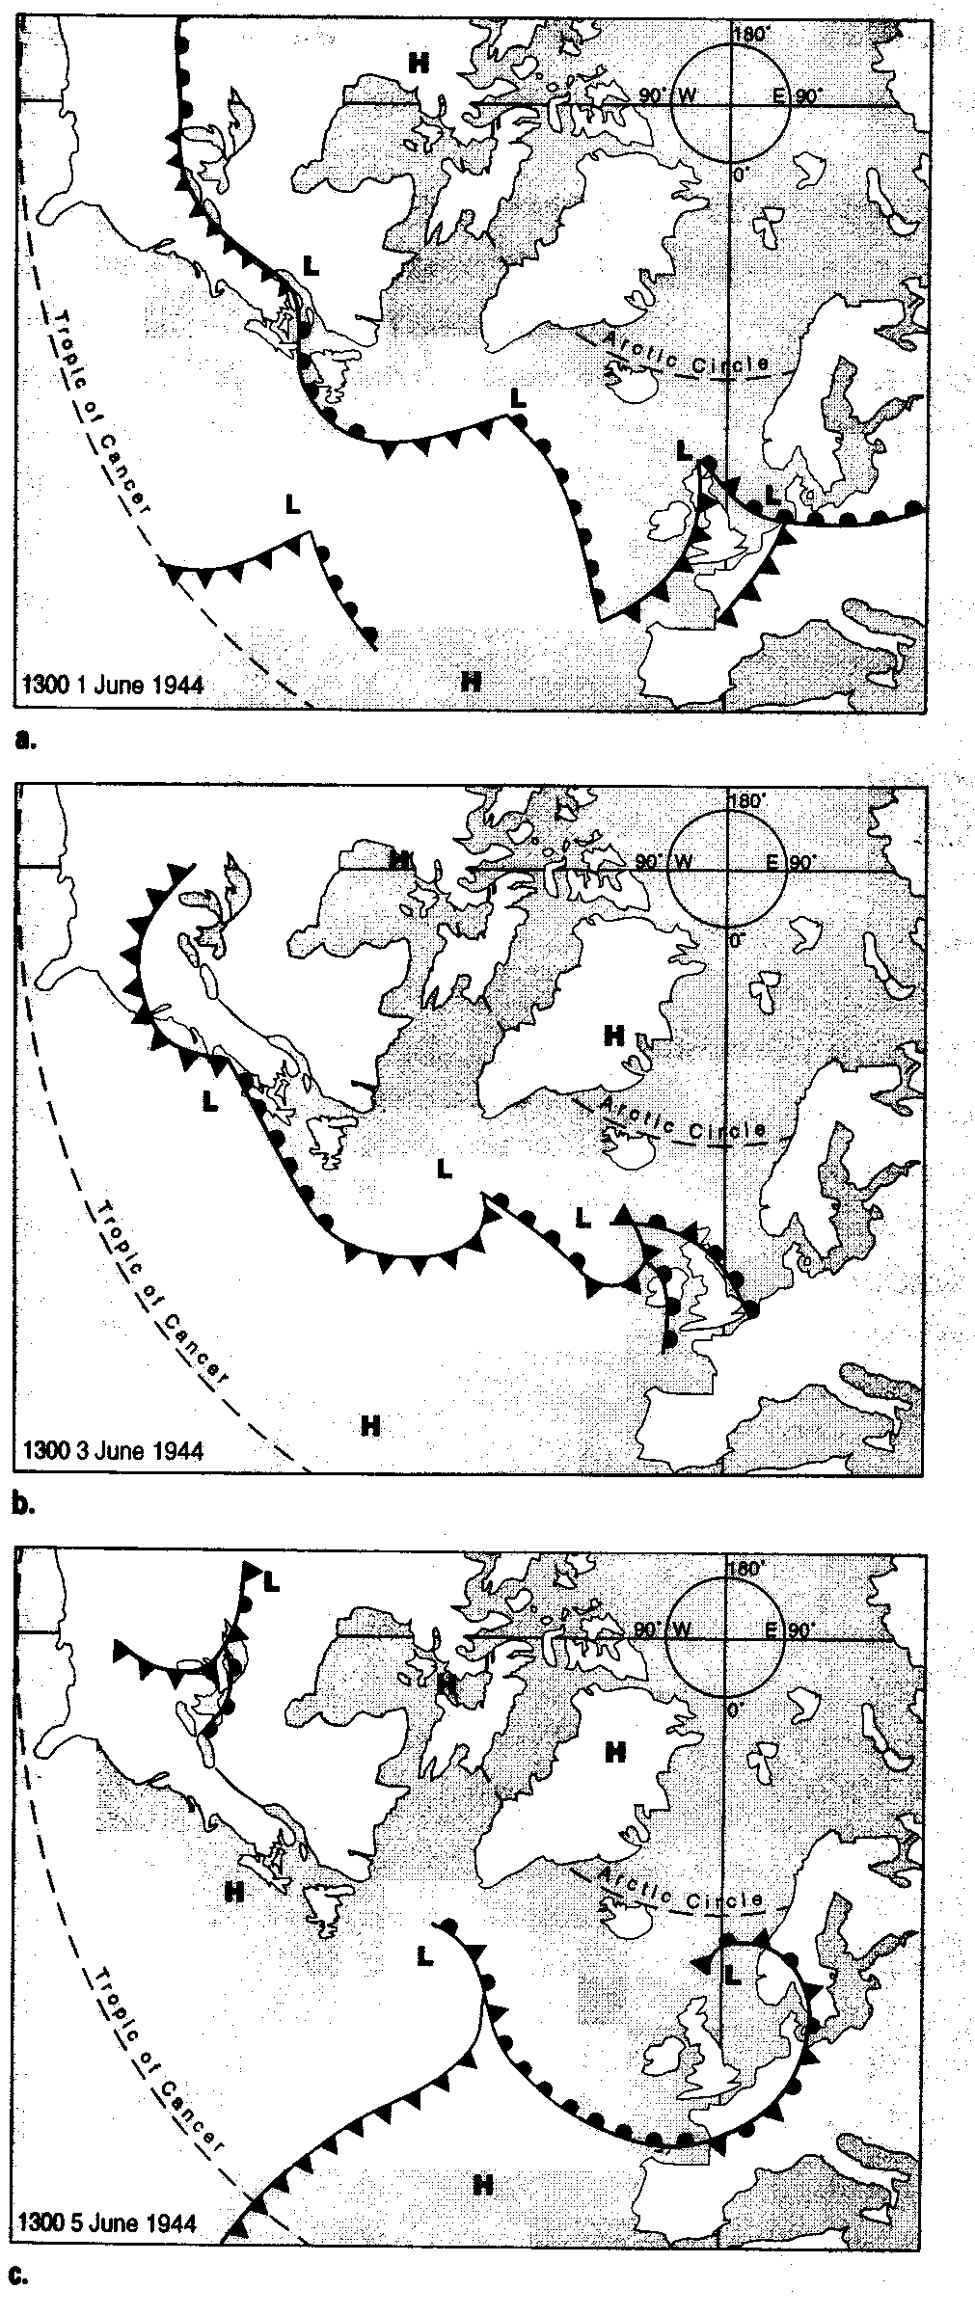
Figure 13.5. Allied surface weather maps for the North Atlantic for the days June 1, June 4, and June 5, 1944. [Figure comes from p. 27 of Winters’ Battling the Elements. However, only the top panel is ok. I want the other two panels to be redrawn for different times, using the figures below that are from Winters’ original source. Reasons: I want different times than Winters had for the middle image, and in the bottom image he makes the front occluded, not a cold front. But the overall approach in Winters’ figure should be emulated, it’s beautiful.]

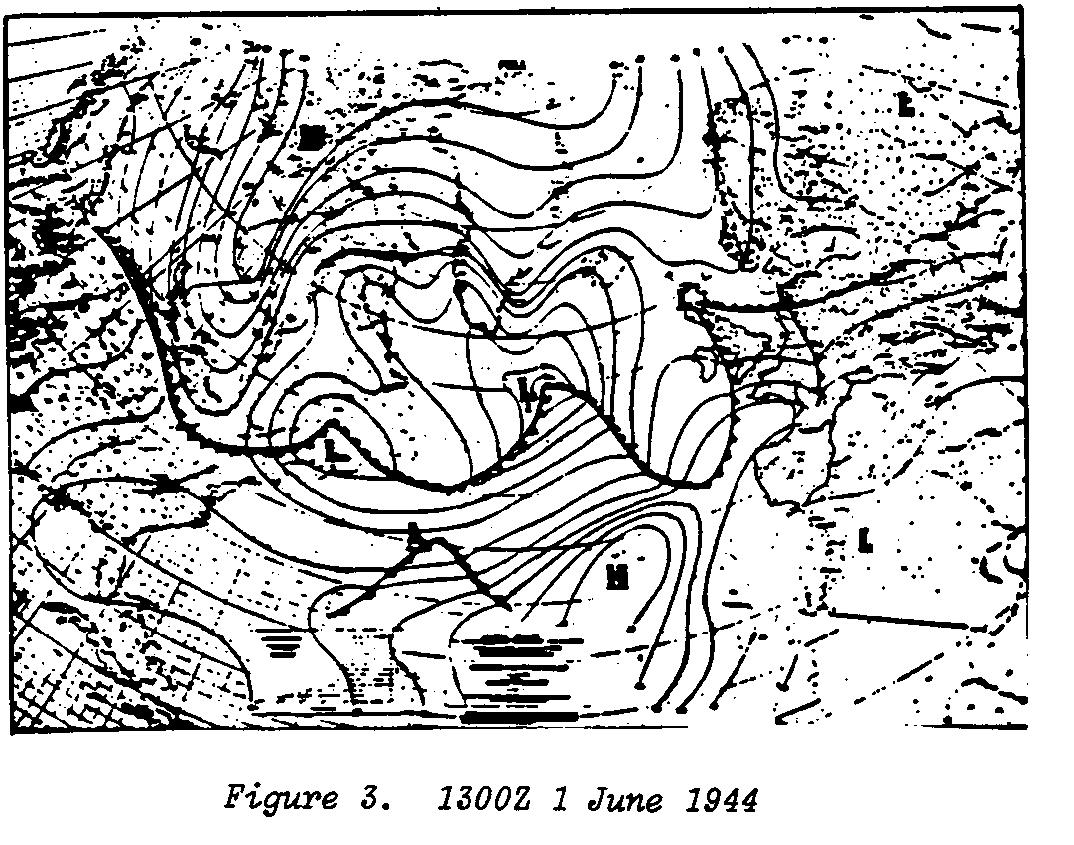
Original detailed weather map from which Fig. 13.5a was created, for reference:

New Fig. 13.5b and c need to be drawn as in Fig. 13.5a, but using the data from the admittedly marginally legible figures below [from pp. 165 and 166 of Some Meteorological Aspects of the D-Day Invasion of Europe, Roger H. Shaw and William Innes, editors, American Meteorological Society, 1984; original for 13.6a is from p. 89 of same publication]:

June 4, 1944 is below:
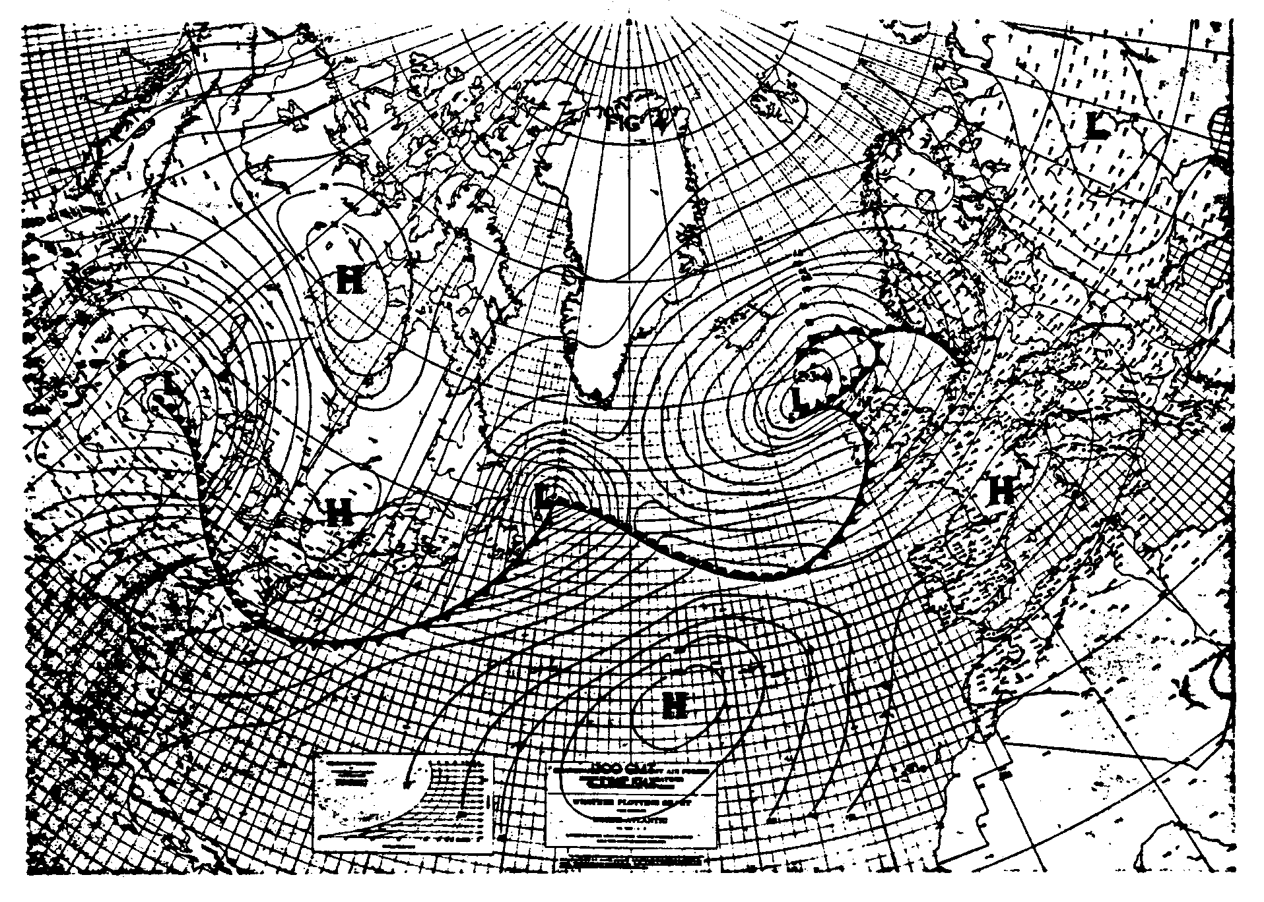
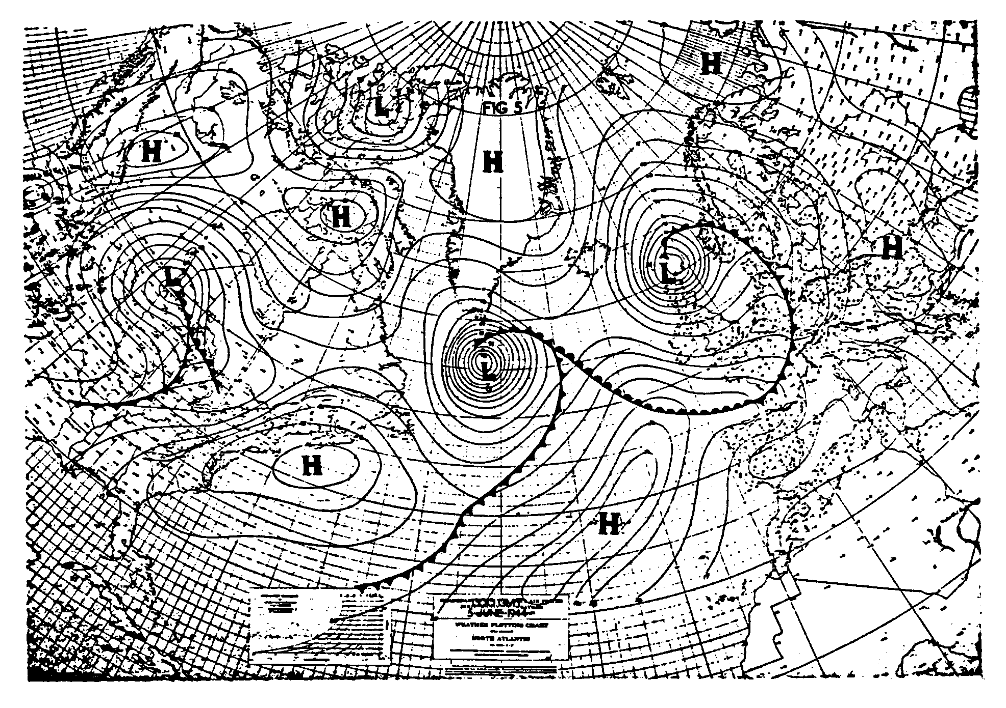
June 5, 1944 is below:
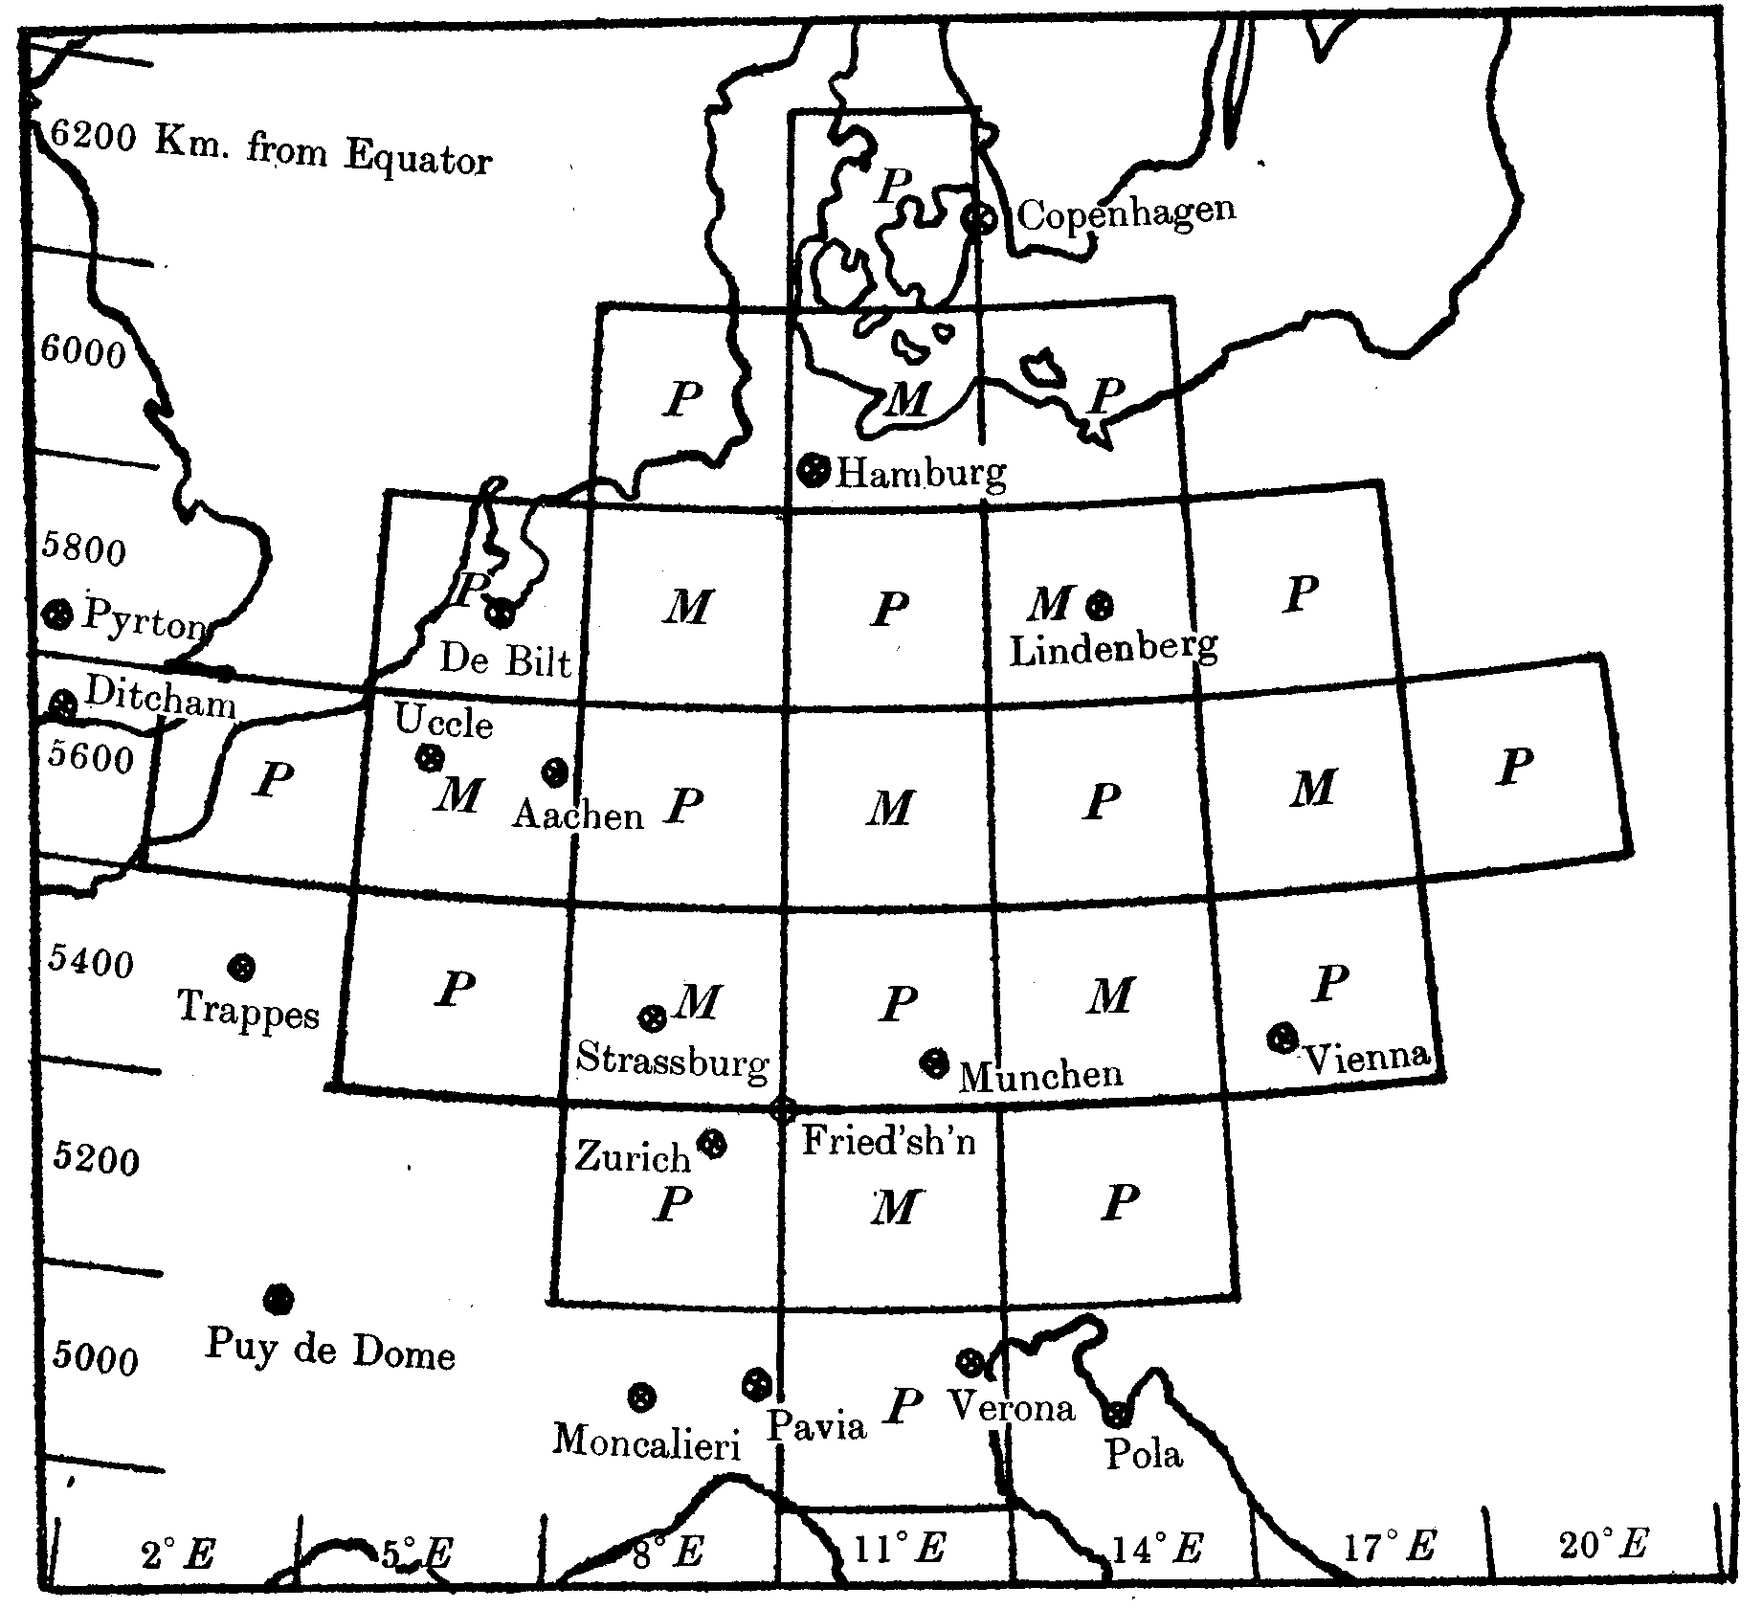
Figure 13.6. An actual map from Richardson’s famous forecast. The circled x’s are stations at which upper-level weather observations were available on May 20, 1910. The M’s and P’s are the model’s gridpoints at which Richardson calculated momentum (i.e., wind) and pressure changes, respectively. The circled P [artists: circle the P near Munchen] is the location for which Richardson obtained his erroneous forecast of a pressure change of 145 mb in 6 hours. The lines on the map divide Europe into a grid that facilitates the numerical forecast. [From Richardson’s Weather Prediction by Numerical Process, Cambridge University Press, 1922, p. 184.]
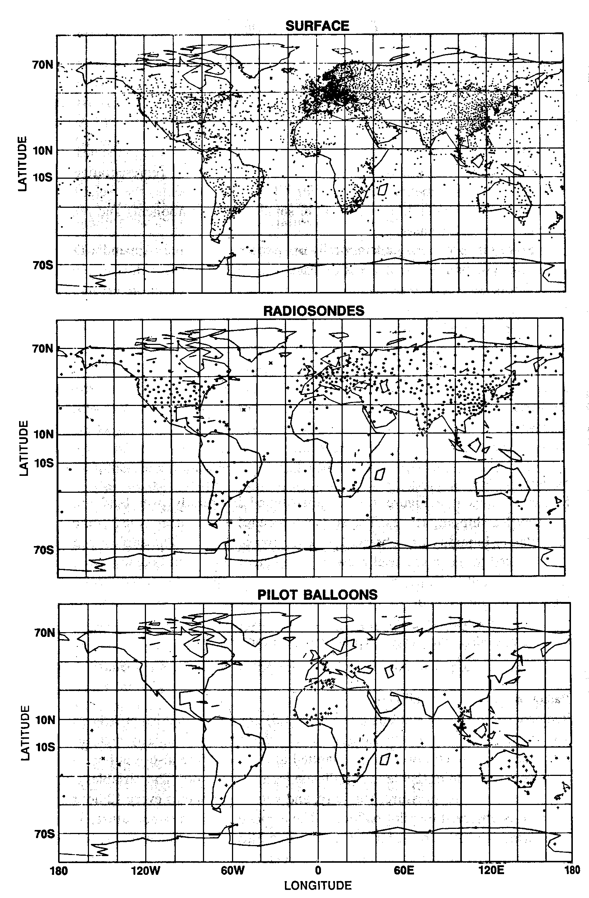

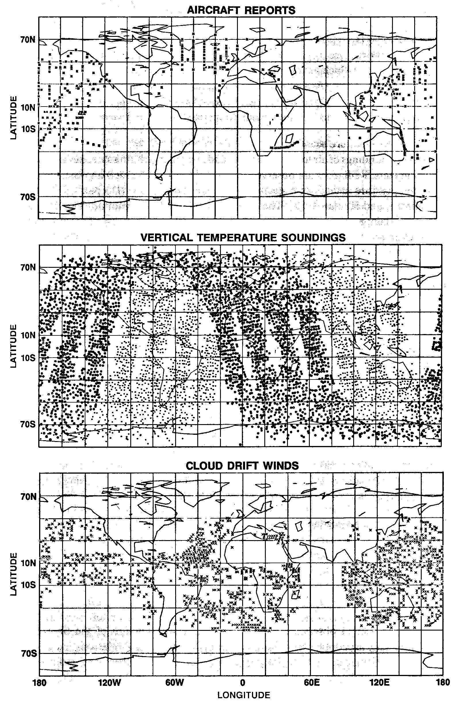
Figure 13.7. Weather data gathered over a six-hour period in 1989 and used in a modern numerical weather prediction model. [From Roger Daley’s Atmospheric Data Analysis, Cambridge University Press, 1991, pp. 14-15. NOTE TO ARTISTS: Will want to omit the panels titled “Pilot Balloons,” “Aircraft Reports,” and “Cloud Drift Winds.” So there will be only three panels. Make the three remaining ones into one long columnar figure. Will need to retitle “vertical temperature soundings” as “satellite observations of temperature,” which isn’t quite right but is close.]
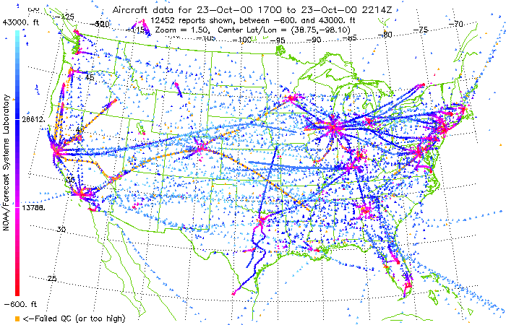
Figure 13.8. Graphic showing the distribution of aircraft meteorological data gathered by wide-bodied jets during a five-hour period on October 23, 2000 over the continental United States. Blue colors indicate flight observations in the upper troposphere or lower stratosphere; red colors indicate observations nearer the ground as the plane was taking off or landing. Image courtesy NOAA/Forecast Systems Laboratory, Boulder, Colorado.
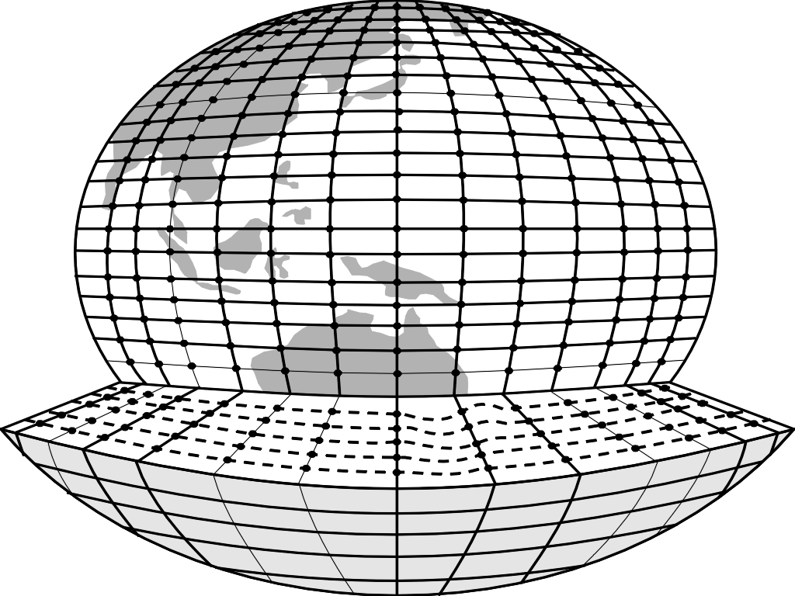
Figure 13.9. Dividing the world up into boxes for use with a gridpoint model. Forecasts and calculations are made only at the gridpoints, which are depicted as dots on this diagram. [From http://www.dar.csiro.au/res/cm/data.htm Artists: will want to revise so that the circular dots themselves are in the middle of each box, not where the lines intersect.]

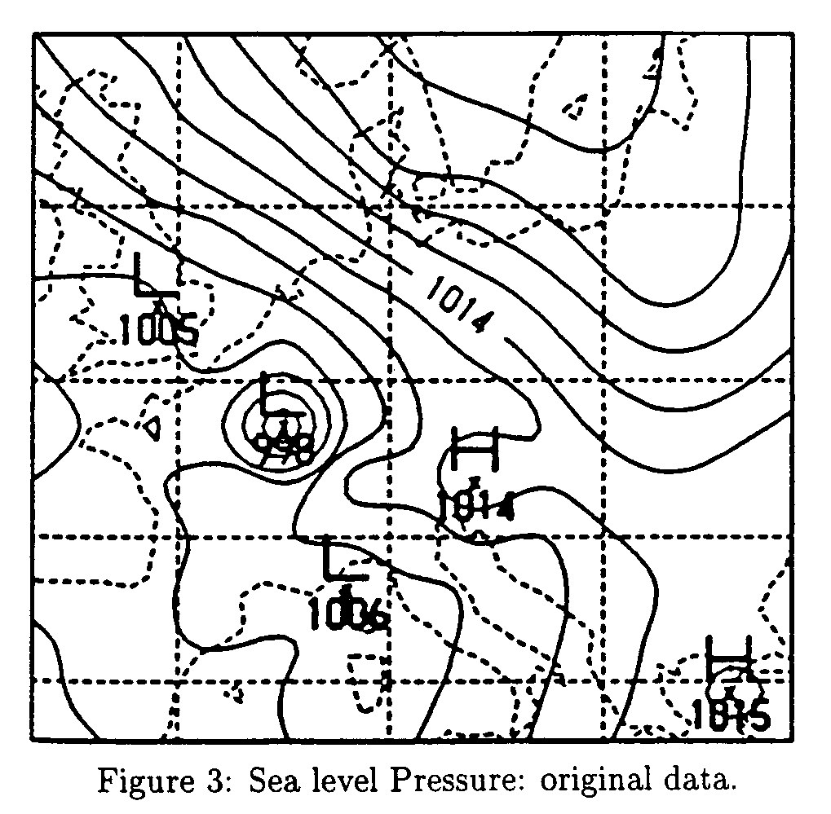

Figure 13.10. Garbage in: the initial conditions for Richardson’s model forecast, including a bullseye low that shouldn’t be there just to the left of center near Germany. Figure courtesy Dr. Peter Lynch, Irish Meteorological Service. [I need to get permission.]

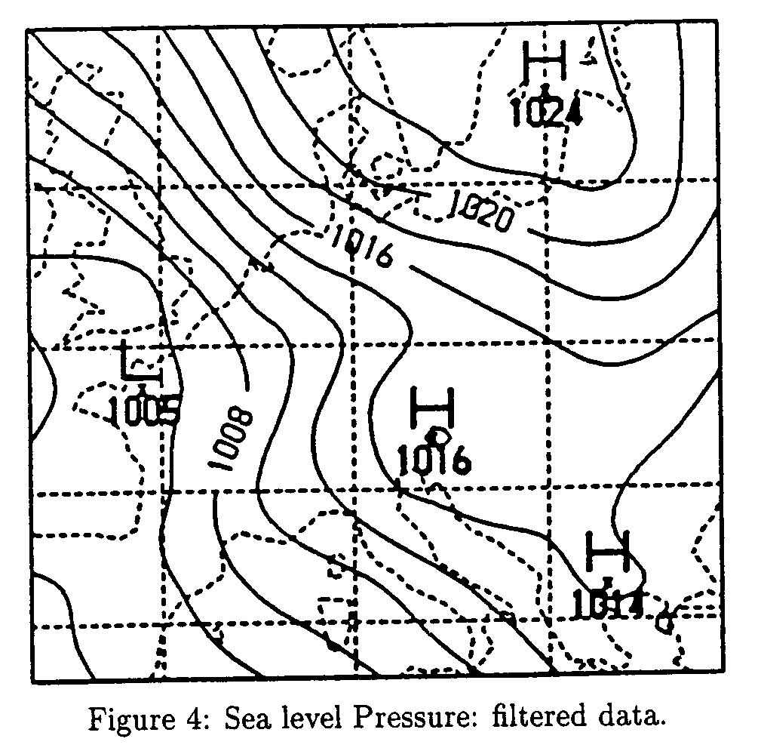
Figure 13.11. The same data as in the previous figure, but smoothed by data initialization. Where did the bullseye low over Germany go? Figure courtesy Peter Lynch.
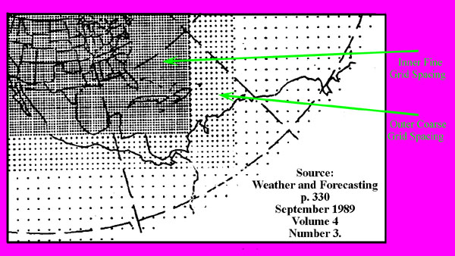
Figure 13.12. The various grid spacings of the Nested Grid Model (NGM). Each dot represents a gridpoint at which the model makes calculations. Notice that coarse grid spacing means fewer gridpoints per unit area than fine resolution. [Figure comes from Texas A&M Web site, but it cites the original source, which would be best to use. Color is superfluous.]

Figure 13.13. Football fans in a stadium can be seen as individuals, or equivalently as part of a group performing “the wave.” Similarly, the atmosphere can be analyzed as a collection of grid points, or in terms of waves. [ARTISTS: What I’d like is a diagram that shows the wave (left picture) going around a stadium so that you can see all the fans (as in right picture). A photo would be great, but I couldn’t find a good one on the Web. Left picture from www.tdo.com, right picture from bengals.enquirer.com]

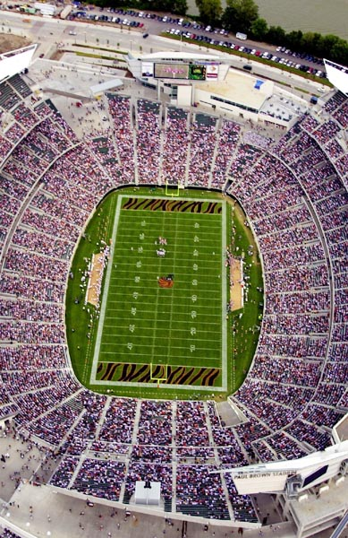

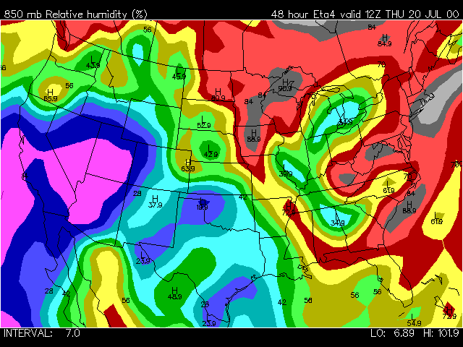
Figure 13.14. An example of an “Eta” model’s 48-hour forecast of relative humidity at 850 mb, valid for 6 AM Central time on July 20, 2000. Image generated via links at http://www.stormchaser.niu.edu/machine. Bluish colors denote relatively dry air, reddish colors indicate relatively moist air. [ARTISTS: Color is very important here!]
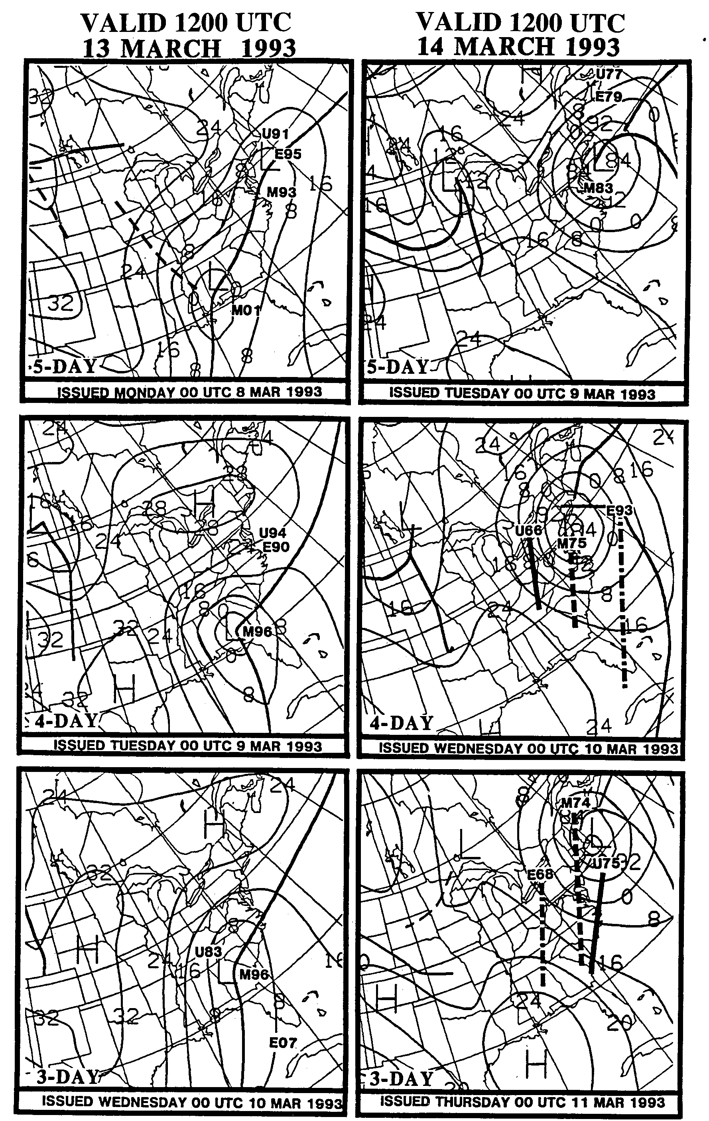
Figure 13.15. Forecasts of the March 1993 “Storm of the Century” from three numerical models: the MRF, ECMWF, and the UKMET models. Numbers indicate the lowest predicted central pressure of the cyclone at that time. The isobars and fronts represent the NMC meteorologists’ own forecast based on a synthesis of the model projections. [NOTE TO ARTISTS: this figure requires a lot of work. First of all, use the right three panels ONLY. Simplify and make intelligible in ways suggested by the mockup on the next page. But that mockup was freehanded, so don’t use it for anything more than stylistic guidance. Finally, will want to label Birmingham and Washington. Figure above is from p. 329 of The Life Cycles of Extratropical Cyclones, Shapiro and Gronas, Eds., American Meteorological Society, 1999.]

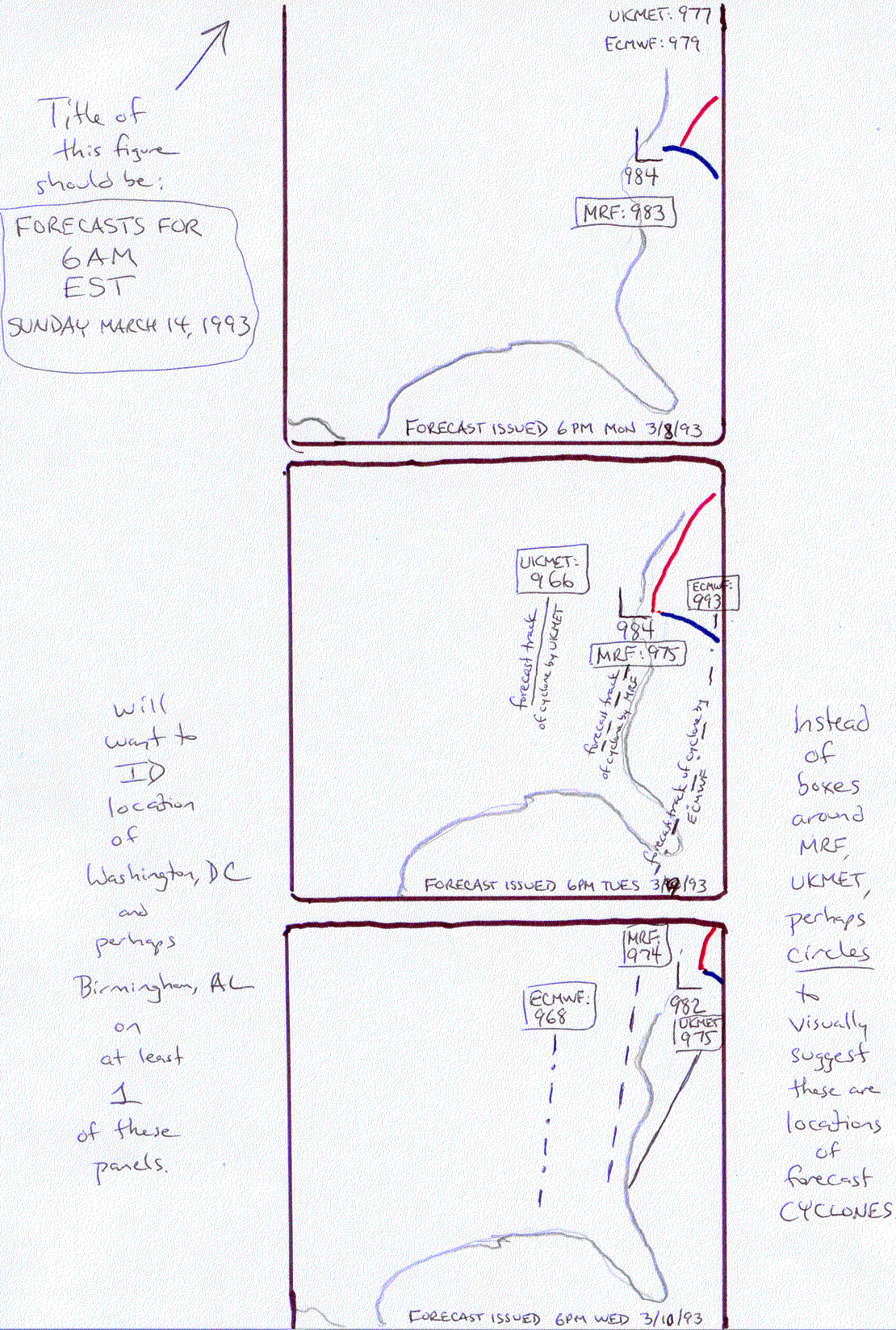
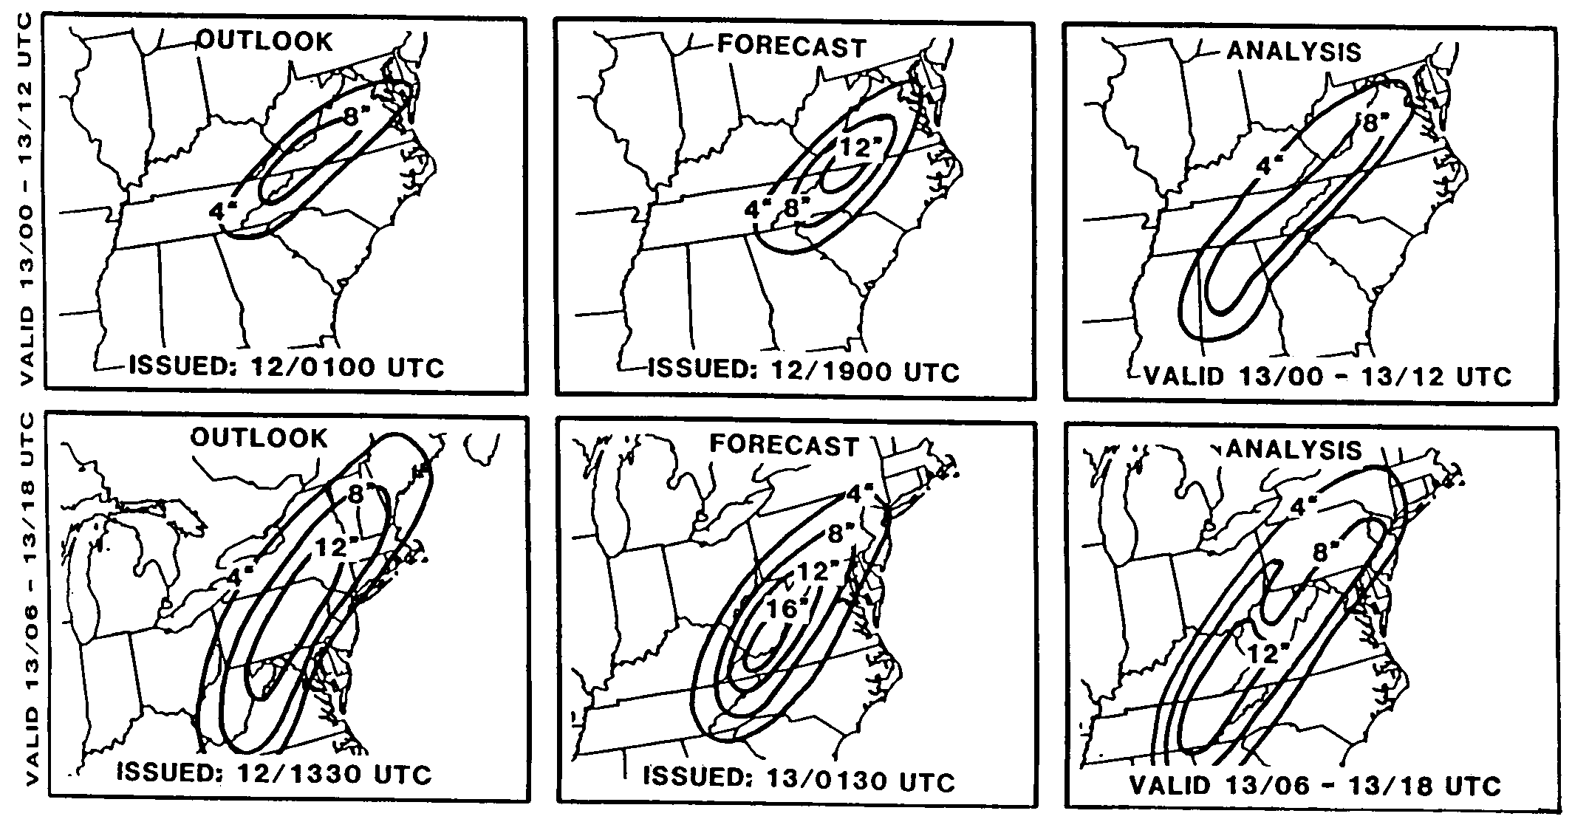
Figure 13.16. NMC’s twelve-hour snow forecasts for the “Storm of the Century” (left) and what actually happened (right) for two overlapping time periods on March 12-13, 1993. The region of 16” snow in the lower left figure was the most snow ever forecast by NMC. [Note: use the rightmost two columns only. The text in the labels at the bottom probably needs translating into civilian time: 12/1900 UTC = March 12 at 2 pm; 13/0130 UTC = March 12 at 7:30 pm; 13/00-13/12 means from 6 pm on March 12 to 6 am on March 13th; and 13/06 - 13/18 UTC means Midnight on March 13th to noon on March 13th. The “a” part of the graphic is the horizontal two frames at the top, and the “b” part of the graphics is the bottom two frames. Will want to label Birmingham and Washington on this figure. Finally, change “Analysis” to “Actual.” From p. 331 of Life Cycles…]
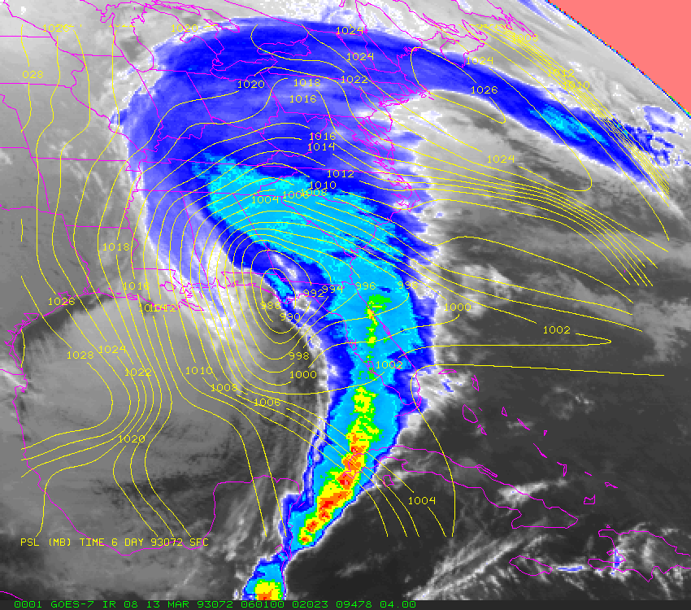
Figure 13.17. An infrared satellite picture of the “Storm of the Century” making landfall over the Florida Panhandle at 1 am Eastern time on March 13, 1993. Estimated surface pressures are shown with yellow lines; yellow- and red-shaded regions indicate high clouds such as thunderstorms. [Figure from C. Eric Williford, Florida State University. He has previously given me permission to publish this image. We’ll use this figure here instead of in Chapter 10.]

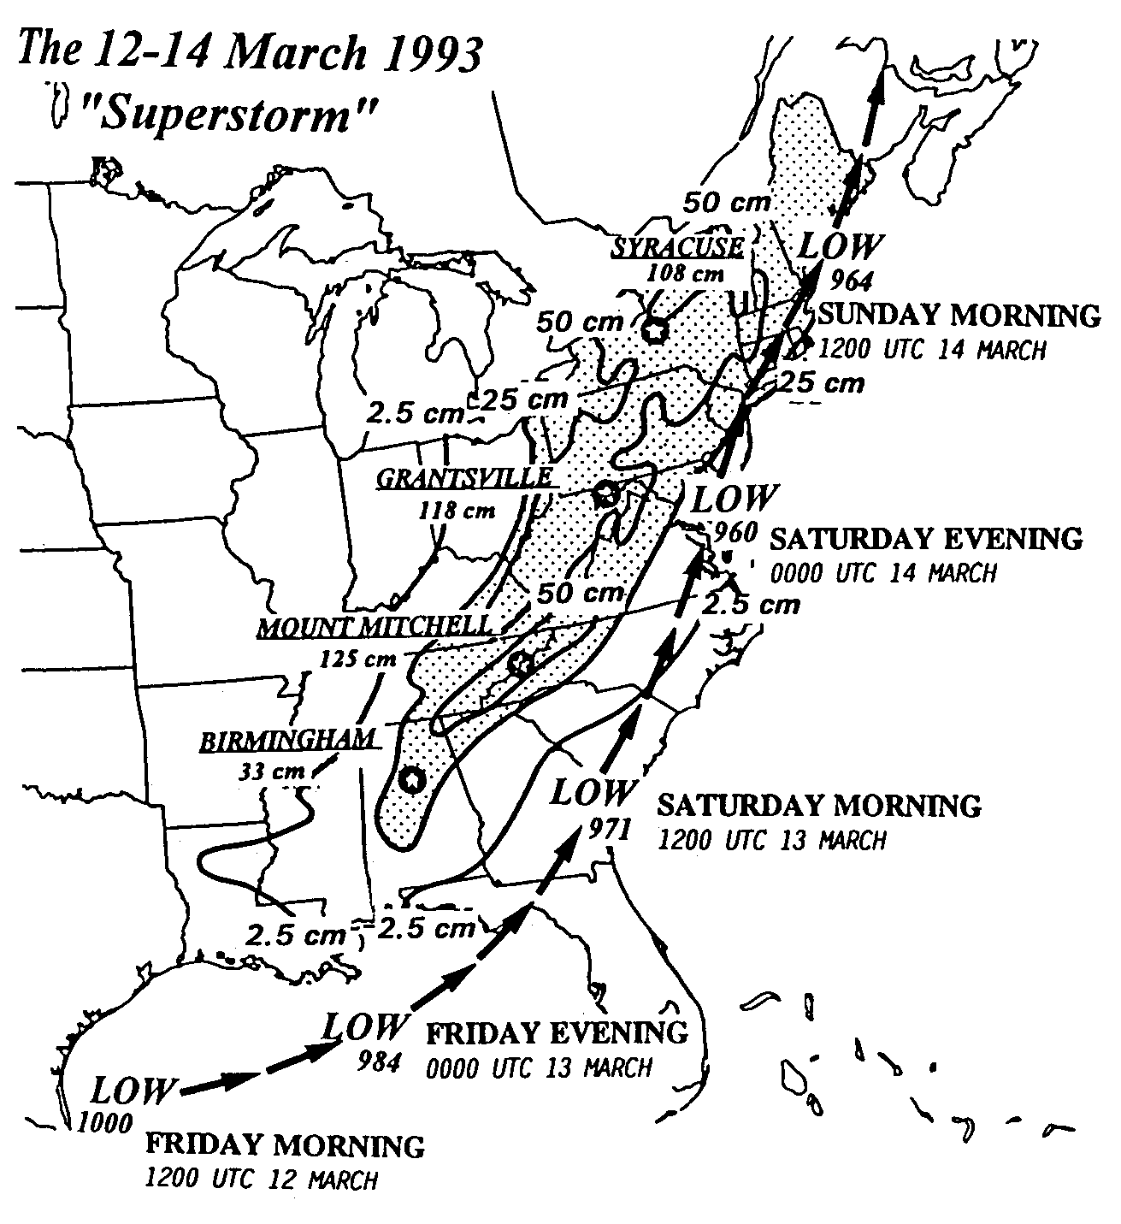
Figure 13.18. The path of the “Storm of the Century” on March 12-14, 1993, along with the total amount of snowfall reported across the southern and eastern United States. [From p. 327 of Life Cycles… Will definitely want to convert cm to inches (2.5 cm = 1 inch). Times could be changed into Eastern time (1200 UTC = 6 AM Eastern). Artists may want to redraft and do a better job than the original here… not a very clean figure. Washington should be indicated.]

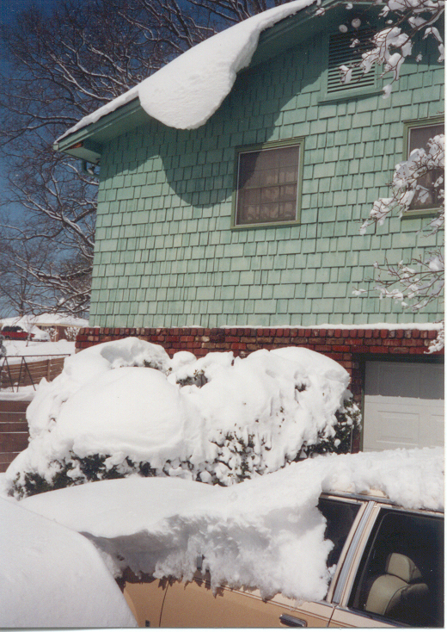
Figure 13.19. The “Storm of the Century” in the hills of Birmingham, Alabama. Wet, wind-driven snow is defying gravity and hanging off the roof of the co-author’s boyhood home. The deep blue sky at top left is a sign of the rapidly sinking and drying air of the intense anticyclone that followed the storm. The record snow led to massive power outages that cut off heat to tens of thousands of homes in Alabama, including this one.

Figure 13.20. [I need a visually impressive photo of Washington, D.C. during this storm. Can the artists help?]

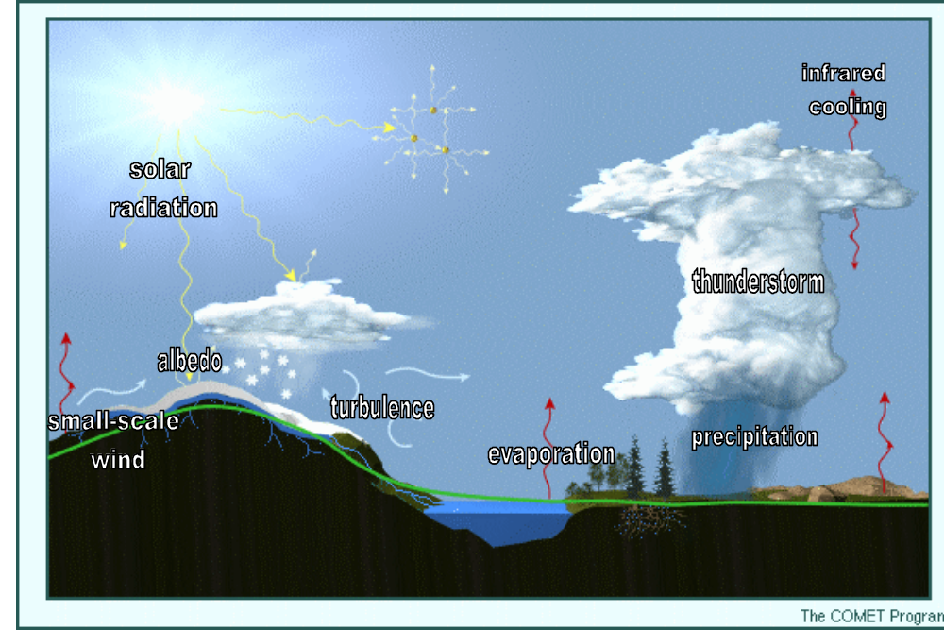
Figure 13.21. About twenty different meteorological processes in this figure require parameterization in forecast models because they are too small and/or too complicated for the models to treat exactly. A few parameterized processes are labeled above. Figure modified from one provided by Dr. Stephen Jascourt, NCEP. [See http://deved.meted.ucar.edu/nwp/pcu1/ic1/2_2.htm
(at least for now). We’d want to omit the more obscure aspects, particularly the aerosols in the top middle part of the diagram. Otherwise, keep more or less as-is.]

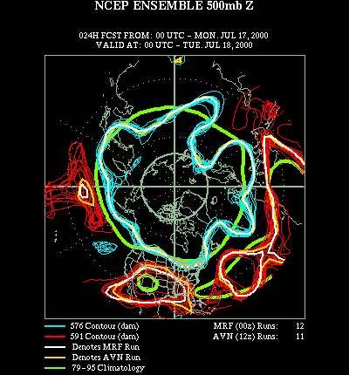
Figure 13.22. An NCEP ensemble forecast 24 hours into the future, valid for 6 PM Eastern time, July 17, 2000. The aqua and red lines represent two different contours on 500-mb maps of the 23 different model runs that comprise the ensemble. The differences between the different aqua lines, and the differences between the red lines, are a measure of the amount of uncertainty (and chaos) in the forecast. Confidence in the forecast is high, particularly in the polar latitudes extending as far south as the Great Lakes region. The heat-wave high over Texas and New Mexico is also predicted to continue the next day with a high degree of confidence. Lower confidence exists for the forecast south and west of Alaska, where the red lines and blue lines both show more separation. Figure courtesy NCEP/Climate Analysis Center. [ARTISTS: See Aguado and Burt, 2nd edition, p. 360 for some guidance on what this should more-or-less look like.]
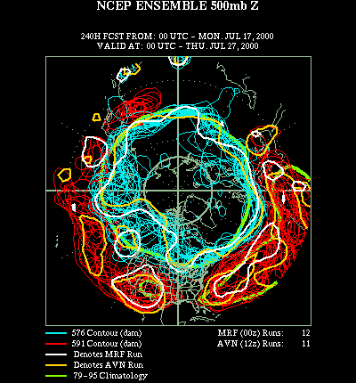

Figure 13.23. As in the previous figure, but for a 10-day forecast. Notice the increased differences in the aqua and red lines versus Figure 13.22. Ten-day forecasts almost always have lower confidence than 1-day forecasts. Figure courtesy NCEP/Climate Analysis Center.

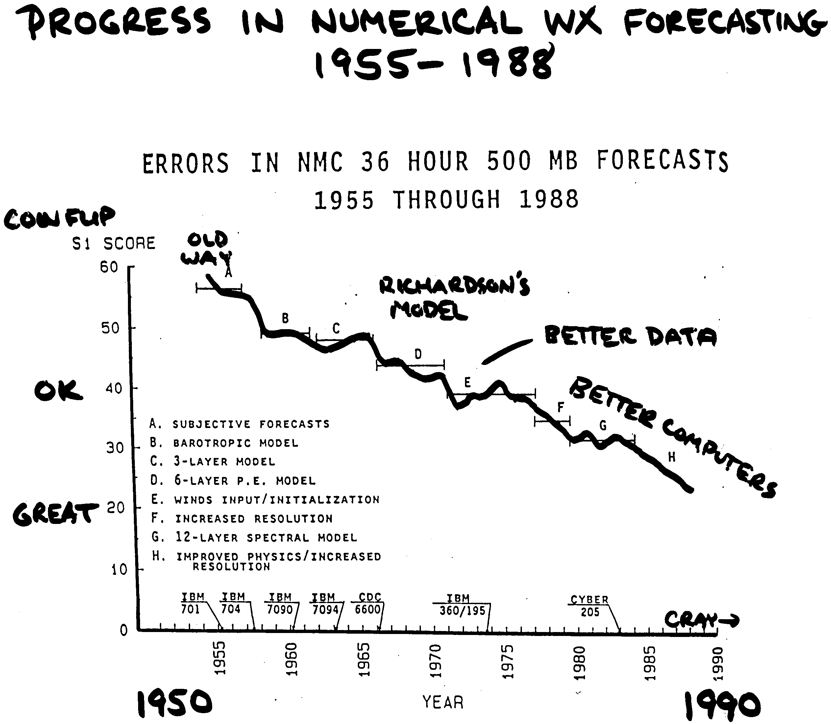
Figure 13.24. Errors in NMC 36-hour forecasts at 500 mb from 1955-1990. Notice the steady decline in errors since the introduction of numerical models in the late 1950s. [ARTISTS: Figure adapted/scribbled on from p. 320 of Life Cycles… Keep the stuff I wrote in and omit the computer names and the A through H list and the corresponding brackets on the figure. Omit title as well. For guidance, use Figure 12-7, p. 288, of the 7th edition of Lutgens and Tarbuck when redrafting, except I prefer the curve to show decreasing errors, not increasing skill. If you use Lutgens’ terminology, change Lutgens’ terminology accordingly: “subjective” to “human”; omit “geostrophic model”; change “hemispheric model” to “Richardson’s model”; change “winds input” to “data initialization”; change “model resolution” to “spectral model”; change “model physics” to “better parameterizations”.]

The very latest numerical models actually compress and combine the steps that follow. To understand the overall approach, however, we keep each step distinct—as was the case for all models until recently.
Richardson, like Forrest Gump or Kilroy, seems to be everywhere. One of your authors learned this the hard way recently when he was doing some obscure mathematical research. He published an equation that the world’s math scholars and researchers hailed as new to the world. A year later, he received an e-mail from France noting that the same equation had been discovered in 1927 by… Lewis Fry Richardson.

