Applications with New Multi-spectral Environmental Remote Sensing Satellites – Ostuni School
Menzel & Antonelli
Quiz 1
12 June 2006

Name:_________________________________________

1. The earth-atmosphere spectrum for a given scene is depicted in the figure below:

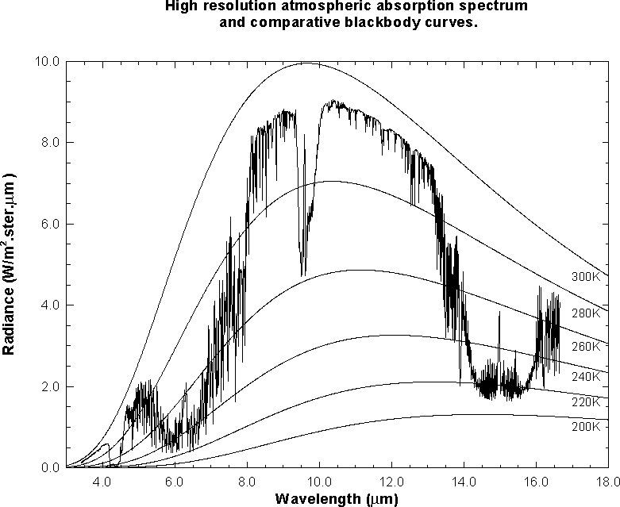

T F The plateau between abscissa values 10.5 and 12 um is a window region of the atmosphere.
T F The tropopause temperature for this scene is roughly 220 K.
T F In this scene, clouds are affecting the 7.5 to 8 um region of the spectrum and thus reducing
the brightness temperature.
T F For a clear scene BT(13.9 um) is typically colder than BT(13.3 um) because of CO2
absorption.
T F A given percentage increase in temperature produces a larger percentage increase in the
Planck radiance at 11 um than at 4 um.

2. If the albedo (cloudiness) of the earth increases from 33% to 50%, what is the corresponding change in the earth effective temperature (from 255 K to what)?. Use Stefan’s law (irradiance is proportional to T⁴) to help you derive your answer.

3. In the scatter plot of BT(11um) on the x-axis and [r(1.6um)-r(.6um)] / [r(1.6um)+r(.6um)] on the y-axis, associate A, B, and C with the feature in the scene (draw a line to the best association)
snow covered land A
non snow covered land B
cloud C



