Laboratory Exercises

for

REMOTE SENSING APPLICATIONS WITH
METEOROLOGICAL SATELLITES

by

W. Paul Menzel
Paolo Antonelli
Kathy Strabala
Liam Gumley



Space Science and Engineering Center
University of Wisconsin
Madison, WI



© 2008 W. Paul Menzel

TABLE OF CONTENTS Pg

Lab 1 – Planck Function 5
Lab 2 – Introduction to HYDRA 8
Appendix – Summary of HYDRA Commands 13
Lab 3 – Multispectral investigations of land, ocean, and atmosphere with MODIS 16

Lab 4 – Staging, Viewing, and Interrogating AIRS Data 26
Lab 5 – Exploring Spectral Properties of Clouds, Moisture, and Volcanic Ash with AIRS 30
Lab 6 – Fire Detection 35
Lab 7 – Investigating Aerosols with MODIS 38
Lab 8 – Dust Detection with MODIS and AIRS 40

Lab 9 – Cloud Phase Determination with MODIS 43
Lab 10 – Sea Surface Temperature and Sediment Concentration 45

Lab 11 – Exploring the AMSU-A Split Window 49

Lab 12 – Combining AMSU Precipitation Estimates and SEVIRI Convection Detection 53

Lab 1 – Planck Function
Gumley / Menzel

1. Open the Planck Tool and familiarize yourself with the display (see Figure 1 below) which opens with energy/time/area/solid angle/wavelength for a 6000 K target (e.g. the Sun).

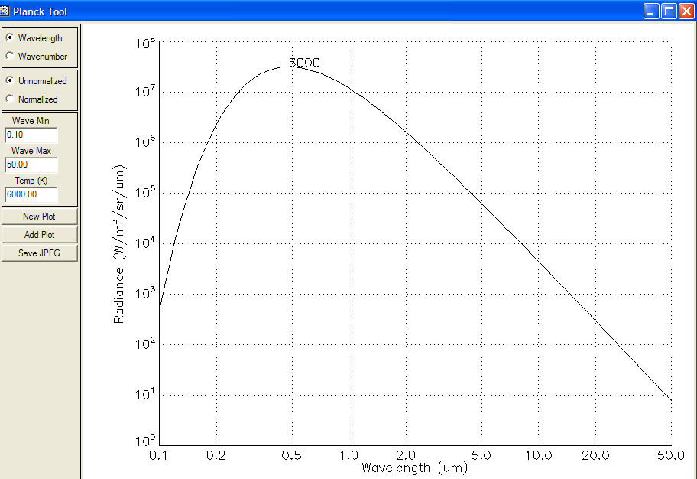

Figure 1: Planck Tool default display; note that the temperature label is placed near the peak of the Planck curve.

1a. Add plots for 4000, 1000, 500, 300, and 200 K.

1b. Verfiy Wiens Law that λmax (cm) = .3 / T (deg K)

1c. Verify that B(λmax, T) ∝ T⁵ . What does this imply about incoming solar versus outgoing terrestrial radiances as represented by B(0.5 μm, 6000 K) / B(10 μm, 300 K)?

1d. Inspect the 6000 K and 300 K curves and establish that ∫ B(λ, T) dλ ∝ T⁴ as Stefans Law requires.
λ_{max} ∞
1e. Inspect the 6000 K curve and verify that ∫ B(λ, T) dλ ~ 1/3 ∫ B(λ, T) dλ.
0 0
2. Using wavenumbers (instead of wavelengths) restart the Planck Tool. Use wave min = 0.1 cm-1, wave max = 20000 cm-1, and T = 1000 K.

2a. Add plots for 500, 300, and 200 K.

2b. Verfiy Wiens Law that νmax (cm-1) = 2 * T (deg K)

2c. Verify that B(νmax, T) ∝ T³ .

2d. Inspect your curves and establish that ∫ B(ν, T) dν ∝ T⁴ as Stefans Law requires.

3. Start a new plot for B(λ, 6000 K) and add B(λ, 300 K). Display these two plots in normalized radiances units.

3a. Where do the two plots overlap. What does this tell you about the possible origin of radiation at these wavelengths when sensed with a satellite radiometer?

4. Start the Planck Calculator. Familiarize yourself with the commands.

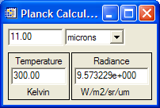

Figure 2: Planck Calculator display

4a. Make a plot of B(10 μm, T) / B(10 μm, 270 K) for terrestrial temperatures (e.g. 200, 220, 240, 260, 280, 300, 320 K). Record the values from the Planck calculator and plot them on a graph.

4b. Make a plot of B(4 μm, T) / B(4 μm, 270 K) for terrestrial temperatures (e.g. 200, 220, 240, 260, 280, 300, 320 K). Record the values from the Planck calculator and plot them on the same graph.

4c. Make a plot of B(0.3 cm, T) / B(0.3 cm, 270 K) for terrestrial temperatures (e.g. 200, 220, 240, 260, 280, 300, 320 K). Record the values from the Planck calculator and plot them on the same graph.

4d. Temperature sensitivity, a, is defined by dB/B=a*dT/T. This is a measure of the percentage radiance change versus the percentage temperature change. Use the Planck calculator to determine the temperature sensitivity at 200 and 300 K for the shortwave (4 μm) and longwave (10 μm) infrared windows? Does this agree with your graph from 4a and 4b? Which window is most sensitive to changes in the earth surface temperature?

5. Consider a field of view (FOV) with a fraction N containing cloud at 200 K and (1-N) containing earth surface at 300 K in clear sky. The brightness temperature for this FOV is given by

BT(10 μm, N) = B⁻¹[N*B(10 μm, 200 K)+(1-N)*B(10 μm, 300 K)].

5a. Using the Planck calculator make a plot of the brightness temperatures BT(10 μm, N) for N = 0.0, 0.2, 0.4, 0.6, 0.8, and 1.0. Do the same for BT(4 μm, N) on the same plot. Does this suggest a test for broken or scattered clouds?

5b. Using the Planck calculator determine the radiances at 8, 11, 12 μm for a scene of clear sky at 300 K and a cloud at 230 K with varying cloud amount. Let the cloud fraction vary from N = 0.0, 0.2, 0.4, 0.6, 0.8, and 1.0. Convert the radiances to brightness temperatures. Plot brightness temperature differences 8 - 11 versus 11 - 12 for the six different cloud fractions.
Lab 2 – Introduction to HYDRA as a tool to view multispectral data
Menzel / Antonelli

Table 1: MODIS Channel Number, Wavelength (μm), and Primary Application

MODIS Reflected Solar Bands |  |  | MODIS Thermal Emissive Bands
Band | Wavelength (micron) | Primary application | Band | Wavelength (micron) | Primary application
1,2 | 0.645, 0.866 | Land, Clouds | 20-23 | 3.75(2), 3.95, 4.05 | Surface / cloud temperature
3,4 | 0.470, 0.555 | Land, Clouds | 24,25 | 4.46, 4.51 | Atmospheric temperature
5-7 | 1.24, 1.64, 2.13 | Land, Clouds | 27,28 | 6.71, 7.32 | Water vapor
8-10 | 0.415, 0.443, 0.490 | Ocean color | 29 | 8.55 | Surface / cloud temperature
11-13 | 0.531, 0.565, 0.653 | Ocean color | 30 | 9.73 | Ozone
14-16 | 0.681, 0.750, 0.865 | Ocean color | 31,32 | 11.03, 12.02 | Surface / cloud temperature
17-19 | 0.905, 0.936, 0.940 | Water vapor | 33,34 | 13.33, 13.63 | Cloud top properties
26 | 1.375 | Cirrus clouds | 35,36 | 13.93, 14.23 | Cloud top properties

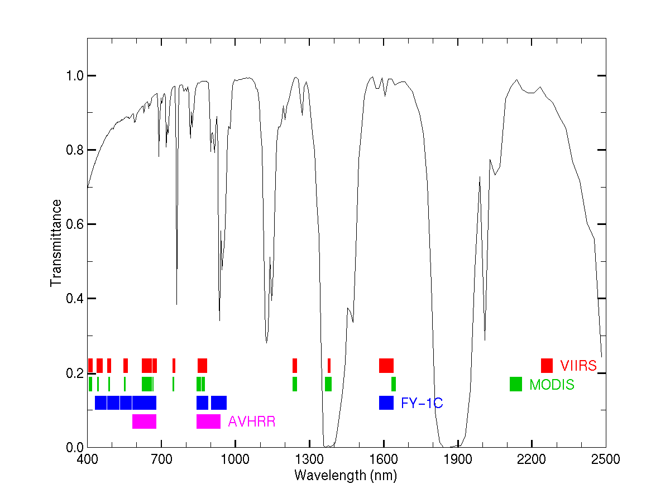

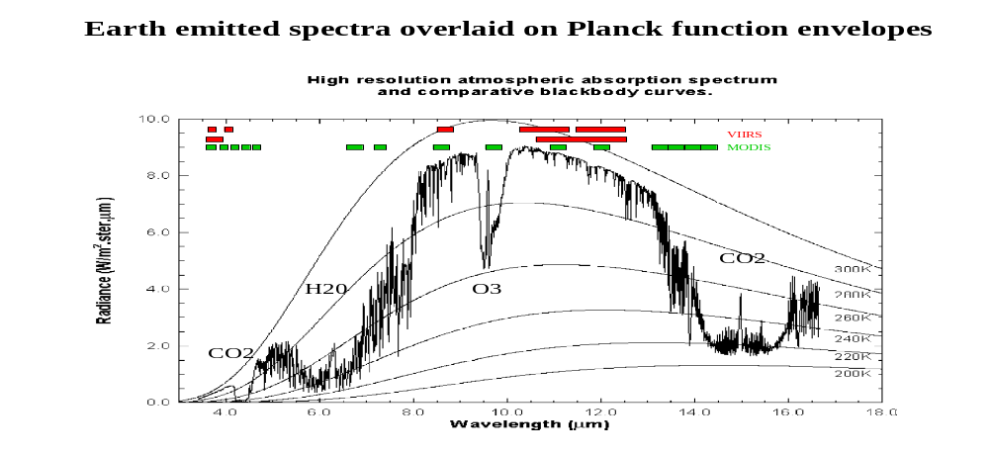Figure 1: Visible and Infrared absorption features and MODIS spectral band locations

1. Inspect the scene over Italy on 29 May 2001 detected by MODIS using HYDRA (see the attached instruction sheet explaining how to run HYDRA). After engaging HYDRA the HYDRA window appears (Figure 2a). To load a MODIS Level-1B 1KM file from disk, click on “data | local” and select the file to be loaded (e.g., MOD021KM.A2001149.1030.003.2001154234131.hdf). When the file is loaded, an image of the 11 μm radiances appears, as shown in Figure 2b.

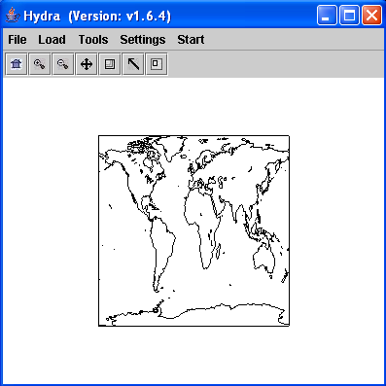

Figure 2a: The HYDRA window.

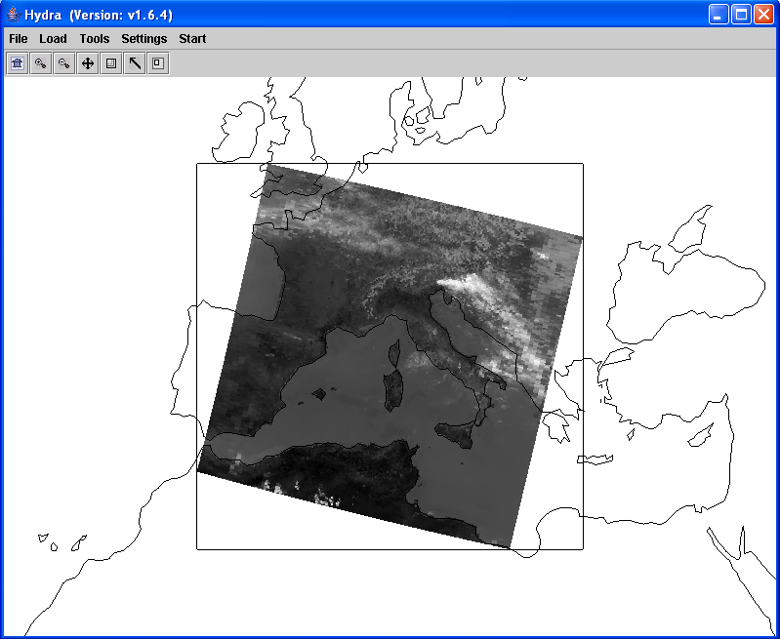

Figure 2b: HYDRA window with a MODIS L1B 1KM file loaded.

1a. Get familiar with the command menu Settings. Band 31 (11 μm) is automatically displayed at reduced resolution. Try different black and white enhancements by adjusting the color range (Set Color Range). Use the toolbar at the top to zoom in and zoom out and translate the image. Reset the image. Display the image in color and try different color enhancements.

2. Start the Multichannel Viewer. Display the data at full resolution by selecting a subset of the data displayed in the Hydra window (right most icon in toolbar in the Hydra window). The one kilometer resolution data will appear in the Multichannel Viewer window (see Figure 3). Zoom in on island of Sardinia west of Italy in the Multi-Channel Viewer window and in the Hydra window – compare the resolution in the images. Use the arrow icon at the bottom of the Multichannel Viewer window to scroll around in the full resolution image – locate the lat & lon of the min and max brightness temperature values in the image.

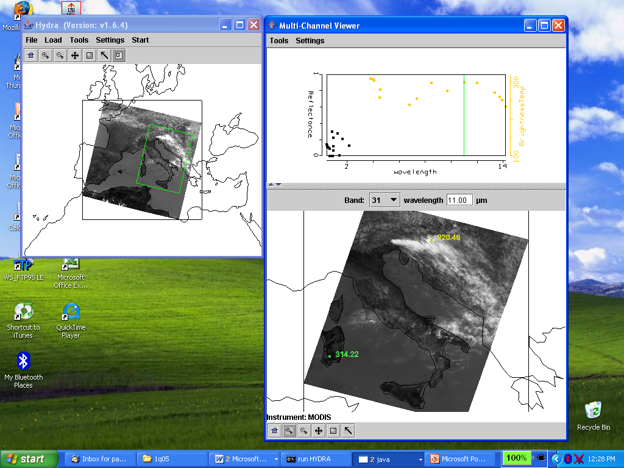

Figure 3: One kilometer resolution data displayed in the Multichannel Viewer window

3. Now select Band number 20 (3.8 μm) and display the image. Note how much warmer the 3.8 μm (band 20) brightness temperatures (BT) are than those for 11 μm (band 31). What can be responsible for this? Create an image of 3.8 μm brightness temperatures (BT3.8) allowing the range of values to span 270 to 310 K (using Set Color Range under Settings). Do the same for 11 μm (BT11). Create a power point slide with the two images side by side. Note how the clouds are much larger in the 11 μm image. Can you explain why?

4. Display a Reference Spectrum (under Tools). Compare the brightness temperature spectra in some locations near the shoreline (over land and sea) in northwestern Italy. Note the patches where the BT3.8 is much greater than BT11. What could be causing this?
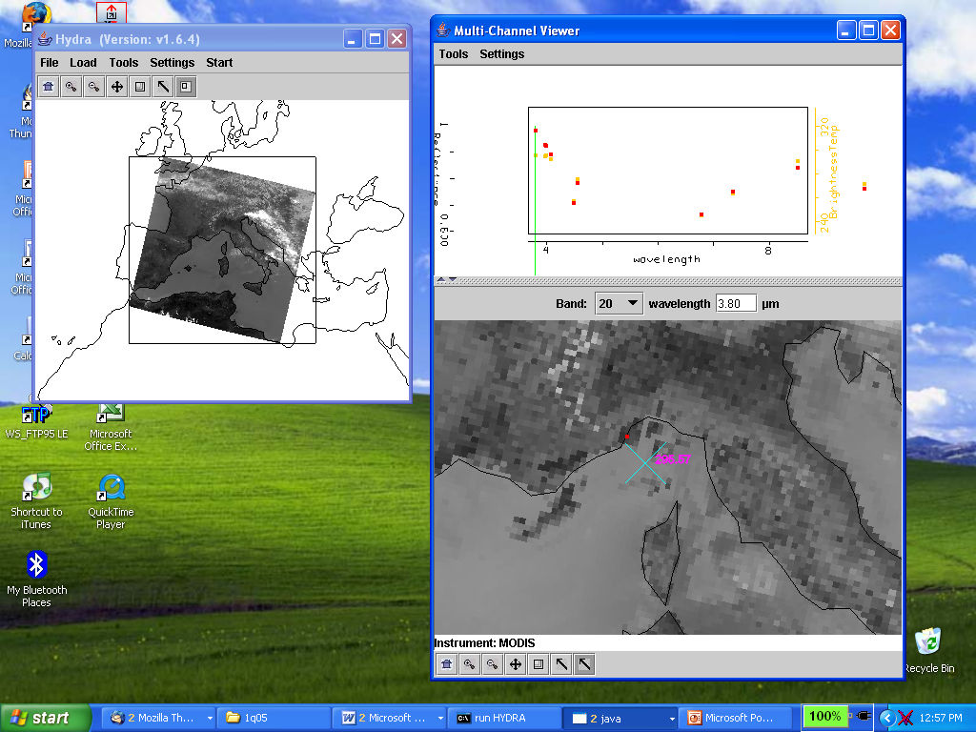

Figure 4: Multichannel Viewer window display of reference spectrum.

5. Display a Transect (under Tools) in the 3.8 μm image going through clouds, sea, and desert (see Figure 5). What are the min and max brightness temperatures encountered. Do the same for 11 μm (note both transects can be overlaid by clicking on Settings in the Transect window and enabling last two). Discuss the difference.

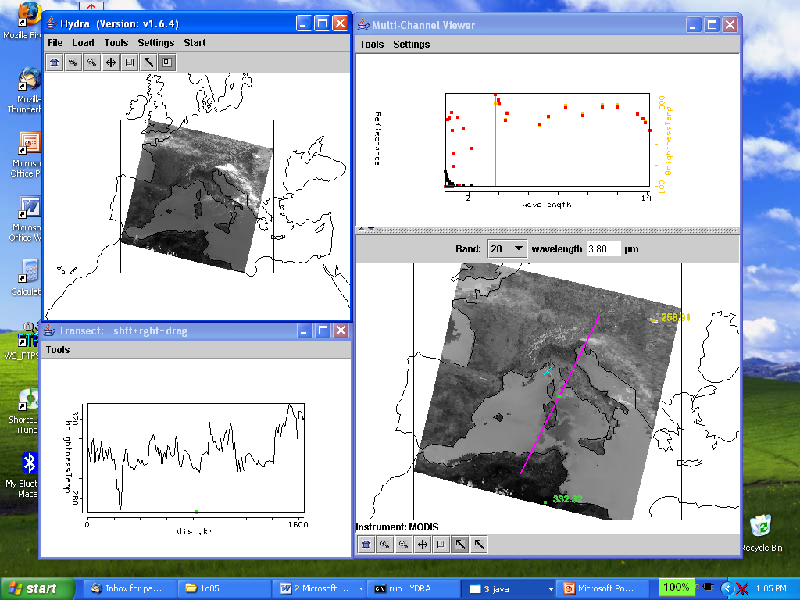

Figure 5: Brightness temperature transect of line displayed in Multichannel Viewer window

6. Open Linear Combinations (under Tools) and display 0.55 μm reflectances (r0.55) on the y-axis and 11 μm brightness temperatures (BT11) on the x-axis of a scatter plot (see Figure 6). Using the color areas boxes (or curves to encircle areas), highlight pixels in the scatter plot and find where they are located in the images. Save your scatter plot and associated images on a power point slide. Explain high / low reflectances and cold / warm brightness temperature combinations in the notes section of the powerpoint slide. Construct the same scatter plot with radiances (W/ster/m2/μm) instead of reflectances and brightness temperatures.

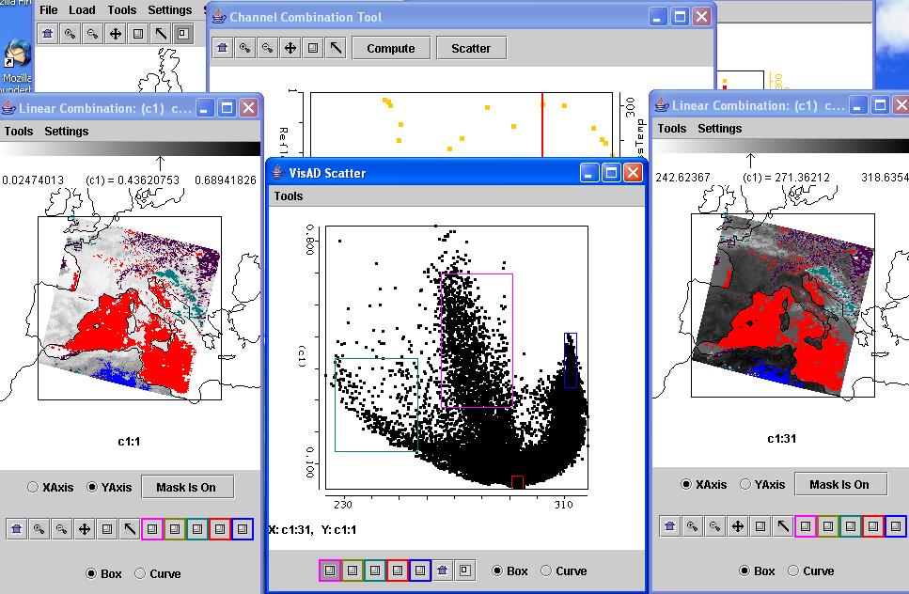

Figure 6: Scatter plot of vis reflectance on y-axis and IRW BT11 on x-axis

7. Using the Linear Combinations window, create an image of the difference of BT3.8 minus BT11. Display the difference image in color. Use set color range under Settings to enhance features in various regions. Save this on a power point slide. Suggest three causes for the large differences for these two window channels? Explain.

8. In the notes section of the three power point slides created for exercises 3, 6, and 7 explain the features you see. Identify regions of ice clouds, ocean sun glint, coastal fog, desert, and snow.
Appendix – Summary of HYDRA Commands

HYDRA main window
Displays a world map and shows File, Load, Tools, Settings, and Start at top.

File offers
Exit to closes this window

Load has the options
Local Data allows you to search local directories to find MODIS, AIRS, GOES or
Meteosat data.
Remote Data allows you to get data from a remote server
(a) Terra or Aqua Direct Broadcast or (b) Goddard DAAC
GOES/MSG allows you to get geostationary satellite data from an ADDE server
Lidar allows you to display Calipso lidar data
AREA allows you to display McIDAS area files
After a data granule is selected HYDRA displays the infrared window (at reduced resolution 4 km for MODIS) on a world map.

Tools offers
Capture Display to save the image as a jpeg

Settings has
Set Color Range where the histogram of brightness temperatures or radiances can
be adjusted to maximize contrast – the color range can be altered with a
right click plus drag at either end of the color scale
Set Color Scale where Color, Gray and Inverse Gray gives choice of color, grey,
or inverse grey (which produces white clouds for infrared channels)

The toolbar at the top enables reset, zoom in, zoom out, translate, box magnify, find location, and subset at full resolution functions
Reset (left click on reset and then click on image to restore original image)
Zoom in (left click on zoom in plus click on image enables enlargement)
Zoom out (left click on zoom out plus click on image enables far view)
Translate (left click on translate plus click on image enables moving the image
within the window)
Rubber band zoom (left click on box plus click and drag to create box for enlargement)
Find location (left click on arrow plus click on image displays location of the
chosen pixel)
Subset of image at full resolution (only after Multi-Channel Viewer is engaged, then left
click on subset plus click and drag on image creates a subset of image at full resolution; this is automatically transferred from HYDRA into the Multi-Channel Viewer when both are engaged – data is displayed at reduced resolution by default unless subset function is used)

Start opens Multi Channel Viewer
wherein the measured spectra (wavenumber on x-axis and radiance or brightness
temperature on y-axis) is displayed along with a spectral band superimposed on a world map. Left click on arrow icon in the bottom toolbar allows you to see the pixel value for a given lat-lon (using left click and drag).

Tools menu (appears in Multi-Channel Viewer window)
Linear Combinations opens the Channel Combination Tool display where you
can specify linear combinations of spectral bands a,b,c and d
(a +-x / b) +-x / (c +-x / d).
RGB allows you to select a spectral channel for each color in the RGB display
Transect allows you to create a line on the image and see the temperatures or
radiances along the transect marked by shift plus right click and drag.
Capture Display allows you to save the image as a jpeg
Statistics displays the min and max values in the image
Reference Spectrum allows you to compare spectral measurements from two
selected pixels (controlled by the arrows in the bottom toolbar)

Settings (on the Viewer) has
Set Color Range where the histogram of brightness temperatures or radiances can
be adjusted to maximize contrast – the color range can be altered with a
right click plus drag at either end of the color scale
BT->radiance allowing you to toggle from brightness temperatures to radiances
in the infrared spectral channels
Projection offers Lambert Equal Area or Instrument projections of the data
Set Color Scale where Color, Gray and Inverse Gray gives choice of color, grey,
or inverse grey (which produces white clouds)
Lat/Lon Grid can be superimposed on the image by using the toggle
Image Label labels the image with the instrument and day/time of the data

Import offers the opportunity to display lidar data (from Calipso)

The Channel Combination Tool (opened when Linear Combinations is selected) offers the usual tool bar and
Compute to create an image of the selected linear combination (you can
indicate at the bottom your preference for this linear combination to be on
the x- or y-axis in the scatter plot) and displays a toolbar for image
manipulations (five color boxes are available in the toolbar to select
regions by boxes or curves in the image that will be displayed in the
scatter plot; a left click drag in the image highlights the chosen points in
the scatter plot).
Scatter creates a scatter plot of the chosen x- and y-axis linear combinations. Five
color area boxes (or area curves) in the bottom toolbar of the scatter plot
allow you to select points in the scatter plot that will be displayed in the x-
axis and y-axis images; a left click drag in the scatter plot highlights the
chosen points in the scatter plot and simultaneously in the x- and y-axis
images. Conversely (as indicated before) left click drag in the x- or y- axis
images shows the locations of the chosen pixels in the scatter plot. Each
color area box (or area curve) can be erased with a left click when the
color box is engaged; after erasure another area box (or area curve) can be
selected for this color. The zoom capability in the scatter plot (on the
bottom right of the toolbar) allows you to enlarge special features in the
scatter plot and investigated them in more detail.

After engaging version 1.8.x of HYDRA, the HYDRA window appears. To load a MODIS Level-1B 1 km resolution file from disk, click on “data | local” and select the file to be loaded (e.g., MYD021KM.A2004144.0510.004.2004145120621.hdf to load the 29 May 2001 data set). When the file is loaded, an image of the 11 μm radiances appears.

Vewing Level 2 Products

When viewing level 2 products (staged in a separate file), HYDRA generates a display of that product. Current choices include the cloud mask (from MOD35), total column ozone and water vapor (from MOD07), cloud top properties (from MOD06), and AIRS profile retrievals (generated using a statistical regression retrieval algorithm trained with AIRS spectra calculated from radiosonde observations).

When viewing MOD07 or AIRS profiles, Variables offers the choice to display
air temperature profiles
total ozone
precipitable water
surface temperature
water vapor profiles
surface pressure
ozone profiles

Levels offers 17 levels between 1100 and 50 hPa for the retrieval field display.

Settings offers a choice to Set Color Range, Set Color Scale, and Show Color Bar. The last choice enables superposition of a color bar label that identifies the values of the product associated with each color.

Tools offers the option of Reference Profile that allows you to compare level 2 products from two selected pixels (controlled by the arrows in the bottom toolbar where the red dot indicates the location of the second profile) and Transect that allows you to construct a transect across the level 2 product image.
Lab 3 – Multispectral investigations of land, ocean, and atmosphere with MODIS
Strabala / Menzel

Table 1: MODIS Channel Number, Wavelength (μm), and Primary Application

MODIS Reflected Solar Bands |  |  | MODIS Thermal Emissive Bands
Band | Wavelength (micron) | Primary application | Band | Wavelength (micron) | Primary application
1,2 | 0.645, 0.866 | Land, Clouds | 20-23 | 3.75(2), 3.95, 4.05 | Surface / cloud temperature
3,4 | 0.470, 0.555 | Land, Clouds | 24,25 | 4.46, 4.51 | Atmospheric temperature
5-7 | 1.24, 1.64, 2.13 | Land, Clouds | 27,28 | 6.71, 7.32 | Water vapor
8-10 | 0.415, 0.443, 0.490 | Ocean color | 29 | 8.55 | Surface / cloud temperature
11-13 | 0.531, 0.565, 0.653 | Ocean color | 30 | 9.73 | Ozone
14-16 | 0.681, 0.750, 0.865 | Ocean color | 31,32 | 11.03, 12.02 | Surface / cloud temperature
17-19 | 0.905, 0.936, 0.940 | Water vapor | 33,34 | 13.33, 13.63 | Cloud top properties
26 | 1.375 | Cirrus clouds | 35,36 | 13.93, 14.23 | Cloud top properties

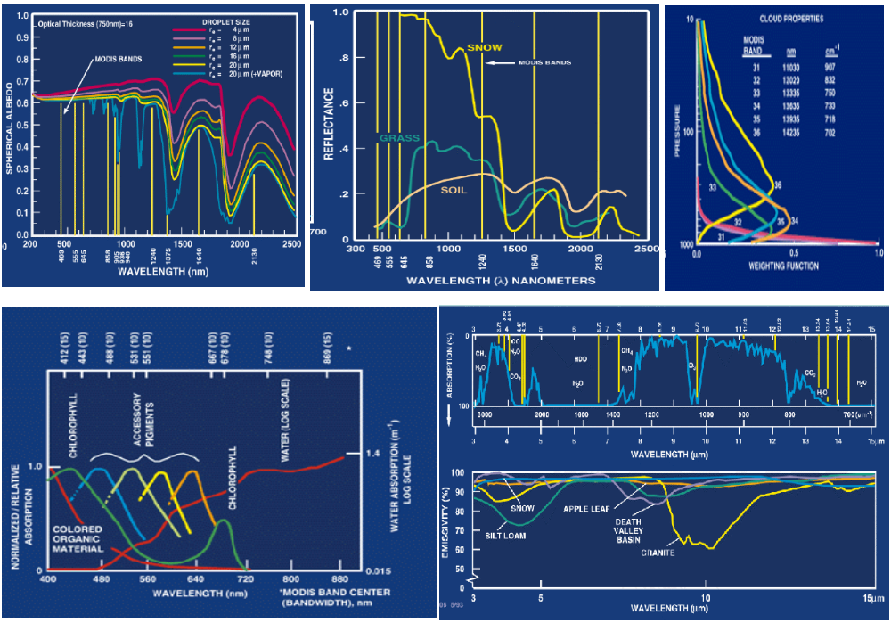

Figure 1: Spectral signatures from land, ocean, and atmosphere

1. Use Hydra to analyze the scene over Italy on 29 May 2001 detected by MODIS (find MOD021KM.A2001149.1030.003.2001154234131.hdf and load it into Hydra). Browse through the scene in several different wavelengths in the Multi-Channel Viewer window. Look at the scene both in BT and radiances (use BT > radiance under Settings):

1a. Verify that the surface features are distinguishable in the infrared window channels while in the infrared absorption channels they are not.

1b. Explore the image in various spectral bands.
i. Look at snow in the Alps in 0.65 and 1.6 μm.
ii. Look at clouds and vegetation in northern Italy in 0.65 and 0.86 μm.
iii. Look at near shore waters in 0.55 and 0.45 μm.

2. Use Linear Combination to stage the vegetation index that is based on the relatively low leaf and grass reflectance from spectral bands below 0.72 μm and relatively high reflectance from spectral bands above.

2a. Construct a pseudo image of normalized vegetation index NDVI = [Band 2 (0.86μm) – Band 1 (0.65μm)] / [Band 2 (0.86μm) + Band 1 (0.65μm)] using Compute. Adjust the contrast using set color range under Settings. Can you discriminate regions with some vegetation from those with little or no vegetation? What are the NDVI values in regions without significant vegetation; what are they in vegetated regions? Create a color image of NDVI and save it in a ppt slide. Make a transect of BT11 through vegetated to non-vegetated clear skies. Save in a ppt slide. What can you say about the BT11 in vegetated versus non-vegetated pixels?

2b. Create an image of Band 31 (11.0 μm) using Compute. Map the NDVI values from 2a on the Y axis (by clicking the Y axis button) against Band 31 (11.0 μm) on the X axis (by clicking the X axis button). Click on Scatter to generate a scatter plot of the chosen variables. Select different regions in the scatter plot (see Figure 2) and look at the corresponding points in the x and y-axis image displays.

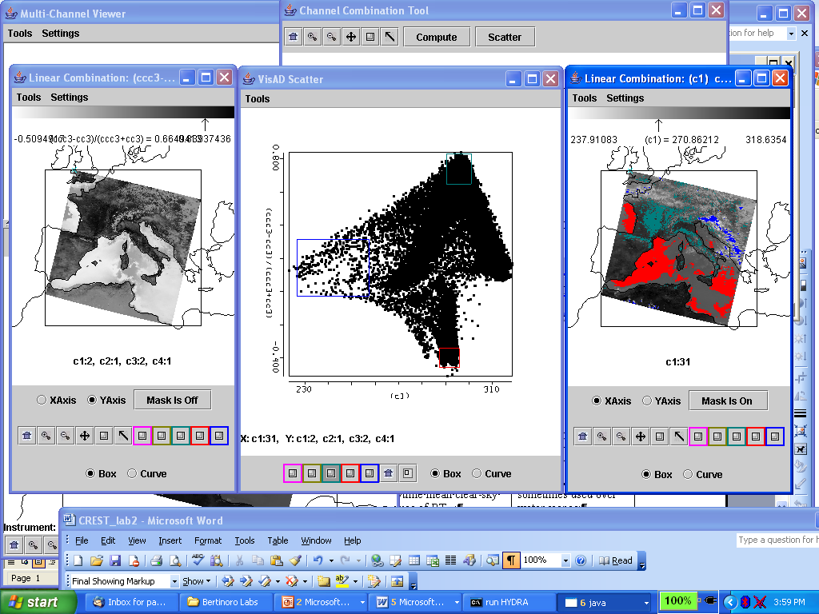

Figure 2: Scatter plot of NDVI (left image & y-axis) versus BT11 (right image & x-axis)

3. Look at several different clouds in different reflective bands. For each cloud (by selecting a single Field Of View) describe the changes in reflectance for different channels (top panel of Multi-channel viewer window). Now look at the clouds in different thermal emissive bands. For each type (by selecting a single Field Of View) describe the changes in radiance detected in different channels (top panel of Multi-channel viewer window).

4. In the Hydra window select the following region (outlined approximately by green box in Figure 3) to display 1 km resolution data of the Alps and northern Adriatic Sea.

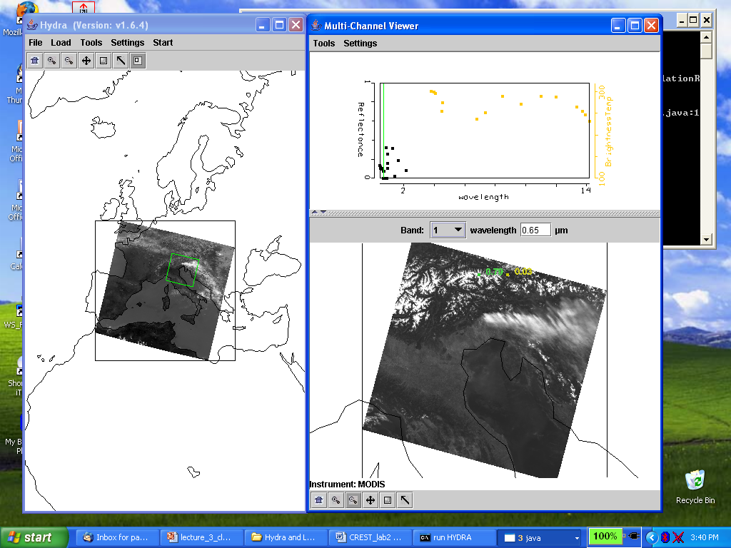

Figure 3: Subset selected for full resolution analysis of snow, clouds, and clear sky (left). Full resolution visible image of subset selected (right).

4a. Investigate the radiances emanating from the cloud within the scene in different wavelengths; look at the following bands
Band 1 (0.65 μm) – clouds and snow reflecting
Band 2 (0.86 μm) – contrast between vegetation and clouds diminished
Band 26 (1.38 μm) – only high clouds and moisture detected
Band 6 (1.64 μm) – water clouds reflecting, snow and ice clouds not reflecting
Band 20 (3.7 μm) – thermal emission plus solar reflection
Band 31 (11 μm) – clouds and snow colder than rest of scene
Band 35 (13.9 μm) – only upper atmospheric thermal emission detected.

4b. Using Linear Combination to combine spectral bands that can be used to detect clouds and to infer cloud properties. Try the following band combinations (by entering the suggested wavelengths in the colored boxes), and for each combination click on the compute button.
Band 2 (0.86 μm) / Band 1 (0.65 μm)
[Band 1 (0.65 μm) - Band 6 (1.6 μm)] / [Band 1 (0.65 μm) + Band 6 (1.6 μm)]
(Band 29 (8.6 μm) - Band 31 (11.0 μm)
(Band 31 (11.0 μm) - Band 32 (12.0 μm)

4c. Map each of the above linear combinations on the Y axis (by clicking the Y axis button) against Band 31 (11.0 μm) on the X axis (by clicking the X axis button). Using Scatter to open a scatter plot, estimate what threshold values you would use in each test to indicate the presence of clouds? Select different regions in the scatter plot window and look at the corresponding points (shown in the linear combination window).

4d. Look at the scatter plot of [Band 29 (8.6 μm) - Band 31 (11 μm)] versus [Band 31 (11 μm) - Band 32 (12 μm)]. Find where the largest differences occur in each image. Are there clouds in these brightness temperature difference images that could not be seen in the visible images?

5. Compare with the MODIS product files.

5a. Load the MODIS cloud mask (find the MOD35 file) using Hydra. How does the cloud mask compare with your own tests for cloud presence? Find three locations where you disagree and explain why you think the cloud mask is in error.

5b. Load the MODIS cloud phase product (find the MOD06 file) using Hydra. How does the cloud phase product compare with your own tests for cloud water / ice. Find three locations where you disagree and explain why you think the cloud product is in error.

6. Back in HYDRA sub-select the region shown in Figure 4a. Compare the cloud depiction at 0.65 and 11 μm.

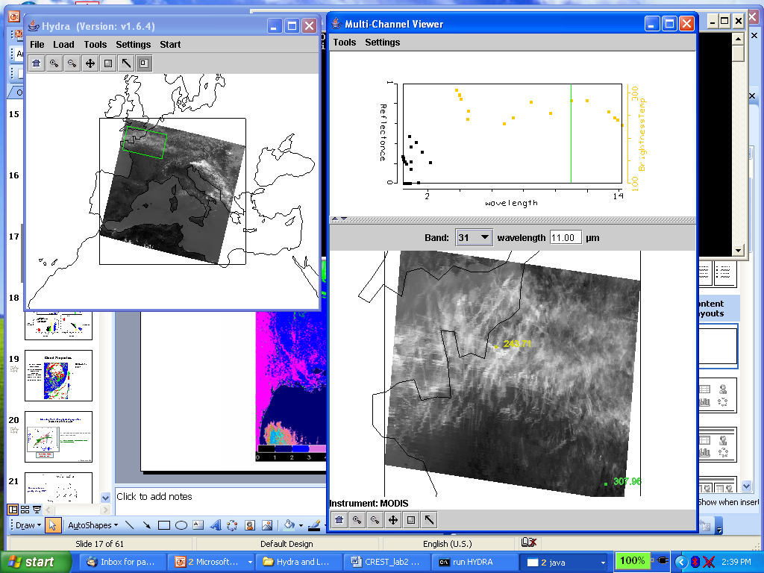
Figure 4a: Cirrus clouds and clear sky

6a. Generate a scatter plot of Band 31 on the x-axis and Band 29 – Band 31 on the y-axis. Now you can select a rectangular region on the scatter plot and look at the images to determine the location of the selected points in the pseudo-images (See Figure 4b).

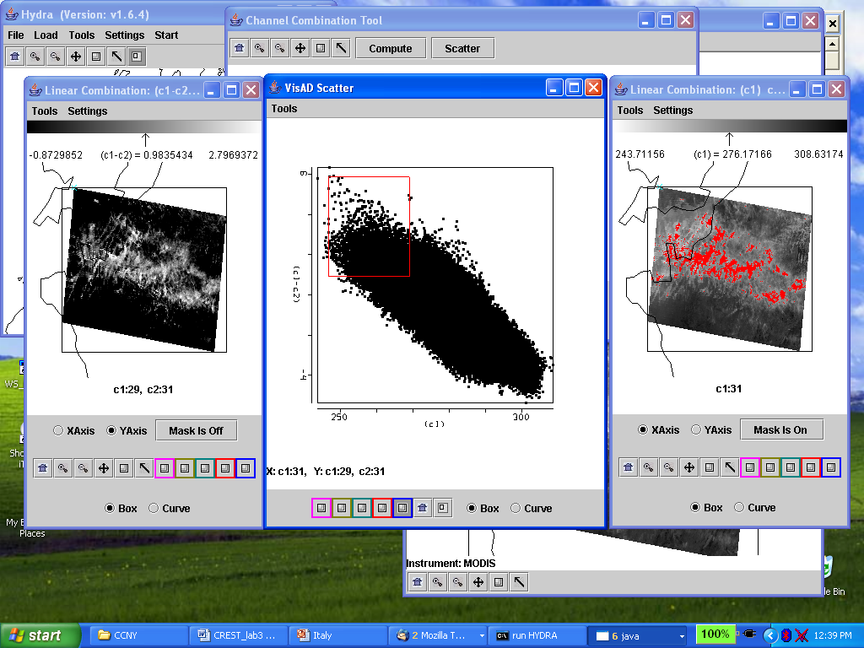

Figure 4b: Scatter plot of BT8.6-BT11 (left image) versus BT11 (right image) with BT8.6-BT11>1 and BT11>270 highlighted in red.

6b. Alternatively, select a rectangular region of one of the pseudo-images (on display in the linear combinations window) and look at the position of the selected pixels in the scatter plot. (Figure 4c)

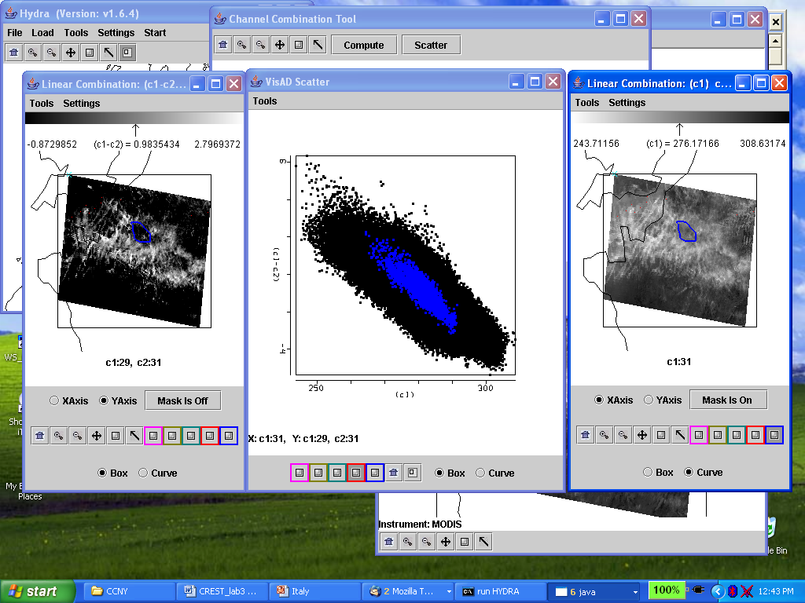

Figure 4c: Scatter plot of BT8.6-BT11 (left image) versus BT11 (right image) with selected cloud feature in BT11 image highlighted in blue and displayed on scatter plot.

6c. What is the cloud type viewed in this region. Does Band 26 (1.38 µm) support or contradict your cloud classification. If you were to design and automated algorithm to detect these cloud types, what would you include in your algorithm?

6d. Which difference is larger for this cloud, [Band 29 (8.6 μm) - Band 31 (11 μm)] or [Band 31 (11 μm) - Band 32 (12 μm)]?

6e. Try two other tests suggested for high thin ice clouds over land and comment on their correlation with the BT8.6 – BT11 test demonstrated above.
Table 2: Summary of some MODIS Cloud Tests

Scene | Solar/Reflectance | Thermal | Comments
Low cloud over water | R_{0.86}, R_{0.67}/R_{0.86},  BT₁₁-BT_{3.7} | Difficult,  Compare BT₁₁ to daytime mean clear-sky values of BT₁₁;  BT₁₁ in combination with BT difference tests;  Over oceans, expect a relationship between  [BT₁₁-BT_{8.6}], [BT₁₁-BT₁₂] due to water vapor correlation to SST | Spatial and temporal uniformity tests sometimes used over water scenes;  Beware of Sun-glint regions
High Thick cloud over water | R_{1.38}, R_{0.86}, R_{0.67}/R_{0.86}, | BT₁₁ ; BT_{13.6} ; BT_{6.7}  [BT₁₁-BT_{8.6}],  [BT₁₁-BT₁₂] | Easy, good contrast in vis and IR
High Thin cloud over water | R_{1.38}, ΔR_{0.86},  [R_{0.65}–R_{1.6}]/[R_{0.65}+R_{1.6}]; | BT_{6.7} ; BT_{13.9}  [BT₁₁-BT₁₂],  [BT_{3.7}-BT₁₂],  [BT_{8.6}-BT₁₁] | For R_{1.38}, be careful of surface reflectance for atmospheres with low total water vapor amounts.  For BT difference tests, beware of variations in surface emissivity.
Low cloud over snow | [R_{0.65}–R_{1.6}]/[R_{0.65}+R_{1.6}];  R_{2.1} back up to 1.6  [BT₁₁-BT_{3.7}]<<0 | Difficult, look for inversions in clr sky  BT₁₁-BT_{6.7} < 0 | NDSI (Normalized Difference Snow Index) is ratio test.  R_{2.1} is also dark over snow and bright for low cloud.
High thick cloud over snow | R_{1.38};  [R_{0.65}–R_{1.6}]/[R_{0.65}+R_{1.6}] | BT₁₁ ; BT_{13.6} ; BT_{6.7}  Look for inversions, suggesting cloud-free. | Usually easy
High thin cloud over snow | R_{1.38};  [R_{0.65}–R_{1.6}]/[R_{0.65}+R_{1.6}] | BT₁₁ ; BT_{13.6} ; BT_{6.7}  Look for inversions, suggesting clear sky.
Low cloud over vegetation | R_{0.86}, R_{0.67}/R_{0.87},  BT₁₁-BT_{3.7};  [R_{0.86}–R_{0.65}]  /[R_{0.86}+R_{0.65}] | Difficult, BT₁₁ in combination with BT difference tests. | NDVI (Normalized Difference Vegetation Index). Other ratio tests also are good. Can make tests a function of ecosystem.
High Thick cloud over vegetation | R_{1.38}, R_{0.86}, R_{0.67}/R_{0.86},  [R_{0.86}–R_{0.65}]  /[R_{0.86}+R_{0.65}] | BT₁₁ ; BT_{13.9}; BT_{6.7}  [BT₁₁-BT_{8.6}],  [BT₁₁-BT₁₂] | Can make tests a function of ecosystem to account for variations in surface emittance and reflectance.
High Thin cloud over vegetation | R_{1.38}, R_{0.86}, R_{0.67}/R_{0.86},  [R_{0.86}–R_{0.65}]  /[R_{0.86}+R_{0.65}] | BT_{13.9}; BT_{6.7}  [BT₁₁-BT_{8.6}],  [BT₁₁-BT₁₂] | Beware of variations in surface emittance and reflectance.
Low cloud over bare soil | R_{0.86}, R_{0.67}/R_{0.86},  [BT₁₁-BT_{3.7}] | BT₁₁ in combination with brightness temperature difference tests.  [BT_{3.7}-BT_{3.9}] | Difficult due to brightness and spectral variation in surface emissivity.  Surface reflectance at 3.7 and 3.9 μm is similar.

High Thick cloud over bare soil | R_{1.38}, R_{0.86}, R_{0.67}/R_{0.86} | BT_{13.9}; BT_{6.7}  BT₁₁ in combination with brightness temperature difference tests.
High Thin cloud over bare soil | R_{1.38}, R_{0.86}, R_{0.67}/R_{0.87},  [BT₁₁-BT_{3.7}] | BT_{13.9}; BT_{6.7}  BT₁₁ in combination with brightness temperature difference tests, for example  [BT_{3.7}-BT_{3.9}] | Difficult; be careful of surface reflectance at 1.38 μm. and variations in surface emittance.
Cloud-top pressure |  | Channels in absorption band of carbon dioxide (13-14μm) | CO2 slicing
Cloud phase | Combination of R_{0.86}; R_{1.6} and R_{2.1} | [BT_{8.6} – BT₁₁]>0 for ice and <0 for water.  [BT₁₁ – BT₁₂] for water clouds > [BT_{8.6} – BT₁₁]. Conversely,  [BT_{8.6} – BT₁₁] for ice cloud > [BT₁₁ – BT₁₂]. | Watch out for cloud overlap  Determine phase by using observations that test for high cloud versus those that test for low.
Cloud particle size | Combination of R_{0.86}; R_{1.6 ,} R_{2.1}; & R_{3.7} | [BT_{8.6} – BT₁₁] values versus [BT₁₁ – BT₁₂] is useful for thin high clouds. | Arches

7. In the Hydra window, sub-select the cloudy region as shown in Figure 5.

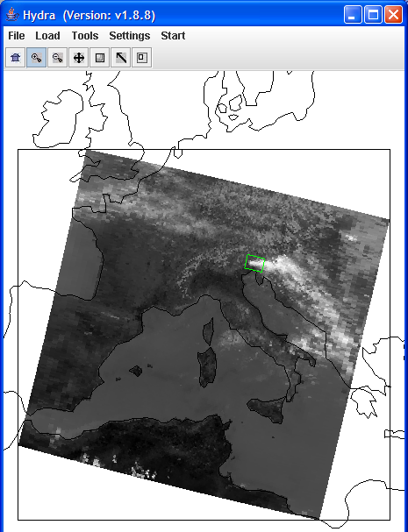

Figure 5: Subset to inspect thermal emission of clouds.

7a. Make a scatter plot of [Band 29 - Band 31] and [Band 31 - Band 32]. You should see a hook shape pattern in the scatter plot window. In this case, which brightness temperature difference gives a stronger signal of cloud presence (larger range of values). Select regions in different parts of the hook shape to see what parts of the image they correspond to. Find the parts of the hook shape that correspond to clear skies, partly cloudy, and overcast cloud. Save a ppt of your work.

7b. To determine what causes the hook shape found in 7a, calculate the radiances at 8.6, 11, 12 μm for a scene of clear sky at 300 K and a cloud at 230 K with varying cloud amount. Let the cloud fraction vary from N = 0.0, 0.2, 0.4, 0.6, 0.8, and 1.0. Convert the radiances to brightness temperatures. Plot brightness temperature differences BT8.6 - BT11 versus BT11 – BT12 for the six different cloud fractions. What does this imply about the hook shape detected in the previous problem? What other factors might influence the hook shape?

8. Select a region in the northern part of the Adriatic Sea (outlined approximately in Figure 6a by the green box) within the Hydra window. Now select Band 9 (0.45 μm) in the Multi-Channel Viewer and display the reflectance image.

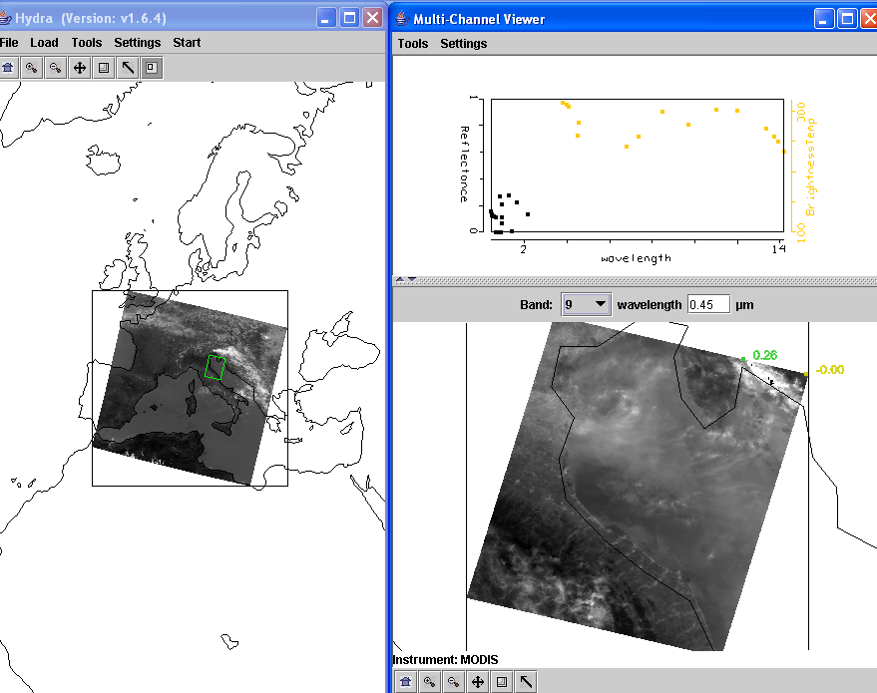

Figure 6a: Northern Adriatic shown in phytoplankton sensitive Band 9.

8a. Construct a pseudo image of [Band 12 (0.56μm) / Band 9 (0.45μm)] using Compute. Adjust the contrast using color range under Settings. Using Figure 6b explain why higher values of this ratio should indicate water regions with more phytoplankton from those with little? What is the likely source of the high phytoplankton plume entering the Adriatic?

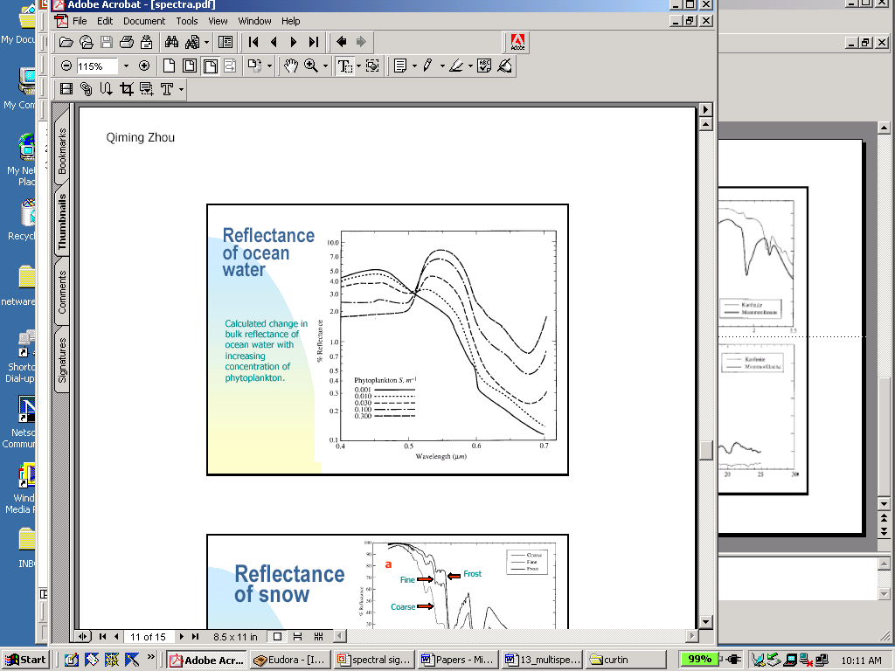

Figure 6b: Reflectance of ocean water with increasing phytoplankton.

8b. Create a pseudo SST image of [2*Band 31 (11.0 μm) – Band 32 (12.0 μm)] using Compute. What is the range of SST values in the northern Adriatic?

8c. Map the phytoplankton values from 7a on the Y axis (by clicking the Y axis button) against the SST from 7b on the X axis (by clicking the X axis button). Click on the Scatter button to open a scatter plot window. Select different regions in the scatter plot window and look at the corresponding points in the linear combination windows. It seems that high concentrations of phytoplankton are associated with warmer or colder waters.

8d. However, one should be sure that there are no clouds in the region. Look at the Band 26 (1.38 μm) image. Did you find high thin cirrus that make the previous conclusion suspect?

9. In the Hydra main menu load MODIS measurements of a volcanic eruption of Mt Etna on 28 October 2002 (MOD021KM.A2002301.1215.003.2002302200901.hdf). Select a region to focus on the eruption (see Figure 7).

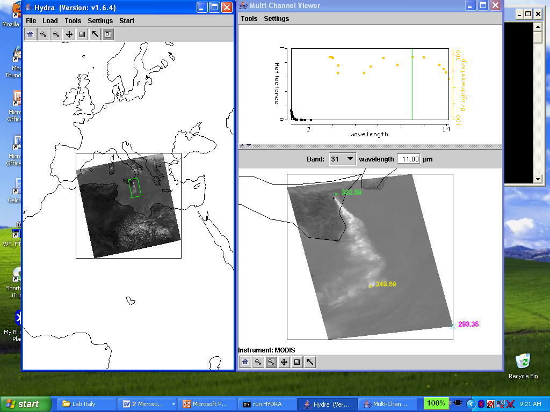

Figure 7: Mt Etna eruption on 28 October 2002

9a. Plot Band 31 (BT11) on the X-axis and the split window difference [Band 31 (BT11) minus Band 32 (BT12)] on the Y-axis and show the scatter plot. Observe that the volcanic ash produces negative temperature differences (between 0 and –6 C) in the split window. Show that the denser ash produces the larger differences by highlighting different negative split window values in the scatter plot with different colors (using the tool bar at the bottom of the scatter plot window) for every two degrees (e.g. box -6 to -4 C with red, box -4 to -2 C with green, and box -2 to 0 C with purple). Will negative values of BT11-BT12 always depict only volcanic ash? Explain.

Lab 4 – Staging, Viewing, and Interrogating AIRS Data

Menzel / Antonelli

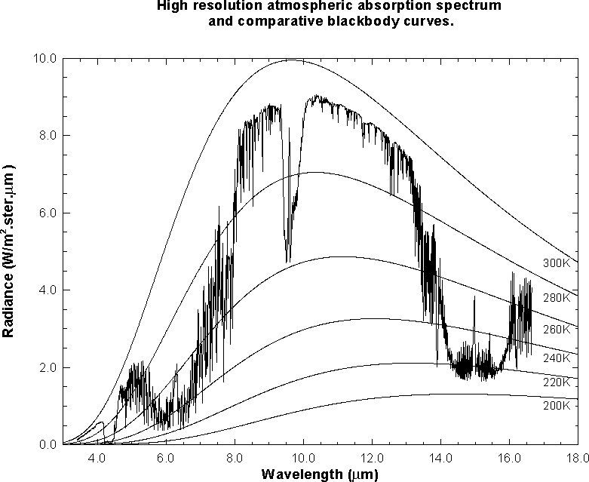

Figure 1: High resolution atmospheric absorption spectrum and comparative blackbody curves

1. Open Hydra and load the file: AIRS.2005.08.28.103.L1B.AIRS_Rad.v4.0.9.0.G05241172839.hdf. Under Start open the MultiChannel Viewer and the following should appear.

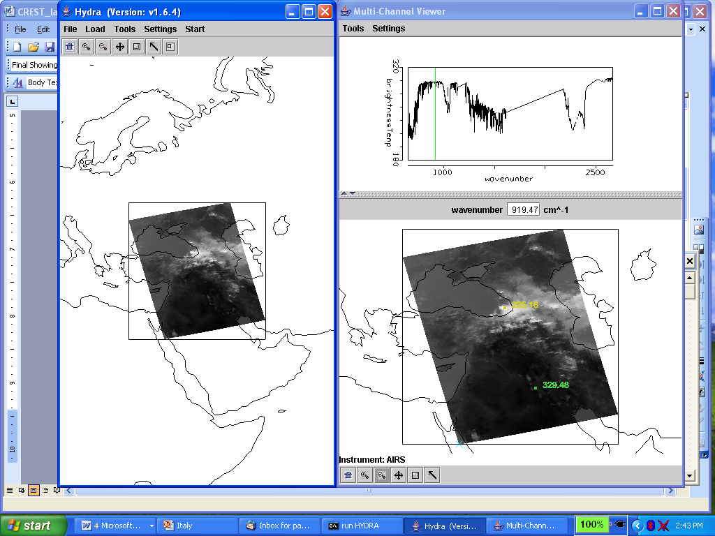

Figure 2: Hydra display of AIRS data showing BT spectra from warmest pixel and IRW image over the Black and Caspian Seas on 28 August 2005.

1a. Explore the image to view the spectra measured in various pixel locations. To do this click on the arrow icon in the tool bar at the bottom of the Multi-Channel Viewer and move the cursor around the image slowly, watching the spectra change from pixel to pixel. View a spectrum over the Black Sea in clear skies and locate the CO2, O3, and H2O absorption features. Now view a spectrum in the clouds at the eastern edge of the Black Sea. The absorption features have been severely diminished. Why? The brightness temperature (BT) at shorter wavelengths is now increasing as wavelengths decreases. Why?

1b. Engage the reference spectrum icon (look under Tools and find Reference Spectrum and click on). Show both spectra from 1a simultaneously by engaging the arrows in the bottom tool bar (Figure 3).

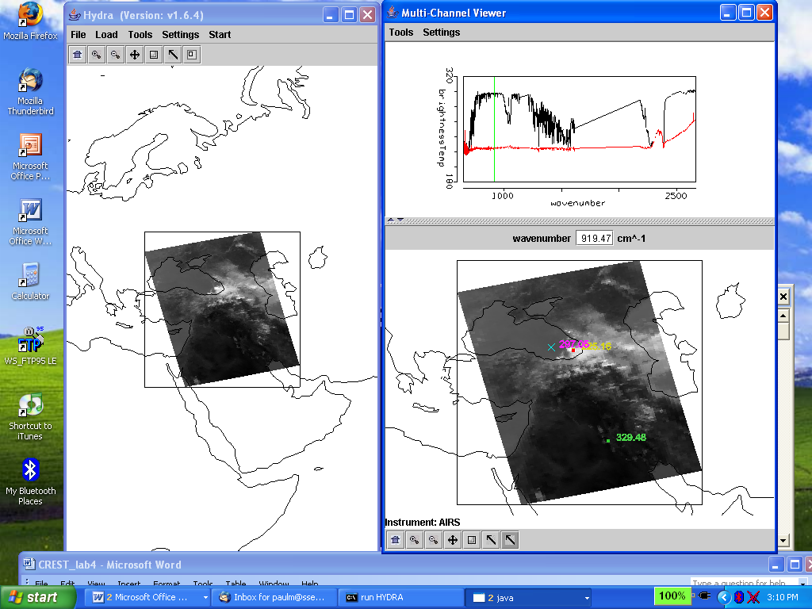

Figure 3: Multi-Channel Viewer display with reference spectrum on showing cloudy and clear sky spectra over the Black Sea

2. Zoom in on the cloudy spectra at 1050 cm-1 (click on the zoom icon third from the right on the toolbar at the bottom and click and drag over the desired part of the spectra). The O3 absorption feature over clouds shows warmer BT as the wavenumber gets closer to the center of the absorption band. What does this tell you about the height of the cloud? Explain.

3. Restore the full spectra (click on the left icon on the toolbar at the bottom and click again over the spectra). Zoom in on the eastern portion of the Black Sea (see Figure 4). Compare the spectra for a clear pixel and a pixel covered by thin cloud. What does the infrared window portion of the spectrum look like?

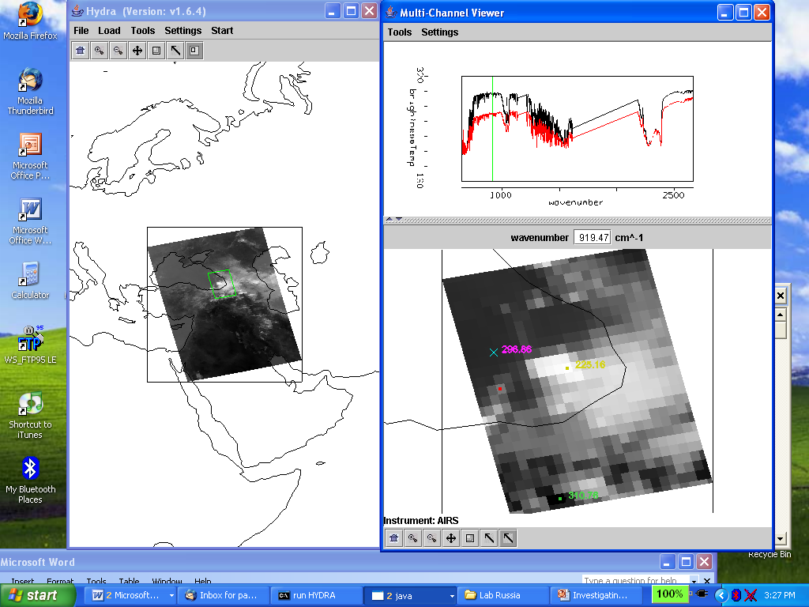

Figure 4: Multi-Channel Viewer display of AIRS measured spectra in partly cloudy and clear skies over the eastern portion of the Black Sea

4. Engage Linear Combinations (under Tools) to open the Channel Combination Tool display. What is the temperature difference for on-absorption-line off-absorption-line spectra at 735 cm⁻¹ for this scene? What is the temperature difference for on-line off-line spectra at 720 cm⁻¹ (at the Q branch of the CO₂ absorption band) for this scene? What does this imply about the 720 cm⁻¹ weighting function with respect to the 735 cm⁻¹ weighting function?

5. Calculate the BT difference on and off a H2O absorption line in the infrared window region (e.g. try 947.4 minus 948.2 cm-1). Display the difference image in color (see Figure 5). What is the range of values in the scene? Differences in the eastern Black Sea are smaller than differences further west; what does this tell you about low level moisture? Explain.

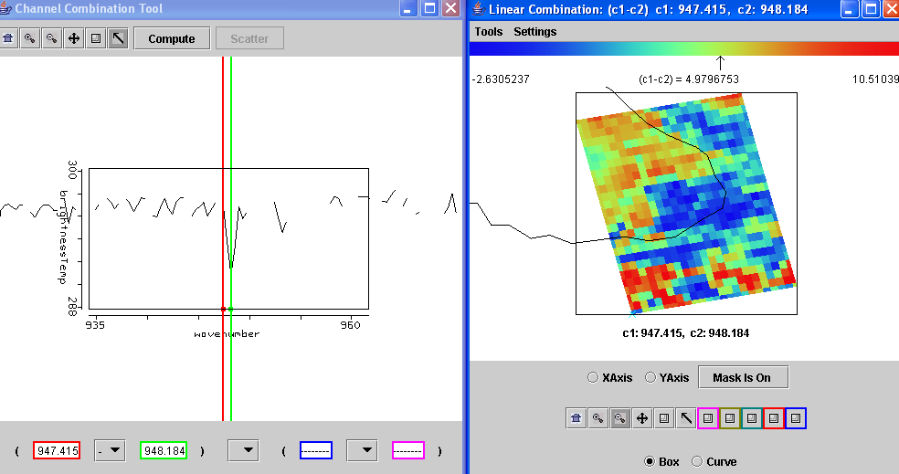

Figure 5: Channel Combinations display of BT947.4 minus BT948.2.

Lab 5 – Exploring Spectral Properties of Clouds, Moisture, and Volcanic Ash Sensed with AIRS
Menzel / Antonelli

1. Open Hydra and load AIRS.2005.08.28.103.L1B.AIRS_Rad.v4.0.9.0.G05241172839.hdf. Under Start open the Multi-Channel Viewer . Engage the reference spectrum icon (look under Tools and find Reference Spectrum and click on). Using Hydra again load the AIRS retrievals for this scene found in AIRS.2005.08.28.103.atm_prof_rtv_npc030.hdf (leave the Multichannel Viewer with the AIRS data open). Under Variables select Air Temperture Profiles and under Tools turn Reference Profile on. In Multi-Channel Viewer, using the arrows in the bottom tool bar select one FOV directly in the cloud in ther eastern Black Sea and another FOV nearby in clear skies.

1a. Observe the characteristic spectral signature of an opaque cloud in the Multi-Channel Viewer (see Figure 3 of Lab 4). Now observe the temperature profiles for the two FOVs in the Hydra AIRS level 2 Products Window (see Figure 1). What can you infer about the height of the opaque cloud? Why? Inspect the temperature retrieval image for various pressure levels (in the Hydra AIRS level 2 Products Window use the first arrow in the bottom tool bar to move the horizontal green line to different pressure levels); the pressure level where the retrieval field shows large contrast over the cloud is indicative of its height.

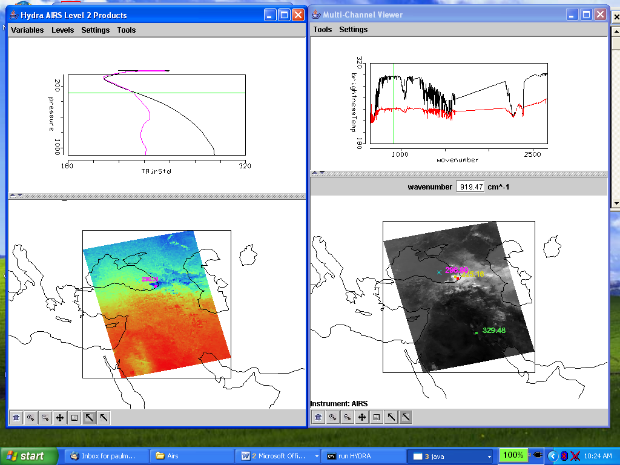

Figure 1. (right) Multi-Channel Viewer display with reference spectrum on showing cloudy and clear sky AIRS spectra over the Black Sea. (left) AIRS temperature profile retrievals in clear and cloudy FOVs and the 300 hPa temperature retrieval field for the granule.
1b. Explore the spectra and the inferred height of several other clouds in the scene. Record their location and your estimate of their height.

2. In the Hydra AIRS level 2 Products Window, under Variables select Water Vapor Profiles.

2a. Inspect the moisture retrieval image for 900 hPa. The western Black Sea appears to have more low level moisture than the eastern part. In the Multi-Channel Viewer display two spectra, one for a FOV in the moister region and one in the drier region. Zoom in on the two spectra at 870 cm-1 (click on the icon third from the right in the bottom tool and then click and drag over the appropriate part of the spectrum – repeat until full resolution of the absorption lines in the IR window are apparent). You should have something that looks like Figure 2. Does the on-line off-line brightness temperature difference in this part of the spectrum agree with the inference from the retrieval field? Explain?

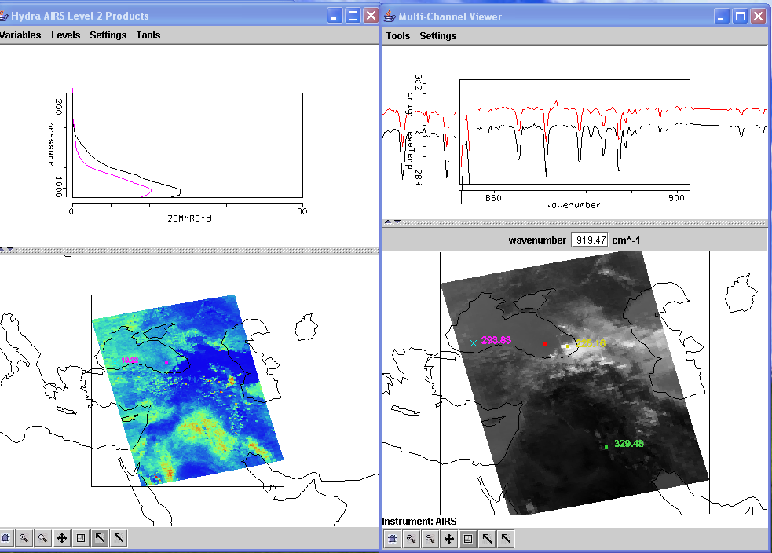

Figure 2. (right) MultiChannel Viewer display with zoom in on IR window spectra near 870 cm-1 over FOVs in eastern and western Black Sea. (left) AIRS water vapor profile retrievals in the two selected FOVs and the 900 hPa water vapor retrieval field for the granule.

3. Repeat your investigation of atmospheric water vapor by displaying 1443 cm-1 measurements in the Multi-Channel Viewer. There is a dry band south of the Black Sea. Display the spectra and the water vapor profiles in and out of the dry band. Zoom in on the spectra between 1380 and 1420 cm-1. See Figure 3. Does the on-line off-line brightness temperature difference in this part of the spectrum agree with the inference from the retrieval field? Explain?

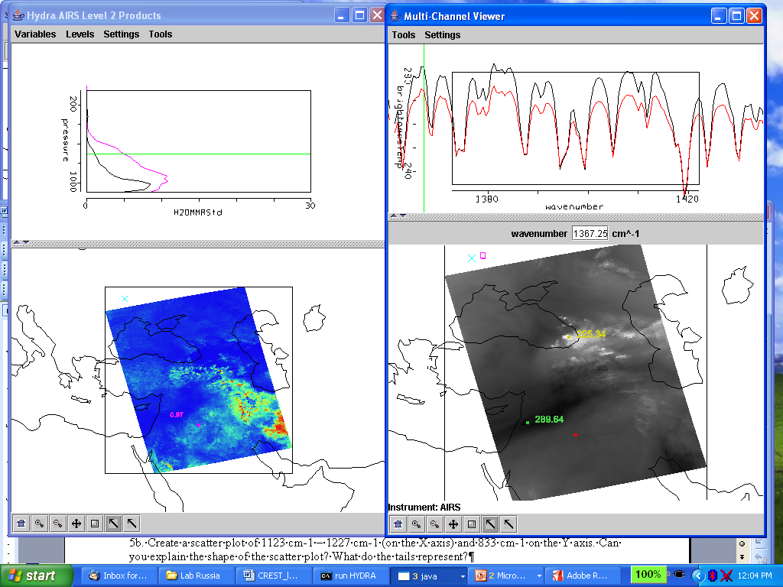

Figure 3. (right) Multi-Channel Viewer display with zoom on H2O spectra between 1380 and 1420 cm-1 over FOVs in and out of the dry band south of the Black Sea. (left) AIRS water vapor profile retrievals in the two selected FOVs and the 700 hPa water vapor retrieval field for the granule.

4. Using Hydra load AIRS.2002.10.28.123.L1.AIRS_Rad.v2.6.10.3.A02302200913.hdf. This granule includes measurements of the eruption of Mount Etna on 28 October 2002 (see Figure 4a).

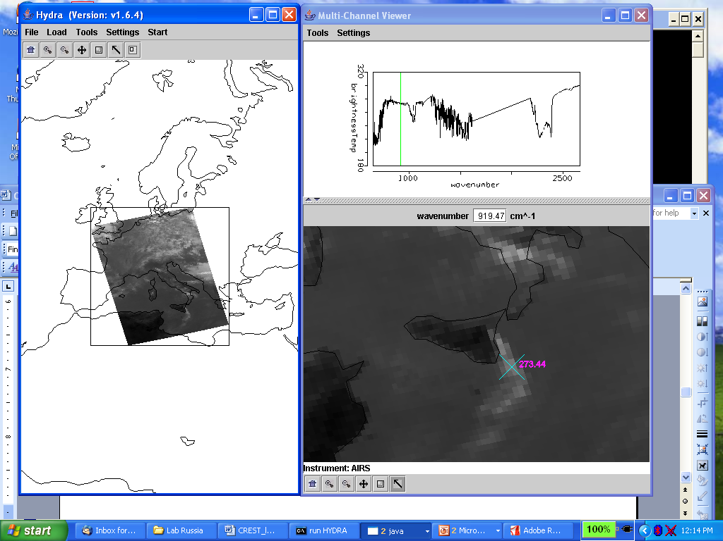

Figure 4a. AIRS measurements over eruption of Mount Etna on 28 October 2002
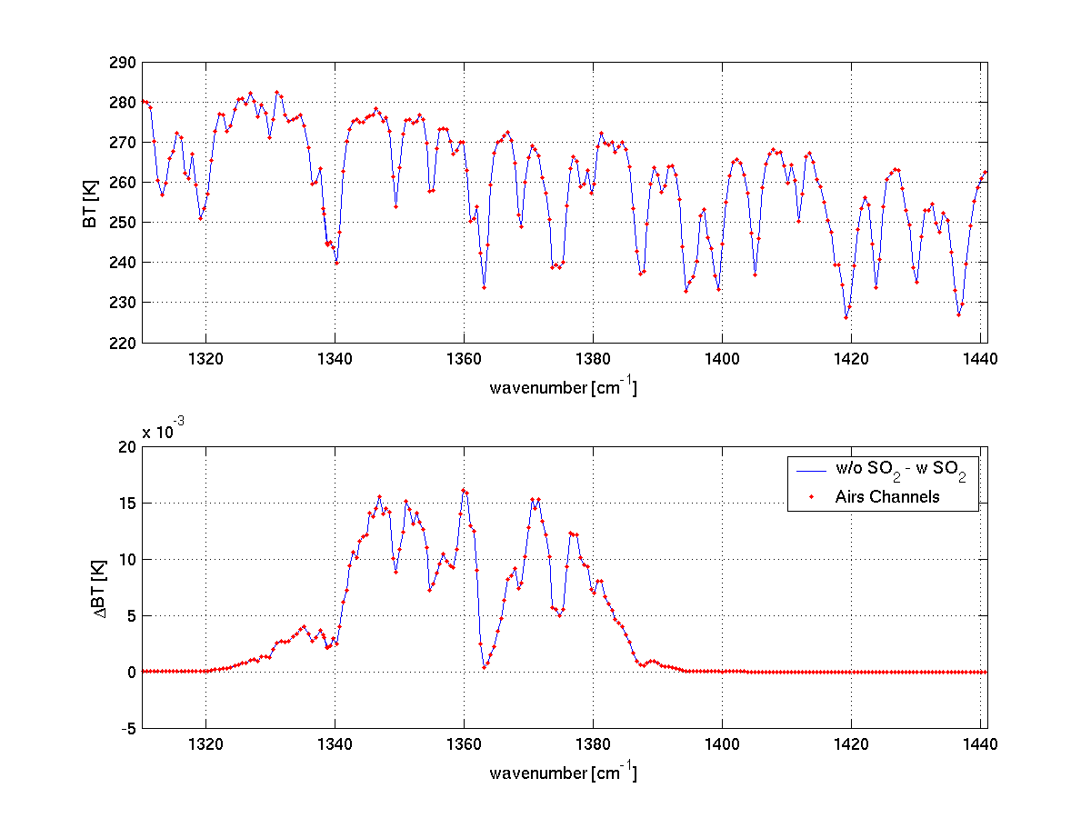
Figure 4b. (top) Simulated AIRS spectrum from 1320 cm⁻¹ to 1441 cm⁻¹. (bottom) Differences between the simulated AIRS spectrum with and without SO₂.
4a. Using Scatter Plot to show the difference between AAAA.A and BBBB.B wavenumber that can be used to detect SO_{2.} Determine optimal values for A and B and map this difference (A-B) to the X axis. With AVHRR we would have used the difference 833.3 minus 909.0 cm-1 to detect volcanic ash (not always co-located with SO2). Map this AVHRR-like difference to the Y axis and get a scatter plot. After getting the scatter plot, get color images for X and Y. How do the two figures compare?

4b. Select a single spectrum over the smoke plume. Identify a peak near 1227.3 cm-1. Select the difference between 1123.0 and 1227.3 wavenumbers and map it to the y-axis (with Channel Combination). Map the difference between 1376.886 and 1414.008 on the x-axis. Produce a scatter plot and display color maps of each difference. Explain the differences between the color maps with the help of the scatter plot.

4c. Map the difference [(BT1123.0 – BT1227.3) – (BT1376.886 – BT1414.008)] to the X axis and BT907.68 to the Y axis. Produce a scatter plot and a color map for the X axis. Try to describe and explain what you observe in the color map with the help of the scatter plot.

4d. Using Hydra, load AIRS.2002.10.28.123.atm_prof_rtv_npc030.hdf which contains the AIRS retrievals for this scene (leave the Multichannel Viewer with the AIRS data open). Under Variables select Air Temperature Profiles. Under Tools turn Reference Profile on. In the Multi-channel Viewer turn Reference Spectrum on also. Using the arrows in the bottom tool bar select one FOV directly in the ask plume and another FOV nearby in clear skies. Observe the characteristic spectral signature of ash in the Multi-Channel Viewer. Observe the temperature profiles for the two FOVs in the Hydra AIRS level 2 Products Window. What can you infer about the height of the ash plume? Why? Inspect the temperature retrieval image for various pressure levels (in the Hydra AIRS level 2 Products Window use the first arrow in the bottom tool bar to move the horizontal green line to different pressure levels); the pressure level where the retrieval field shows large contrast over the ash plume is indicative of its height.

5. Consider the AIRS measurements in the CO2 region of the spectrum (see Figure 5). The red dots indicate the spectral region where the on-line channel BT is warmer than the off-line channel BT. Can you explain why? The magenta circles indicate the spectral region where the on-line channel BT is colder than the off-line channel BT. What is the difference between the two spectral regions.

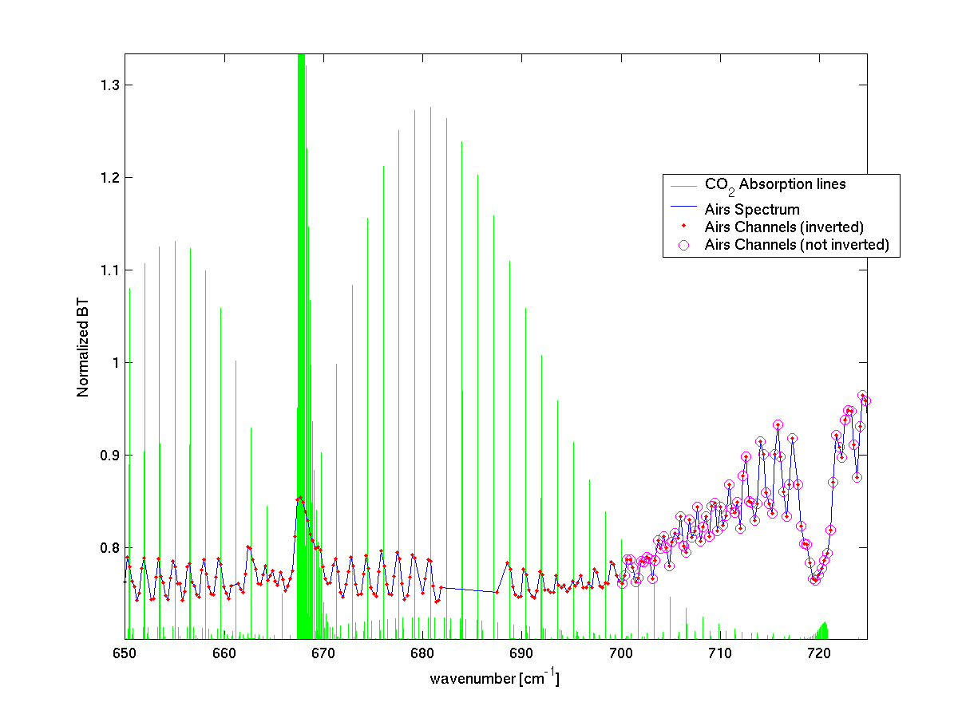
Figure 5. AIRS normalized spectrum (blue) and locations of CO2 lines (green).

5a. Using Hydra, plot a color map of the tropopause temperature for the granule over Italy.
5b. Create a scatter plot of 1123 cm-1 – 1227 cm-1 (on the x-axis) and 833 cm-1 on the y-axis. Can you explain the shape of the scatter plot? What do the tails represent?
Lab 6 – Fire Detection
Strabala

1. Load into Hydra the MODIS file from 20 August 2003 covering Southeastern Africa and Madagascar, MYD021KM.A2003232.1110.004.2004148203517.hdf. Start the Multi-Channel Viewer and then select the small region displayed in Figure 1. Load Band 22 (3.99 μm) into the Multi-Channel Viewer window.

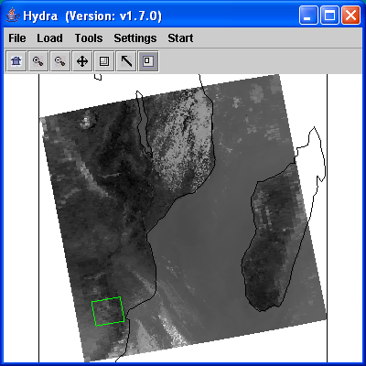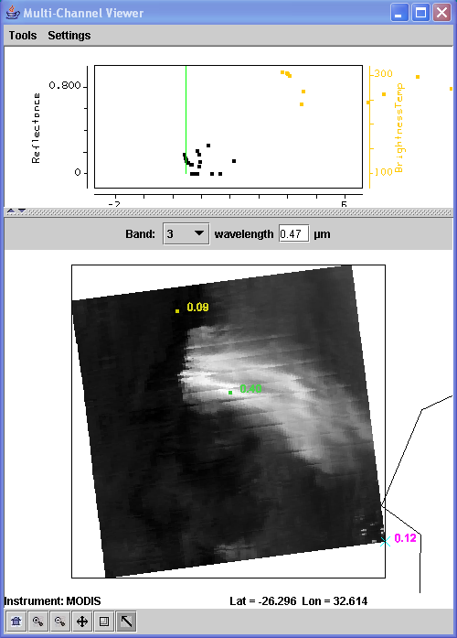

- Figure 1: Hydra display with 11 μm brightness temperature image at 10 km from Aqua MODIS on 20 August 2003 at 1110 UTC (left) and 1 km resolution Band 3 (0.45 μm) reflectance image in the Multi-Channel Viewer (right).

1a. Create a transect across the hottest pixels in the scene. Try to overlay your transect across the source of the smoke plumes seen in band 3 (0.47 μm). What range of values do you observe in the transect? Do you notice anything unusual? Engage the transect point locater by right clicking and holding down the mouse button on the green point located at the bottom of the transect window X-axis. Move the position to the location along the transect where data seems to be missing. Do the same for other missing data points. Where do these points lie in the image? Why do you think the values are missing?

1b. Leave the transect window open and load band 21 (3.99 μm) into the Multi-Channel Viewer. How do the range of values compare? Are there missing values? Now repeat for band 31 (11 μm).

1c. What could cause the differences that you have found between the three channels?

2. The MODIS fire algorithm uses a series of tests to determine if a pixel contains a fire. The first step is to identify potential fire pixels. This involves testing if BT4 (Band 21 @ 3.99 μm) > 310 K and BTDIF4-11 [(Band 21 @ 3.99 μm) – (Band 31 @ 11 μm)] > 10 K.

2a. Open Linear Combinations and make an image of BT4 from Band 21 (3.99 μm) and another of BT4-BT11 from [(Band 21(3.99 μm) – Band 31(11 μm)]. Choose BT4 as the x-axis and BT4-BT11 as the y-axis, then create a scatter diagram. Try out these thresholds by grabbing the pixels that meet this criteria within the scatter diagram (drag the box over the region which satisfies both thresholds). How do you think this preliminary test performs? Do you think it captures all of the fire pixels? Too many?

2b. Once the potential fire pixels are identified, other tests are applied to this subset of data points. The first is a simple Band 21 (3.99 μm) brightness temperature threshold test: BT4 (Band 21 @ 3.99 μm) > 360 K.

2c. Try out this threshold test in the scene you are looking at. You may wish to set the Set Color Range window to help you with this. How many of the previously chosen pixels does this test find? If this test is passed, then the pixel is labeled as a fire pixel.

3. Next, the MODIS fire algorithm attempts to differentiate fire pixels from nearby non-fire (background) pixels. This involves comparing the potential fire pixel to the surrounding pixels. This contextual approach uses the average brightness temperature of the non-fire pixels in Band 21(3.99 μm) that surround the potential fire pixel and also the Mean Absolute Deviation (MAD). MAD is the mean of the absolute value of the differences between the average and the deviation from the average:

MAD =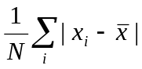 where i is the number of points you are summing.

For pixels that did not pass the first BT4 test, they must pass the next 3 dynamic thresholds to be labeled a fire pixel.

Threshold tests | Thresholds for data selected in Figure 1 from 20 August 2003
- BTDIF4-11 > Average BTDIF4-11 + 3.5 (MAD BTDIF4-11) | - BTDIF4-11 > 3.2 K + 3.5 * (.63) K  - BTDIF4-11 > 5.40
BTDIF4-11 > Average BTDIF4-11 + 6 K | BTDIF4-11 > 6K + 3.2 K  BTDIF4-11 > 9.2 K
BT4 (Band 21 3.99 μm BT) > Average BT4 + 3(MAD BT4) | BT4 > 298.52 K + 3 * 16.57 K  BT4 > 348.23 K

Apply these tests to the scene (you can use the scatter diagram if you like). How do you think this detection algorithm performs in this region? Are there places where it fails? Note that we have not examined all the tests that go into a final fire pixel determination, but we have included most of them. There are also tests that discriminate clouds from fire pixels, and special algorithms for differentiating desert boundaries, sun glint and coastal regions.

3a. How do you think clouds would affect the results? When you are finished, close the Channel Combination Tool Window.

4. Select the region outlined in Figure 2. Repeat steps 2 and 3 for this new scene. Comment on the results.

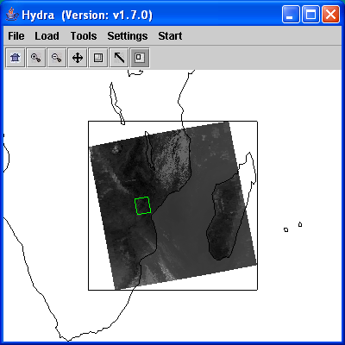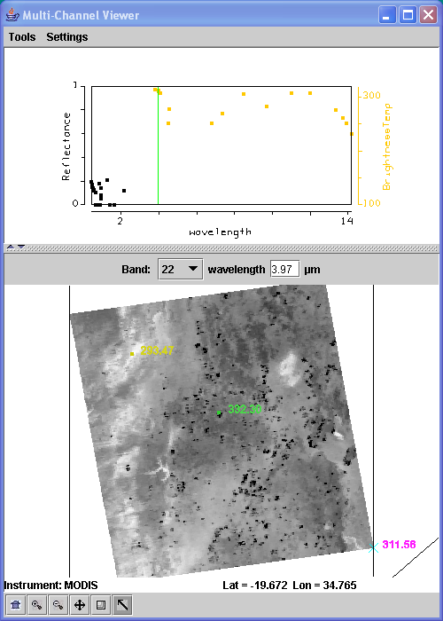

- Figure 2: Main hydra window with selection of image from Aqua MODIS on 20 August 2003 at 11:10 UTC (left) and high resolution band 22 (3.99 μm) reflectance image in the Multi-Channel Viewer (right).

4a. Looking at the variability of the scene, can you think of some reasons why you would not want to use one set of thresholds for the entire scene? Are there some types of backgrounds where it would be easier to detect fires? More difficult?

5. Load Band 22 (3.99 μm) into the Multi-Channel Viewer and overlay the MODIS fire Level 2 product by loading local image file MYD14.A2003232.1110.004.2004152085610.hdf. The fire product will be displayed over the image and a new MODIS Fire Mask Product window will be displayed, with a button at the bottom that allows you to toggle the mask off and on (you may have to re-size the window to see it). How do you think the official fire product performs on this scene?

6. (Extra) Compute and apply contextual thresholds. Select a potential fire region and determine a BT4 average and BT4 MAD and a BTDIF4-11 average and BTDIF4-11 MAD. Use 4 pixels to determine the statistics and remember not to choose any in your background calculation that are included as potential fires. You can either do the calculations by hand or with a calculator that may be included as software on your PC. Calculate what the contextual fire thresholds should be for the pixel as was done in step 3. Now apply the thresholds to the pixel you are working on and all the pixels in the scene. How did your fire thresholds perform on (a) the current pixel and (b) on the whole scene?

Lab 7 – Investigating Aerosols with MODIS

Strabala

- 1. Load into Hydra the local Aqua MODIS file from 20 August 2003 covering Southeastern Africa and Madagascar, MYD021KM.A2003232.1110.004.2004148203517.hdf. Start the Multi-Channel Viewer and then select the small region displayed in Figure 1.

- Figure 1. Main hydra window with a selection of the image from Aqua MODIS on 20 August 2003 at 11:10 UTC (left) and high resolution band 3 (.45 μm) reflectance image in the Multi-Channel Viewer (right).

- 1a. Examine the scene in the visible and near infrared with Band 1 (0.68 μm), Band 3 (0.47 μm) and Band 7 (2.13 μm) and in the infrared with bands Band 20 (3.80 μm), Band 21 (3.99 μm), and Band 31 (11 μm). Describe what you see. Are there differences in the max/min reflectances and brightness temperatures? Can you think of some reasons for these differences?

Band 1  (0.65 μm) | Band 3  (0.47 μm) | Band 7  (2.1 μm) | Band 20  (3.8 μm) | Band 21  (3.99 μm) | Band 31  (11 μm)

2. Open Linear Combinations and create images of Band 1 (0.68 μm), Band 3 (0.47 μm) and Band 7 (2.13 μm). Change the color scale to gray and enhance the images. Now create a scatter diagram of Band 3 (0.47 μm) on the X-axis and Band 7 (2.13 μm) on the Y-axis. Select regions of the plume in the image to see where the points lie on the scatter diagram. In which band is the smoke signal stronger? Replace Band 3 with Band 1 (0.68 μm) and repeat this exercise. How does Band 1 vs Band 7 compare with the Band 3 vs Band 7? Can you determine a relationship between the reflectances of the surface background just using the scatter diagram (Hint: what is the slope of the background land pixels).

- 3. The MODIS aerosol algorithm utilizes a look up table to get an initial estimate of the aerosol optical thickness τ_{λ} over land, based upon the measured reflectances and the surface reflectance. This relationship can also be approximated by:

- τ_{.68} ~ (r_{.68} - .50*r_{2.1})
- τ_{.47} ~ (r_{.47} - .25*r_{2.1})

- 3a. Calculate τ_{.68} and τ_{.47} at 3 locations over the smoke plume. You can get the values of the same pixels for different channels selecting the Arrow button in the Multi-Channel Viewer as you change bands, and then do your calculations. What values did you get? How do the τ values change as the plume moves away from the source?

3b. What is the purpose of subtracting out the reflectances in Band 7 (2.13 μm)?

- 4. Now use the Channel Combinations Tool to create approximate τ_{.68} and τ_{.47} images. Create an image of Band 1 (0.68 μm) - .50 * Band 7 (2.13 μm). Use the white coefficient box in front of the band selector box to type in the constant. Do the same for Band 3 (0.47 μm) - .25 * Band 7 (2.13 μm).

- 4a. How do the τ_{.68} and τ_{.47} values compare? What are some causes for the differences? Once you are done, close the Linear Combinations Window.

5. Now load the cloud mask for our small section of data (file MYD35_L2.A2003232.1110.hdf). Overlay the Unobstructed_FOV_Quality_Flag onto the Band 1 (0.68 μm). How do you think the mask performs over this region? When you are finished, close the Cloud Mask Window and the Multi Channel Viewer.

Lab 8 - Dust Detection with MODIS and AIRS

Strabala / Menzel

1. Using Load Data in the main menu load MOD021KM.A2006055.1130.005.2006056124414.hdf. This granule shows a dust storm over North Africa. Sub-select a region in the dust storm. For each of the following cases use the scatter plot tools to determine (and describe) the features of the dust storm.

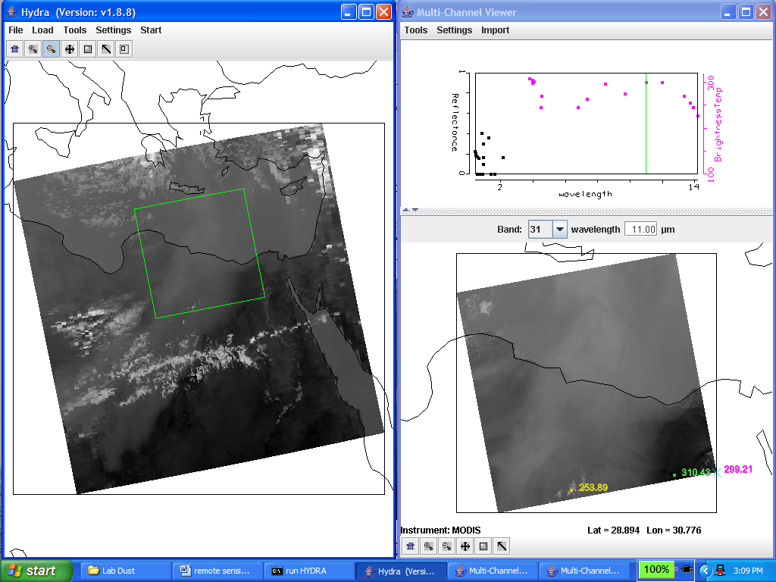

Figure 1. Dust scene over Central Africa viewed with MODIS.

1a. Plot Band 31 on the x-axis and [Band 31 - Band 32] on the y-axis and click on the Scatter button.

1b. Repeat with Band 31 (11 μm) on the x-axis and [Band 29 (8.6 μm) minus Band 31 (11 μm)] on the y-axis.

1c. Repeat with Band 31 (11 μm) versus [Band 31 (11 μm) minus Band 32 (12 μm)].

1d. Which brightness temperature differences show a larger range of values?

1e. How does this compare to the cloud diagrams? Do you think you can distinguish dust storms from clouds using these channels? Why?
2. Load AIRS data (AIRS.2006.02.24.115.L1B.AIRS_Rad.v4.0.9.0.G06055204038.hdf) from the same scene as shown in Figure 2. Using reference spectrum synch the cursor over the AIRS and MODIS data.

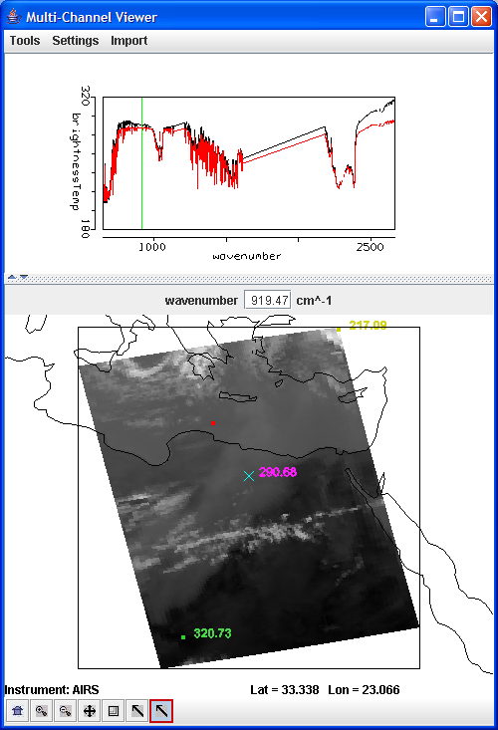

Figure 2. AIRS measurements over the same dust storm

2a. For pixels where MODIS indicates the greatest amount of dust (where the brightness temperature differences are the greatest), observe the AIRS spectral measurements in the infrared window region from 1200 cm-1 to 800 cm-1. Describe the distinctive spectrum measured over dust.

2b. Moving around in the dust storm can you distinguish between several dust affected spectra? Are the differences in spectra affected by size of the dust particles? By amount of dust in the FOV?

3. The imaginary part of the dielectric function (related to the absorption coefficient) for dust and ice particles is shown below in Figure 3.

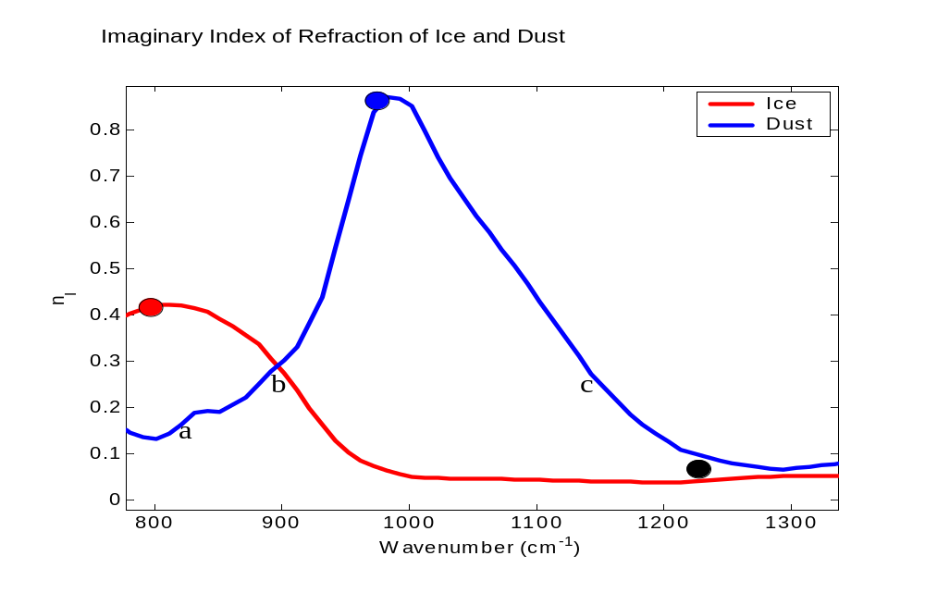
Figure 3. Imaginary part of the dielectric function for dust and ice

3a. As dust in the atmosphere increases, what do you expect BT[833] – BT[909] to do? What will BT[909] – BT[1160] do? As you enter a thin ice cloud what would these brightness temperature differences to do? Give you answers in terms of clock positions as shown below in Figure 4.

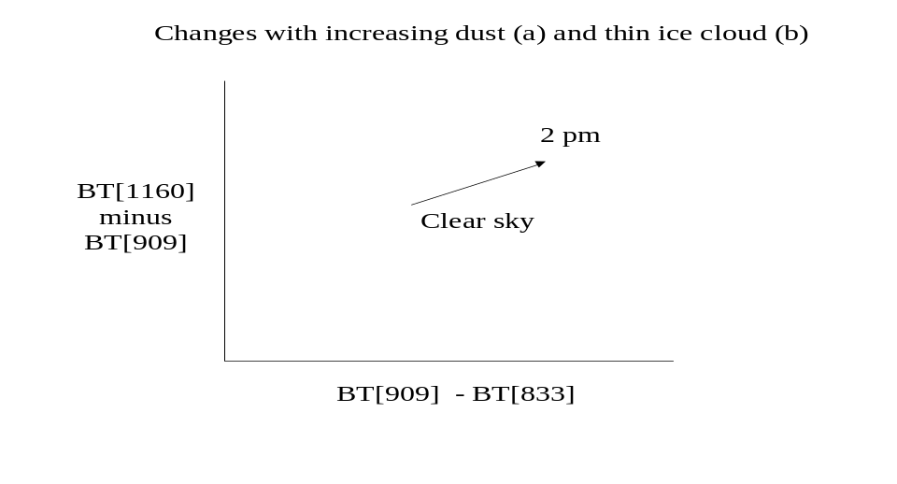
Figure 4. Clock diagram used for illustrating the brightness temperature differences [BT(1160)-BT(909)] versus [BT(909)-BT(833)] when measuring snow and ice

3b. What three clock positions would be optimal for detecting dust? For detecting ice? Explain.

Lab 9 - Cloud Phase determination with MODIS

Strabala / Menzel

- 1. Load the cloud scene over South Eastern Africa and the Mozambique Channel from 2 March 2003 at 1130 UTC detected by Aqua MODIS using the Hydra software (file MYD021KM.A2003061.1130.004.2004079065535.hdf). Open the Multi-Channel Viewer and select the small scene shown in Figure 1 in the main Hydra window.

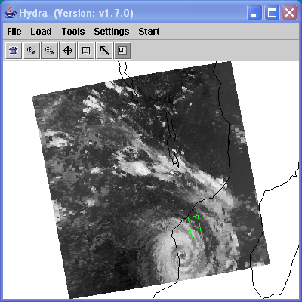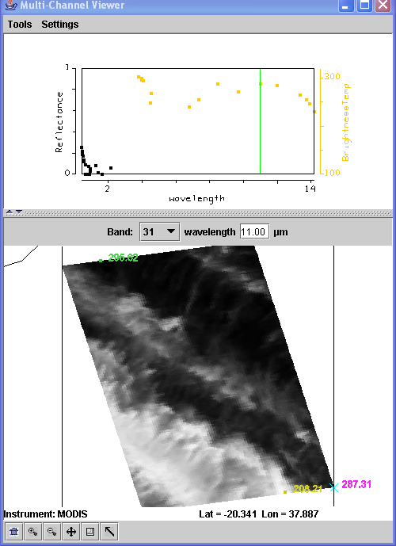

- Figure 3. Cyclone cloud band section of image from Aqua MODIS on 3 March 2003 at 11:30 UTC.

- 1a. What range of brightness temperatures do you see in Band 31 (11 μm) over the clouds? Look at the scene in Band 35 (13.9 μm) and Band 26 (1.38 μm). Can you tell what kind of clouds these are?

- 2. The MODIS infrared phase detection algorithm is based upon the differential absorption of ice and water over the 8-12 micron window region. To examine the technique more closely, create a scatter plot of Band 31 (11 μm) on the x-axis and [Band 29 (8.6 μm) - Band 31 (11 μm)] on the y-axis. Make sure the color scale of the combined difference image is set to gray.

- 2a. Describe what you see. Where are biggest differences (where do they lie in the images)? What can you infer about cloud amount from the scatter diagram? What can you infer about ice cloud absorption between 8 and 11 microns?

- 3. The MODIS infrared phase detection algorithm uses the following thresholds to determine the presence of ice cloud:

Band 31 (11 μm) BT < 238 K

or

Band 29 – Band 31 BTD > 0.5 K

- 3a. Using this criteria, how much of the scene will be identified as ice cloud?

- 4. The water cloud thresholds are:

Band 31 (11 μm) BT > 238 K and Band 29 – Band 31 BTD < -1.0 K
- or

Band 31 (11 μm) BT > 285 K and Band 29 – Band 31 BTD < -0.5 K

- 4a. Map these thresholds onto the scatter diagram and describe how well the algorithm performs on the ice and/or water clouds. Remember, the clear scenes should not be counted. They will be excluded by the cloud mask. Note also that the remaining regions are labeled as uncertain.

4b. After this investigation, how would you describe the strengths and weaknesses of the algorithm?

5. Now create a scatter diagram of [Band 31 (11.0 μm) - Band 32 (12 μm)] on the x-axis and

[Band 29 (8.6 μm) - Band 31 (11 μm)] on the y-axis. What sort of pattern do you see? (You should see a hook shape). By selecting a region in the scatter plot, try to identify the origin of the clear portion of the hook shape. Now identify the origin of the cloud portion.

6. To determine what causes the hook shape, estimate the Planck radiance (using Planck tool) at 8.6, 11, 12 μm for a scene containing clear sky at 300 K and a cloud at 230 K with varying cloud amount, where the cloud fraction varies from N = 0.0, 0.2, 0.4, 0.6, 0.8, and 1.0 (0.0 is completely clear; 1.0 is completely cloudy). The total radiance B_{λ}obs emanating from a partially cloudy field of view (FOV) for a given wavelength is given by

B_{λ}obs = (1-N) B_{λ}clear + N B_{λ}cloud

where B_{λ}obs is the observed radiance, N is the cloud fraction, B_{λ}clear is the radiance from the clear part of the FOV, B_{λ}cloud is the radiance emanating from the cloudy part of the FOV. Convert the Planck radiances to brightness temperatures (using the Planck tool). Plot the brightness temperature difference [Band 29 (8.6 μm) - Band 31 (11 μm)] versus Band 31 (11 μm) for the six different cloud fractions. What does this imply about the hook shape detected in section 2(b)? What other factors might influence the shape of this 'hook'?

Lab 10 - Sea Surface Temperature and Sediment Concentration
Strabala / Menzel

1. Load the Aqua MODIS Level 1B scene (MYD021KM.A2006073.1240.005.2006075012425.hdf) over southwest coast of Africa. Start the Multi-Channel Viewer and examine the entire scene in Band 31 (11 μm). At this wavelength, recall that the atmosphere is almost transparent (i.e., Band 31 is a window band), so the majority of the photons reaching the sensor are from the surface, with a small amount of absorption occurring in the atmosphere due to water vapor.

1a. What are the minimuim and maximum brightness temperatures you observe in Band 31 over the ocean?

1b. Check for evidence of clouds over the ocean as you learned in the cloud masking exercise. You may need to use other MODIS bands to screen out clouds. What are the minimum and maximum brightness temperatures in Band 31 over the ocean in cloud free regions?

2. Now load the full resolution subset region shown in Figure 1, and check for the presence of clouds in the subset region.

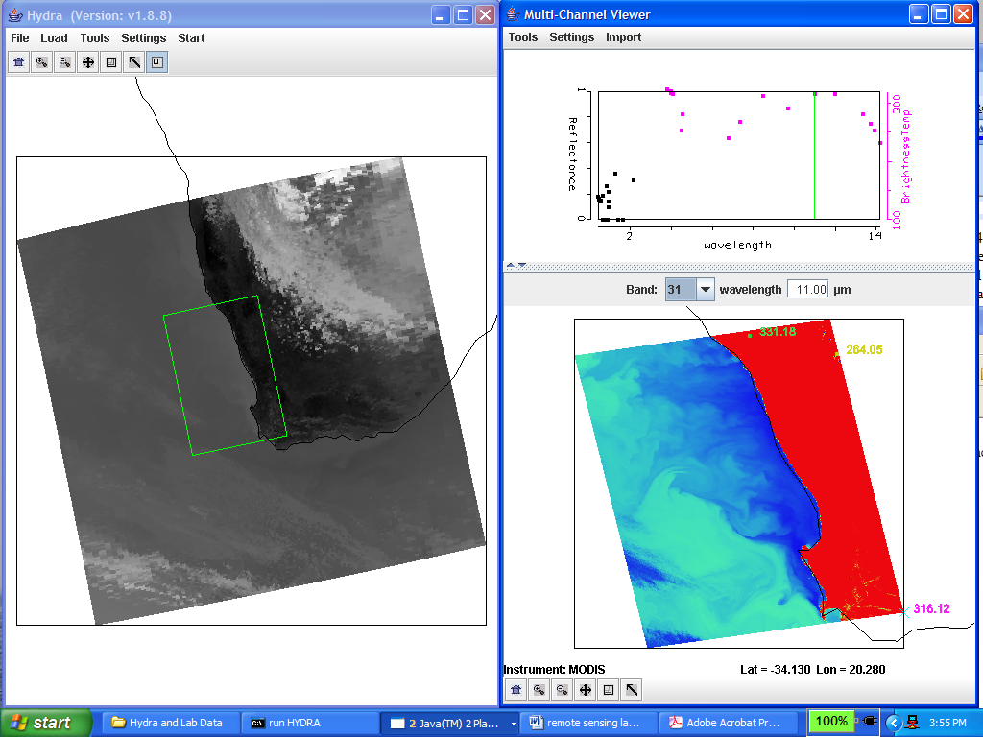

Figure 1: Ocean subset image

2a. Are there clouds present in this region? If so, which bands identify them best? Is there any evidence of cirrus clouds? How can you tell?

2b. What is the brightness temperature range over clear ocean in Band 31 within this region?

3. Bands 31 (11 μm) and 32 (12 μm) of MODIS are sensitive to changes in sea surface temperature, because the atmosphere is almost (but not completely) transparent at these wavelengths. An estimate of the sea surface temperature (SST) can be made from Band 31, with a water vapor correction derived from the difference between the Band 31 and Band 32 brightness temperatures:

SST ≈ BT11 + (BT11 – BT12)

Writing the equation in this form makes it clear that the (BT11 –BT12) term (coming from Band 31 minus Band 32) is a correction factor which compensates for water vapor, i.e., the higher the amount of water vapor, the greater the correction to B31. Figure 2 shows the radiance arising from the ocean surface as a function of water vapor in the atmosphere. You can see that as the water vapor amount increases, the difference between the radiance (and hence the brightness temperature) between Band 31 and Band 32 increases. Thus the difference between Bands 31 and 32 is used as a way to correct for the influence of water vapor on Band 31. Note that this is a very simplified version of the equations used to derive SST from MODIS.

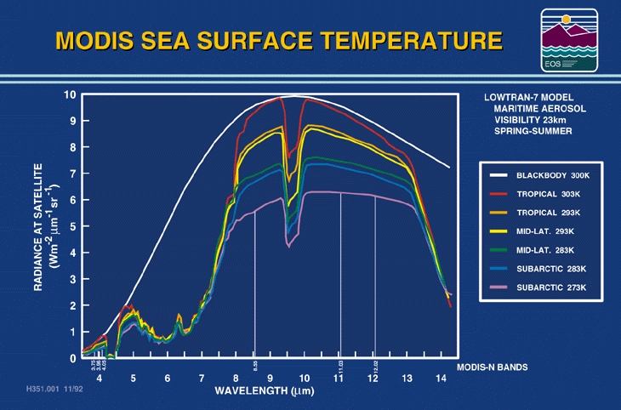

Figure 2: Ocean upwelling radiance for varying water vapor amounts

3a. Construct an image of SST for the subset region using the Linear Combinations tool. Compare the SST derived image to the original Band 31 image. Do they look significantly different? Estimate the magnitude of the water vapor correction (BT11 – BT12) in degrees Kelvin.

3b. What range of SST values do you find along the coast, compared to the deep offshore waters? Can you explain why the SST is different near the coast, compared to the deeper waters?

4. MODIS bands 3 (0.45 μm), 1 (0.65 μm), and 2 (0.87 μm) microns are sensitive to the reflectance of the ocean surface. Clear ocean waters are most reflective at shorter wavelengths, and become darker at longer wavelengths. Sediment laden waters are however more reflective at longer wavelengths, which gives them a brownish to reddish color.

4a. Construct images of bands 3 and 4 over the region shown in Figure 3, and describe the patterns of sediment seen in each band in the vicinity of the Orange River outflow.

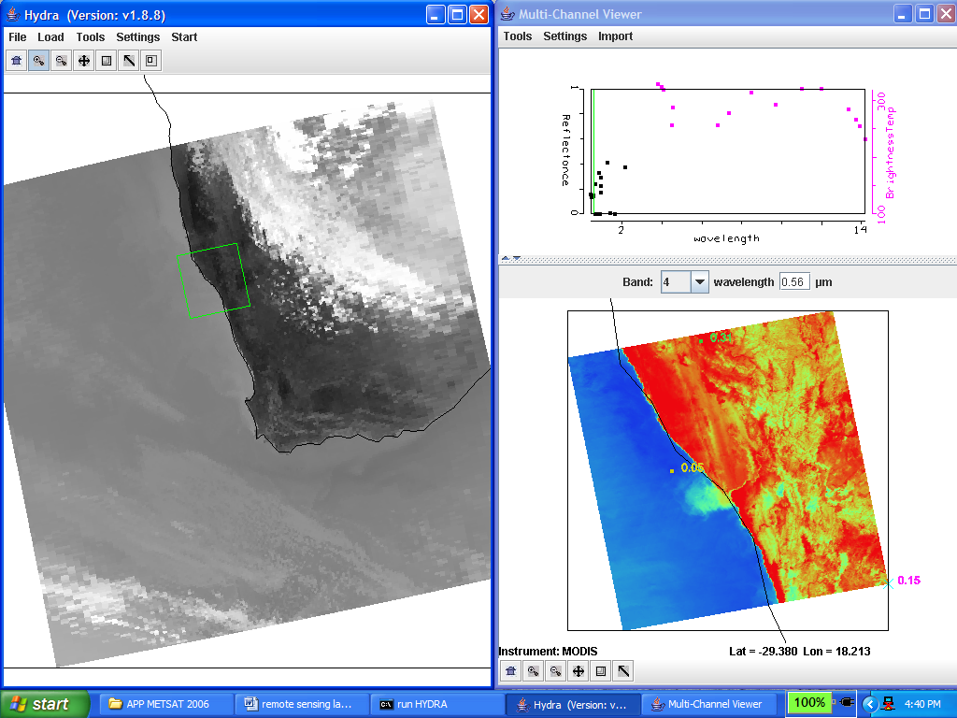

Figure 3: Region selection for Orange River outflow

4b. Which band is most sensitive to low amounts of sediment? Which band is most sensitive to high amounts of sediment? Use Figure 4 to help you with your answer.

Figure 4: Reflectance of ocean water with increasing phytoplankton.

4c. Try constructing an image of Band 4 / Band 3 and compare it to an image of SST as described previously. Do you see any correlation between sediment and SST? What might cause the sediment and SST values to be related?

4d. Confirm your thesis by constructing a scatter plot of SST [2*BT31 (11 μm) – BT32 (12 μm)] on the x-axis and [refl4 (0.56 μm) / refl3 (0.47 μm)] on the y-axis. It should look like Figure 5.

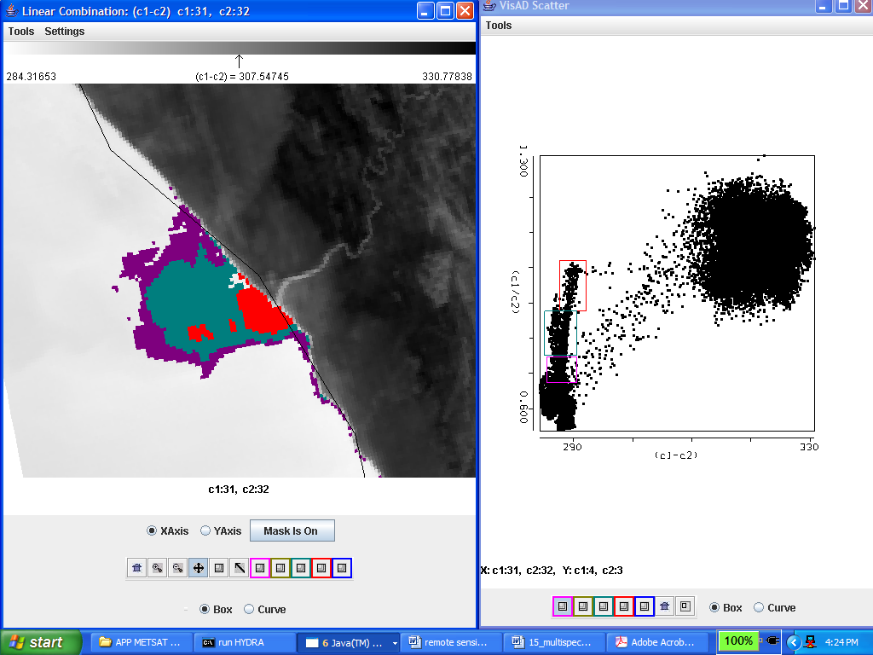

Figure 5: Warmer waters (closer to the Orange River outflow) contain more phytoplankton.
Lab 11 – Exploring the AMSU-A split window
Paul Menzel and Paolo Antonelli

1. Open HYDRA from the Windows Start Menu:

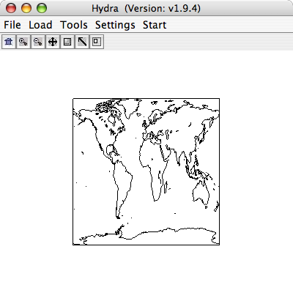

Use the Load→Local Data command to load the 08 March 2008 AMSU-A files in netcdf format (the file is called ama068s0853e0905.nc). Use the Start→Multi-Channel Viewer to open the actual data display interface. Display Band 2.

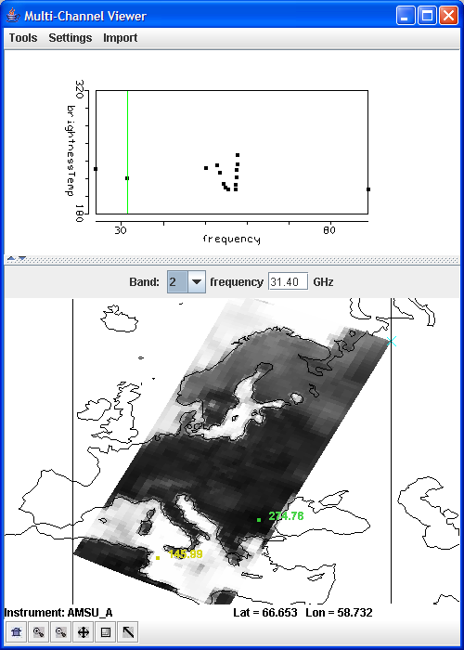

Open another Multi-Channel Viewer and display Band 1. Now the two Multi-Channel windows are linked together and they will allow you to explore the data in a synchronous mode.

2. From the Band 1 Multi-Channel Viewer window engage the Tools→Transect command. A new Transect window will pop up. While holding down the Shift key, right click and drag the cursor to draw a straight line on the image in the Mediterranean Sea south of Italy and the brightness temperature values along the selected line will be displayed in the Transect window. From the Band 2 Multi-Channel Viewer window select the Tools→Transect also on this window, the transects for the 23 and 31 GHz channels will be shown in the Transect window. You will be able to clearly see the difference in sensitivity to low level moisture between the two channels. Close the Transect window. Close the Band 1 Multi-channel Viewer window.

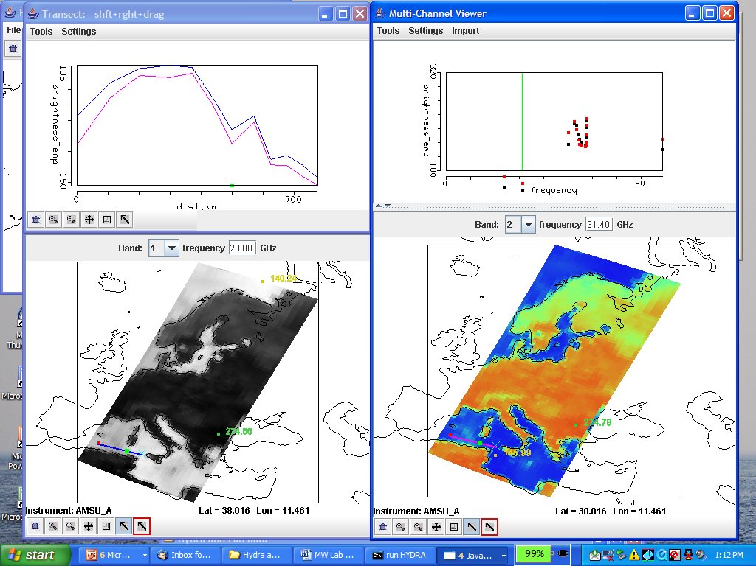

3. From the Multi-Channel Viewer window select the Tool→Linear Combinations command. A new Channel Combination Tool window will pop up. Use this window to create linear combinations of available channels (hereafter referred to as pseudo-channel). You can either enter manually the frequencies or click on the arrow button on the top-right part of the window and then move the colored vertical bars in the figure to select the individual channel to be used to create the desired pseudo-channel.

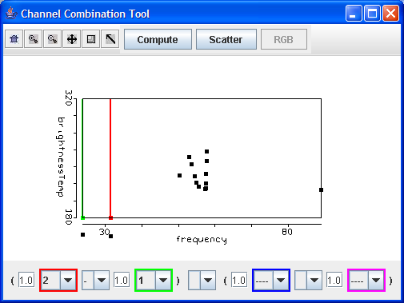

Choose channel 2 (31 GHz) minus channel 1 (23 GHz), click on the compute button on the top part of the Channel Combination Tool window, and the BT31-BT23 pseudo-channel will be displayed in a new Linear Combination window.

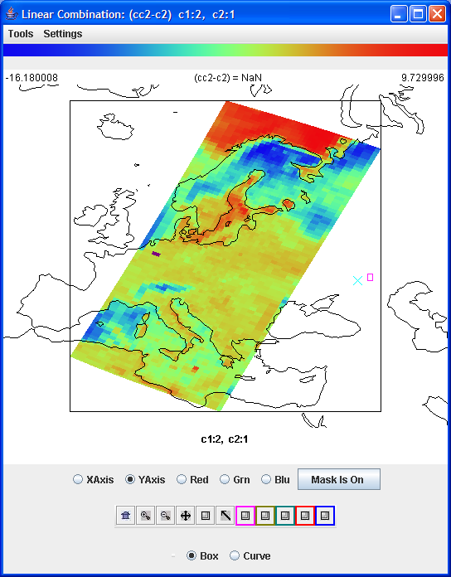

In this new window select the Settings→Set Color Scale→Color command to change from the grey scale to a color scale. Looking at the BT31-BT23 pseudo-channel over oceans (over land surface emissivity differences in the two channels dominate), guess where you might have larger concentrations of atmospheric moisture (please keep in mind that you have no background information available). Create a second pseudo-channel of BT31 alone (disable the operand by selecting no function). Now map the BT31-BT23 pseudo-channel onto the y-axis, the BT31 pseudo-channel onto the x-axis, and create a scatter plot by clicking on the Scatter button in the Channel Combination Tool Window. A new window with a scatter plot will pop up. Click on one of the colored squares and select a group of points on the scatter plot.

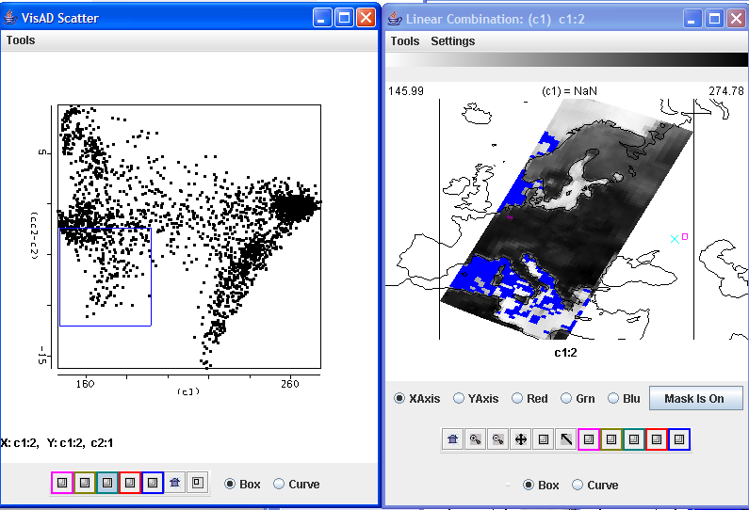

The corresponding pixels will be highlighted in the Linear Combination windows. This operation can be repeated using 5 different colors simultaneously, to identify different parts of the scatterplot.

The highlighting operation can be reversed; an area selected in the Linear Combination image will identify those pixels in the scatter plot.

4. Over oceans, when viewing clouds and atmospheric moisture BT31 is colder than BT23. Can you explain why?

Lab 12 – Combining AMSU Precipitation Estimates and SEVIRI Convection Detection
Paolo Antonelli and Paul Menzel

1. Open HYDRA from the Windows Start Menu:

Use the Load→Local Data command to load the 08 March 2008 AMSU-A files in netcdf format (the file is called ama068s0853e0905.nc). Use the Start→Multi-Channel Viewer to open the actual data display interface.

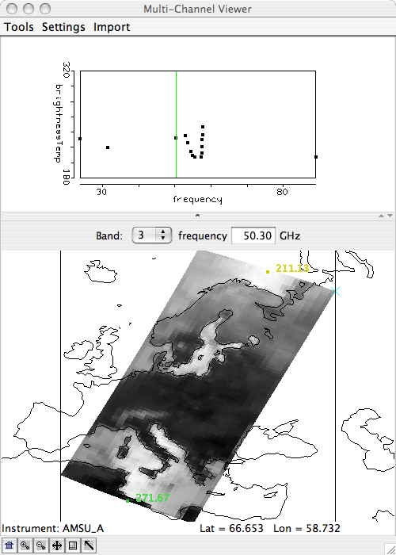

Repeat the loading operation to load the MHS (AMSU-B) file (bma068s0853e0905.nc) and open a new Multi-Channel Viewer. Now the two Multi-Channel windows are linked together and they will allow you to explore the data in a synchronous mode. Familiarize yourself with the data by selecting different channels.

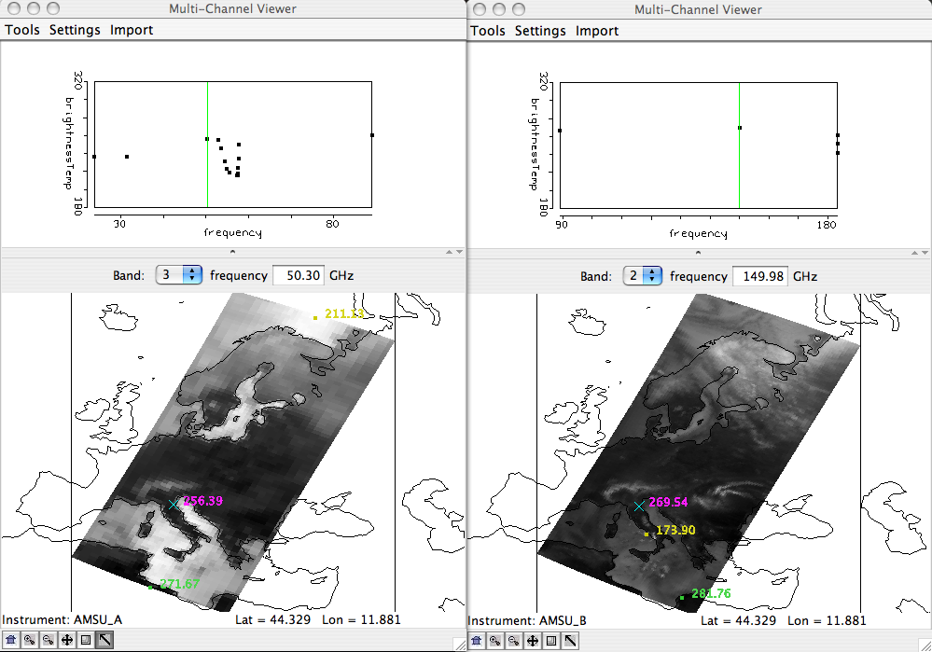

2. From the AMSU-A Multi-Channel Viewer window select channel 15 (89 GHz) and then engage the Tools→Transect command. A new Transect window will pop up. While holding down the Shift key, right click and drag the cursor to draw a straight line on the image and the brightness temperature values along the selected line will be displayed in the Transect window. From the AMSU-B Multi-Channel Viewer window select channel 1 (89 GHz) and then select the Tools→Transect also on this window, the transects for the 89 GHz channel from both instruments will be shown in the Transect window. You will be able to clearly see the difference in spatial resolution between the two instruments. Close the Transect window.

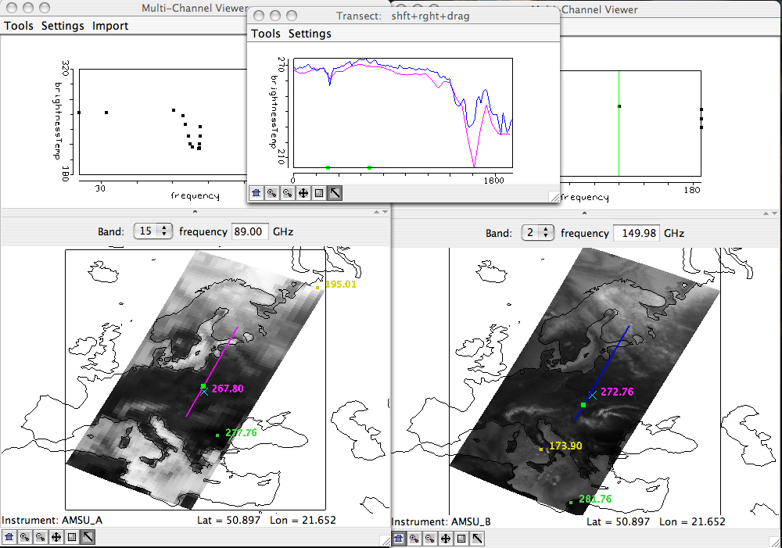

3. From the AMSU-B Multi-Channel Viewer window select the Tool→Linear Combinations command. A new Channel Combination Tool window will pop up. Use this window to create linear combinations of available channels (hereafter referred to as pseudo-channel). You can either enter manually the frequencies or click on the arrow button on the top-right part of the window and then move the colored vertical bars in the figure to select the individual channel to be used to create the desired pseudo-channel.

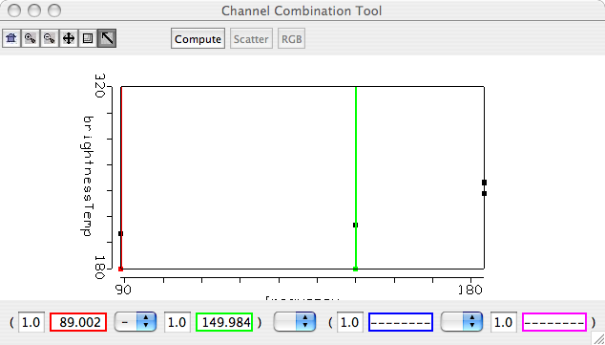

Choose channel 1 (89 GHz) minus channel 2 (150 GHz), click on the compute button on the top part of the Channel Combination Tool window, and the BT89-BT150 pseudo-channel will be displayed in a new Linear Combination window. This is the basis for the Scattering Index calculation.

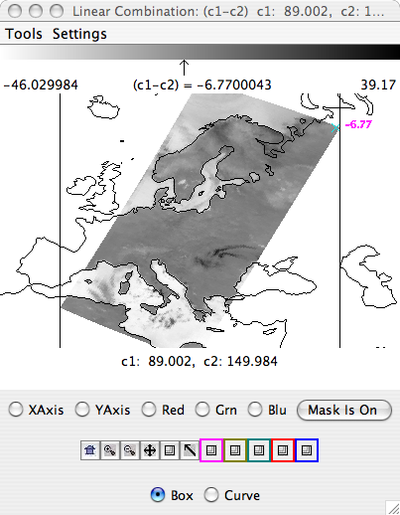

In this new window select the Settings→Set Color Scale→Color command to change from the grey scale to a color scale. Looking at the BT89-BT150 pseudo-channel, guess where you might have precipitation (please keep in mind that you have no background information available). Create a second pseudo-channel of BT89 alone (disable the operand by selecting no function). Now map the BT89-BT150 pseudo-channel onto the y-axis, the BT89 pseudo-channelonto the x-axis, and create a scatter plot by clicking on the Scatter button in the Channel Combination Tool Window. A new window with a scatter plot will pop up. Click on one of the colored squares and select a group of points on the scatter plot.

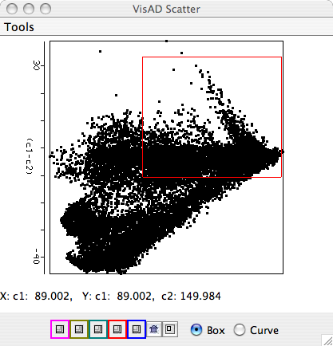

The corresponding pixels will be highlighted in the Linear Combination windows. This operation can be repeated using 5 different colors simultaneously, to identify different parts of the scatterplot.

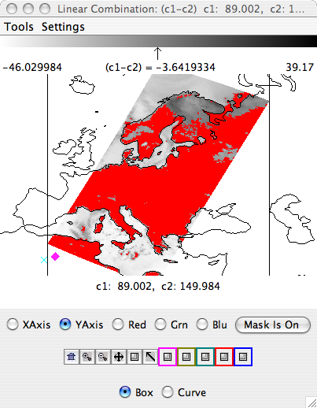

The highlighting operation can be reversed; an area selected in the Linear Combination image will identify those pixels in the scatter plot.

4. From the Hydra window select Load→Local and load the SEVIRI file met9_1234567891011_2008_068_0845.area. Start a new Multi channel viewer (Start→Multi-Channel Viewer). In the Hydra window click on the most right button on and select an area which covers southern Europe:

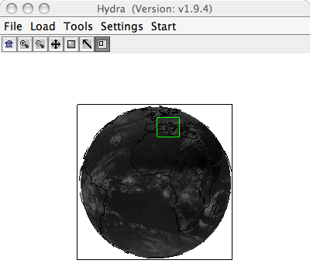
The Multi-Channel Viewer window will show the SEVIRI data for the selected region at full spatial resolution. This image will be in sync with the AMSU images. From this window repeat the channel linear combination sequence and create two pseudo channels (ch7-ch9) and (ch9-ch10) and make a scatter plot (BT7-BT9 on the y-axis and BT9-BT10 on the x-axis). Identify in the scatter plot the pixels associated with ice and water clouds.

5. From the Multi-Channel Viewer window select Tools→rgb and choose three SEVIRI channels, click on the compute button on the RGB combine tool window to display a false color image of the selected area. In the false color image the first selected channel is mapped on the red channel, the second the green and the third in blue.

