GUIDELINES FOR THE PREPARATION OF FINAL PAPERS FOR EUMETSAT-supported CONFERENCEs

Firstname Surname (of presenter), firstname surname (of further authors)

your organisation, street address, city, country

Abstract

In order to achieve a consistent appearance on the web, all papers should comply with these guidelines.

Every author is responsible for his/her article. He/she should therefore ensure that the correct procedures for authorisation of publication or for the use of any material possibly protected by authors’ rights have been followed.

Maximum length
Maximum length for a final paper for inclusion in conference or workshop proceedings will be 8 pages for a regular presentation, 10 pages for a “Keynote” or “Special” presentation, maximum file size is 8MB – please respect font sizes and layout specifics given below.

File formats:
Papers should be submitted in Adobe PDF format.

Page layout:
A4 page in Arial 10 point font size justified, 2.5 cm margin on either side, 3 cm margin each for top and bottom, line spacing single, single-column layout (text runs from left margin through to right margin, NO split into two or more columns), one clear line between paragraphs. Do not use additional footers or headers.

Please DO include the title of your paper and the author information in the final paper PDF file you upload.

Paper title 14 point bold, author names 10 point bold after three clear lines below the title, affiliations 10 point regular (do not include any logos) after one clear line below the authors – all of these centred

Headings level one 11 point bold in capital letters, headings level two 10 point bold – all of these left aligned

Ideally each paper should start with an abstract giving a brief description of the most significant elements – heading “Abstract” 10 point bold and centred

Images and tables
Images and tables should be numbered consecutively throughout the whole paper. Image and table captions should be kept underneath the respective image/table, in size 8 point bold regular, only the labels (“Figure 1:” or “Table 1:”) in bold and italics. Text does not flow around the images/tables, but stops above the image and recontinues below the image/table caption. All tables, figures and mathematical symbols must respect top, bottom and side margins.

Images:
Please insert each image/figure as one file into your document in either jpg, .tiff or .eps format, in a print-suitable resolution of 300 dpi.

Do not combine several image files into one figure, and, especially, please do NOT draw arrows or similar over an inserted image - both of these constellations might cause your figure to be muddled when viewed on other systems. Any arrows or lines to appear on the figure must be a genuine part of the image file.

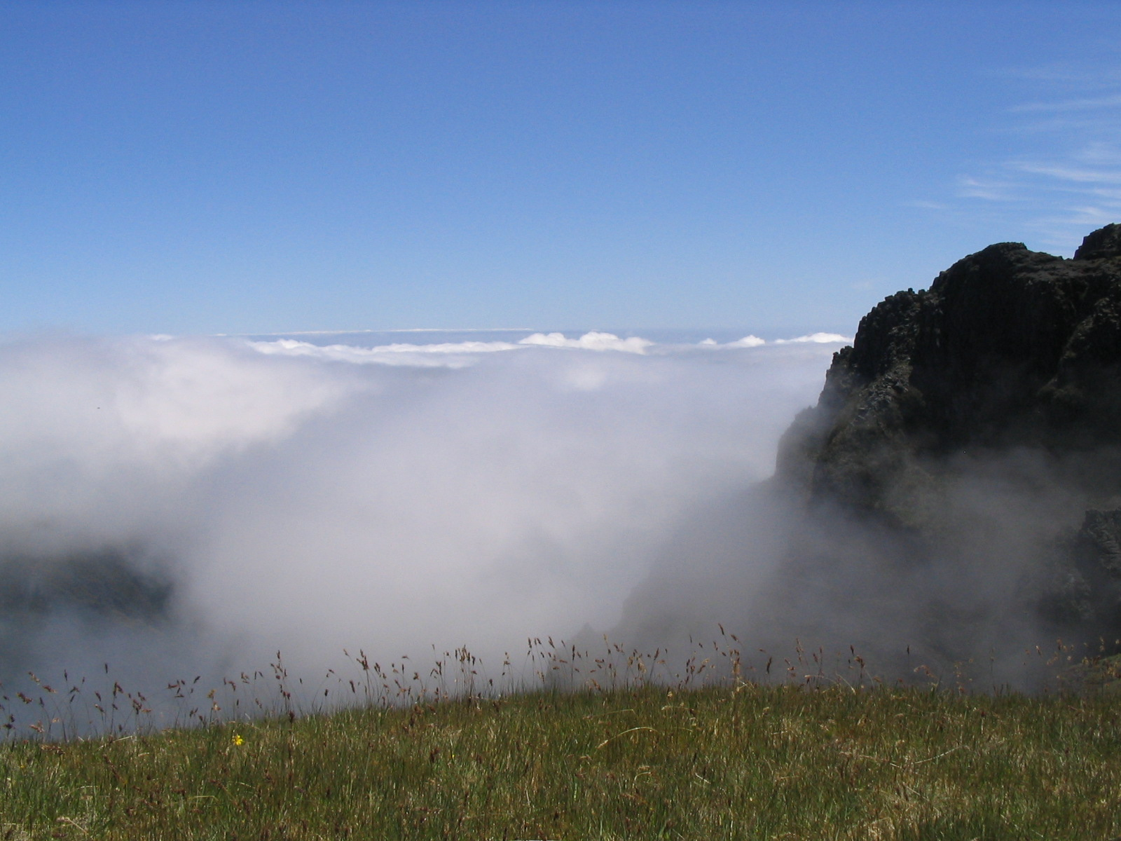
Figure 1: Image and table captions should be kept underneath the respective image or table, in size 8 point bold regular, only the labels in bold and italics.

Tables:
Tables may not have background colours or background images. Please try to keep them simple.

 | Day | Night | Dawn
Situation A | 1 | 2 | 3
Situation B | 4 | 5 | 6
Situation C | 7 | 8 | 9
Situation D | 10 | 11 | 12
Table 1: Image and table captions should be kept underneath the respective image or table, in size 8 point bold regular, only the labels in bold and italics.

References and footnotes:
Bibliographic references must be listed at the end of the paper in Arial 10 point and in alphabetical order of the main author’s surname, e.g.: “Family Name, Initials, (year) Title. Journal, Volume, Issue Number, page numbers (i.e. pp xxx-yyy)”

Please do not include footnotes, but rather endnotes, i.e. all on the last page of your paper – in Arial 8 point

Final paper submission
Please email to Steve Wanzong – stevew@ssec.wisc.edu, with cc to mary.forsythe@metoffice.gov.uk and jaime.daniels@noaa.gov .

References
Family Name, Initials, (year) Title. Journal, Volume, Issue Number, pp 1-100

- No footnotes, but endnotes please
- Listed at the end of the paper, in font Arial 8 point
- etc…..

Copyright ©EUMETSAT 2015
This copyright notice applies only to the overall collection of papers: authors retain their individual rights and should be contacted directly for permission to use their material separately. Contact EUMETSAT for permission pertaining to the overall volume.

The papers collected in this volume comprise the proceedings of the conference mentioned above. They reflect the authors’ opinions and are published as presented, without editing. Their inclusion in this publication does not necessarily constitute endorsement by EUMETSAT or the co-organisers

For more information, please visit www.eumetsat.int

