CGMS XXXVI

International operational AMV algorithms comparison study
Status Report

Summary and Purpose of Document

This paper reports on the current status of the international operational AMV algorithms comparison study proposed at the 8th International Winds Workshop and formulated as Recommendation 34.15 at the 34th CGMS meeting. Part 1 of the Study is completed and the results are presented in this document. Part 2 of the Study is ongoing and it is anticipated to be completed by end of 2008.

Action Requested: See Section “Conclusions and Outlook”

International operational AMV algorithms comparison study

Iliana Genkova (1), Regis Borde (2),
Johannes Schmetz (2), Jaime Daniels (3), Chris Velden (1), Ken Holmlund (2)
1) University of Wisconsin – Madison, SSEC, CIMSS;
2) EUMETSAT ; 3) NOAA-NESDIS

INTRODUCTION
Atmospheric Motion Vectors (AMVs) are amongst the data assimilated routinely by a number of weather prediction centers. The AMV data disseminated by the producers around the world undergo a thorough quality control including quality indicator (QI) and/or recursive filter function (RFF) threshold-based AMV pre-selection, blacklisting, thinning of the data, etc.. Until now there has been a lack of an in depth understanding of how consistent all the data sets are, how algorithm set up and tuning impact the quality of the results, are the quality indicator routines implemented in a consistent fashion, etc. Some of these issues are addressed in this study.

In Part 1 of the study ( known as CGMS-1 Study) five AMV producers – EUMETSAT, NOAA-NESDIS, JMA, KMA, and the Brazilian Meteorological services retrieved AMVs from one MSG-SEVIRI image triplet applying their own retrieval algorithm as it is used in operations, once with the operationally used first guess forecast model, and second time with first guess forecast model from ECMWF. Winds derived by the various producers from the 10.8 μm IR channel are inter-compared. Special attention is given to spatial coherence, agreement in height assignment, and quality indicator consistency between the various wind datasets. This study assesses how the various AMV producer’s data inter-compare in terms of global coverage, speed and direction, what is the importance of the choice of first guess forecast initiating the AMV extraction, the strengths and weaknesses of each retrieval algorithm, and suggests how to better interpret the winds sets prior to and during their assimilation into NWP models.

In Part 2 of the study ( known as CGMS-2 Study) is ongoing at the time of writing of this document. In this study the AMV producers are requested to produce AMVs from the same SEVIRI images, but using consistent target and search box sizes. This will allow for a more meaningful comparison of target height assignments and target height estimation algorithms.

STUDY SETUP (Part 1)

A triplet of SEVIRI images (18 August 2006, 12UTC - 13 UTC) and the corresponding ECMWF model forecast were provided to the AMV producers to apply their own AMV retrieval algorithms, with their own operational settings, using IR (10.8μm) spectral band. One of the triplet images is shown on Figure 1. It is a SEVIRI full disk image from 18 August 2006, 12:15 UTC, band 9 = 10.8μm. This full disk image shows a typical cloud coverage over Europe and Africa – mostly convective development and anvil cirrus over the tropics, low level marine cumulus over the ocean, and a variety of clouds are observed in the mid to high latitudes. Producers first used their operational choice of forecast model data to derive AMVs. They then derived AMVs using ECMWF model forecast data that was made available by EUMETSAT. The resulting winds datasets were collected from five AMV producers and compared. The AMV producers included: EUMETSAT, NOAA-NESDIS/CIMSS, Brazilian Meteorological services, Japanese Meteorological Agency (JMA) and Korean Meteorological Agency (KMA). More spectral bands were considered initially for the study, but only the 10.8μm and 6.2μm bands were used by all producers, thus, the 10.8μm band was selected for this study.

RESULTS AND ANALYSIS

Operational AMV extraction schemes track cloud or water vapour features in a sequence of images. Despite that commonality, the individual AMV producer’s AMV retrieval algorithms are different in many aspects. A summary of these differences is presented in Table 1.

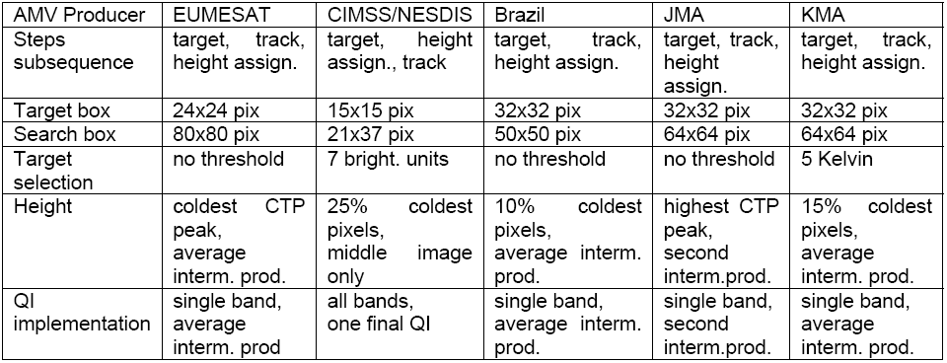
Table 1. Specifics of AMV retrieval schemes used by the various AMV producers

Two major differences in the AMV schemes include: i) The order in which target selection, tracking, and height assignment are done and ii) The selection of pixels from the target scene used for AMV height assignment. NESDIS/CIMSS is the only AMV producer that assigns a height to a target scene from the second image in the triplet before the feature tracking step. The other AMV producers select a target form the first image in the triplet, track it through the sequence and then assign height to it. At the height assignment step, EUMETSAT (at the time of the study runs) builds a histogram of the target pixels CTP and selects the coldest peak of the distribution to be AMV height. Such heights are calculated for the two intermediate products and then an average of the two is assigned to the final AMV. NESDIS/CIMSS uses the second image in the triplet for height assignment. The 25% coldest pixels are used to calculate a mean radiance and retrieve an effective altitude for the AMV. Brazil and KMA follow the approach adopted by NESDIS/CIMSS, however they use 10% and 15% of the coldest pixels, correspondingly. JMA has adopted the EUMETSAT AMV approach in terms of the order in which they run the target selection and height assignment. However, for the height assignment they use the most frequent of the target pixels cloud top heights.
Another important difference among the inter-compared retrievals is the implementation of the Quality Indicator (QI) flag. NESDIS and CIMSS calculate the QI after winds from all spectral bands are extracted. Thus there is a denser AMV coverage to look for buddies from. Intermediate wind vector QI is not calculated. EUMETSAT, KMA, Brazil and JMA calculate QI for the intermediate AMV products. All AMV producers, with the exception of JMA, average the intermediate vectors and associated QI scores. JMA does not average the intermediate vectors and associated QI scores. They report the second intermediate vector and its associated QI only.

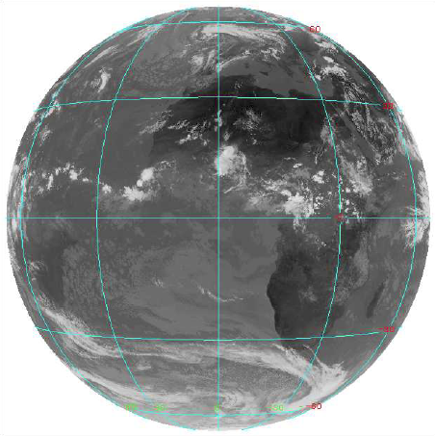

Figure 1. MSG SEVIRI full disk image, 18 August 2006, 12:15 UTC, band 9 (10.8μm)

All producers found that the use of different forecast model data (ie., their own versus ECMWF), does not lead to significant differences in the determination of AMV’s speed and direction. This result suggests that the AMV derivation schemes are not overly dependent on the forecast data. Since the forecast data used operationally by each AMV producer contains a different number of pressure levels, it was decided to closely analyze and inter-compare the AMVs each AMV producer derived when the ECMWF model forecast was used. The expectation was that this would remove one degree of freedom when trying to inter-compare the AMV datasets.

For each wind vector derived from 10.8μm imagery, the AMV producers output latitudinal and longitudinal location, the algorithms target and search box sizes in pixels, AMV speed and direction, brightness temperature, assigned altitude (pressure), corresponding guess speed and direction, height assignment method, and forecast independent quality indicator (QI).

Figures 2-6 illustrate each AMV dataset’s spatial distribution of vectors of all qualities, as well as the frequency distribution for the quality indicator (QI), speed (SPD), direction (DIR), height (H) and heights assignment method (HAM). Employed are the following height assignment methods: 0= EBBT (i.e. IR channel method), 1=CO2 slicing, 2=STC/IR rationing method, 3=Other method. Table 2 offers a statistical summary of the winds datasets generated by each AMV producer. In general, the data sets exhibit similar histogram shapes, number and location of maxima. Bulk statistics (see Table 2) support this observation. CIMSS QI have significantly higher values than the rest, due to fact that target do not follow a model grid distribution, thus the distance check component from QI is contributing more as the distances at non-gridded AMV locations are shorter. Also, CIMSS/NESDIS pre-screen targets, thus only high contrast targets (more than 7 brightness units) are processed; hence winds are expected to be better due to algorithm specifics.

KMA’s number of winds is significantly lower. Most probably, this is associated with threshold requirement for selecting a target and following a model grid for target’s location. It is also interesting that KMA reports a significantly lower amount of mid level clouds. This may be due to erroneous high assignment. Brazil’s lower value for low winds Pmean is due to not applying a low level inversion correction. Similar explanation could be attributed to CIMSS slightly higher low level winds mean altitude. Every data set has its own low limit for reliable speed retrieval, and this governs the slight differences in mean speed. The noticeably high speed retrieved for low level winds is obviously unrealistic and evidence for wrong height assignments in situations such as thin cirrus clouds over lower cloud decks, when the fast speed of the cirrus is assigned to a low warm cloud dominating the value of the brightness temperature. CIMSS/NESDISS and EUMETSAT retrievals seem to handle best such cases thanks to adopting algorithm checks for multilayer scenes.
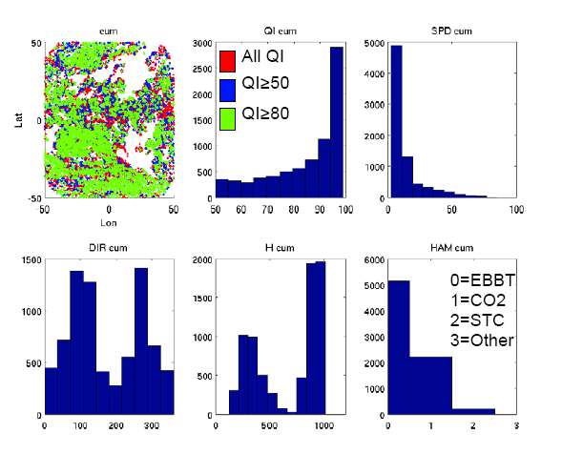
Figure 2. Spatial distribution of all AMVs (red), AMVs with QI≥50 (blue) and AMVs with QI≥80 (green) (top left panel); QI distribution (top middle panel); Speed (m/s) distribution (top right panel); Direction (deg) distribution (bottom left panel); AMV Pressure (hPa) (bottom middle panel) and Height Assignment Method (HAM) (bottom right panel) for EUMETSAT’s IR10.8 winds from 18 August 2006, 12:15 UTC.

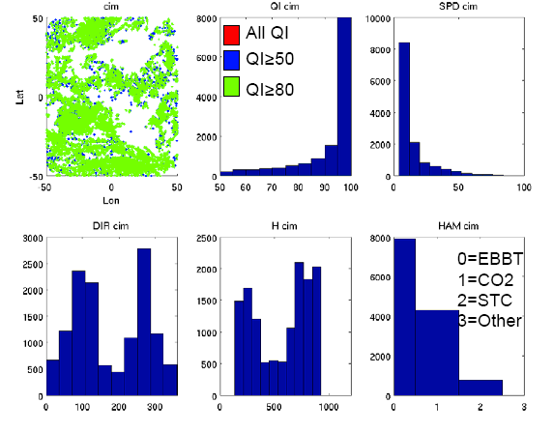

Figure 3. Same as Figure 2, but for NESDIS/CIMSS winds dataset
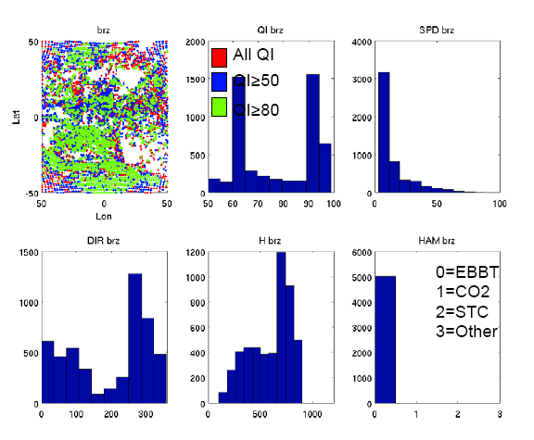
Figure 4. Same as Figure 2, but for Brazil winds dataset

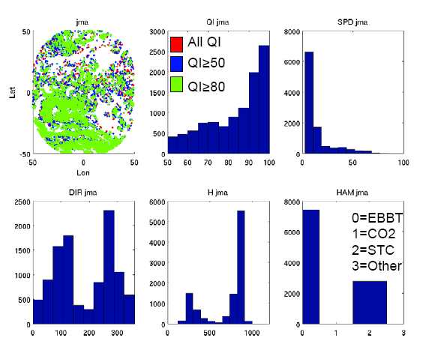
Figure 5. Same as Figure 2, but for JMA winds dataset

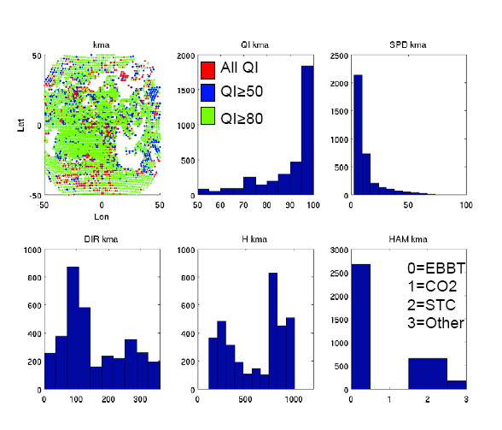
Figure 6. Same as Figure 2, but for KMA winds dataset

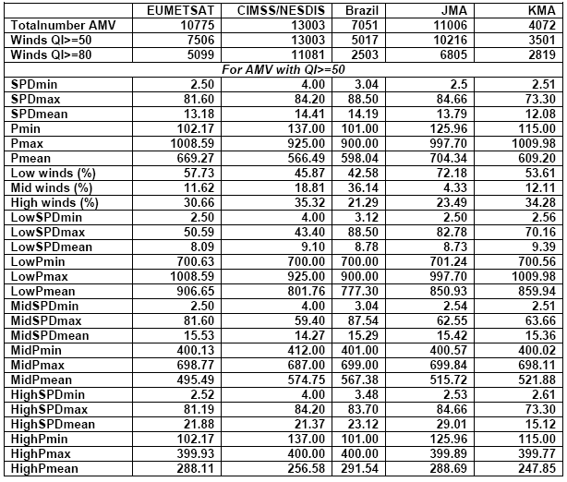
Table 2. Statistical summary of the AMV datasets generated by each AMV producer. Only AMVs with QI scores > 50 are included in these statistics.

Next, the datasets are collocated such that the distance between matched AMVs is equal or less than 0.5 deg longitude- and latitude-wise, and all participating teams have retrieved a wind vector for the matched location. The collocated subset consists of 647 AMVs. Note that because of the very few mid level winds from KMA, our conclusions from here on will pertain mostly to low and highs clouds. Figure 7 depicts the speed, direction, height and quality indicator comparison for the collocated winds. Best agreement is observed for the speed, with increasing divergence for faster winds. The difference in speeds retrieved by all producers for a single AMV match could vary from 0 and 25.34 m/s, and the median value is 2.99m/s. The median directional difference is 22.6 deg. However it is worth noticing that KMA is contributing most to it, due to an unexplained high number of winds with 90 degree direction. This will be investigated further. The winds altitude comparison on Figure 7 shows that the EUMETESAT AMV heights for low clouds have the lowest values due to low level correction applied to them. JMA is implementing a low level correction as well. The other AMV producers are advised to consider adding such a low level correction scheme allowing for a fairer comparison of the low level wind heights. For high clouds the pressure spread is larger, but no tendencies are observed. Height discrepancies are as little as 20hPa and as large as 747 hPa, and the median value is 175 hPa. A valuable, but surprising finding of this comparison is the large spread of QI values for each matched wind despite the reasonable agreement in speed, direction and height. Thus, using QI for data thinning and screening prior to data assimilation is probably not very efficient, as it will include winds of different quality. Despite all teams have followed Holmlund, 1998 paper to code their QI schemas, the particular implementation are different, see table 1. Thus, one major recommendation from this study is to review the QI implementation. Further more thorough investigation will guide the teams to reconcile the QI differences.

The last component of the first part of this study is to inter-compare the heights of the AMVs generated by the various AMV producers. Figure 8 shows the CIMSS/NESDIS, Brazil, JMA and KMA winds altitudes are plotted against the EUMETSAT heights. For high clouds the linear correlation is quite good, except for a few outliers. For low clouds however, there is a significant amount of winds, derived by KMA, placed too high in the atmosphere. They are circled in a crossed red oval curve. Their locations on the full disk image are shown on Figure 9(a), thus illustrating what conditions are driving this strong disagreement. It is evident that over ocean areas the low clouds are assigned wrong heights. The reasons for this phenomenon will be investigated. Since there is a consistent cloud situation that is causing these wrong height assignments, we hope it could be addressed in further KMA HA version, and for this study we will exclude these data from the statistical analysis. The other distinct group of problematic cases is on the top left part of the plot and circled in red. Brazil, JMA and KMA have assigned mid level to low heights instead of high heights as EUMETSAT and CIMSS did. The spatial distribution on Figure 9(b) however shows that there are many and various condition causing this - broken clouds, cirrus clouds, convective regions, cloud edges, etc., thus it would probably be more difficult to address all these issues at once, so we will leave these data point as is. Finally, plotting a linear fit for each data set against the EUMETSAT winds derives the following fit equations:

CIMSS Y=0.8*x+34.1
BRAZIL Y=0.6*x+196.8
JMA Y=0.8*x+53.7
KMA Y=0.8*x+21.4

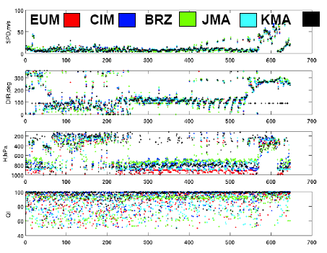
Figure7. Speed, Direction, AMV Height and QI for the collocated dataset for AMVs with QI scores ≥50

STUDY SETUP (Part 2)

In the second part of the global international operational AMV algorithms comparison study we requested that the producers use the same SEVIRI imagery as in study Part 1, but apply their own operational wind retrieval algorithm using target box size 24x24 pixels and search box size 80x80 pixels. The aim was to understand the importance of pixel selection on the HA routines, and also how consistent the QI implementation is when AMV are derived on the same spatial grid. Again the IR(10.8micron) spectral band, is used along with forecast model data from ECMWF. The 00:15 UTC image is used for AMV height assignment (when algorithm permits).

Table 3 presents the bulk statistics of each AMV data set using 24 target and 80 pix search box size. Only winds with QI equal or greater than 50 are included.

IR-10.8 EUM CIMSS Brazil JMA KMA
Total num AMV 10775 4019 10128 10464 17082
Winds QI>=50 7506 4019 5759 9786 12684
Winds QI>=80 5099 2541 3869 6488 6037
***For AMV with QI>=50 ******************************
SPD min 2.50 4.00 3.04 2.5 2.61
SPD max 81.60 89.10 110.25 82.25 135.27
SPD mean 13.18 14.40 14.70 13.72 12.85
P min 102.17 137.00 105.00 129.18 20.00
P max 1008.5 925.00 900.00 996.28 999.00
P mean 669.27 537.7 612.17 724.81 650.64
Low winds% 57.73 43.15 47.54 74.45 55.18
Mid winds% 11.62 13.31 34.24 2.84 24.09
High winds% 30.66 43.54 18.21 22.71 20.73
Low SPD min 2.50 4.00 3.04 2.50 2.89
Low SPD max 50.59 26.50 97.92 52.33 91.85
Low SPD mean 8.09 8.53 9.12 8.96 8.76
Low P min 700.63 700.00 700.00 720.98 700.02
Low P max 1008.5 925.00 900.00 996.28 999.00
Low P mean 906.65 808.39 770.85 869.40 825.92
Mid SPD min 2.50 4.00 3.04 2.63 2.61
Mid SPD max 81.60 64.30 72.90 60.96 81.47
Mid SPD mean 15.53 13.67 15.74 18.07 16.93
Mid P min 400.13 412.00 401.00 400.44 400.18
Mid P max 698.77 687.00 699.00 697.26 699.99
Mid P mean 495.49 519.94 573.94 470.63 578.29
High SPD min 2.52 4.00 3.48 2.53 2.89
High SPD max 81.19 89.10 110.25 82.25 135.27
High SPD mean 21.88 20.43 27.07 28.79 18.97
High P min 102.17 137.00 105.00 129.18 20.00
High P max 399.93 400.00 400.00 399.25 399.81
High P mean 288.11 275.90 297.30 282.52 268.10

Table 3. Statistical summary of the AMV datasets with target/search box 24/80 pix.

The statistics in Table 3 show that, despite the cut-off threshold of QI=50, there are still AMVs which show high QI scores, but are in fact, outliers. For example, Pmin reported by KMA is 20 hPA, while all other producers Pmin values are around 100 hPa.. KMA’s data set show highest SPDmax , while it shows the slowest SPD max in Table 2. Brazil and KMA report consitently extremely high Low level winds SPD max. Another alert about KMA’s data set is the very high number of AMVs compared to the Part 1 study. JMA’s reported amount of mid-level winds remains too low compared to the other AMV producers. Finally, NESDIS/CIMSS algorithms appear to be not well suited for larger target and search box sized, as the correlation requirements during the tracking step are very strict. We find it necessary that all this issues are addressed before going into further investigations about the HA and QI as stated in the Introduction section.

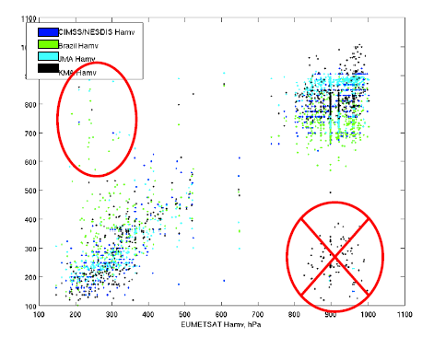
Figure 8. AMV heights inter-comparison

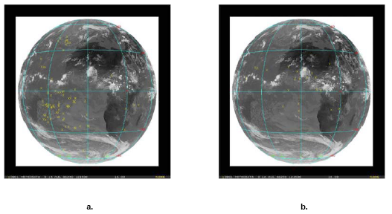
Figure 9. (a) Location of AMVs with low bias from KMA; (b) location of AMVs with high bias from Brazil, JMA and KMA

CONCLUSIONS AND OUTLOOK

In this study, AMVs generated from a common MSG-SEVIRI dataset (18 August 2006) by five AMV producers – EUMETSAT, NOAA-NESDIS, JMA, KMA, and the Brazilian Meteorological services, were compared. A statistical analysis of the differences between these various datasets showed median values for the difference in Speed, Direction and Pressure to be 2.99m/s, 22 deg and 175 hPa, respectively. It is recognized that the process of target selection remains important for the quality of retrieved AMVs, including the size of the target and search box sizes. AMV height assignment differences between operational producers are driven by numerous differences in algorithms - target box size, pixel selection for height assignment, height assignment method, image used for the assignment. Quality indicator remains the simplest, yet efficient measure of the AMV quality. However, its implementation needs to be revisited and unified across the AMV producing centers.

Using a common model forecast (JMA used their own model forecast) eliminated height assignment discrepancies introduced by temperature to pressure conversion. Retrieving AMVs on the model forecast grid explains the lower number of winds from Brazil and KMA. It is hard to interpret the differences in the assigned AMV altitudes when various target sizes are used. Based on the findings in this study the following recommendations are made to the AMV producers in anticipation of future inter-comparison studies:

- KMA could investigate the reasons for too few mid-level AMVs;
- JMA - height assignment for low broken clouds over ocean; slower mean speeds;
- All AMV producers review their low level inversion correction and implement one if they do not do so currently;
- CIMSS could increase the size of the target and search box sizes;

The second part of this study revealed that every producer’s algorithm is fine tuned to the satellite it has been developed for, and this is why a number of AMV outliers are observed when consistent target and search box sizes are applied. They have to be removed and/or explained before we carry one with interpretation of the height assignment and the quality indication inconsistencies.

The importance of unifying the implementation of the QI is driven by the fact that QI is the only AMV quality metric used by many of the operational NWP centers when assimilating the AMV products. When carrying on with the Part 2 of this study, it may be helpful to inter-compare the five data sets only for geographical areas which are not blacklisted during the data assimilation step. Lastly, the AMVs quality will have to evaluated independently through comparisons to RAOBS and/or ECMWF model U-V wind fields.

REFERENCES:
Velden, C. S., J. Daniels, D. Stettner, D. Santek, J. Key, J. Dunion, K. Holmlund, G. Dengel, W. Bresky, and P. Menzel, (2005) Recent Innovations in Deriving Tropospheric Winds from Meteorological Satellites. Bull. Amer. Meteor. Soc., 86, 205-223.

Holmlund, K., (1998) The utilization of statistical properties of satellite−derived atmospheric motion vectors to derive quality indicators. Wea. Forecasting, 12, 1093−1103.

