4th NOAA Hyperspectral Workshop

17-19 August 2004

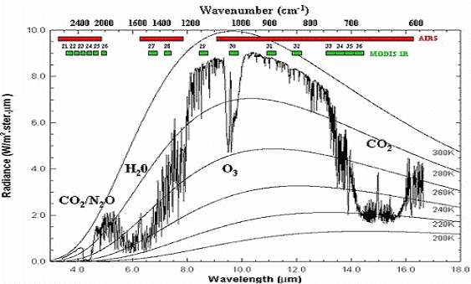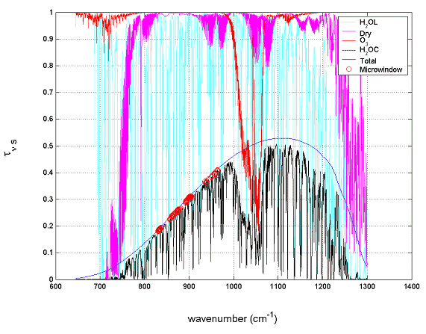
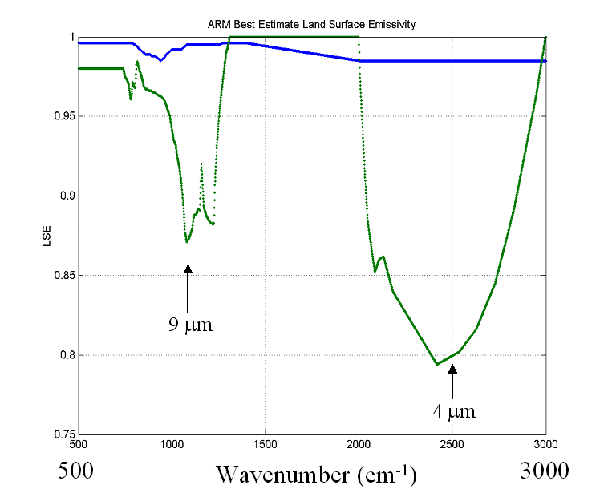

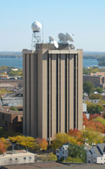
At the
University of Wisconsin-Madison
Cooperative Institute for Meteorological Satellite Studies
Madison, WI

 | NOAA Satellite and Information Services  National Environmental Satellite, Data, and Information Service

Report on the
4th NOAA Hyperspectral Workshop

17-19 August 2004

at the

University of Wisconsin-Madison
Space Science and Engineering Center
Madison, WI

Sponsored by the NOAA National Environmental Satellite, Data, and Information Service (NESDIS) Office of Research and Applications (ORA) and the Cooperative Institute for Meteorological Satellite Studies (CIMSS)

Report compiled by
Timothy J. Schmit
Office of Research and Applications
National Environmental Satellite, Data, and Information Service
National Oceanic and Atmospheric Administration

03 September 2004

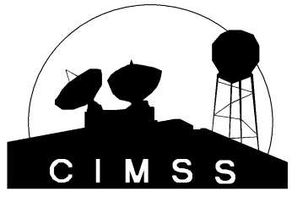

Table of Contents

Executive Summary 3
Recommendations 3
Meeting Summary 5
Introduction 5
Issues of hyperspectral data in relationship to Radiative Transfer (RT) 5
Applications of hyperspectral data 9
Instrument Options 16
System Strategies 18
Tools 20
Break-out sessions 24
Ocean /Coastal/Land 24
Climate/Trace Gases 25
Atmosphere/Clouds 26
Concluding Remarks 26
Appendix 1: Workshop Goals 27
Appendix 2: Participant List 28
Appendix 3: Agenda 30

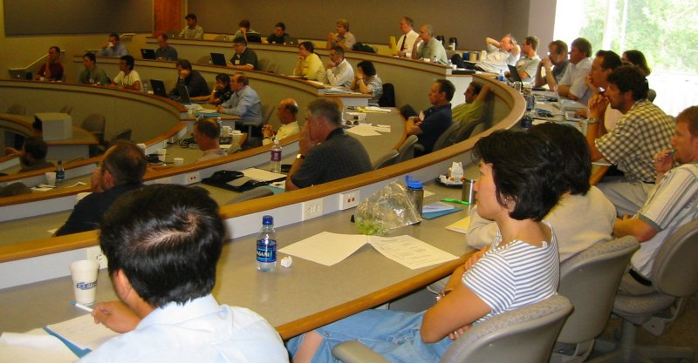

Executive Summary
The 4th NOAA Hyperspectral Workshop was held August 17-19, 2004 in Madison, WI. There were more than 50 total participants from the government, academia, and the private sector. The main goal was to explore broadband adequacy versus hyperspectral necessity for environmental characterizations (land, ocean, atmosphere, etc.). This and the other workshop goals were successfully met. Presentations were given on a range of topics showing how hyperspectral information can help fulfill NOAA’s goals. The presentations are on-line at: http://cimss.ssec.wisc.edu/goes/meetings/4th_hyperspectral/slides/4th_hyperspectral_list.html.

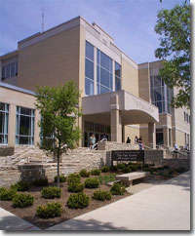
The workshop was hosted by the Space Science and Engineering Center (SSEC), University of Wisconsin-Madison (UW) by the Cooperative Institute for Meteorological Satellite Studies (CIMSS) and the Advanced Satellite Products Team (ASPT) of the NOAA National Environmental Satellite, Data, and Information Service (NESDIS) Office of Research and Applications (ORA). The meeting was held at the Pyle Center on the University of Madison campus. It is anticipated that future workshops will continue this effort to understand how best hyperspectral observations complement other observations of the earth, atmosphere and land system.

Recommendations
During the workshop, several recommendations were made. They are:

Recommendation #1: Continue these series of workshops. Continue to rotate the location of the workshop. One potential topic to include in a future workshop could be to understand how best hyperspectral observations complement other observations of the earth, atmosphere and land system. No location or date was set.

Recommendation #2: Field campaigns to “ground truth” (land, ocean and atmosphere) both before and after launch are needed. Before launch would be used to simulate what the satellite data would be like. After launch would be for product/radiance validations.

Recommendation #3: Develop testbeds, etc with select forecast offices to look at some products before the flood of data. NOAA NWS (and other users) need to be part of the process. Develop testbed now. Use simulated and polar data (AIRS, IASI (Infrared Atmospheric Sounding Interferometer), etc) before launch. Support must be given to GIFTS for HES- associated GOES-R Risk Reduction activities.
• How do we move all these data around? Within the NWS?
• Compression?
• Develop user support tools/forecast guidance

Recommendation #4: Synergy between HES/CW/ABI (Advanced Baseline Imager) means the data needs to be not only temporally synched up, but also, more importantly, there needs to be similar path/view angles. For example, using the data together would be complicated if there were only one sounder located in the center of the country and two imagers on the “wings”.

Recommendation #5: It needs to be understood that for climate change, the surface is changing over time (hyperspectral is more flexible).
Recommendation #6: We need to develop our capability of using hyperspectral measurements with AIRS. We need to learn to do it right now to save future resources. Reprocessing is a needed requirement for using hyperspectral observations for climate (resources need to be identified). Systems for hyperspectral data archiving and processing need to be in place.

Recommendation #7: More intra-satellite data needs to be planned, but also resources allocated.

Recommendation #8: Several questions need to be researched:

What does hyperspectral add for forecasting Ice—freezing rain and snow, blowing dust, dust level? smoke? Downburst (dry) potential? Ash? Clouds? Consider the effect of hyperspectral data on traffic weather – reach out to other communities.

How do we combine HS IR (4km) with all other measuring systems including the HS VNIR (150-300 m) with lower spatial resolution be accurate GPS OS (Occultation Sounding). The GPS OS can help with tropopause, etc. How will improved retrievals improve the watch/warning “storm alerts?

Investigate, within NWP capabilities, the different roles of GOES-R, global-scale versus synoptic and meso-scales. Taking into account the fixed nature of the polar satellites and the adaptive nature of the geo satellites. Are there international agreements? Systems of Satellites. Leverage the work of THORPEX.

Recommendation #9: More work needs to be done to bring the various hyperspectral communities together. For example, needs for atmospheric determinations, cloud detection, etc are shared by both the atmospheric and oceanographic communities. Similar tools could be shared. An effort must be made to include more scientists with land and ocean hyperspectral experience so all of NOAA’s goals can be properly addressed.

Recommendation #10: Allocate sufficient resources to research (including Radiative Transfer), product development, user readiness (training, testbeds), etc. With the total system cost of a GOES-R system likely to exceed $100K/day an adequate amount should be invested--at least 1% of total costs. The total system cost must include all the resources necessary to actually use the data operationally.

Recommendation #11: The scientific community needs to resolve issues of nomenclature. Having people refer to the same instrument as hyperspectral, high spectral, and ultraspectral is unnecessarily confusing.

Meeting Summary

Introduction
T. Schmit, NOAA NESDIS ORA gave a short summary as to the need of hyperspectral observations. It was noted that tightening requirements are one of the reasons that hyperspectral observations are needed. Hyperspectral data allows for a greater number of products and applications. Use of hyperspectral data can improve products in a number of areas: atmosphere, hazards, climate, ocean, land, etc. Hyperspectral measurements can help fulfill each NOAA goal:

- Protect, restore, and manage the use of coastal and ocean resources through ecosystem-based management

- Serve society’s needs for weather and water information

- Understand climate variability and change to enhance society’s ability to plan and respond

- Support the Nation’s commerce with information for safe, efficient, and environmentally sound transportation

Ed Howard, NOAA NESDIS OSD spoke on the complexity of the littoral zone and the potential benefits of hyperspectral data, specifically in the areas of habitat, water quality, living resource and waterways.

Issues of hyperspectral data in relationship to Radiative Transfer (RT)
Three talks were given dealing with the issues of hyperspectral data and radiative transfer. The first two dealt with the infrared (IR) and the final presentation with the visible/near IR.

Larrabee Strow, UMBC spoke on recent updates. In general, RTA accuracy is now on order of instrument accuracy. Work is being done to account for the effects of scattering in the IR. More work needs to be done; dust needs to be accounted for in the cloud detection step.

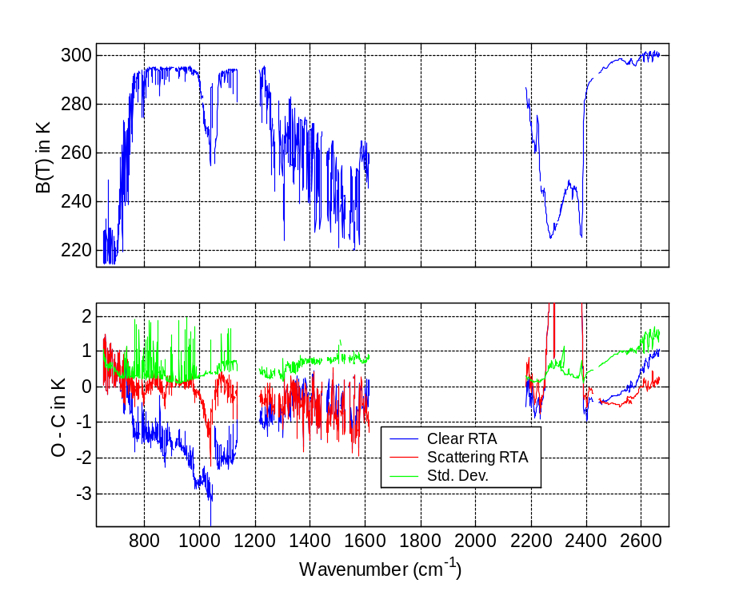
Spectral Fitting: Bias and Standard Deviation that shows the need to include dust.

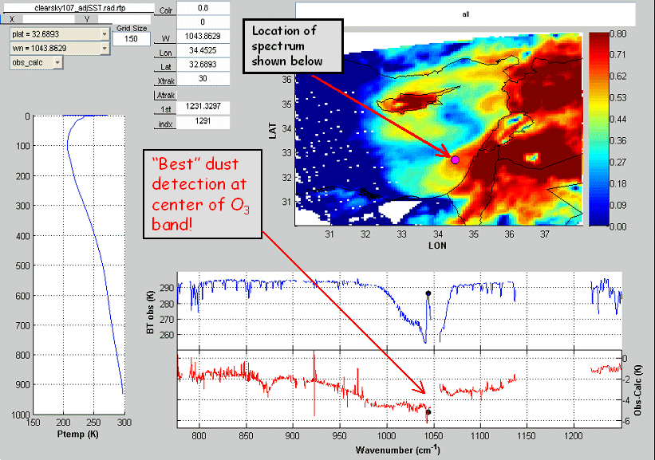

Dust Signature from AIRS (Atmospheric InfraRed Sounder) over the Ocean.

Tom Greenwald, CIMSS, gave a summary of RT of clouds -- Computing High-Spectral-Resolution Thermal Radiances in Cloudy Atmospheres. He demonstrated the relatively large effect of Crystal Habit on IR Brightness Temperature spectra. Note that there can be brightness temperature differences of over 6K just due to changes in the crystal shape.

Tom also raised a number of issues:
- How to treat gas absorption in a scattering atmosphere?
- How accurate do fast models need to be?
- What model should be used as accuracy benchmark?
- Is particle shape important?
- Should 3D effects be addressed?

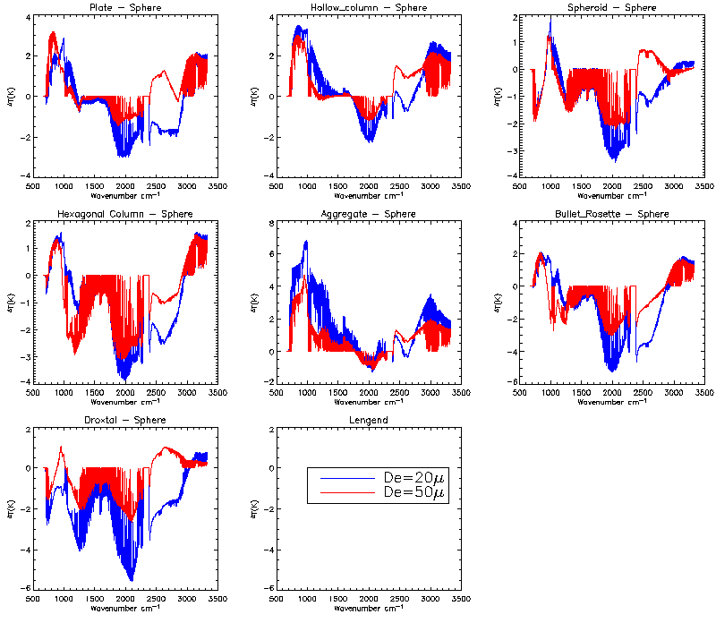
Crystal Habit effect on IR Brightness Temperature. Changes spectrally and due to the particle size and shape.

Mike Griffin MIT/LL and Andy Heidinger, NOAA NESDIS ORA, spoke on the Radiative Transfer in the VNIR/SWIR spectral region. Top of the Atmosphere for a number of surfaces show the potential of hyperspectral observations for understanding the surface features.

Some of the issues raised:

• Scattering is rarely negligible in VIS/NIR remote sensing – makes any radiative calculation time consuming. Due to a lack of azimuthal symmetry, methods used in IR/MW (two-stream) are not applicable.
• Even in absorption lines where scattering is reduced, radiative transfer is difficult to parameterize in an efficient and accurate way. Requires knowledge of the photon pathlength distribution.
• Approximate techniques exist for assumed profiles (single layer clouds, smooth aerosol profiles)
• The concept of “super” channels has proven useful in VIS/NIR hyperspectral remote sensing. Super channels involve the grouping of channels by similar absorption strength to improve noise and speed computation.
• Other methods involve the use of the “equivalence theorem” where knowledge of the photon path length and the value of the reflectance in a non-absorbing part of the spectrum allows for rapid computation of the reflectance within absorption lines.

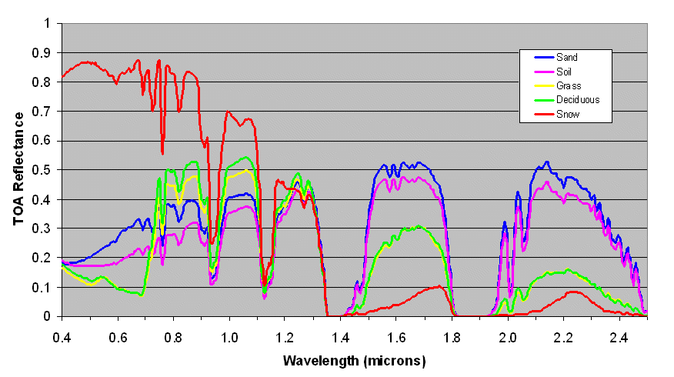
TOA Reflectance -- Nadir View, 23 km Visibility, SZA = 30o

Applications of hyperspectral data

There were presentations on a host of applications of hyperspectral data. These applications ranged from the atmosphere, clouds/aerosols, tropical cyclones, numerical weather prediction, land, ocean, climate, and trace gases. Only select points are summarized here, more information was given during each presentation. Those interested should review the entire presentations.

Allen Huang, CIMSS, spoke on various atmospheric applications. He showed the improved resolving power of the hyperspectral measurements, compared to broadband instruments. (Allen Huang also reminded us that the term ultraspectral should be used when we have more than 1000 channels).

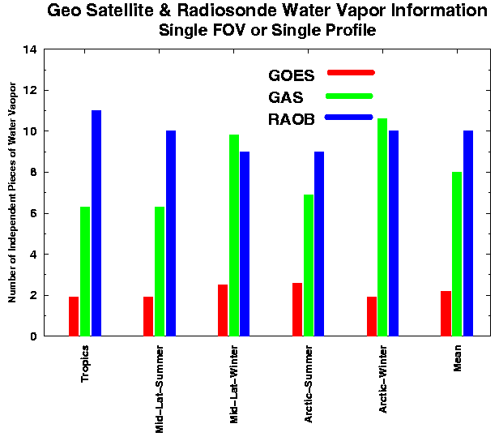
Much enhanced measurement information content with hyperspectral data.

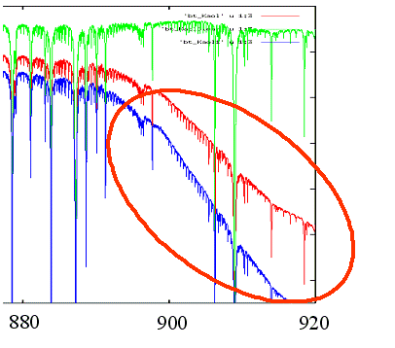
Dust Spectral Slope -- Green – clear sky; Red – dust layer from 1013 to 701.2 hPa; Blue – dust layer from 900 to 600 hPa

Steve Ackerman, director of CIMSS, gave a talk entitled “High Spectral Resolution Observation of Earth’s Clouds and Aerosols”. He noted that CIMSS supports a wide range of use and validations of hyperspectral observations and products.
Some of his conclusions:
•High spectral resolution observations will improve cloud/aerosol detection and cloud/aerosol property retrieval. (narrow band still very useful.)
•Surface properties and near surface properties retrieval improved with spectral resolution
•Best combined with other observations
•Need to quickly move from research to operations.

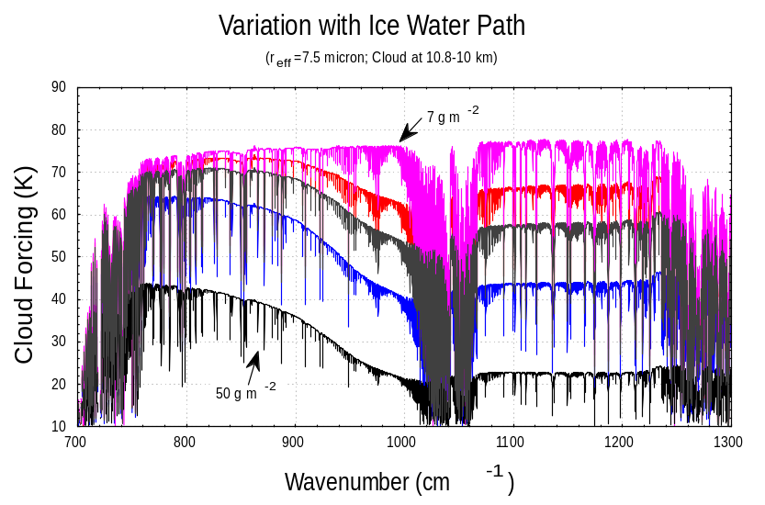
IR Hyperspectral observations can be used to determine the ice water path, especially for larger amounts.

Mark DeMaria, NOAA/NESDIS ORA spoke on “Tropical Cyclone Applications of Hyperspectral Observations.” The main question raised was: Can hyperspectral observations improve sampling of hurricane environments? It was shown that the cloud mask seems to need more work, but AIRS T errors smaller than Eta first guess in lower troposphere and despite a moist bias, AIRS Td has higher correlation with GPS Td than Eta first guess profiles.

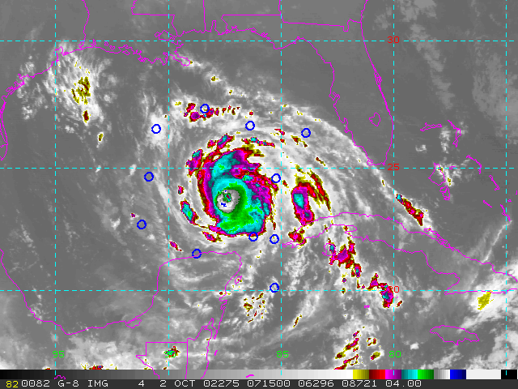

Location of 11 AIRS soundings 0715 UTC

Ralph Petersen, CIMSS, spoke on the potential benefits of hyperspectral data on Numerical Weather Prediction (NWP). The improved Spectral, Spatial and Temporal coverage of
Hyperspectral Systems will be critical in meeting a broad range of future NWP goals. This includes traditional NWP (Global and Mesoscale), Objective Nowcasting and Real-time Forecaster Products. These hyperspectral data are part of an INTEGRATED (complementary) DATA SYSTEM. Success is measured as the benefit from the full SET of observations, strengths of one system will compensate weakness of others.

Hyperspectral observations will be a major source of moisture observations:
- Horizontal and vertical moisture gradients
- Hyperspectral systems will observe 6-8 individual layers
- Essential to resolve convective instability
- Moisture fluxes possible with sufficient horizontal resolution
- Wind and Moisture --- Need identified by NAOS
--- G-NWP Diurnal precipitation now wrong
- Cloud properties
- Location, top height, ice vs. water, . . .
Surface Properties
- Land - Vegetation, Surface emissivity,
- Oceans - SST, Ocean color,
Surface motion, . . .
Trace gases, etc.
- Fire, Smoke, Dust, O3, CO2, . .

Before any Hyperspectral System can be used successfully and beneficially, we need to determine how to deal with (manage and use) the incredibly huge amount of data, both spectrally and temporally. Recent studies have shown that with the current usage of AIRS clear radiances in the ECMWF system it is demonstrated they are equivalent to a least the radiances from one AMSU-A instrument!

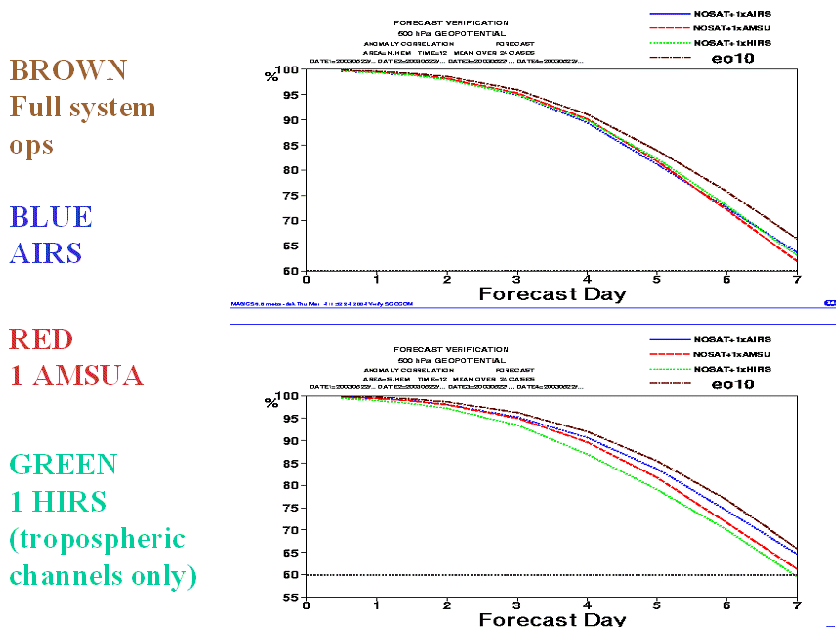

Impact of single instrument on no-radiance assimilation 500 hPa geopotential height.

Bob Knuteson, CIMSS, spoke on the IR surface properties. His conclusions were
- The high spectral resolution structure of the surface reflection contains the information needed to separate the value of skin temperature from the effective surface emissivity within the instrument field of view.
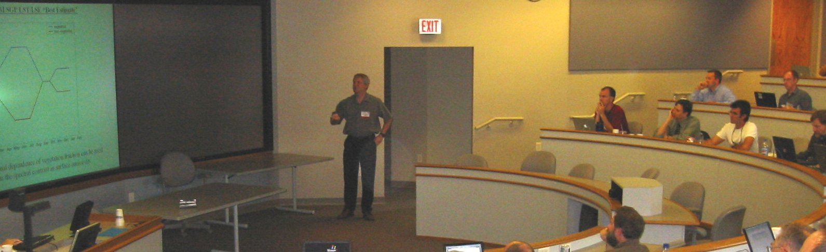
- Using ground-based and aircraft measurements in the U.S. Southern Great Plains, the area averaged surface emissivity can be accurately represented using a single parameter (vegetation fraction) and two pure scene types; vegetation (grass) and bare soil (quartz signature).
- Future progress requires the synergistic use of multi-spectral (or hyperspectral) at high spatial resolution with high spectral resolution observations at coarser spatial scales.

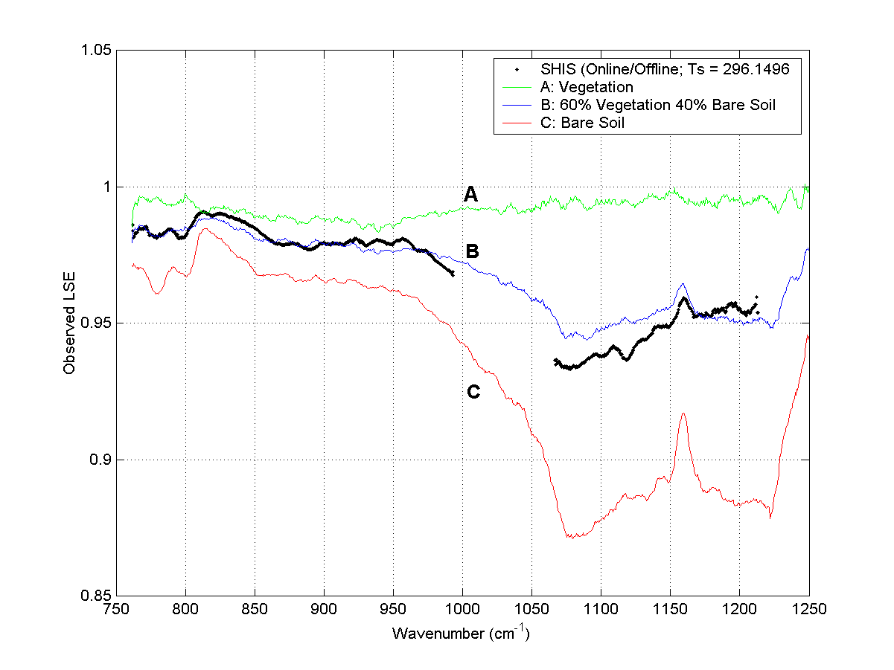
Aircraft validation measurements are consistent with a linear combination of vegetation and bare soil.

Nick Nalli, QSS Group Inc., spoke on Ocean applications of High Spectral resolution infrared data. Some of the applications include Ocean surface retrievals (Sea surface skin temperature (SST), Spectral emissivity/reflectivity), Marine atmospheric retrievals (Temperature/humidity profiles, Aerosol/cloud detection) and calibration/validation (Radiometrically well-characterized surface and accurate “ground truth”, potential for characterization of other narrow-band sensors, Validation/refinements in radiative transfer models).

Hyperspectral data can resolve transparent microwindow channels (regions between strong absorption lines). This will provide maximum surface thermal signal, optimize potential for water vapor continuum correction and can avert errors due to trace gases (CO2, O3, CFCs).

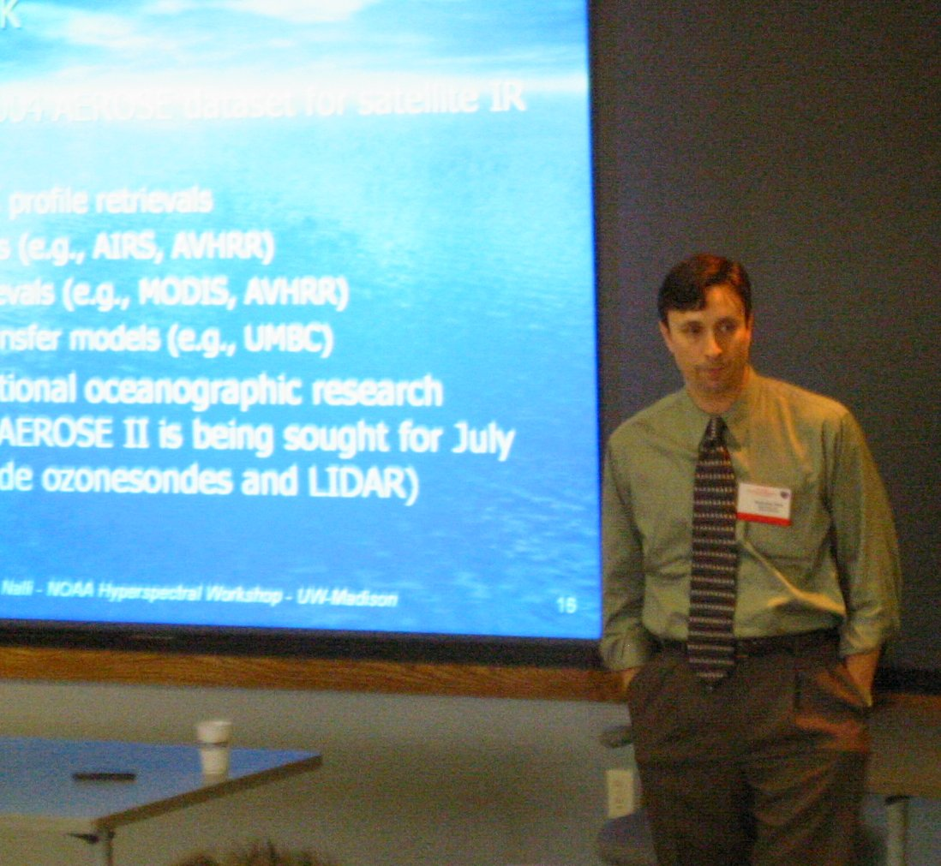
Note that the microwindows can be chosen to stay away from absorption due to moisture or other gases. UMBC NAST-I transmittance spectra and microwindows.

In summary, High spectral resolution IR spectrometers offer optimal spectral atmospheric correction for retrieval of ocean surface parameters. In addition, Hyperspectral data has been fundamental in many recent advancements in satellite oceanography, remote sensing and radiative transfer (e.g., skin SST, skin effect, emissivity/reflectivity, etc.).

Hsiao-hua Burke of MIT/LL spoke on Climate Change Detection: Potential Roles of High Spectral Resolution (HSR) IR Sensors. For climate change detection, monitoring of both forcing and feedback mechanisms is required. This includes Broadband measurements quantify radiative forcings (e.g., ERBE), but also HyperSpectral Resolution-IR provides monitoring of feedback processes. Some of the essential climate variables include: Temperature, water vapor, clouds and profiles, path-integrated quantities, microphysical properties. High spectral resolution is required to exploit individual absorption lines (species, amount and atmospheric level).
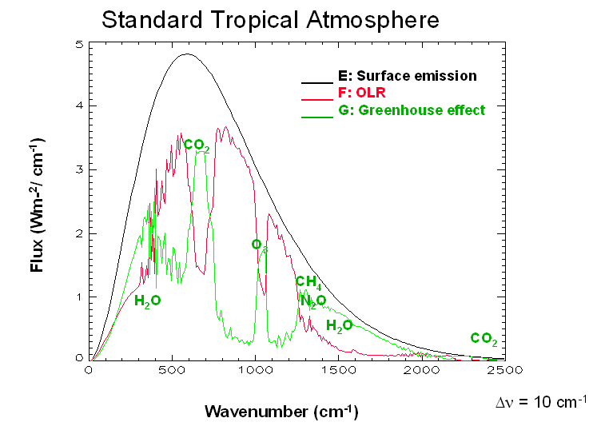
Spectral Variation of Total Atmospheric Greenhouse Effect

Larrabee Strow, UMBC spoke on Minor Gas Retrievals with AIRS. He summarized some of the trace gas work with data from the AIRS. To date:
• CO₂: Monthly zonal averages, soon will have a 2-year record (clear, ocean only)
• CH₄: Global 2 degree maps + zonal averages (clear, ocean only)
• SO₂: Case studies (about 8 eruptions studied so far), no monitoring
• CO: Large scale retrievals using C. Barnet’s AIRS “science code” in addition to monthly averages. Land and ocean, uses cloud-cleared radiances.

Contact Dr. Strow if interested in his clear-sky (ocean-only) AIRS radiance database.
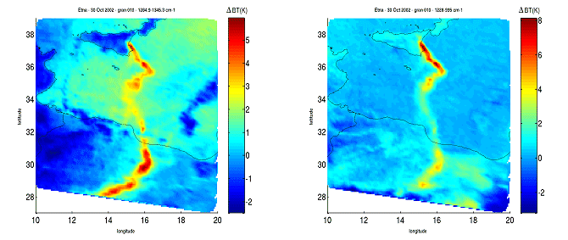
AIRS showing volcanic ash and SO2 from Mount Etna.

Instrument Options
Monica Coakley, MIT/LL, gave a talk entitled “What is HES?” The HES (Hyperspectral Environmental Suite) will supply powerful sounding capability to NOAA from GEO orbit. It will be either an Interferometer or Dispersive Spectrometer instead of filter wheel. The HES will have ~1500 spectral channels and ~ 5x faster coverage (HES-DS) than current sounder. The HES will afford a 4 km severe weather/Mesoscale coverage in 4.4 minutes. The HES also addresses coastal and ocean requirements of NOAA. It will provide at least 300 m spatial resolution. A survey mode capability and a staring mode capability will be investigated during formulation.

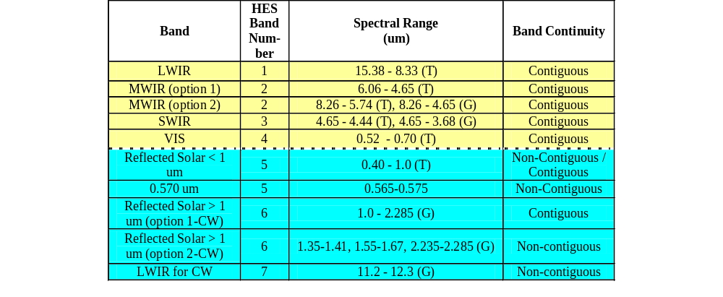Bands highlighted yellow contribute to soundings, highlighted in blue contribute to observation of coastal and shelf waters, estuaries, and lakes. Threshold = (T) denotes required coverage. Goal = (G) denotes coverage under study during formulation.
Richard Baron, JPL gave an overview of the AIRS instrument and some of the products/uses.

Some of the conclusions of the AIRS talk include: AIRS Instrument Extremely Stable
(Thermally Controlled Grating Spectrometer), AIRS Instrument Accurate (Calibration Equations Straightforward) AIRS High Reliability (Cooler, Scanner, PC Chopper Only Moving Parts, More tolerant to FPA pixel outages), Improved SNR with wide field of view (SIRAS) and that the Grating Systems well suited to Sounding and Climate Studies.

NASA DAO studies have shown positive impact in the Southern Hemisphere using AIRS data. It was also shown that AIRS reduces the global cyclone position and magnitude error.

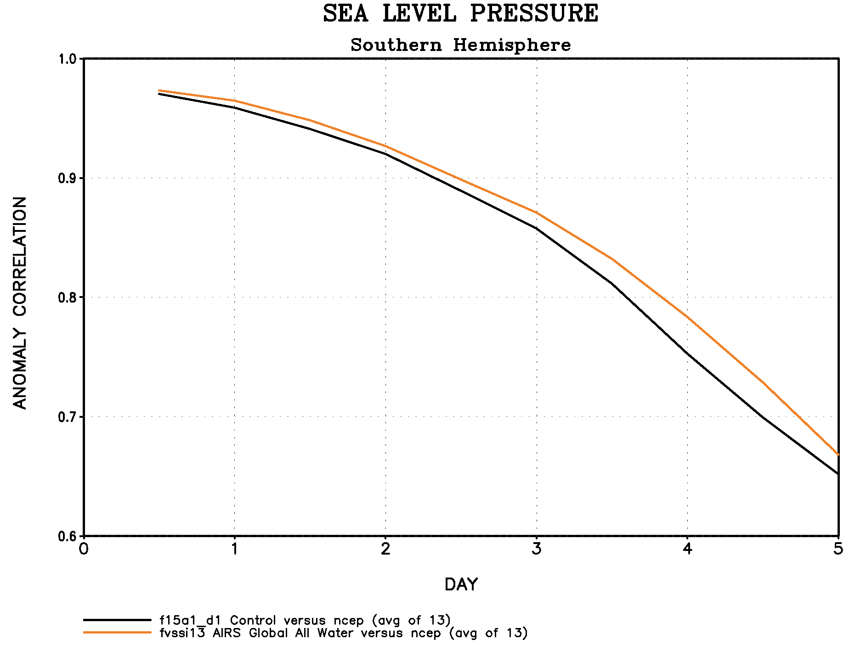
AIRS Improves 5 Day Forecast Score by 5-8 hours in the SH.

Hank Revercomb, Director of SSEC summarized the GIFTS (Geosynchronous Imaging Fourier Transform Spectrometer) during a talk entitled “Interferometer for HES and the GIFTS Connection.” This included information on some of the recent high-quality results from the CrIS instrument. Some of the potential advantages for an interferometer were listed. They include:
• The instrument itself is a fundamental spectral standard, independent of hard to characterize optical characteristics like blur [CrIS example follows]
• The Instrument Line Shape (ILS) has no significant dependence on scene content (cloud non-uniformity), for the small angles involved from geo orbit [a single-footprint grating instrument designed like AIRS has this advantage also, but not an imaging grating that must use the detector array as the exit slit]
• Broader spectral coverage from a given set of detector arrays, because the time dimension gives the spectrum, not different array pixels. Less spectral outages for a given spectra.
• Similar effective noise performance, since both designs can be scene photon limited
[unlike AIRS and CrIS, for which CrIS has major LW advantage & AIRS a SW advantage]

With regard to the GIFTS, it was stated that:
• Testing Goal: Prove the Imaging FTS system concept and test other technologies as a system to validate the thermal mechanical design
• Thermal Vacuum Testing to be performed largely as originally defined
• Completion will provide many useful lessons as risk reduction for the GOES-R HES
• Continuing to seek flight opportunities, including international partnerships

System Strategies
James F.W. Purdom, CIRA, spoke on Intra-Satellite, Intra-System and Inter-System Synergy. An example of Intra-Satellite (USA Operational) would be either the GOES: ABI and HES (adaptive) or NPOESS: VIIRS and CrIS (fixed). Intra-System (USA Geo + operational polar) would be GOES-E and GOES-W (or other possibilities) or for NPOESS AM and PM, METOP, FY-3, METEOR-3, etc. Inter-System would be GOES-R and NPOESS (ABI, VIIRS, HES and CrIS) or GOES-R, NPOESS and other operational and research satellites.

The spatial and temporal domains of the phenomena being observed drive the satellite systems’ spectral needs as a function of space, time, and signal to noise.

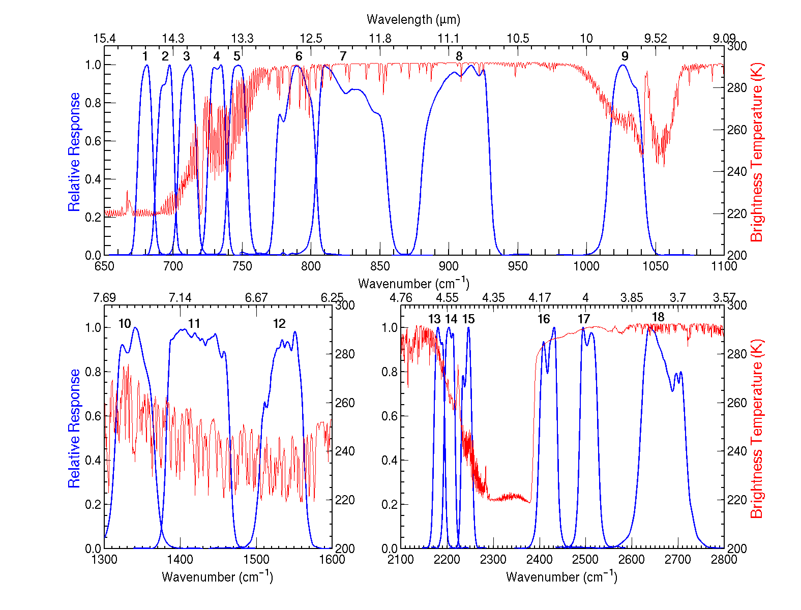
Current GOES Sounder spectral coverage (18 bands) is contrasted with an earth-emitted spectra.

T. Schmit, NOAA NESDIS ORA gave a brief overview on some of the uses of the AIRS and MODIS together. These instruments help lead the way for processing from the HES and the ABI. He also described a recent test with current GOES Sounder cloud data that was used to autonomously task the EO-1 instrument.

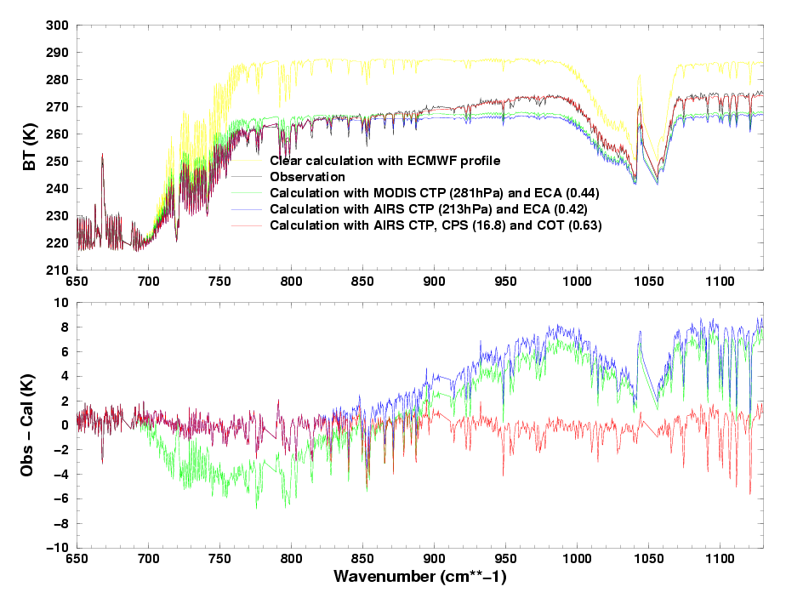
The AIRS longwave clear BT calculation from the ECMWF forecast model analysis (yellow line), the cloudy BT calculation with the MODIS cloud top pressure (CTP) and effective cloud amount (ECA) (green line), the BT calculation from the AIRS retrieved CTP and ECA, and the BT calculation with AIRS retrieved CTP as well as cloud particle size (CPS) and cloud optical thickness (COT) (redline), along with the cloudy BT observation (black line) spectra; the lower panel shows the corresponding BT difference between observation and calculation.

Tools
With new hyperspectral data, new tools are needed to visualize and interrogate the information. There were a number of talks on various tools that can be used. Given the relatively large hyperspectral datasets, data compression can also be seen to be a “tool.”

Mike Griffin, MIT/LL, gave a demonstration of the AHABS tool that he has developed. The software allows simulation of bands and products from many current and future multispectral sensors from Visible through LWIR (currently 21 sensors), works in both radiance and reflectance space, works with AVIRIS, Hyperion and AIRS data, and allows user defined band specifications (imagery can be saved and reapplied). It is written in IDL®.

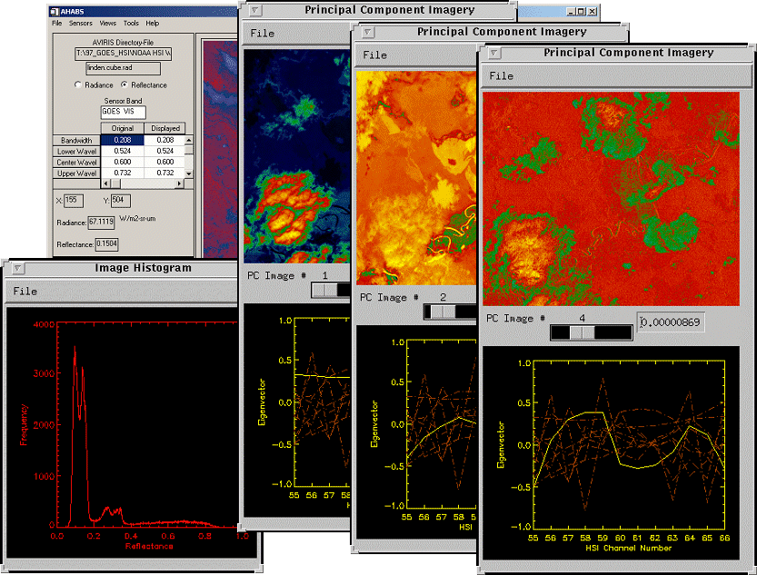

AHABS GUI Interface

Tom Whittaker, SSEC. The Next generation McIDAS (V) is being investigated as a means to transition existing McIDAS-X applications to operate in a new environment that does not have the limitations of the current McIDAS-X system. The goal is to choose a system that can operate with the current satellite data, and applications, while positioning for new development on future satellite platforms (for example hyperspectral data). One candidate system is Unidata’s newest scientific analysis and visualization tool. It is freely available Java™ framework and reference application, provides 2- and 3-D displays of geo-scientific data (plus, of course, animations), stand-alone or networked application and built on VisAD library.
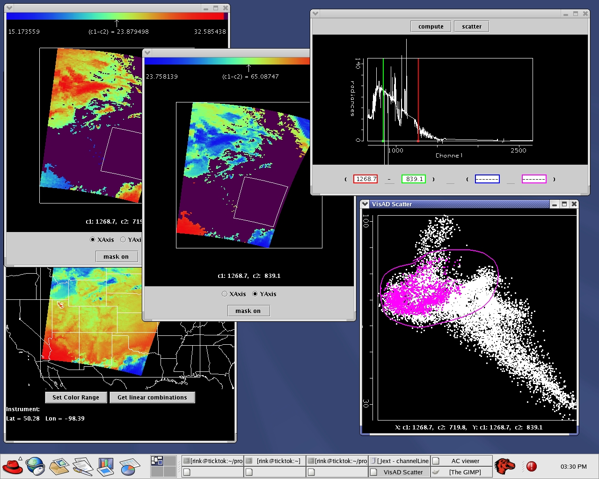
New views of data will be possible.

Kevin Baggett, CIMSS, gave a demonstration on “HYDRA” (Hyper-Spectral Data Research Application). This is Java-based, freely available software to access multi/hyperspectral data.

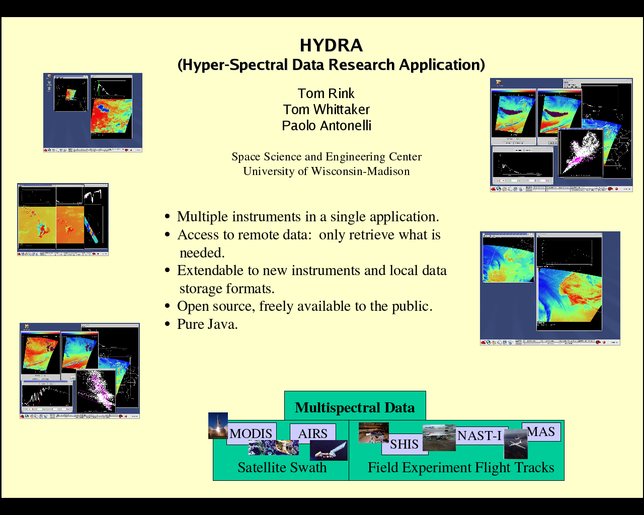
Some sample images from HYDRA.

Su May Hsu, MIT LL, gave a talk summarizing VNIR/SWIR compression results. In general, lossy compression ratios of 50-100 were obtained for derivations of NDVI (Normalized Difference Vegetation Index) and column water vapor.

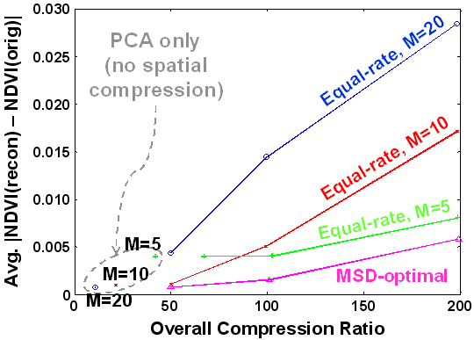
Compressed and uncompressed NDVI from AVIRIS data

Bormin Huang, CIMSS, spoke on recent progress on IR hyperspectral Sounder data. In support of the NOAA/NESDIS GOES-R HES data processing studies, they have investigated lossless compression of 3D ultraspectral sounder data using the state-of-the-art wavelet-based schemes (3D SPIHT, JPEG2000) and predictor-based schemes (CALIC, JPEG-LS).

In addition, they have developed the BAR (Bias-Adjusted Reordering) scheme for data preprocessing to significantly improves the compression ratios of the state-of-the-art compression schemes (JPEG-LS, 3D SPIHT, JPEG2000 & CALIC) to about the same level!

Finally, they have also developed a new compression scheme, PPVQ (Predictive Partitioned Vector Quantization), which outperforms JPEG2000 by 39% on average on 10 AIRS digital counts.
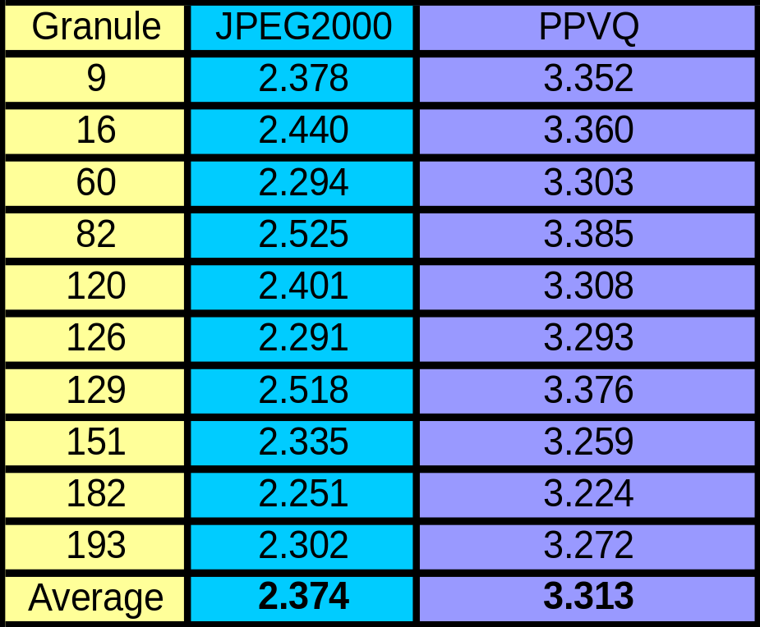
Compression Ratios on AIRS Digital Counts

W. Blackwell of MIT LL gave a talk entitled “Neural Network Retrieval of Atmospheric Temperature and Moisture Profiles from Cloud-Cleared AIRS/AMSU Radiances”. PPC (Projected Principal Components) compression significantly outperforms PC compression (sometimes by > 10X). High-performance PPC compression allows the use of smaller neural networks for profile retrieval. PPC/NN (Neural Network) profile retrieval performance meets or (in most cases) exceeds the performance of state-of-the-art IMV (Iterated Minimum-Variance) method. PPC/NN is extremely fast: Trains in a few hours on PC; execution ~1000 times faster than iterated physical methods. Tropospheric temperature / relative humidity performance near 1K/15% for cloud-cleared AIRS/AMSU observations.

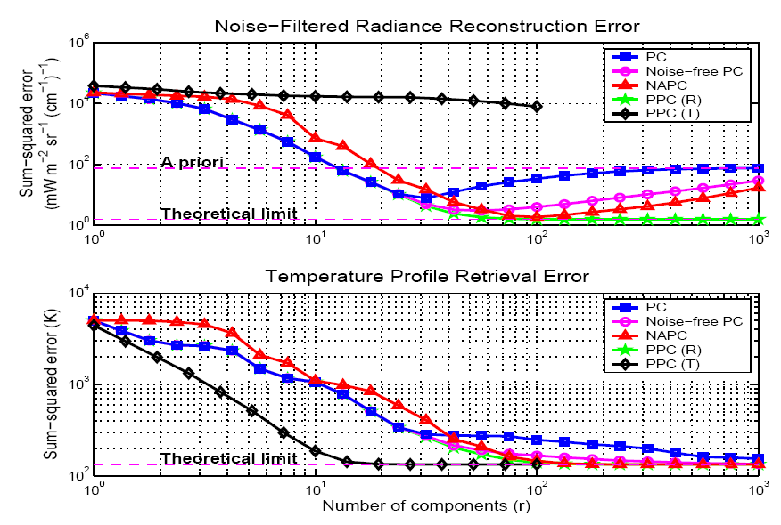
Approximately 50 PC are needed to reconstruct the temperature profiles.

Break-out sessions
There were three breakout sessions. They covered the surface: Ocean//Coastal/ Land, Climate/Trace Gases and Atmosphere/Clouds. Due to time limitations the following items are meant only to give a sample of the options, and not be an exhaustive list.

Ocean /Coastal/Land
Reasons/example for the use of hyperspectral observations for the Ocean /Coastal/Land:

Open Ocean
• SST (4km res, 0.1K)
• Color (Chl-a concentration)
• Bubbles in water column
• Atmospheric Correction
• Carbon Cycle

Coastal Waters
• Color (chl-a and sediment, nice to have 150m)
• SST (0.1K for things like coral reefs)
• Bathymetry
• Oil spills
• Bubbles
• Atmospheric Correction
• Land adjacency
• Carbon Cycle

Land
• Land Surface Temperature (hourly 250m/ 1k)
• IR emissivity (1%)
• Near surface air temp (2m height)
• Vegetation fraction, class, and type
• Biomass burning
• Land use
• Carbon Cycle
• Drought/Deforestation
• Atmospheric Correction

Climate/Trace Gases
• Hyperspectral sensors provide core measurements for climate monitoring and prediction needs. A significant portion of the climate mission can be accomplished with the planned operational hyperspectral instruments. Hyperspectral sensors are capable of providing accurate products for climate use.

• Hyperspectral sensors are necessary to understand the processes and feedbacks that cannot be observed with long record of broadband multi-spectral data. Full spectral radiance coverage is critical for climate records including ultraviolet to visible to microwave. Hyperspectral measurements in the UV, visible, far infrared and microwave are needed for the complete climate job. Hyperspectral IR data is a good start.

• Hyperspectral sensors allow for characterization of the climate record from the existing satellite records: intercalibration and characterization.

• Hyperspectral data provides a way to monitor a complex range of atmospheric phenomena: water vapor throughout most of the atmosphere, trace gases such as ozone and SO2, aerosols, and clouds.

• Excellent radiometric calibration is critical for a stable long term climate record. A specially designed reference satellite sensor will ensure the radiometric calibration of the HES and CRIS sensors.

• Full disk HES scans are required for climate. Making a climate record from a taskable sensor may be difficult due to sampling issues.

• GEO observations are critical for some climate monitoring tasks. - Diurnal cycle of clouds and precipitation and fires and land skin temperature, etc.

Atmosphere/Clouds
• Offers unique characterization of non-surface level moisture (this is important for severe weather potential and NWP applications) as well as the rapid temporal update to monitor the meso-scale moisture distribution. The HES-VIS/NIR can go into partly cloudy regions to modify the baseline (from the HES-IR) on the amount of moisture. If moisture increases, then it’s from a flux from the surface.

• First chance to monitor moisture on small temporal and spatial scales, e.g. monitoring the energy of the small scale storm environment. If this (moisture energy) is characterized, we should be able to forecast (not just follow) storm development (timing and location).

• Cloud/moisture motions can be derived from the HES-CW as well as the HES-IR (maybe with the use of “super-channels”—several layers of moisture). Infrared satellite observations provide the only option for initializing cloud distribution and structure globally.

• Color images can be used for finding major tornado damage tracks (VNIR). Look at deviations for a background scene. This can be used for flooding (hazards). Other hazards could also be monitored. (Fire/hot spots, etc.)

• HS data can be used as an educational tool. Data can be worked with to understand the earth/ocean/atmosphere system.

Concluding Remarks
In summary, this workshop was a productive one. It improved the lines of communication between some of the hyperspectral communities. Each of the presenters and attendees are to be thanked. Progress was made on each of the workshop goals:

- Update on Radiative Transfer (RT), both in the visible/near IR and the infrared
- Explore broadband adequacy versus Hyperspectral necessity for environmental characterizations (land, ocean, atmosphere)
- Discuss some of the instrument trade-space with respect to applications
- Understand the roles of LEO and GEO for various applications
- Familiarization with tools for interrogating and visualizing hyperspectral data

Appendix 1: Workshop Goals

Goals :

- Update on Radiative Transfer (RT), both in the visible/near IR and the infrared
- Explore broadband adequacy versus Hyperspectral necessity for environmental characterizations (land, ocean, atmosphere)
- Discuss some of the instrument trade-space with respect to applications
- Understand the roles of LEO and GEO for various applications
- Familiarization with tools for interrogating and visualizing hyperspectral data

Questions:

- What are the advantages/disadvantages of Hyperspectral over multispectral data?
- What are the future directions/shortfalls for Hyperspectral radiative transfer?
- How can NOAA best prepare for autonomous instrument synergy?
- What are the future directions/shortfalls for data compression?

Appendix 2: Participant List
Steve Ackerman stevea@ssec.wisc.edu
Kevin Baggett kevinb@ssec.wisc.edu
Richard Baron richard.baron@jpl.nasa.gov
William Blackwell wjb@ll.mit.edu
Emmanuel Bosc emmanuel.bosc@jpl.nasa.gov
Carl Bruce cbrucejr@jpl.nasa.gov
Hsiao-hua Burke burke@ll.mit.edu
Monica Coakley mcoakley@ll.mit.edu
James Davies jimd@ssec.wisc.edu
Mark DeMaria Mark.DeMaria@noaa.gov
Gerald Dittberner Gerald.Dittberner@noaa.gov
Wayne Feltz wayne.feltz@ssec.wisc.edu
Charles Fink charles.fink@aero.org
Ray Garcia rayg@ssec.wisc.edu
James Gardner james.gardner@hanscom.af.mil
Tom Greenwald tomg@ssec.wisc.edu
Michael Griffin griffin@ll.mit.edu
Mathew Gunshor matg@ssec.wisc.edu
James Gurka James.Gurka@noaa.gov
Anthony Harvey THarvey@ac-tech.com
Andrew Heidinger Andrew.Heidinger@noaa.gov
Donald Hillger Don.Hillger@noaa.gov
Bob Holz reholz@ssec.wisc.edu
Edward Howard edward.howard@noaa.gov
Su May Hsu sumayhsu@ll.mit.edu
Allen Huang allen.huang@ssec.wisc.edu
Bormin Huang bormin@ssec.wisc.edu
James Jung Jim.Jung@noaa.gov
Jeffrey Key jkey@ssec.wisc.edu
Robert Knuteson robert.knuteson@ssec.wisc.edu
Chian-Yi Liu cyliu@ssec.wisc.edu
Edwin Mierkiewicz emierk@wisp.physics.wisc.edu
Grzegorz Miecznik gmieczni@ball.com
Leslie Moy lesliem@ssec.wisc.edu
Nicholas Nalli Nick.Nalli@noaa.gov
Erik Olson eriko@ssec.wisc.edu
Ralph Petersen RalphP@ssec.wisc.edu
James Purdom purdom@cira.colostate.edu
Bob Rabin Rabin@ssec.wisc.edu
Hank Revercomb hankr@ssec.wisc.edu
Chris Schmidt chris.schmidt@ssec.wisc.edu
Tim Schmit tim.schmit@ssec.wisc.edu
Kevin Schrab kevin.schrab@noaa.gov
Maciek Smuga-Otto maciek@ssec.wisc.edu
Joseph Snow snow@ll.mit.edu
Larrabee Strow strow@umbc.edu
Shahram Tehranian stehranian@ac-tech.com
David Tobin davet@ssec.wisc.edu
Maria Vasys mariav@ssec.wisc.edu
Chris Velden Chrisv@ssec.wisc.edu
Xuanji Wang xuanjiw@ssec.wisc.edu
Tom Whittaker tomw@ssec.wisc.edu
Hong Zhang hong.zhang@ssec.wisc.edu
Attendance by organization type was approximately:

University of Wisconsin-Madison, CIMSS (12)
NOAA/NESDIS (8)
MIT/LL (6)
SSEC (4)
NASA (2)
NOAA/NWS (1)
CIRA (1)
Air Force (1)
Private/Other (7)

Appendix 3: Agenda
4th NOAA Hyperspectral Workshop
Pyle Center, 702 Langdon Street, Madison, WI
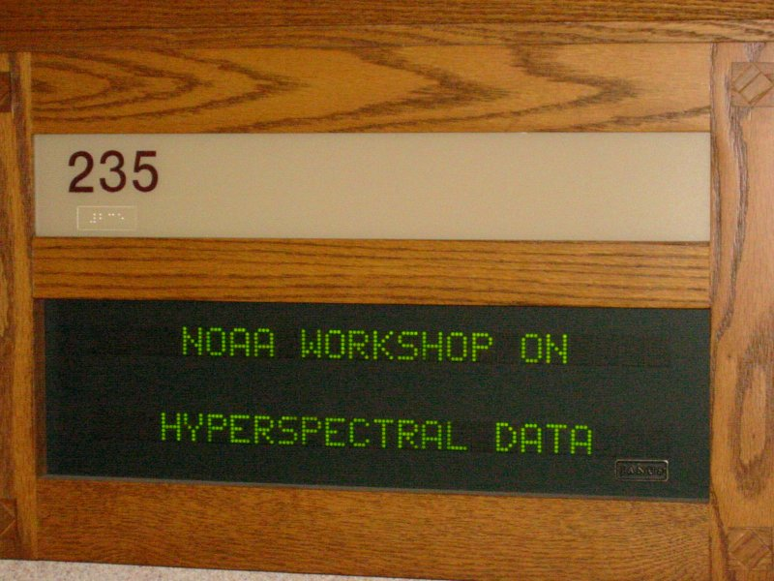

Tuesday Afternoon 17 August 2004

Introduction

1300-1310 Welcome Steve Ackerman, CIMSS
1310-1320 Introductory Remarks/Logistics/Agenda T. Schmit, NOAA NESDIS
& Ed Howard, NOAA
1320-1330 NOAA’s needs for hyper-spectral imaging T. Schmit, NOAA NESDIS
and sounding

Issues of hyperspectral data in relationship to Radiative Transfer (RT)

1345-1400 IR RT (recent updates) Larrabee Strow, UMBC
1400-1415 RT of clouds T. Greenwald, CIMSS
1415-1430 Discussion All

1430-1445 Break

1445-1515 Vis/NearIR RT Mike Griffin MIT/LL &
A. Heidinger, NOAA NESDIS

Applications of hyperspectral data

1515-1545 Atmosphere Summary + discussion Allen Huang, CIMSS
1545-1615 Climate + discussion Hsiao-hua Burke, MIT/LL
1615-1645 Tropical Applications M. DeMaria, NOAA/NESDIS
1645-1700 Temporal/spectral/spatial J. Purdom, CIRA
1700-1715 Closing Discussions for Tuesday All

Dinner – Location: Informal in the area
4th NOAA Hyperspectral Workshop
Pyle Center, 702 Langdon Street

Wednesday 18 August 2004

0825-0830 Intro/Logistics T. Schmit, NOAA NESDIS

Instrument Options

0830-0845 What is HES? Monica Coakley, MIT/LL
0845-0900 Grating Richard Baron, JPL
0900-0915 Interferometer Hank Revercomb, SSEC
0915-0930 Discussions All

Applications (Continued from Tuesday)

0930-1000 NWP + discussion Ralph Petersen, CIMSS

Break
1015-1045 Land Summary + discussion Bob Knuteson, CIMSS
1045-1115 Ocean Summary + discussion Nick Nalli, QSS Group Inc.
1115-1145 Clouds/Aerosols Summary + discussion Steve Ackerman, CIMSS
1145-1215 Trace gases + discussion Larrabee Strow, UMBC
Working Lunch – Location: Pyle Center

Working Groups

1315-1530 Split into Working Groups
land&ocean atmosphere&clouds climate&trace gases
What does Hyperspectral add over broadband imagers?

1415-1430 Break

1530-1630 “Report” from each working group
1630-1700 Closing Discussion for Wednesday

Dinner – Location: University Club 803 State Street (5:30 Cash Bar, 6:30 Dinner)
4th NOAA Hyperspectral Workshop
Pyle Center, 702 Langdon Street

Thursday 19 August 2004

0830-0845 Intro/Logistics T. Schmit/A. Heidinger, NOAA NESDIS

System Strategies

0845-0900 HES/ABI synergy T. Schmit, NOAA
0900-0915
0915-0930 Discussion All

Tools

0930-0945 Application Analysis Tools / Mike Griffin MIT/LL
AHABS Demonstration
0945-1000 Next generation McIDAS (V) Tom Whittaker, SSEC

1000-1015 Break

1015-1030 Application Analysis Tools / “HYDRA” Kevin Baggett, CIMSS
1030-1045 VNIR/SWIR compression results Su May Hsu, MIT LL
1045-1100 Compression Techniques: HES IR Sounder B. Huang/CIMSS
1100-1115 Compression Techniques: IR Sounder W. Blackwell/MIT LL
1115-1200 Wrap up/future of Workshop(s) All

Working Lunch – Location: Pyle Center

End of workshop

Simulated GIFTS winds (left) versus GOES current operational winds (right)

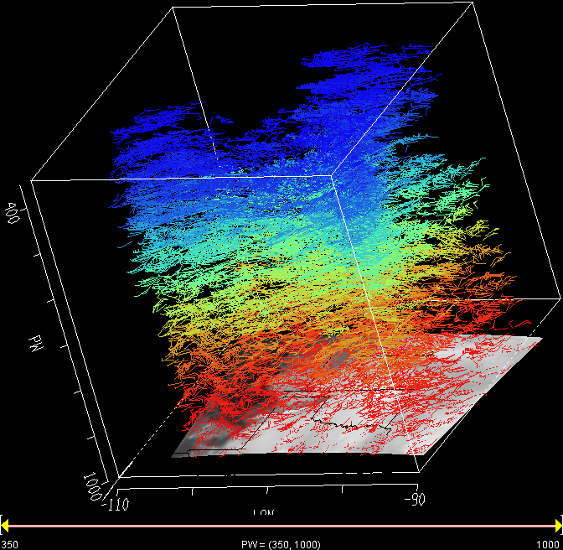
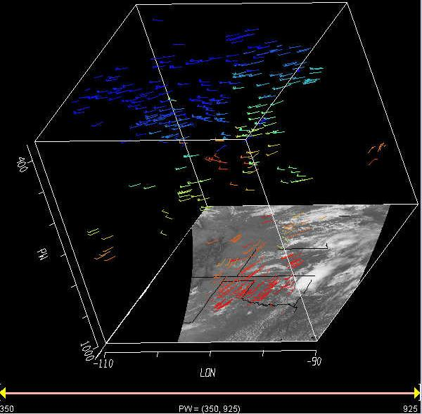



NOAA Satellite and Information Services

National Environmental Satellite, Data, and Information Service

