GOES-R Series Virtual Science Fair Photo Release Form
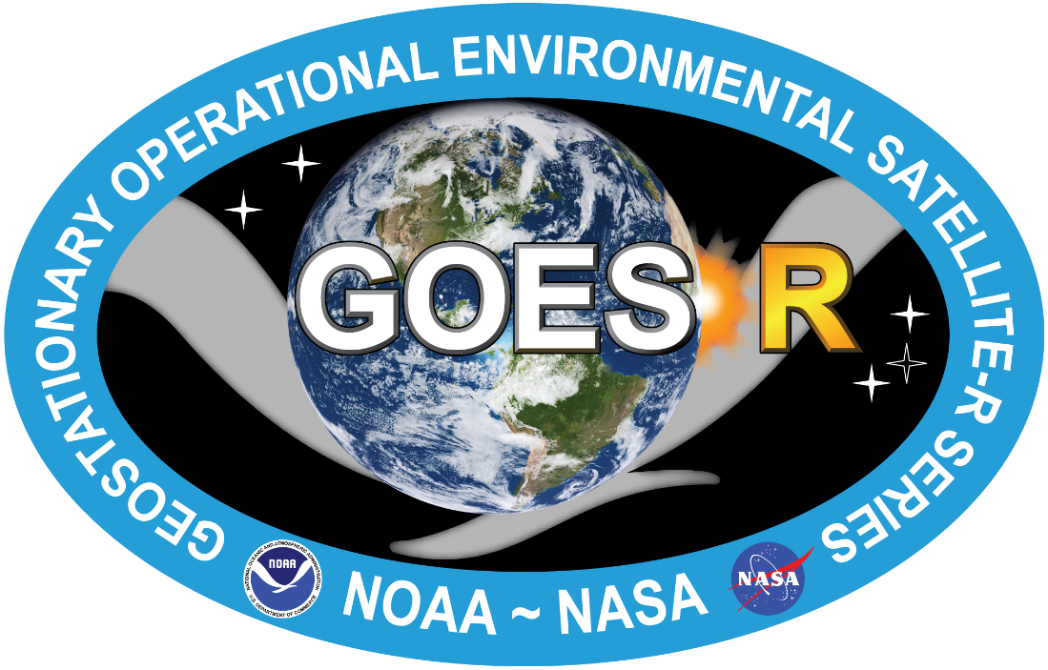

I, ______________________________ attending ______________ ______________________________ School
in the City of ______________________, and State of ______________________ grant permission and consent to NOAA’s Cooperative Institute for Meteorological Satellite Studies (CIMSS) for the use of any group photo(s) we submit to the 2019 GOES-16/17 Virtual Science Fair for presentation under any legal condition, including but not limited to: publicity, copyright purposes, illustration, advertising, and web content.

Student Signature____________________ ______________________ Date ______________

Print Name _______________________________________________ Date ______________

Teacher’s Signature _________________________________________ Date ______________

Print Name ________________________________________________ Date ______________

Accepting entries between March 1st and May 3rd, 2019
2-4 students allowed on each submission, 1 teacher/coach per entry, details and updates on-line at
http:///cimss.ssec.wisc.edu/education/goesr/vsf
