 

Space Science and Engineering Center

University of Wisconsin-Madison

AN EXERCISE IN RADIATIVE TRANSFER MODELLING WITH RTTOV-10

prepared by Nadia Smith

19 MAY 2011

^^^^^^^^^^^^^^^^^^^^^^^^^^ **RESOURCES** ^^^^^^^^^^^^^^^^^^^^^^

We downloaded RTTOV for you from this site:

<ftp://ftp.ecmwf.int/pub/dserv/RTTOV/rttov10.tar.gz>

For more documentation and coefficient files:

<http://research.metoffice.gov.uk/research/interproj/nwpsaf/rtm/>

The official RTTOV-10 user guide:

${HOME}/rttov10/docs/users_guide_10_v1.3.pdf

Available **text editors** for viewing script/intput/output files:

$ VIM (opens in your terminal window, to exit type “:q”)

$ gedit (opens a separate window for easy viewing and closing)

**Data description documents** in the directory /rttov10/exercise/sample_data/:

*profile_key.dat*: a list of the fields you need to populate before running RTTOV.

*rttov_parameter_limits.dat*: a list of the RTTOV thresholds (min/max values) for atmospheric/surface parameters.

*pressure_levels.dat*: the atmospheric pressure (hPa) at each of the profile levels, nlev=51.

^^^^^^^^^^^^^^^^^^^^^^^^^^^^ **NOTATION** ^^^^^^^^^^^^^^^^^^^^^^^^

Brightness Temperature (BT) has units degree Kelvin [K]

Home directory = ${HOME}. To get there, type “cd” in a terminal command line.

nchan = number of channels

Radiance (rad) has units [mw/cm-1/ster/m2]

TOA = top of atmosphere

Tskin = surface skin temperature

Wavenumber (wn) = (10,000/wavelength[micron meter]) with units [cm-1]

Working directory = ${WDIR} = $HOME/rttov10/exercise

^^^^^^^^^^^^^^^^^^^^^^^^^^^^ **INSTRUCTIONS** ^^^^^^^^^^^^^^^^^^^^^^^^

RTTOV is a Linux command-line program, which means that you will need to type commands in the terminal window you opened in order to run it. In the text below, all commands you need to type are preceded by a dollar sign ($) and instructions or discussion points are preceded by a dash sign (-).

You will model infrared TOA radiance and BT for two instruments:

**MODIS** (MODerate resolution Imaging Spectroradiometer) <http://modis.gsfc.nasa.gov/>

**AIRS** (Atmospheric InfraRed Sounder): <http://airs.jpl.nasa.gov/>

Table 1: Description of the infrared spectral region

|  |  |  |
| --- | --- | --- |
| **Spectral range (wn)** | **Trace gas sensitivity** | **Relevant atmospheric property** |
| 650-770 | CO2 | Temperature profile |
| 790-980 | Atmospheric window | Surface and cloud properties |
| 1000-1070 | O3 | O3 sounding |
| 1080-1150 | Atmospheric window | Surface and cloud properties |
| 1210-1650 | H2O | Humidity profile, CH4, N2O column amounts |
| 2100-2150 | CO | CO column amount |
| 2150-2250 | N2O & CO2 | Temperature profile, N2O column amount |
| 2350-2420 | CO2 | Temperature profile |
| 2420-2700 | Atmospheric window | Surface and cloud properties |
| 2700-2760 | CH4 | CH4 column amount |

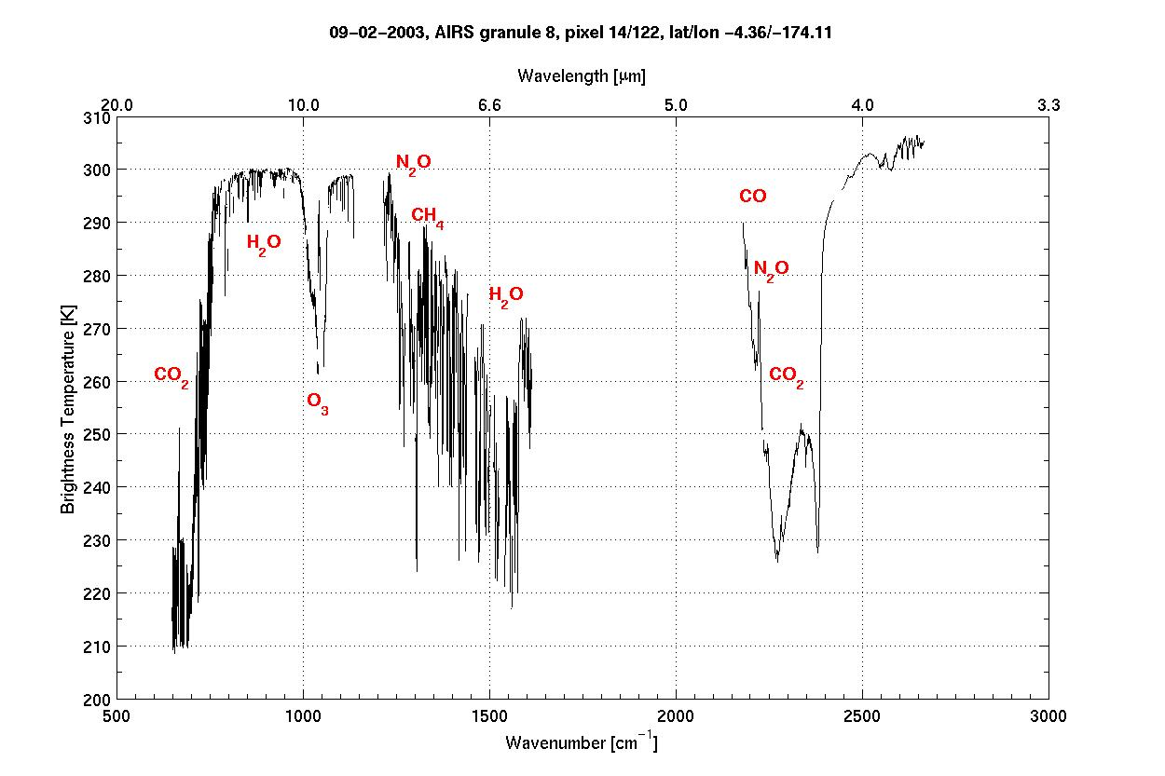

Figure 1: AIRS infrared BT spectrum (nchan = 2378) with indications of atmospheric absorption zones.

- Navigate to your working directory.

$ cd $HOME/rttov10/exercise

* All the data files you need to run RTTOV is on $WDIR/sample_data/. There are descriptions for six atmospheres.
* RTTOV requires a number of basic fields to run. Find a list of them in ./sample_data/**profile_key.dat.** This is an important reference and you should keep this file open while working.

**(1) Basic MODIS run (nchan = 16)**

* Open ./run_rttov.sh using either “VIM” or “gedit”.

$ gedit run_rttov.sh

* Navigate to the section labeled “USER INPUT”. There you will see a list of variables. Check that they have these values:

PLATFORM=eos

PLATFORM_N=9

INST=modis

INST_N=13

SATID=2

FILE_PROFILE=prof1.dat

FILE_CHAN=modis_16chan.dat

SUNZEN=10

SUNAZ=150

INSTZEN=55

INSTAZ=25

SURF_TYPE=0

WATER_TYPE=0

NLEVELS=51

LAT=0

GASES=0

OUTFN=output_${INST}.dat

* Two of these variables refer to external files. They are

1. ${FILE_PROFILE}: the profile structure file. Refer to ./sample_data/profile_key.dat for a full description. We have prepared a number of valid files for you in ${WDIR}/sample_data/prof*. Later you will practice using different profile files. For this exercise, specify “prof1.dat”.
2. ${FILE_CHAN}: a file that lists three columns, the channel index (1 to nchan), a valid/invalid flag (1 or 0, respectively) and emissivity (value between 0 and 1).

* Close run_rttov.sh and run RTTOV.

$ bash run_rttov.sh

* View your output file $WDIR/output/output_modis.dat. This is what it should look like (you can also find the answer in ${WDIR}/answers/answer1.dat):

Instrument 13

-----------------

Profile 1

INST ZENITH ANGLE = 0.00

INST AZIMUTH ANGLE = 25.00

SOLAR RADIATION = NO

SUN ZENITH ANGLE = 10.00

SUN AZIMUTH ANGLE = 150.00

SURFACE TYPE = 0

WATER TYPE = 0

LATITUDE = 0.00

SURFACE PRESSURE = 1008.30

AEROSOLS = NO

CLOUD FRACTION = 0.50

CLOUD TOP HEIGHT = 500.00

These first 12 fields define your input selection. It is just to remind you what you specified. You are really interested in the column fields below that specify channel, wavenumber, radiance and brightness temperature.

NUMBER OF CHANNELS = 16

CHN WN RAD BT

1 2647.41 0.21 274.26

2 2511.83 0.35 273.83

3 2517.99 0.34 273.84

4 2462.43 0.39 272.01

5 2248.36 0.17 237.80

6 2209.62 0.49 254.56

7 1474.24 5.52 239.83

8 1361.61 12.35 251.14

9 1169.66 36.72 269.05

10 1028.82 37.22 252.74

11 907.69 70.87 269.73

12 830.84 81.66 269.33

13 748.37 75.18 255.72

14 730.83 66.78 246.99

15 718.25 60.56 240.20

16 703.60 48.84 227.30

**(2) Basic AIRS run (nchan = 2378)**

* Repeat this, but for the AIRS instrument this time. All you have to edit in the run_rttov.sh file are the following fields:

INST=airs

INST_N=11

FILE_CHAN=airs_2378chan.dat

* Your output file (${WDIR}/output/output_airs.dat) should have CHN, WV, RAD, BT fields for all 2378 AIRS channels. Compare your values against the values in ${WDIR}/answers/answer2.dat.

**(3) Now you are ready to have some fun**:

1. Remember to consult ${WDIR}/sample_data/rttov_parameter_limits.dat for the RTTOV valid limits on most of the atmospheric and surface parameters.
2. Remember to consult ${WDIR}/sample_data/profile_key.dat to know where to change the values of certain variables.
3. Remember BT values range roughly between 150 and 400 K, and randiance values range between 0 and 120. You should always check your output against these values.
4. All the exercises below will be completed for MODIS, but when you have worked through them all and there is some time left, you can rerun them again for AIRS.

* *Try a different atmosphere*. Open ${WDIR}/sample_data/prof2.dat. Compare it with the file you used in the basic runs, prof1.dat. Specify FILE_PROFILE=prof2.dat, OUTFN=output_modis_prof2.dat in run_rttov.sh. Compare the output with output_modis.dat. Do you notice a difference?

*Repeat this four more times, once for each of the remaining profile files*. When you are done you should have six MODIS output files, one of each of the atmospheres.

Investigate the correlation between atmospheric definition and TOA radiance and BT values, e.g. what happens when the T profile is higher?

* *Define your own trace gas profiles.*

When you do not specify values for the gases, CO2, CO, CH4 and N2O, then RTTOV uses standard trace gas climatologies to calculate TOA radiance. However, it is often very useful to define your own trace gas profiles. You can do this by changing three variables in run_rttov.sh,

GASES=1

FILE_PROFILE=prof1_gases.dat.

OUTFN=output_modis_prof1_gases.dat

Before you run RTTOV, open prof1_gases.dat and look at the values for the different gases (remember to consult profile_key.dat to learn the order in which they are written). Run RTTOV and compare your results with that from the basic run in (1).

You can manually change the values of gases in prof1_gases.dat to see how the TOA radiances are affected (look again at Table 1 and Figure 1 to notice that only certain spectral regions will be affected when you change the values of specific gases).

Run RTTOV using prof1_gases.dat, but double the values of CO2. Describe your output.

You can now change the values of the other gases, e.g. CO, O3, N2O, CH4, but make sure you do not exceed the min/max limits of the atmospheric parameters when you change their values manually (${WDIR}/sample_data/rttov_parameter_limits.dat).

* *Define different surface parameters*

TOA radiance is not just affected by gases in the atmosphere, it is also highly sensitive to the state of the Earth surface. There are three surface parameters you can easily change, Tskin, emissivity and surface type.

* Surface Type.

Open run_rttov.sh. Change the value of ${SURF_TYPE} to 0 for land, name your output file “output_modis_land.dat’, and keep all other values the same as in (1). Run RTTOV.

Next, specify SURF_TYPE=1 for ocean. Name your output file “output_modis_ocean.dat’, and keep all other values the same as in (1). Run RTTOV.

Lastly, specify SURF_TYPE=2 for ice/snow. Name your output file “output_modis_snow.dat’, and keep all other values the same as in (1). Run RTTOV.

Compare the output radiance and BT of each of the three files. Which channels (or spectral regions) are most affected by this surface description?

* Surface Temperature

Open prof2.dat. Navigate to the bottom. In the TSKIN field, change the value to 350 and save the file as prof2_tskin.dat. Specify FILE_PROFILE=prof2_tskin.dat, and OUTFN=output_modis_tskin.dat in run_rttov.sh. Run RTTOV and compare your results with output_modis.dat you generated in (1). Do you notice a difference? In which spectral region?

* Surface Emissivity

In (1) you specified FILE_CHAN=modis_16chan_098emis.dat. Open this file and inspect the content. Column three refers to the emissivity value of each channel. The value of 0.98 is often used as a standard for all surfaces. You can investigate how the TOA radiances are altered when the emissivity changes by specifying FILE_CHAN=modis_16chan_05emis.dat. This file lists a value of 0.5 for all channels. (Remember that this is just an exercise and not realistic values). Name your output file “output_modis_emis.dat”. Run RTTOV (with all other variables as specified in (1)) and investigate your results.

Note: if you specify zero emissivity values, then RTTOV uses climatology values.

* *Add clouds*

You can do a simple calculation for TOA radiances in a cloudy atmosphere. Open prof1.dat. Navigate to the bottom and change the CFRAC (cloud fraction) variable to 0.8 (0 means clear sky, and 1 means overcast). Save the file as “prof1_cfrac.dat. Close this file. Now specify FILE_CHAN=modis_16chan_098emis.dat, FILE_PROF=prof1_cfrac.dat, OUTFN=output_modis_cfrac.dat in run_rttov.sh. Run RTTOV. Which spectral channels are affected when clouds are present in the atmosphere?

* *Switch off some of the channels*

MODIS has only 16 channels in the infrared spectral region. This makes it fast to process and convenient to evaluate. However, AIRS, with its narrow spectral sampling rate provides more information on the vertical structure of the atmosphere. It does take longer to process, but often not all channels are necessary in the analysis. You can practice selecting different channel sets by editing the ${FILE_CHAN} variable in run_rttov.sh.

Open modis_16chan_098emis.dat. Switch off channels 1,4,8,10,11, and 14 by changing their values in the second column from 1 to 0 (1 = on, 0 = off.). Save the file. Specify FILE_CHAN= modis_16chan_098emis.dat, FILE_PROF=prof1_cfrac.dat, OUTFN=output_modis_chan.dat in run_rttov.sh. Run RTTOV. Open ${OUTFN}. Did it work? Do you see results for channels 2,3,5,6,7,9,12,13,15 and 16 only?

*Advance exercise*: Run RTTOV for AIRS but switch on only those channels that fall in the CO2 absorption range. Name your channel file airs_2378chan_098emis_CO2.dat. Make sure to specify the appropriate variables in run_rttov.dat. Name your output “output_airs_co2.dat”. Run RTTOV.

----------------- This concludes the exercise ------------------