NAME_____________________________

IPCC LIKELIHOOD ACTIVITY: “Most of the global average warming over the past 50 years
is very likely due to anthropogenic GHG increases…” (IPCC 2007)

The IPCC uses three different approaches for uncertainty, depending on whether the data are qualitative, quantitative, or based on expert judgment. For the quantitative assessments, most often used in the scientific disciplines, the IPCC uses a Likelihood Scale to consistently define the probability, or likelihood of occurrence. The Likelihood Scale is based on statistics and probability. Statistics is the language that scientists generally use to objectively, and consistently make conclusions about their data – despite uncertainty that is inherent in all datasets. By using the Likelihood Scale, the IPCC can effectively communicate what we know or don’t know about climate change using words rather than numbers.

In this exercise, you will use statistics to analyze a dataset from Lake Mendota in Madison Wisconsin that spans the last 160 years. Every year, since 1855, someone has recorded when the lake froze (ice on), and when the lake thawed (ice off). We are going to use these data to ask, ‘Is ice off date on Lake Mendota earlier?’ To answer this question and at the same time quantify the uncertainty around the answer, you will use one of the most basic statistical techniques – a t-test. | 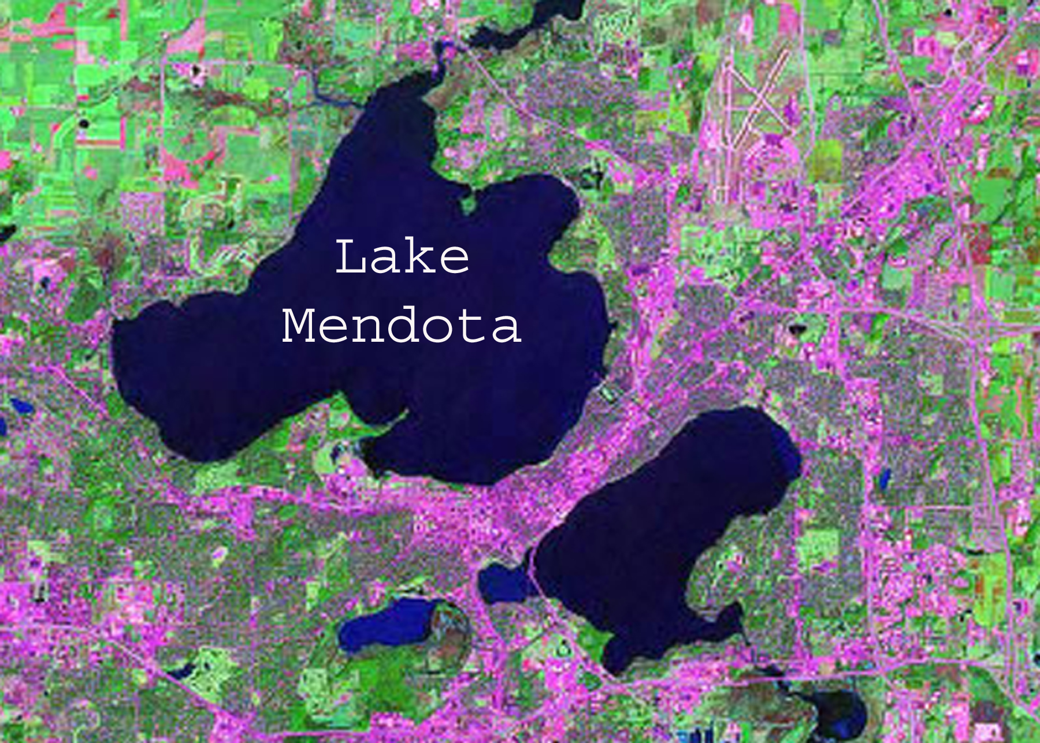
The learning objectives for this activity are:

- Analyze a historical, climatic dataset qualitatively and then quantitatively..

- Relate statistical results to the IPCC Likelihood Scale.

- Consider how statistics provide a consistent, objective way of making conclusions despite uncertainty.

Qualitative analysis
Historical climate data show a substantial amount of year-to-year variation. This variation is one form of uncertainty when scientists analyze trends in climate data. Study the graph below to make a qualitative assessment of ice off date. Record whether ice off date in the 2000’s is earlier than it was in the 1850’s. Report your level of certainty using the language from the IPCC Likelihood Scale.

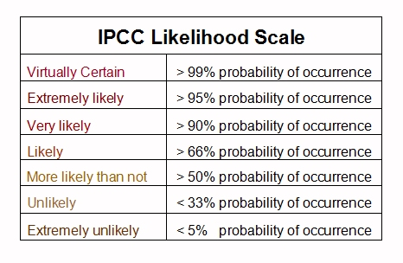

Is ice off date earlier today?
Level of certainty

Quantitative analysis

Without quantitative, probabilistic analysis, it is difficult to analyze data with certainty. Now that you have qualitatively analyzed Mendota’s ice off data, you will quantitatively analyze the data. Using 160 years’ worth of ice off data categorized into several twenty year columns and a powerful statistics webapp, you are going to ask, ‘Is ice off date on Lake Mendota earlier?’.

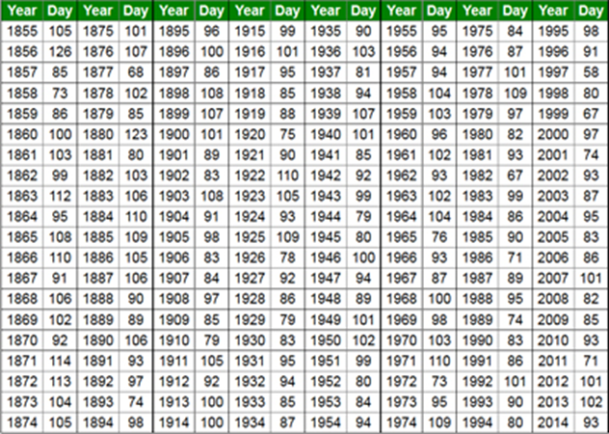 | First, you will ask the question as if you were alive in 1894 (Is the first twenty year section statistically different from the second twenty year section), and then again every 20 years until 2014. In this way, you will be able to visualize how the level of certainty changes over time.  Note – the “ice-off day” are Julian dates which represent a continuous count of days starting on January 1 each year. For example, Day 93 indicates the 93rd day of the year.

You will use a very basic statistical test, the t-test to answer these questions. A t-test compares means between two samples, while also considering the variation around each mean. You will use a webapp to run the t-test, but it is important to note the actual equation that the application is using:

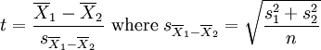
Where X = sample mean and s = standard deviation, and n = sample size.

The webapp tool and the ice-off data is located on-line at http://cimss.ssec.wisc.edu/climatechange/globalCC/lesson9/activity.html

The t stat is the number we are interested in analyzing. Statisticians use a look-up table to determine whether a particular t-statistic, with a particular sample size, shows that two samples actually differ. The IPCC has basically taken this table and added their own language to describe the likelihood of various climatic changes in a consistent way.
(The webapp also calculates the p-value, a measure of how extreme an observation is, and the standard deviation.)

t-statistic | P-value | Probability of occurrence | IPCC Likelihood Scale
0.681 | 0.25 | 75% | Likely
0.851 | 0.20 | 80%
1.05 | 0.15 | 85%
1.303 | 0.10 | 90% | Very Likely
1.684 | 0.05 | 95% | Extremely Likely
2.021 | 0.025 | 97.5%
2.123 | 0.02 | 98%
2.423 | 0.01 | 99% | Virtually Certain
2.704 | 0.005 | 99.5%
2.971 | 0.0025 | 99.75%
3.307 | 0.001 | 99.9%
3.551 | 0.005 | 99.95%
3.790 | 0.0001 | 99.99%

The t-statistic from comparing the first two columns of ice-off data is 0.958 which indicates that the probability that ice off date changed between the two sections of time is somewhere between 80 – 85%. The IPCC would then conclude, “It is likely that by the year 1894, ice off date was earlier on Lake Mendota in Wisconsin.”
- Hypothesize how likelihood will change over time, based on looking at the graph of ice off data.
- Run the same analyses to test for differences in ice off date between section 1 and subsequent sections (1 vs. 3, 1 vs. 4 etc… )
- Enter your results in this table:
Which comparison? | T Stat | Probability of Occurrence | IPCC Likelihood Scale
1 vs. 2 | 0.958 | < 85% | Likely
1 vs. 3
1 vs. 4
1 vs. 5
1 vs 6
1 vs 7
1 vs 8

1) Did the certainty level for 1994 and 2014 match the certainty level you reported for the qualitative analysis? Why or why not?

2) Did the level of certainty change over time as you hypothesized it would?

3)Why do you think the period from 1955 to 1974 (column 7) results in a lower probability of occurrence than comparisons with the 20 years before or the 20 years after?

4) Briefly comment on the significance between the 2001 IPCC report that stated "most of the global average warming over the past 50 years was likely due to anthropogenic greenhouse gas increases…”
to the 2007 IPCC report when they changed the wording in the same phrases to “very likely”.

5) The 2013 IPCC report concluded that “Warming of the climate system is unequivocal” does this correspond to your findings?

http://cimss.ssec.wisc.edu/climatechange/globalCC/lesson9/activity.html

