Name____________________ Class____

Probabilities, Uncertainties & Units Used to Quantify Climate Change

“Most of the global average warming over the past 50 years is very likely due to anthropogenic GHG increases…”

How does the IPCC know whether the statement about global warming’s cause is extremely likely, very likely, or more likely than not? How does the IPCC consistently, across many different disciplines (scientific, technical, and socio-economic), quantify uncertainty? The IPCC uses three different approaches for uncertainty, depending on whether the data are qualitative, quantitative, or based on expert judgment. For the quantitative assessments, most often used in the scientific disciplines, the IPCC uses a Likelihood Scale to consistently define the probability, or likelihood of occurrence. The Likelihood Scale is based on statistics and probability. Statistics is the language that scientists generally use to objectively, and consistently make conclusions about their data – despite uncertainty that is inherent in all datasets. However, statistics is not the best way to communicate findings to a broad audience for the purpose of making new policies or educating the public. By using the Likelihood Scale, the IPCC can effectively communicate what we know and what we don’t know about global climate change.
In this exercise, you will use statistics to analyze a dataset from Lake Mendota that spans the last 150 years. Every year, since 1855, someone has recorded when the lake froze (ice on), and when the lake thawed (ice off). We are going to use these data to ask, ‘Is ice off date on Lake Mendota earlier?’ To answer this question and at the same time quantify the uncertainty around the answer, you will use one of the most basic statistical techniques – a t-test.

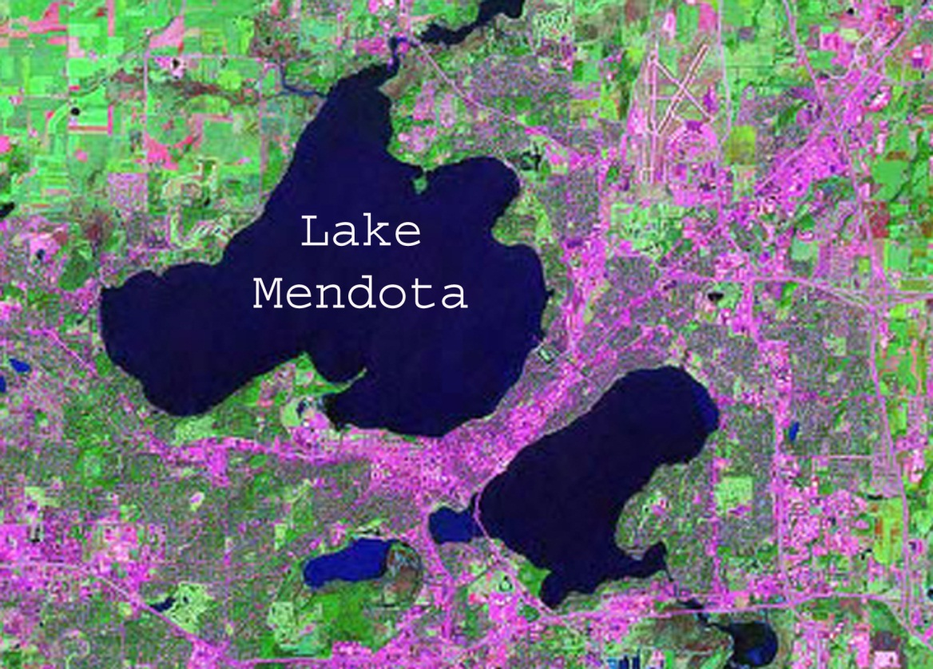

The learning objectives for this lab are to:

- Analyze a historical, climatic dataset qualitatively and then quantitatively, using a probabilistic technique – the t-test.

- Relate statistical results to the IPCC Likelihood Scale.

- Consider how statistics provide a consistent, objective way of making conclusions despite uncertainty in scientific data.

Qualitative analysis
Historical climate data show a substantial amount of year-to-year variation. This variation is one form of uncertainty when scientists analyze for trends in climate data. For example, if you were alive in 1920 and you looked back at the data would you say, with certainty, ice off date is earlier? Think about how you determine your level of confidence – especially considering the year-to-year variation.

- Study the graph below to make a qualitative assessment of ice off date. Record whether ice off date today is earlier than it was in the 1850’s. Report your level of certainty (using the language from the IPCC Likelihood Scale).

Is ice off date different today?
Level of certainty

Quantitative analysis
Without quantitative, probabilistic analysis, it is difficult to analyze data with certainty. Now that you have qualitatively analyzed Mendota’s ice off data, you will quantitatively analyze the same data. The dataset is provided as an excel file, and is divided into several twenty year sections. You are going to ask, using statistics, ‘Is ice off date on Lake Mendota earlier?’. First, you will ask the question as if you were alive in 1914 (Is the first twenty year section statistically different from the second twenty year section), and then again in 1934, and so on until 1994. In this way, you will be able to visualize how the level of certainty changes as time goes on.
You will use a very basic statistical test, the t-test to answer these questions. A t-test compares means between two samples, while also considering the variation around each mean. You will use Excel to run the t-test, but it is important to note the actual equation Excel is using:

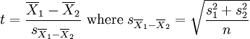
Where X = sample mean and s = standard deviation, and n = sample size.

Statistical analysis – (Excel 2007)
- Open the Excel spreadsheet 150 year dataset from Lake Mendota
- Click on Tools and then click on More Functions and Statistical. In the Statistical list, scroll down to TTEST.

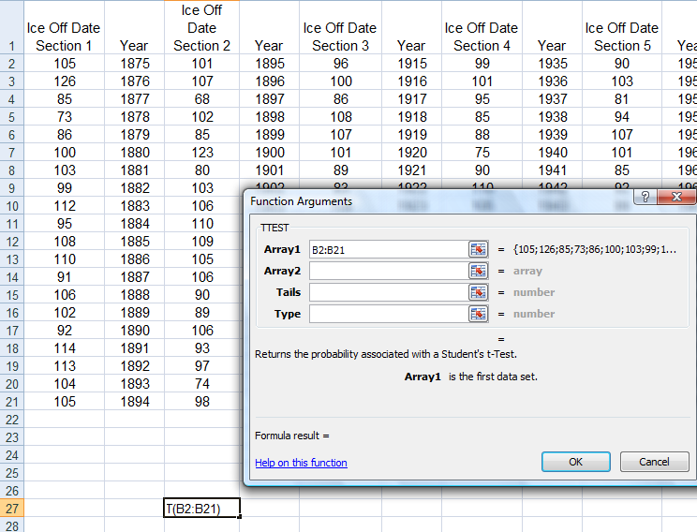

- The first set of data or the first Array is the dates in section 1, B2:B21. You may either type in B2:B21 or you can highlight that section.
- The second set of data is Section 2, D2:D21
- This is a 1-tail T-test and a type 2 (equal variance) T-test. When you are done, the window should look like the window shown below, showing the T-test result of 0.172
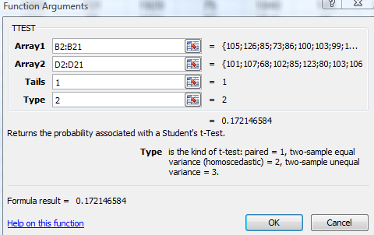

- A t-test of the type you have just performed, tells you the probability that the two data sets could be the result of chance. A t-test of 0.50 would indicate that there was a 50% chance that the differences between the two sets of data are the result of chance variations rather than the result of an actual warming process. However, a t-test result of 0.25 would indicate that there is a 25% probability that the data sets differ because of chance, and a 75% chance that the difference is due to a real effect. At that point the IPCC would call climate change being responsible for the difference between the two data sets as “Likely”. Below you will see the IPCC likelihood scale.

t-statistic  (probability that data is a result of chance) | Probability of occurrence  (from an effect rather than from chance) | IPCC Likelihood Scale
0.25 | 75% | Likely
0.20 | 80%
0.15 | 85%
0.10 | 90% | Very Likely
0.05 | 95% | Extremely Likely
0.025 | 97.5%
0.02 | 98%
0.01 | 99% | Virtually Certain
0.005 | 99.5%
0.0025 | 99.75%
0.001 | 99.9%
0.0005 | 99.95%
0.0001 | 99.99%

- Hypothesize how likelihood will change as you move along in time, based on looking at the graph of ice off data.

- Run the same analyses to test for differences in ice off date between section 1 and subsequent sections (1 vs. 3 then 1 vs. 4 and finally 1 vs. 7). When you click on Tools and select Data Analysis, the dialog box should open with your last specifications still in place. All you need to change is the Variable 2 Range (F2:F21 for section 3, H2:H21 for section 4, N2:N21 for section 7) and the New Worksheet Ply (1 vs. 3, 1 vs. 4, and 1 vs. 7).

- Enter your results on a table like this:
Which comparison? | T Stat | Probability of Occurrence  (not chance) | IPCC Likelihood Scale
1 vs. 2 | 0.172 | 83 | Likely
1 vs. 3
1 vs. 4
1 vs. 7

- Report the Likelihood Scale results on the graph below:
- Did the certainty level for 1994 match the certainty level you reported for the qualitative analysis? Why or why not?

- Did the level of certainty change over time as you hypothesized it would?

